Research's title:

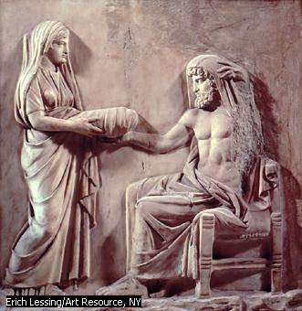

By : Al-Kawthar Shady Hussen

Teacher: Siba Ali

Date: 2014-2015

INTRODUCTION

The ancient Greeks had many myths or stories about gods and heroes. These gods and heroes acted very much like human beings, though on a grander scale. They fell in love, had children…
Some myths are stories about how the universe, the world, and human beings were created. Other myths offer explanations for why such things as war, earthquakes, and floods happen. We still read the Greek myths today.
According to Greek myths, there was nothing but emptiness at first. Then came Gaea, the earth, who gave birth to Uranus, god of the heavens. Gaea and Uranus had 12 children called Titans.
Uranus was afraid that the Titans would take his power. He was right to be afraid. The youngest Titan, Cronus, killed his father. then tried to kill his own children by swallowing them. He didn't succeed. His youngest child, Zeus, overcame Cronus and helped the other children to escape. Zeus’s brothers were the gods Poseidon and Hades, and his sisters were the goddesses Hera, Demeter, and Hestia.
The new gods—the children of Cronus—were known as the Olympians because their home was on Mount Olympus, but not all of them lived there.

THE STRUGLE

Who are the Greek Gods?

Are they real?

How did it all end?

THE UNDERWRITING

A-THE FIRST DOOR:
RHEA AND CRONUS:

In Greek myths, Rhea and Cronus were the parents of six Greek gods. Cronus feared a child would overcome him, so he wanted to swallow his newborn children. In this picture, Rhea is handing him a wrapped stone to swallow, instead of his youngest son Zeus.

B- THE SECOND DOOR:
CHILDREN OF RHEA AND CRONUS:
1-ZEUS:
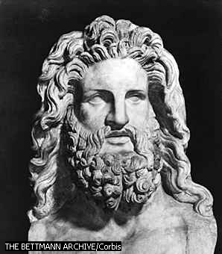
Zeus was the god of thy sky and the king of the other Greek gods and goddesses who lived on mount Olympus .
Family of Zeus:
Parents: he was the youngest child of the Titans Cronus and Rhea
Wife: he married his own sister Hera . He loved her so much but at the same time he was giving her a lot of reasons to be jealous since he advertised his plenty love stories. As a reason : he had a lot of children.
Children: Zeus’s children included the twins Artemis, goddess of hunting, and the sun god Apollo.
Zeus was also father of the three Fates, who controlled human life and decided when people should die. Even Zeus could not make them change their decisions.
Role and responsibilities:
Zeus had his golden throne on the highest summit of mount Olympus. He was respected and awed by all mortals and immortals. All of the kings were proud because they were descended from Zeus.
Zeus was the " lord of justice" , he punished anyone who lied or broke an oath. He was very fair and tried to keep the balance of all things.
Zeus was responsible for the weather and was shaping it according to his mood. When his spirit was high, he blessed the world with fine weather. But if his mood is bad , he would throw rain, winds, thunderbolts and lightnings to cause a disaster to the mortals. But even Zeus's powers had their limits, as an example: he had neither the right nor the ability to change the decisions of the Fates.
The personality of Zeus:
Zeus was carefree and loved to laugh out loudly. He had the perfect knowledge and merciful. But he was unpredictable since no one could guess what would he do.
Appearance of Zeus:
Zeus was strong with long, blue hair.
Symbols of Zeus:
The symbols of Zeus were the throne, the scepter and the thunderbolt which is a gift from the cyclopes because he liberated them. Zeus's tree was the oak tree and his sacred animal was the eagle.
The roman name of Zeus is: Jupiter
2- Poseidon:
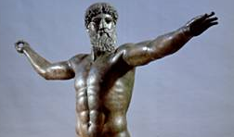

Poseidon was the Greek god of the sea , earthquakes and horses. Poseidon had his own kingdom of the sea. Sailors had to be careful not to annoy him. If he was angry, he might start a storm.
Family of Poseidon:
Parents: he was a child of the Titans
Wife: he married the sea goddess Amphitrite , but according to a tradition he married more than once.
Famous children: the mermen Triton and the Nymphs Rhode and Benthesicyme.
The personality of Poseidon and his way of life:
he was bad-tempered , moody and greedy. Once insulted, he would revenge.
The powers of Poseidon:
He's responsible for the supernatural events mainly the ones associated to the sea, he was the savor of the ships. He had a trident which was so powerful , it could shake the earth. He was able to cause earthquakes and tempets, drown lands, shatter rocks and had the ability to bring back peace after them.
He had two places, one on mount Olympus and the other was located in the depth of the seas, filled with gold ,jeweleries and presious gems. He prefaired to stay beneath the ocean with his wife Amphitrite.
Appearance of Poseidon:
He was strong and imposing with blue hair.
Symbols of Poseidon:
His symbol was the trident , his sacred animals were the horse and the dolphin. According to a tradition: he created the first horse on earth.
The roman name of Poseidon is: Neptune.

3-Hestia:
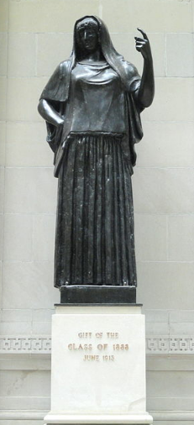
The goddess of hearth and the domistic life. She's one of the three virgin goddesses next to Athena and Artemis. Both Zeus and Poseidon wished to marry her, but she had given in oath to Zeus to never enter a union with a male , and remain pure forever.
Family of Hestia:
Parents: She was the daughter of the Titans Cronus and Rhea Husband: Hestia never married
Worship of Hestia:
she personified the fire burning in every home. All families poured sweet wine in her name. she was always worshiped in any temple no matter who's the god it was built for.
Personality of Hestia:
She was kind and forgiving. She never left mount Olympus, never participated in a war. For that: all olompyan gods respected and loved her.
Appearance of Hestia:
She was a bashful woman , usually seated
In ancient Greek Hestia means: hearth, fireplace
The roman name of Hestia is: Vesta
4-Hades:
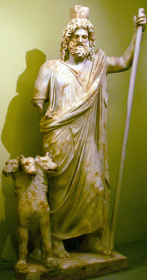
Hades was the Greek god of dead
Family of Hades:
Parents: he's a son of the Titans Cronus and Rhea
Wife: Persephone , he saved her from his sister Demeter and took her down with him to the underworld .
Hades, the ruler of the underworld:
Hades ruled the underworld—a place beneath Earth where the souls of the dead go. Hades kidnapped Persephone, the daughter of Demeter, goddess of grain. Demeter was too busy searching for her child to look after the harvest, and people began to starve.
Zeus ordered Hades to let Persephone go, but she had eaten a little of Hades’s food. Because of that, she had to spend part of every year in the underworld. When Persephone is with Hades, it is winter on Earth and nothing grows. When she returns, spring comes with her.
Symbols of Hades:
The sacred symbol of Hades was his helmet, which helped him to stay invisible. His sacred animal was Cerberus , his own three-headed dog.
Hades in Greek means invisible
The roman name of Hades is : Pluto 5-Demeter:The goddess of agriculture.
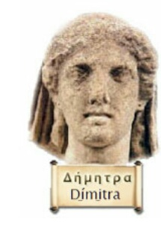
Family of Demeter:
Parents: she's a child of the Titans Cronus and Rhea.
Children: Persephone, the goddess of the underworld.
Demeter's personality and her roles as a goddess:
She was a peace-loving goddess. Demeter was appreciated for introducing wheat to mankid and making men so much different from animals.
Appearance of Demeter:
Demeter was a rich-haired woman. She was usually wearing a dark cloak and holding a golden sword in her hands.
Symbols of Demeter:
The symbols of Demeter were the ear of wheat and the grains.
The roman name of Demeter is: Ceres
6-Hera:
Hera is the goddess of marriage, mothers and families. She's the protecter of marriage and gives special care of the married women.
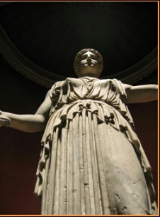
Family of Hera:
Parents: she's a daughter of the Titans Cronus and Rhea.
Husband:she's Zeus's wife and sister.
Hera and Zeus:
Zeus was devious , when he saw Hera he turned himself to a cuckoo and placed himself on her window. When Hera saw the bird she felt sorry and took it inside. Once inside, Zeus returned to his real identity and gained her, so she married him to cover her shame.
Zeus was giving Hera plenty of reasons to be jealous since he advertised his plenty love stories. As a reason, she killed his girlfriends.
Symbols of Hera:
Pomegranate, cow (the motherly animal) and the peacock.
The roman name of Hera is Juno.

C-Some children of Zeus:
1-Athena:
The goddess of wisdom.
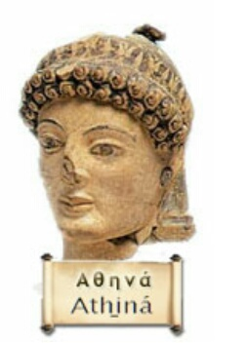

Family of Athena:
Parents: goddess Athena was a daughter of Zeus –the king of gods- and Metis –the first wife of Zeus- who was keeping inside herself all the world's wisdom.
Husband: Athena never married or had children.

The role of Athena:
She's the goddess who taught mankid different skills as waving and sewing to the women, and agriculture and metallurgy to men. She was always giving precious advice.
Appearance of Athena:
She was tall, slim woman with two green eyes trickling light wearing a suit of armor and a golden helmet.
Symbols of Athena:
Athena's symbols were the spear, the distaff and the aegis (a shield of goatskin).
Athena's tree was the olive tree and her sacred animal was the owl –the symbol of wisdom-.
The roman name of Athena is Minerva.

2-Dionysus:
The god of wine and joy.
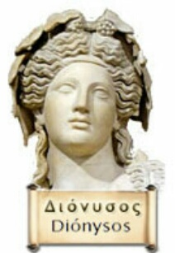

Family of Dionysus:
Parents: he was a son of Zeus –the king of gods- and the beautiful princess Semele.
Because of his mortal mother, his birthplace –Thebis- refused to acknowledge him as an immortal at first.
Relationships: Aphrodite –the goddess of love- and Nix –the goddess of the night-.
Wife: Ariadne –the princess of Crete-.
Famous children: Priapus , Phthonus and Deianira.
Personality and style of Dionysus:
He was the god who offered help to anyone in need. He didn't live on mount Olympus, actually he was travelling around the world to discover the secrets of winemaking.
Appearance of Dionysus:
He was a handsome young man with impressive hair usually falling below his shoulders and a wreath of ivy on his head.
In his hand, he was holding a "thyrsus" which was a light stuff wrapped with leaves of ivy and a pinecone on its top.
Symbols of Dionysus:
The thyrsus ( a wooden stick wrapped with ivy leaves and vines), the flute and the wine barrels.
His sacred animals were the panther and the tiger.
The roman name of Dionysus is Bacchus.

3-Hermes:
The messenger of God and conductor of souls.

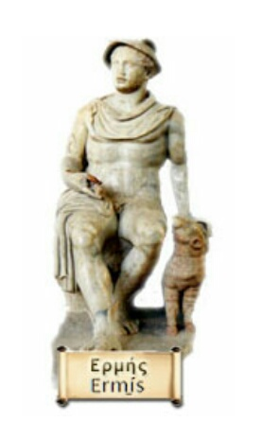
Hermes was born in a cave on mount Cyllene in Arcadia, southern Greece.
Hermes weared wings on his sandals and he was the speediest god of all.
Family of Hermes:
Parents: he's the son of Zeus and the mountain Nymph –Maea- who was a daughter of the Titan Atlas .
Famous children: Hermaphroditus and the Satyr Pan.
Hermes special relationship with Zeus:
Hermes was the messenger of all gods but specially Zeus. He was known for performing duties for his father Zeus.
Zeus appreciated Hermes and always asked for his assistance throughout his decisions , especially when it came to cheating on his wife Hera.
Appearance of Hermes:
He was a young man wearing travelling clothes, a flat hat known as " petasus" and winged sandals on his feet.
Symbols of Hermes:
The caduceus (his staff), the leather pouch , the winged sandals the ram and the petasus (his hat).
The Roman name of Hermes is Mercury

References

Photos | Information
www.greek-gods.info | www.greek-gods.info
Incarta kids | www.rickriordan.com/my-books/percy-jackson/explore-mythology/greek-gods.aspx
 | www.standrewgonj.org
 | www.ancientgreece.co.uk/gods/explore/exp_set.html
 | www.desy.de/gna/interpedia/greek_myths/olympian.html
 | Incarta kids
 | Onegreece.org

THE ENDING

فاTHE ENDING

We met the some of the Greek gods. Many people think they're real and worship them until now and others think that they're just stories and myths that can't be real.
Anyway, we can't figure out if they're real or not!

