**Syrian Arab Republic**

**Ministry of Education**

**National Centre For Distinguished**

***The Mystery of All Time***

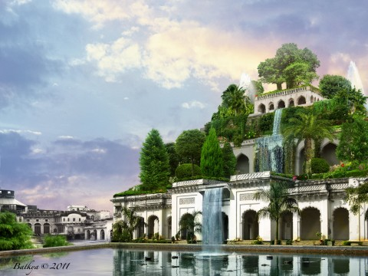

Presented by the student : Alissar Salman

Supervised by The English teacher : Mirna Samaan

2o14 - 2015

Schema of Research

**Introduction**

**The first chapter**: Babylon Civilization

**The second chapter**: The Hanging Gardens of Babylon

* facts
* Greek historians ' descriptions

**The third chapter:** Two theories about the existence of The Hanging Gardens

**The forth chapter** **;** Last Researches Done About The Hanging Gardens of Babylon

**Results**

**Conclusion**

**preface**

With each end of a book , I finish asking myself this question : " How extensive is our history ?! " incredibly our history is so wide .

All along , historians try to solve some of the mysteries mentioned in the ancient history as well as archaeologists who keep on excavating new places in order to find more evidences about history ; Nevertheless , neither historians nor archaeologists could find an overwhelming proof for some of the world's most argumentative history mysteries like " The Pyramids of Giza " , " The Light House of Alexandria " and " The Hanging Gardens of Babylon " as three of the seven wonders of the world .

In fact , I wanted to do this research as a first step to answer some of the questions related to the legendary of The Hanging Gardens of Babylon .

**Introduction**

All along , historians considered the mystery of " The Hanging Gardens of Babylon " as one of the most obscure mysteries in the world .

It is the only one of the seven wonders of the ancient world that may not even have existed ; there are plenty of theories about the gardens , why they were built , how they were built and their size , some of them even described how they were watered .

However, there is no documentation in Babylon sources that the gardens ever existed or any archaeological evidence that they existed .

**The problem of research**

Up till today , there is no proof about the existence of the Hanging Gardens of Babylon ; therefore , I will try to combine all the information about them in this research , and try to put an answer about the question " Have The Hanging Gardens of Babylon ever existed ? ".

**The First Chapter**

**Babylon Civilization**

Babylon was originally a Semitic Acadian speaking city dating from the period of the Acadian empire ( 2300 BC ) .

It was originally built on the river Euphrates and was divided into equal parts along its left and right banks with steep embankments in order to control the seasonal floods of the river .

**Babylon history :**

It has been estimated that Babylon was the biggest city in the world between ( 1770 – 1670 BC ) and again between ( 612 – 320 BC ) , besides , It was perhaps the first city to reach a population above 200,000 !

In addition , It's been estimated that the maximum extent for its size was about 900 hectares .

The first Babylonian dynasty was established by an Amorite chieftain named Sumu-abum who announced the separation from the neighboring city " Kazulla " .

In fact , The Amorite were , unlike the Acadian Semites and Sumerians , not from " Mesopotamia " , which is taken from the ancient Greek , and means the land between the rivers , but now it's a name for the area between the rivers Euphrates and Tigris containing Iraq , Kuwait , the northern part of Syria , southern part of Turkey and some small parts from the southwestern part of Iran , they were semi nomadic Canaanite from northern Levant .

Recently , Many excavation workings has been done in the place of Babylon…

The first reported archaeological excavation was conducted by " Claudius James rich " in 1811 and again in 1817. After that , there was an excavation conducted by " Hormuzd Rassam " . The work begun in 1879 and continued till 1882 , since this excavation , Rassam recovered a large quantity of cuneiform tablets and other finds .

Unfortunately , the zealous digging methods , which are used these days , caused much damage to the archaeological context .

[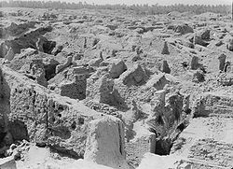](http://en.wikipedia.org/wiki/File:Babylon,_1932.jpg)

Babylon in 1932

------------------------------------------

**The Second Chapter**

**The Hanging Gardens of Babylon**

*Some facts about the hanging gardens*

The Hanging Gardens of Babylon are thought to have been built in the ancient city of Babylon . Even though there is no proof that they actually existed , they are considered to be one of the seven wonders of the world .

Also , It is believed that the word " Hanging " comes from the Latin word " pensilis ", which isthe translation of the Greek word " kremastos "**,** that actually means ' overhanging ' instead of just ' hanging ' .

' The gardens were about 75 feet which equals 22 meters high . The image of the gardens was impressive not only for its blossoming flowers , ripe fruit , gushing waterfalls , terraces that are lush with rich foliage and exotic creatures , but also for the engineering feat of supplying the massive and raising the gardens with soil and water .'[1]

German architect and archaeologist " Robert Koldewey " , who is known for revealing the semilegendary Babylon as a geographic and historical reality , discovered huge vaults and arches at the site and he also discovered a hydraulic system for drawling the water from the river . Experts say that if the gardens had actually existed , it would have taken about 8,200 gallons each day to keep the plants watered !

*How did Greek historians describe the Hanging Gardens ?*

' Some of the historians from ancient Greek and other civilizations that time described the " Hanging Gardens of Babylon " , while some other claimed that they had been there and even seen it !

For example , the three ancient Greek historians " Strabo " , " Philo " and " Diadorus " , gave us three descriptions of the Hanging Gardens of Babylon :

Strabo : " The garden is quadrangular , and each side is four plethra long . It consists arched vaults which are located on checkered cube-like fountains … The ascent of the upper most terrace-roofs is made by a stair way … "

Philo : " The Hanging Garden had plants cultivated above ground level , and the roots of the trees embedded in an upper terrace rather than in the earth . The hole mass is supported on stone columns … streams of water emerging from elevated sources flow down slopping channels … these waters irrigate the hole garden saturating the roots of plants and keeping the hole area moist . Hence the grass is permanently green and the leaves of trees grow firmly attached to supple branches … This is a work of art of royal luxury and its striking feature is that the labor of cultivation is suspended above the head of the spectators " .

Diadorus : " The approach of the garden sloped like a hill slide and the several parts of the structure rose from another tier on tier . On all this , the earth had been piled … and was thickly planted with trees of every kind , that by their great size and other charm , gave pleasure to the beholder . The water machines raised the water in great abundance from the river although no one outside could see it .' [2]

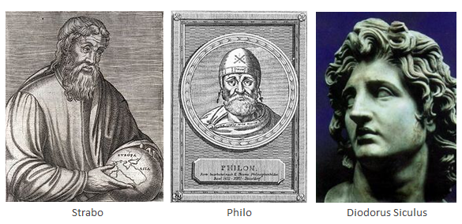

**The Third Chapter**

**Two theories about the existence of the Hanging gardens**

There is no certain conception of how the gardens were built or even by who they were built , but today there are two credible theories about who built " The Hanging Gardens of Babylon " .

In fact , It is assumed that they are the work either of the semilegendary queen " Sammuramat " which is in Greek " Samiramis " , who is the Assyrian queen who reigned ( from 810 to 783 ) BC, or of king "Nebuchadnezzar II" , the king of the Babylonian Empire , who reigned ( from 605 to 562 ) BC .

The First Theory :

Some historians believe that queen " Samiramis " built the Gardens ; They say :

Through centuries the legend of Samiramis attracted not only the attention of Greek historians , but she also was the muse of novelists , poets and even story tellers .

Great warrior queens in history have been called " The Samiramis of their time " .

Moreover , there have been many rumors , which have been spread which made a gossip around her name ; that says : " Samiramis is said to have had a long string of one-night stands with handsome soldiers ". That's besides another rumor which says : " Samiramis had each lover killed after a night of passion , so that her power wouldn't be impended by a man who exploited their relationship .

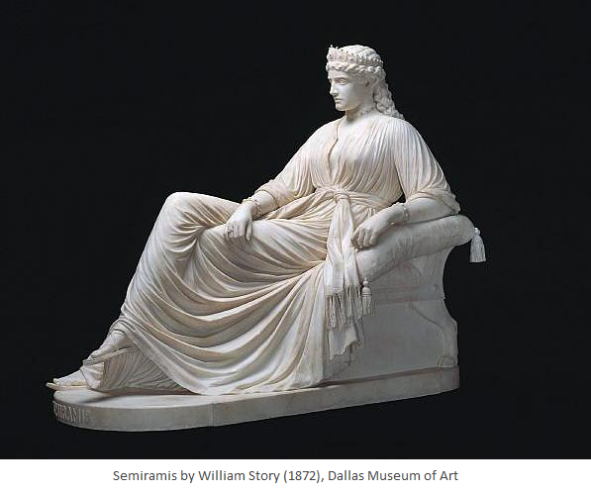

The Second Theory :

On the other hand ,the second theory says that the other supposed builder " King Nebuchadnezzar II " who reigned ( from 605 to 562 ) BC built the legendary Gardens to console his wife " Amytis " , because she was homesick and missed the mountains and greenery of her homeland .

It is important to mention that Nebuchadnezzar II is most known for his portrayal in the bible . According to which , he conquered Judah and Jerusalem , and sent the Jews into exile .

These are the theories about the development of The Hanging Gardens of Babylon , *so how about the ending of those Gardens ?*

Actually , some historians and archaeologists believe that the gardens did exist and were destroyed by war and erosion . But others believe it was earthquakes that actually devastated and destroyed the Gardens .[3]

**The Forth Chapter**

**Last researches done about the Hanging Gardens of Babylon**

' Three or four decades ago , Stephanie Dalley , an Oxford – based archaeologist , cunieformist and gardener , specializing in ancient Assyria since the 1960s , gave a lecture on ancient gardens to the department of Continuing Education in Oxford .

After an extensive reinterpretation of the archaeological and epigraphic evidence with contributions from others outside the immediate field , including those who joined her in a BBC program on the subject in 1999 " Secret's of The Ancients " , which attempted to recreate the enigmatic water supply of the Hanging Gardens in a middle eastern location , Dalley offers her solution to the problem , which she describes in forensic detail .

" For the Greeks and Romans , The Hanging Gardens of Babylon were one of the seven wonders of the world , along with the Pyramids of Giza , the Light House of Alexandria and the Colossus of Rhodes . Supposedly constructed by Nebuchadnezzar II in the 6th century BC , the Hanging Gardens were fed by water taken from the river Euphrates , which was somehow lifted onto some artificial terraces in Nebuchadnezzar's palace ."

Yet , no trace of the gardens was found when Babylon was excavated in 1898 – 1917 by a German team led by Robert Koldewey .

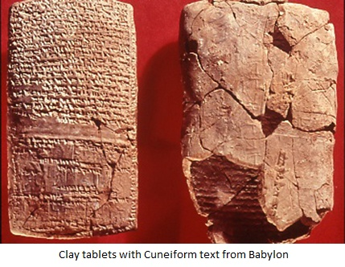

Nor are the Gardens ever mentioned in Nebuchadnezzar's cuneiform inscriptions ; the first references to them come from Roman authors , writing five centuries after the time of Nebuchadnezzar , such as Diadorus siculus and Strabo .

Furthermore, in the 1st century , Strabo described the Gardens , the terraces , the stairway and how the water was drawn up into the Garden by the screws From the Euphrates river , he even described the location of the Garden upon the river . But there is no archaeological or epigraphical evidence that the Babylonians possessed such an advanced hydraulic technology that is able to raise large quantities of water through many meters .

" If only there were the slightest evidence from the cuneiform inscriptions or archaeology that the Hanging Gardens were built in Babylon by Nebuchadnezzar , there would be no need to search for a solution , for there would be no mystery " writes Dalley .

For Dalley , she thinks that they were located not in the flat plain of the Euphrates at Babylon , but close to the mountains and the region of higher rainfall beside the Tigris at Nineveh , north of Babylon , in the palace of the Assyrian ruler Sennacherib , who ruled around 700 BC and was renowned for his water engineering ; the remains of his tunnels and aqueducts can still be seen .

Not only does Sennacherib's palace art depict splendid raised gardens , a key cuneiform inscription by Sennacherib appears – as read by Dalley – to refer an amazing helical water screw cast in bronze , centuries ahead of Archimedes' screw .

'Another theory that says that the name ' Babylon ' , meaning " Gate of God " was applied for several Mesopotamian cities . Sennacherib renamed the city gates of Nineveh after Gods , which suggests that he wished his city to be considered a ' Babylon ' .'[4]

Nevertheless , like many of the links in Dalley's argument , there is no overwhelming proof .

Easier to follow in her argument as to how Nineveh may have been confused with Babylon by Greek and Roman writers . In the cuneiform inscriptions there is an indigenous tradition , dating from the 12th century BC or earlier , that several cities in southern Mesopotamia such as Borsippa and Erido were known as ' Babylon ' . The confusion is that in the opening words of the Biblical book of Judith , which declares : " It was the twelfth year of Nebuchadnezzar who reigned over the Assyrians in the great city of Nineveh " , while the early Greek historian , Xenophon , writes of Babylon , rather than Nineveh as the capital of the Assyrians .

At the end of her research she found that , the Hanging Gardens of Babylon were in Nineveh not Babylon , they were built by Sennacherib , not Nebuchadnezzar and they were watered by a system using kind of screw .But sadly , we shall never really know what the wondrous gardens themselves looked like .

As The BBC program nicely concluded : " one of the seven wonders of the ancient world is also a nature's best kept secrets" . ' [5]

--------------------------------------------

Results :

1. Babylon was originally a Semitic Acadian speaking city , built upon the river Euphrates , and was reigned by the famous king ' Nebuchadnezzar II ' between ( 605 – 562 BC )
2. It was the biggest city in the world and the first one to reach a population above 200000
3. The Hanging Gardens of Babylon , is one of the most obscure mysteries from the ancient world ; therefore , many excavation workings have been done , the most important of which was for a German team led by ' Robert Koldewey '
4. Some Greek historians claimed that they had visited the Hanging Garden , and described it as mesmeric garden , such as Strabo , Philio …
5. There are two possible theories about the existence of the Gardens , the first one says that they would have been done by King ' Nebuchadnezzar II ' for his beloved wife , but the second one says that it was built by the queen ' Samiramis '
6. Dr. Stephanie Dalley , an archaeologist from Oxford university has done a research about the Gardens and found that they were in Nineveh not Babylon , they were built by ' Sennacherib ' not ' Nebuchadnezzar II ' , and they were watered by a system using kind of screw .

Conclusion

In conclusion, the Hanging Gardens of Babylon , have always been the most incredible secret of the ancient world , that attracts the researchers of all time . It has also been the muse of historians and archaeologists all along .

There wasn't any overwhelming proof that they ever existed , which made their existence a mystery that baffled historians in the last few centuries…

Some recent researches like dr. Dalley's , found with the evidence the real place of the Gardens which was different of what we hear from stories " The Gardens were in Babylon " , actually they found that the Gardens were in Nineveh not Babylon and made by the king ' Sennacherib ' .

Maybe we were confused by the name of the city …

It seems that the name of ' Babylon have been changed through centuries .

As the BBC program nicely concluded : " One of the seven wonders of the ancient world is also a nature's best kept secrets " .

References

1. An essay titled " New theory for the Hanging Garden of Babylon " published on Wednesday 27 November 2013
2. Stephanie Dalley , (2013) *The Mystery of The Hanging* *Garden of Babylon* : An Elusive world Wonder Traced
3. http://www. ancientworldwonders.com/tag/the-hanging-garden
4. [www.world-archaeology.com](http://www.world-archaeology.com)
5. [www.bible-history.com](http://www.bible-history.com)
6. Chisholm, Hugh , ed. (1911). "Babylon" .*Encyclopedia Britannica*

OUP ISBN 978-0-19-966226-5

1. The Cambridge Ancient History : prolegomena and prehistory : vol. 1, part 1 . Accessed 15 December 2010

List of Contents

|  |  |
| --- | --- |
| Chapter | page |
| Preface | 3 |
| Introduction | 4 |
| The first Chapter : Babylon Civilization | 5 |
| The second Chapter : a Hint About The Hanging Gardens of Babylon | 7 |
| The Third Chapter : Two Theories About The Existence of The Gardens | 10 |
| The Forth Chapter : Last Researches done About The Gardens | 12 |
| Results | 15 |
| Conclusion | 16 |
| References | 17 |

Figures

|  |  |
| --- | --- |
| Figure | Commentary |
| Figure 1 | Babylon in 1932 |
| Figure 2 | Three Greek historians |
| Figure 3 | Semiramis by William Story ( 1872 ) , Dallas Museum of Art |
| Figure 4 | Clay tablets with cuneiform text from Babylon |

1. http://www. ancientworldwonders.com/tag/the-hanging-garden
2. 2http://www. ancientworldwonders.com/tag/the-hanging-garden
3. http://www. ancientworldwonders.com/tag/the-hanging-garden
4. An essay titled " New theory for the Hanging Garden of Babylon " published on Wednesday 27 November 2013
5. Stephanie Dalley , (2013) *The Mystery of The Hanging* *Garden of Babylon* : An Elusive world Wonder Traced