2014-2015
Syrian Arab Republic
Ministry of education
National Centre for the Distinguished
Course: English
Presented by the student: Amal Abo Tk
Supervised by: Miss Merna Smaan

The Polymers

Introduction

The polymers, a word that we does not hear about it a lot, but it is very important and we cannot imagine our life without it, they are used in a lot of product that we use in daily life. They are a large class of materials consist of many small molecules (called monomers) that are linked together to form long chains.
Since many years, people used polymers in their life but they did not know it well until several years ago.
We classify polymers in different ways because these polymers have many features that make it different and more important than other materials. Therefore, we need a classification to make the study of polymers easier and more organized.
In this research, we are going to cover some basics in polymers… I hope you love this information and be able to use it in your daily life…

The problematic

- What are polymers?
- How we classify polymers?
- What are the applications of polymers?
- How do we process polymers?

Aims of the research

- Defining polymers and its components.
- To discover the history of polymers.
- To know how to classify polymers.
- To discover the applications of polymers.
- To discover how to process polymers.

What is a polymer?

Polymers, or sometimes "macromolecule", this word "polymer" is derived from classical Greek poly meaning "many" and meres meaning "parts". The polymer molecule has very high molecular weight between (10, 000-1000, 000 g/mol) and consist of several structure units bound together by covalent bonds.
Polymers are obtained through chemical reaction of small compounds called monomers; it is a small chemical compound that has small molecular weight. This molecular have the ability to react with another molecule from the same type and in the suitable conditions to form the polymer chain.
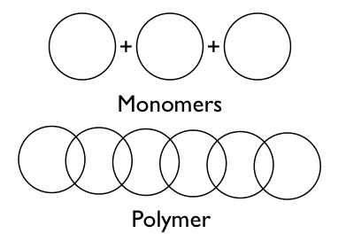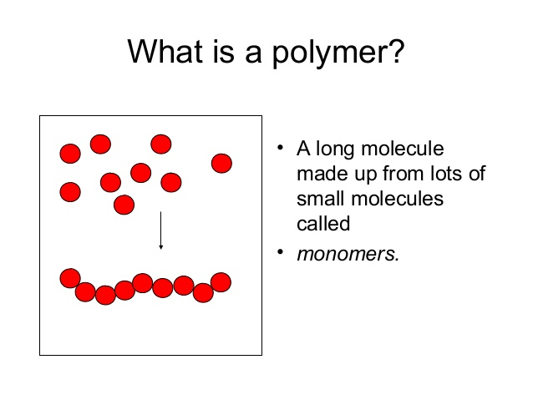
Figure 1: monomers and polymers

The polymer chain consist of structural units, which is named in the terminology of polymers "repeating units", represent the rest structure from the monomer molecule after its reaction to form polymer. Its formula is placed between parentheses and these units equals the monomer molecule or minus an atom or some atoms.
The degree of polymerization (DP), it represents the number of repeating units in the polymer, it is expressed by the number (n) which is put in the bottom of the parentheses that contain the formula of the repeating unit. In addition, with the increasing of DP the molecular weight of polymer increases.
For example, we have polyethylene that is a long chain polymer and it is represented as:

Where the structural (or repeated) unit is –CH₂–CH₂– and n represents the chain length of the polymer.
For example, polyethylene in the previous equation is formed from the monomer "ethylene". In order to form polymers, monomers have reactive functional groups or double (or triple) bonds which its reaction provides the necessary linkages between repeat units. Polymeric materials usually have high strength, possess a glass transition temperature, exhibit rubber elasticity, and have high viscosity as melts and soluble.
Polymers in the natural world have been around us since the beginning of time. Starch, cellulose, and rubber all possess polymeric proprieties. Man-made polymers have been studied since 1832. Today, the polymers industry has grown to be larger than the aluminum, copper and steel industries combined.

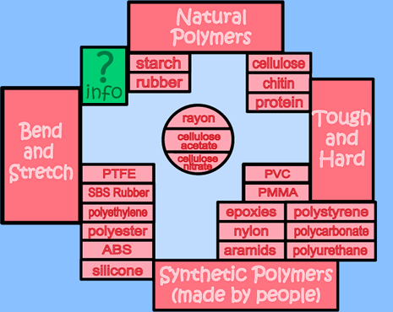
Figure 2: examples of polymers

The history of Polymers

1500's: British explorers discover the ancient Mayan civilization in Central America. The Mayans are assumed to be among the first to find an application for polymers as their children were fond of playing with balls made from local rubber trees.
In 1839: vulcanization was discovered, by combining natural rubber with sulfur and heating it to 270-Fahrenheit degrees. Vulcanized rubber is a polymeric substance that it is much more durable than its natural counterpart. It is most common use today is in automobile tires.
In 1907: the oldest recorded synthetic plastic is fiber by Leo Bakeland. Bakelite's hardness and high heat resistivity made it an excellent choice as an electrical insulator.
In 1917: X-ray crystallography is invented as a method of analyzing crystal structures. Eight years later, this method is used by M. Polanyi to discover the chemical structure of cellulose; this establishes the fact that the polymer unit cells contain section of long chain molecules rather than small molecular species.
In 1920: Staudinger published his classic paper entitled "Uber polymerization" publication of this paper heralded a decade of intense research and presented to the world to the world the development of modern polymer theory.
In 1930: Polystyrene was invented. This polymeric material is used in videocassettes and other packaging. Expanded polystyrene is used in cups, packaging, and thermally insulated containers.
Then in 1938: Wallace Carothers of the DuPont Company produced another well-known polymeric product nylon, which is a common material used today for such application as ropes and clothes.
In 1941: Polyethylene was developed. Billions of pounds of both high and low density versions of this material are produced annually for everything from packaging film to piping to toys.
Later to 1976: the polymer/plastic industry outstripped steel as the nation's most widely used material per unit volume. Now we use plastic more than steel, aluminum and copper combined.
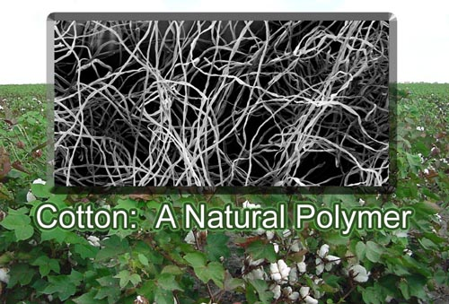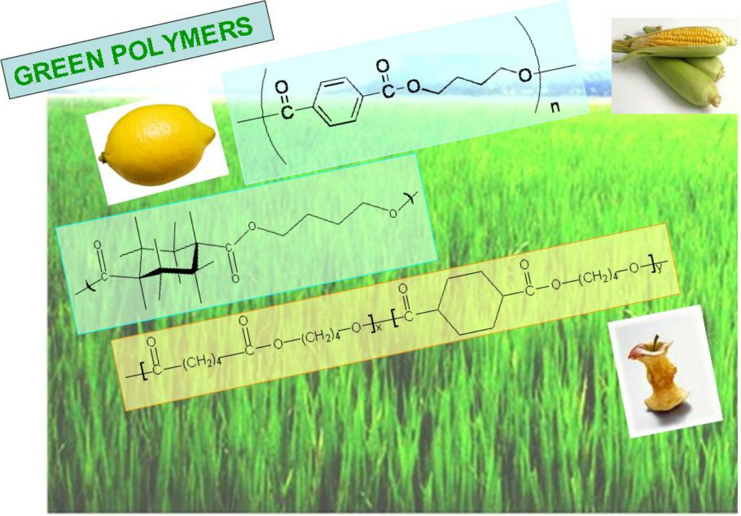
Figure 3: some Polymers

Classification of polymers

Polymers are classified in several ways – by how the molecules are synthesized, by their molecular structure, or by their chemical family... etc. The better way to classify polymers is according to their mechanical and thermal behavior. Industrially polymers are classified into two main classes – plastics and elastomers.
polymers are either natural or synthetic, and are processed by forming or molding into shapes. Plastics are important engineering materials for many reasons. They have a wide range of properties, some of which are unattainable from any other materials, and in most cases, they are relatively low in cost. Some of the plastics properties: lightweight, wide range of colors, low thermal and electrical conductivity, less brittle, good toughness, good resistance to acids, bases and moisture, high dielectric strength (use in electrical insulation), etc.
The elastomers also known as rubbers, these are polymers, which can undergo large elongations under load, at room temperature, and return to their original shape when the load is released. There are number of man-made elastomers in addition to natural rubber. These consist of coil-like polymer chains those can reversibly stretch by applying a force.
Polymers are again classified in two groups depending on their mechanical and thermal behavior as thermoplastics and thermosets polymers. In Thermoplastic, polymers melt in heating and solidify in cooling; the heating and cooling can applied several times without affecting the properties, but thermoset polymers, melt only the first time they are heated; during the first heating the polymer is "cured", doesn't melt on reheating, but degrades.

A more important classification of polymers is based on molecular structure, according to this system the polymer could be:
- Liner chain polymer
- Branched chain polymer
- Network or gel polymer
As we said before, to form polymers the monomers must have reactive functional group, double, or triple bonds. The number of these groups defines the functionality of the monomer. The functionality of the double bond considered as 2, and the triple bond has a functionality of 4. Therefore, in the order of forming polymers, the monomer must be at least bifunctional ; when it is bifunctional the polymer chain are always linear and all the thermoplastic polymers are essentially liner molecules.
In liner chains, the repeat units are held by strong covalent bonds, while different molecule are held by secondary forces. When thermal energy is supplied to the polymer, it increases the random motion of the molecule, which tries to overcome the secondary forces. When all forces are overcome the secondary forces, the molecule become free to move around and it melts and that explain the nature of thermoplastic nature of polymers.
Branched polymers contain molecule having a liner backbone with branches emanating randomly from it. In order to form this class of material, the monomer must have a capability of growing in more than two direction, which implies that the starting monomer must have a functionality greater than 2.
In fact, whenever a multifunctional monomer is polymerized, the polymer evolves through a collection of linear chains to a collection of branched chains, which ultimately forms a network (a gel) polymer.
In all cases, when the polymer is examined at the molecular level, it is found to consist of covalently bonded chains made up of one or more repeat units. The name given to any polymer spices usually depends on the chemical structure of the repeating groups.
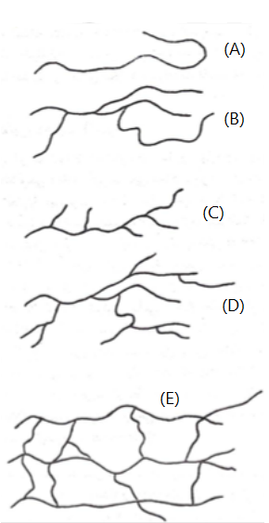
Figure 4: (A) is a liner polymer, (B) (C) (D) are branched polymers, (E) is a network polymer.

Application of polymers

The unique properties of the polymers has made polymers extremely useful for the mankind especially after it had been using in many life's and here are some of its applications:
In Agriculture and agribusiness, the polymers material are used in and on soil to improve aeration, provide mulch and promote plant growth and health.
We also can see the polymers in medicine because many biomaterials, especially heart valve replacements and blood vessels, are made of polymers like Dacron, Teflon and polyurethane.
In Consumer Science, we also find polymers, where plastic containers of all shapes and sizes are lightweight and economically less expensive than the more traditional containers. In addition, clothing, floor coverings, garbage disposal bags, and packaging are other polymer applications.
In the industry, we see the polymers a lot, in automobile parts, windshields for fighter planes, pipes tanks, packaging materials, insulation, wood substitutes, adhesives, matrix for composites, and elastomers. They all are polymer applications used in the industrial market.
Moreover, the polymers also used in sports, such in playground equipment, various balls, and protective helmets are often produced from polymers.
If we wanted to classify the polymers application in accordance with their properties
- The Thermoplastics polymers are used in:

Refrigerator lining, lawn and garden equipment, toys, highway safety devices, lenses, transparent aircraft enclosures, drafting equipment, outdoor signs, anticorrosive seals, chemical pipes and valves, bearings, anti-adhesive coating, high temperature electronic parts, gears, cams, bushings, handles, jacketing for wires and cables, safety helmets, lenses light globes, base for photographic films, flexible bottles, tumblers, battery parts, ice trays and film wrapping material.

- And the Thermosetting polymers are used in:

Electrical moldings, sinks, adhesives, protective coatings, motor housing, telephones, auto distributors, electrical fixtures.

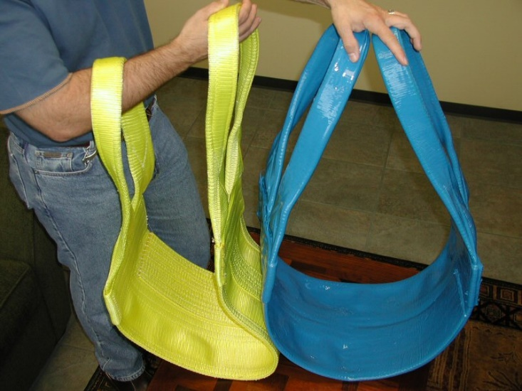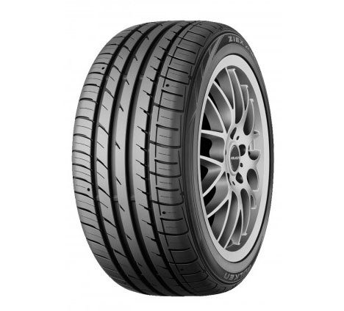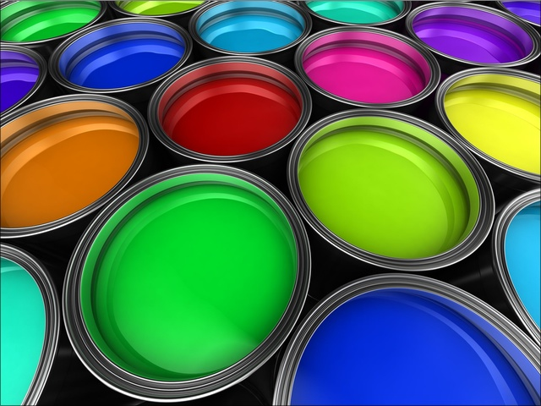
Picture 1: Application of polymers.

Polymer process

Once a polymer with the right properties is produced, it must be manipulated into some useful shape or object. Various methods are used in industry to do this, Injection molding and extrusion are wildly used to process plastics while spinning is the process used to produce fibers.
Injection Molding:
One of the most widely used forms of plastic processing is injection molding. Basically, a plastic is heated above its glass transition temperature (enough so that it will flow) and then is forced under high pressure to fill the contents of a mold. The molten plastic in usually "squeezed" into the mold by a ram or a reciprocating screw. The plastic is allowed to cool and is then removed from the mold in its final form. The advantage of injection molding is speed; this process can be performed many times each second.
Extrusion:
Extrusion is similar to injection molding except that the plastic is forced through a die rather than into a mold. However, the disadvantage of extrusion is that the objects made must have the same cross-sectional shape. Plastic tubing and hose is produced in this manner.
Spinning:
The process of producing fibers is called spinning. There are three main types of spinning: melt, dry, and wet. Melt spinning is used for polymers that can be melted easily. Dry spinning involves dissolving the polymer into a solution that can be evaporated. Wet spinning is used when the solvent cannot be evaporated and must be removed by chemical means. All types of spinning use the same principle, and the process of melt spinning is the simplest one. In melt spinning, a mass of polymer is heated until it will flow. The molten polymer is pumped to the face of a metal disk containing many small holes, called the spinneret. Tiny streams of polymer that emerge from these holes (called filaments) are wound together as they solidify, forming a long fiber.
Fibers are stretched substantially - from (3 to 8) or more times their original length to produce increased chain alignment and enhanced crystallinity in order to yield improved strength.
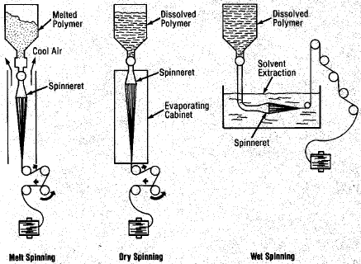
Figure 5: melt, dry, wet spinning

The Conclusion

- Polymers are chemical species of high molecular mass made up of many small repeating units.
- Polymers are either natural or synthetic, or we con classify them in accordance with their mechanical and thermal behavior.
- The industrial polymers are classified into two main classes – plastics and elastomers.
- Synthetic polymers are extremely important products, such as plastics, fibers and nylon.
- The most widely process which is used in forming polymers (plastics and fibers) are Injection molding, extrusion and spinning.

The references

- General Chemistry -the 9th edition - Ebbing, Gammon.
- Fundamentals of polymers- Anil Kumar, Rakesh K. Gupta. - International Edition 1998.
- Polymer science 2000.
- The educational website: http://plc.cwru.edu/tutorial/enhanced/files/polymers.htm
- Material Science - Prof. Satish V. Kailas- Indian Institute of Science, Bangalore, India.

FIGURES INDEX

Figure 1: monomers and polymers 2
Figure 2: examples of polymers 3
Figure 3: some Polymers 5
Figure 4: (A) is a liner polymer, (B) (C) (D) are branched polymers, (E) is a network polymer. 8
Figure 5: melt, dry, wet spinning 12

table of contents
Introduction 1
The problematic 1
Aims of the research 1
What is a polymer? 2
The history of Polymers 4
Classification of polymers 6
Application of polymers 9
Polymer process 11
The Conclusion 13
The references 14
FIGURES INDEX 15
table of contents 16

http://plc.cwru.edu/tutorial/enhanced/files/polymers/intro.htm
Bifunctional: have functionality of 2
Material Science- Prof. Satish V. Kailas- Chapter 11- page 3-4
Material Science- Prof. Satish V. Kailas- Chapter 11-11.5 – page 12-13
From the same previous website.

