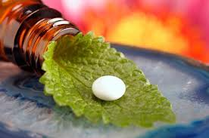

***National Center for Distinguished***

***Year: 2014-2015***

***Supervisor: Ms. Merna Samaan***

***Presented by: Mouna Ghassah***

***Alternative Medicine***

***Ministry of Education***

***Syrian Arab Republic***

***Problematic***

***In this period most of people when they feel sick , they use the chemical medicines which they may have side effects on health , and they forget about the plants ,oils and herbs which can treat them with no side effects.***

***So why don’t we learn more and more about the alternative medicine???***

***And why don’t we try to exchange the chemical medicines with natural treatments???***

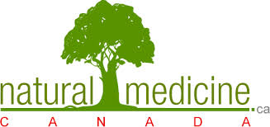

***Introduction:***

***Since the beginning of the twentieth century, human Turn to add chemicals in various pharmaceutical manufacturing and some food, and with this adding, the problems of this time start to spread, such as the immune system diseases, arteriosclerosis, heart troubles, high blood pressure and accompanied by increased incidence of cancer, in its different forms. All these are results directly to a large imbalance in the nature and environment pollution caused by industrial progress and stay away from all the natural medicine. And it is clear that the most important reason in environment pollution in our time in most countries of the world, which infects humans, animals and plants, is involve chemicals in most of the products needed by the human such as food and medicines.***

***In return there must be an awakening, restore human interest in plants and useful herbs, fruits, legumes, vegetables and oils, because of the great interest to maintain human safety, and treat of a lot of physical and mental illness.***  
***Therefore, in this seminar we will see the importance of some plants, and their medical properties, advantages, benefits and importance for health and strong constitution and treatment of many different diseases.***

***Chapter 1 :***

***Herbs***

***Section 1: Rosemary***

***Is an aromatic plant, medical spices, improved flavor and treat a lot of diseases, it contains a lot of antioxidants such as flavonoids and Alrozamanik, Alagoesertich, acid tannins, volatile oil, and this oil contains Arsenal, Albroonjul, camphene and Alcamo, and uses all the plant to boil or soak in boiling water and drink it like tea or added to salads, meat and soups.***

**Medical Properties:**

***1. Lessens the menstrual pains.  
2. Assists in digestion.  
3. Protective against cancer.  
4. Protective against heart disease.  
5. Counterweight the sugar in blood.  
6. Hardens the memory and ability to concentrate and resist oblivion.  
7. Organizes the work of respiratory.  
8. Lessens the symptoms of nausea.  
9. Helps the immune system in the body.  
10. Helps the circulatory system.  
11. Filter and softener for the skin.  
12. Blocks the hair loss and an assistant for its growth.  
13. Protective against wrinkles.  
14. Protective against white water in the eyes.***

***Section 2: Trefoil***

***Is a herbaceous plant grows in fertile land and mild weather is a major and a certified food for the animals to its richness in fiber, protein and minerals such as magnesium, potassium, calcium, copper, zinc, manganese, and many of the vitamins and a lot of the nutrients. It’s a plant that has violet and yellow flowers. The plant is cut several times a year and then grows again, and tastes good and unpalatable such as vegetables, a staple food for the animals.***

***Medical Properties:***   
***1. Strengthen the body's immune and resistant to cancer.  
2. Anti-virus and fungi.  
3. The treatment of anemia.  
4. Resists podagra of uric acid disease.  
5. Treats the gum and teeth diseases.   
6. Help blood to clot.  
7. Lowers the cholesterol level in the blood.  
8. Get rid of the stench of the mouth.  
9. Organizer in diabetes.  
10. Treats the diseases of aging.  
13. Get rid of the body fat and toxins and harmful metals.  
14. Regulate menstrual disorders and hormones regulate the body in general.  
How to eat it:  
1. It’s eaten fresh green added to salads and cuisine.  
2. Squeezed and drank as iced juice.  
3. Boiled such as tea, sweetened and drink.***

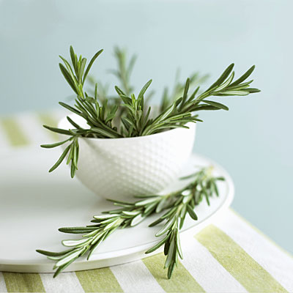

***Picture (1)***  
0

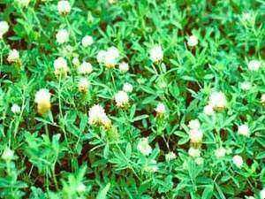

***Picture (2)***

***Chapter 2:***

***Food***

***First: Fruits***

***Section 1: Grape***

***Grapes contain sugary substances such as glucose, vitamins and a good proportion of mineral such as potassium, calcium, sodium and also protein and fatty substances and organic acids like citric acid.  
Medical Properties:   
1. Grapes helps liver activation and safety of its functions and makes yellow livered excretion in regular basis.  
2. Lowers folic acid in the blood, which is deposited in the joints and limbs and cause pain which is known disease gout.  
3. Research indicates that countries where they grow lots of grape production is almost where cancer is rarely spread but nonexistent because the grapes contain on many nutrients that contribute to the output carcinogens "free radicals" materials and posed outside the body, where the grape has on many of the vitamins, minerals, antioxidants and some mineral elements also contains soluble fiber and on non-soluble.  
4. Contribute to the treatment of osteoporosis.  
5. Useful to expel phlegm and soothe the cough.  
7. Prevent gum-ache helps and loss of teeth.***

***Section 2: Guava***

***Guava fruit contains sugar, protein and fatty substances, and some minerals such as phosphorus, iron, potassium, sodium, and also contain many vitamins such as A, B, C. The outer shell and the first layer of the fruit pulp are the richest parts of the vitamins and minerals from within.  
Medical Properties:   
1. dealing with colds and coughs and resist cold symptoms for children.  
2. Prevent scurvy disease.  
3. Medical material treats wounds and dental pain.  
4. Protect the body from the risk of cancer and heart disease.  
5. Recommended for those who suffer from constipation.  
6. Suitable for diabetic’s patients because of low sugar in it.  
ϖ When we boil guava leaf in clean water and drinking water paper can:   
1. Eat it for three days and it helps to give the eye snow white.  
2. Use it to clear the face because it helps it to remove acne and freckles.  
And it gives a snow white teeth.***

***Section 3: kiwi***

***Kiwi is one of the most desirable fruits during diet because of the very small number of calories (only about 20 calories), it also contains a large amount of the vitamin and salts like phosphorus, potassium and iron.  
Medical Properties:   
1. Strengthens bones and prevents fragility.  
2. Eases the digest.  
4. Activates nerve tissues and cells.  
5. Lowers blood cholesterol.  
6. Activates the immune system in the body.  
7. Protects against colon cancer.  
8. fights overweight and obesity.  
9. Lowers high blood pressure.  
10. Treats cough and shortness of breath and allergy skin.  
15. Helps the skin to removes dark spots and wrinkles in the face.***

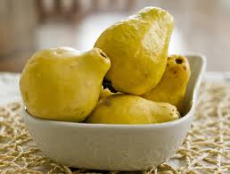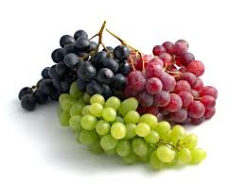

***Picture (4)***  
0

***Picture (3)***  
0

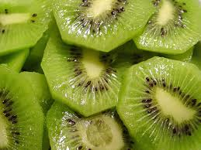

***Picture (5)***  
0

***Second: vegetables***

***Section 1: cucumber***

***Cucumber fruit is very rich in water and contain large amounts of vitamins, so it is very useful for those who have a diet, because it gives a sense of fullness without giving calories, fat or sugars.  
Medical Properties:   
1. purifies the body of toxins, and purifies the skin and gives it freshness and beauty.  
2. It is advised to diabetic Urine patients, because it is a diuretic.  
3. Protects against liver diseases.  
4. Prevent jaundice.  
5. Ease the wounds, blisters and burns pain.  
6. Expels phlegm.  
7. Activates the stomach, kidneys, intestines, and most of the organs of the body.  
8. Purgative for the birth.  
9. Lowers blood cholesterol.  
10. Treats sore throat, cough, shortness of breath and bronchitis.***

***Section 2: parsley***

***Parsley contains fatty oils, carotene, and vitamins like B, C, and K.***

***Medical Properties:   
1. A study showed that parsley has protective effect such as the drug-reducing sugar labeled "Glibornuride".  
2. Prevents abdominal pains and accelerate digestion and makes bloating go.  
3. Smooths stomach and appetizing.  
4. Works on Lithotripsy and strengthens the kidneys.  
5. Protects the body from chest pain cold, and cough.  
6. Gives the body a nice smell when you chew it.  
7. Protects against infection cancers.  
8. Address fever and prevent anemia.  
9. Parsley oil is useful in re-germination hair for people with hair loss.  
10. Calms the nerves.  
11. Parsley juice helps a lot to lose weight, including his apparent effectiveness in melting fat and grease accumulated in the body.  
12. Strengthens the nervous system, as well as it strengthens memory, and resists oblivion.***

***Section 3: broccoli***

***Broccoli is the green kind of Cauliflower, broccoli contain antioxidants that protect body cells from damage and cancer diseases and has a height of vitamin and minerals such as calcium, iron, potassium and magnesium, and proteins, folic acid and fibers.***

***Medical Properties:   
1. Prevent most cancers.  
2. Protects heart from heart attacks and strokes.  
3. Activates the body's immune system.  
4. Protect against infections and increases the number of white blood cells which resist bacteria.  
5. Prevents osteoporosis and strengthens bones.  
6. Prevent the symptoms of premature aging.  
7. Protects the skin from ultraviolet radiation.  
8. Prevent cataracts and eye cancer.  
9. Lowers sugar in blood.***

***10. Enhances the functionality of the brain.  
11. Improves the functions of the nervous system.  
12. Protects the eye from the white water.  
13. Increases the freshness of the skin.  
14. Protect against arthritis.  
15. Protects genes.  
16. Prevent blood clots.***

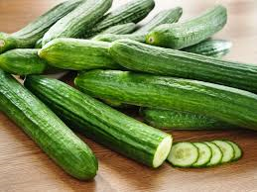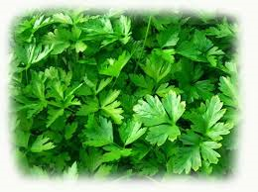

***Picture (6)***  
0

***Picture (7)***  
0

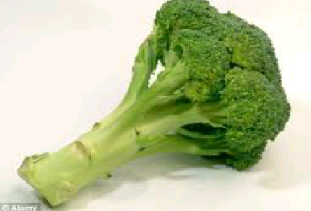

***Picture (8)***  
0

***Chapter 3:***

***Oils:***

***Section 1: olive oil***

***Olive oil is one of the most important foods that benefits the body and prevents a lot of diseases in the human body, also, the crunched foliage’s olive trees is considered of antibiotics and deadly viruses and parasites, as well as strengthen the immune system-based to protect the human body from disease and prevent infection of the disease, and olive oil of unsaturated fats anti-oxidants, which is easy to digest and absorb food and rich in carbohydrates and cellulose, protein, vitamins and minerals.***

***Medical Properties:   
1. lowers high blood pressure.  
2. Powerful antibiotic.  
3. Relieve the symptoms of chicken pox and herpes and colds.  
4. Kills viruses, parasites and lice.  
5. Resists heart disease and clogged arteries.  
6. Softens the digestive system and protects it from shrinking the stomach.  
7. Lowers cholesterol and sugar in blood.  
8. Protects against breast cancer.  
9. Protects the formation of gallstones.  
10. Protects against inflammation.  
11. Renew the body's cells.  
12. Resist rheumatism and arthritis.  
13. Protects the brain from strokes.  
14. activates pancreatic secretions.  
15. develops the brain and nervous system.  
16. Strengthens bones especially with children and the elderly.  
17. Keeps the skin soft.  
18. Strengthens the hair follicles.  
19. Helps heal wounds.  
20. Protects against rickets.***

***Section 2: castor oil***

***Castor oil contains unsaturated fatty acids such as oleic and linoleic Alrsenaulike, which is an anti-inflammatory and antioxidant, and it uses for treat outside and inside the body.  
Medical Properties:   
1. prevents hair loss and it is useful in lengthen it and lengthen eyelashes and eyebrows and intensifies it.  
2. softens the joints and digestive system and facilitates the movement of the intestines and colon.  
3. Softens and moisturizes the skin and removes feet pains.  
4. Expels phlegm and sticky blends.  
5. Activates the body's immune system.  
6. Helps to move out the placenta at birth.  
7. Prevents constipation.  
8. moisturizes the nails and prevents their crackle.  
9. Resists bacteria, fungous and yeasts.  
10. Treats acne and removes dark spots on the skin and freckles and facial wrinkles.  
11. Treats colds and chest infections.  
12. Treats eye irritation and redness.  
13. Treats warts.***

***Results and suggestions:***

1. ***Avoid industrial food and chemical treatments, because since they were used, new problems and diseases started to spread.***
2. ***We should restore our attention to plants and herbs because of their great benefits in stay healthy and treat a lot of illnesses.***
3. ***We should learn about all of these oils, herbs and plants because in this research I couldn’t mention all the plants and their benefits, so when we enrich our information about alternative medicine and become interested in applying it in our delay life ,we will be protected from many illnesses and our health will better ,and our activity will increase ,because spreading of manufacturing and technical development decreased the human’s activity who did everything with his hand and walk long distances to reach to the place that he wanted it, but now machines do a lot of things instead of him.***

***Conclusion***

***In the end I want to say that God created this nature to us and created in it drugs for every disease, in the plants and oils, so we should profit from all these to be more safe from a lot of diseases, without add to it chemical materials which have a lot of sides effects on health, and without remove delicious food taste when we manufacture canned food which may cause cancer if we eat it a lot.***

***And in my seminar, I mentioned some plants and their benefits and medical properties, and I found that they can treat us and safe us from a lot of diseases, and also a lot of positive effects on health, and the number of the plants which I mentioned is very small comparison with the number of the plants in the world, so if we study all the plants, we will found drugs for all the diseases in the world.***

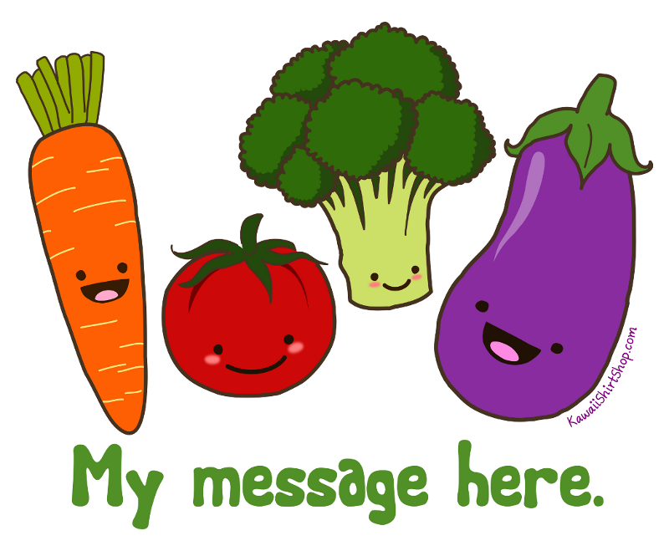

***Resources:***

1. إسماعيل,ندى,موسوعة المعارف العامة (جسم الإنسان)الجزء الأول,المركز الثقافي اللبناني للطباعة والنشر والترجمة والتوزيع ,بيروت.
2. إسماعيل,ندى ,موسوعة المعارف العامة (جسم الإنسان)الجزء الثاني ,المركز الثقافي اللبناني للطباعة والنشر والترجمة والتوزيع ,بيروت .
3. إسماعيل,ندى,موسوعة المعارف العامة(عالم النبات),المركز الثقافي اللبناني للطباعة والنشر والترجمة والتوزيع .بيروت.
4. عقيل,محسن,طب النبي,الطبعة الاولى,المركز الثقافي اللبناني ,بيروت,2000م.

***Pictures index:***

|  |  |  |
| --- | --- | --- |
| *Picture number* | *Picture name* | *Page number* |
| *1* | Rosemary | 1 |
| *2* | Trefoil | 2 |
| *3* | Grape | 3 |
| *4* | Guava | 4 |
| *5* | Kiwi | 5 |
| *6* | Cucumber | 6 |
| *7* | parsley | 7 |
| *8* | Broccoli | 8 |

***Index:***

|  |  |
| --- | --- |
|  | *Page number* |
| *Aim of research* | 2 |
| *introduction* | 2 |
| *Chapter 1* | 3 |
| *Rosemary* | 3 |
| *Trefoil* | 4 |
| *Chapter 2* | 6 |
| *Grape* | 6 |
| *Guava* | 7 |
| *Kiwi* | 7 |
| *Cucumber* | 9 |
| *Parsley* | 9 |
| *Broccoli* | 10 |
| *Chapter 3* | 12 |
| *Olive oil* | 12 |
| *Castor oil* | 13 |
| *Results and conclusion* | 14 |
| *The end* | 15 |
| *Resources* | 16 |
| *Pictures index* | 16 |
| *Index* | 17 |