Syrian Arab Republic
Ministry Of Education
National Center For Distinguished

[اجذب انتباه القارئ باستخدام اقتباس كبير من المستند أو استخدام هذه المساحة للتأكيد على نقطة أساسية. لوضع مربع النص هذا في أي مكان بالصفحة، فقط قم بسحبه.]

THE IMMUNE SYSTEM

Prepared by:
REEMA DEEB
Supervisor:
Bayan Soufi

- INTRODUCTION ………………………………………………………………….. 1
- FIRST: THE STRUCTURE OF THE IMMUNE SYSTEM ……………… 2
- SECOND: IMMUNE CELLS AND THEIR PRODUCTS ……………….. 6
- THIRD: THE IMMUNE SYSTEM AND THE NERVOUS SYSTEM … 14
- FORTH: IMMUNITY: NATURAL AND ACQUIRED …………………… 15
- IMMUNOLOGY AND TRANSPLANTS ……………………………………. 17
- SUMMARY ………………………………………………………………………….. 18
- GLOSSARY …………………………………………………………………………… 19
- TABLE F FIGURES ………………………………………………………………… 21
- RECOURCES AND REFERENCES …………………………………………… 22

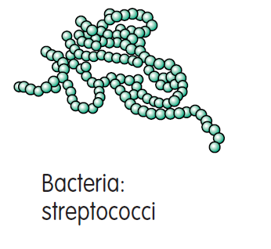
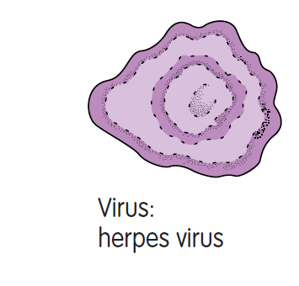
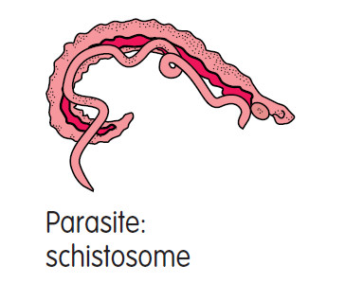
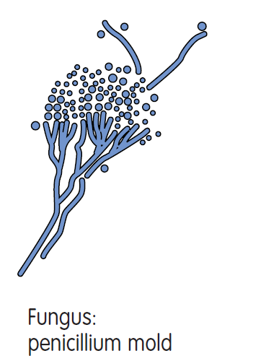

The immune system is a network of cells, tissues, and organs that work together to defend the body against attacks by ``foreign`` invaders. These are primarily microbes (germs) – tiny, infection-causing organisms such as bacteria, viruses, parasites, and fungi .Because the human body provides an ideal environment for many microbes, they try to break in. It is the immune system`s job to keep them out or, failing that, to seek out and destroy them.
When the immune system hits the wrong target or is crippled, however, it can unleash a torrent of diseases, including allergy, arthritis, or AIDS.
The immune system is amazingly complex. It can recognise and remember millions of different enemies, and it can produce secretions and cells to match up with and wipe out each one of them.
The secret to its success is an elaborate and dynamic communications network. Millions and millions of cells, organized into sets and subsets, gather like clouds of bees swarming around a hive and pass information back and forth. Once immune cells receive the alarm, they undergo tactical changes and begin to produce powerful chemicals. These substances allow the cells to regulate their own growth and behavior, enlist their fellows, and direct new recruits to trouble spots.

THE STRUCTURE OF THE IMMUNE SYSTEM
The organs of the immune system are positioned throughout the body [ Figure n ( 1 ) ] . They are called lymphoid organs because they are home to lymphocytes, small white blood cells that are the key players in the immune system.
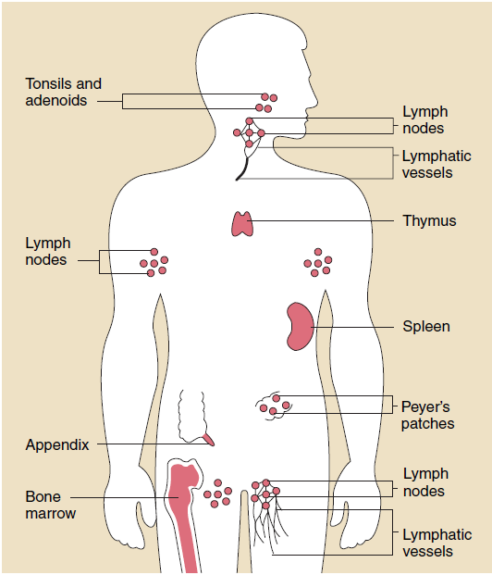
Figure ( 1 )
Bone marrow: The soft tissue in the hollow center of bones , is the ultimate source of all blood cells , including white blood cells destined to become immune cells .
The thymus: Is an organ that lies behind the breastbone ; lymphocytes known as T lymphocytes , or just '' T cells '', mature in the thymus .
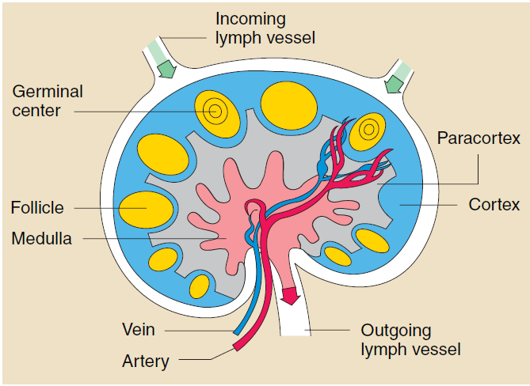
Figure ( 2 )
Lymphocytes can travel throughout the body using the blood vessels.
The cells can also travel through a system of lymphatic vessels that closely parallels the body`s veins and arteries. Cells and fluids are exchanged between blood and lymphatic vessels, enabling the lymphatic system to monitor the body for invading microbes.
The lymphatic vessels carry lymph, a clear fluid that bathes the body`s tissues.
Lymph Nodes: Small, bean–shaped lymph nodes are laced along the lymphatic vessels, with clusters in the neck, armpits, abdomen, and groin. Each lymph node contains specialized compartments where immune cells congregate, and where they can encounter antigens.
Immune cells and foreign particles enter the lymph nodes via incoming lymphatic vessels or the lymph nodes ` tiny blood vessels .
All lymphocytes exist lymph nodes through outgoing lymphatic vessels .
Once in the bloodstream , they are transported to tissues throughout the body . They patrol everywhere for foreign antigens , then gradually drift back into the lymphatic system , to begin the cycle all over again .

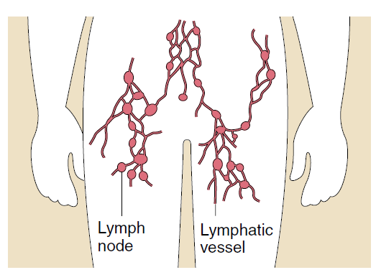
Figure ( 3 )
The Spleen: Is a flattened organ at the upper left of the abdomen. like the lymph nodes , the spleen contains specialized compartments where immune cells gather and work , and serves as a meeting ground where immune defenses confront antigens .
Clumps of lymphoid tissues are found in many parts of the body, especially in the linings of the digestive tract and the air ways and lungs - territories that serve as gateways to the body. these tissues include the tonsils , adenoids , and appendix .
IMMUNE CELLS AND THEIR PRODUCTS

The immune system stockpiles a huge arsenal of cells, not only lymphocytes but also cell–devouring phagocytes
and their relatives .
Some immune cells take on all comers, while others are trained on highly specific targets. To work effectively, most immune cells need the cooperation of the comrades. Sometimes immune cells communicate by direct physical contact, sometimes by releasing chemical messengers.
The immune system stores just a few of each kind of the different cells needed to recognize millions of possible enemies.
When an antigen appears, those few matching cells multiply into a full-scale army. After their job is done, they fade away, leaving sentries behind to watch for future attacks.
All immune cells begin as immature stem cells in the bone marrow. They respond to different cytokines and other signals to grow into specific immune cell types, such as T cells , B cells , or phagocytes . Because stem cells have not yet committed to a particular future , they are an interesting possibility for treating some immune system disorders . Researches currently are investigating if a person`s own stem cells can be used to regenerate damaged immune responses in autoimmune diseases and immune deficiency diseases .
B Lymphocytes
B cells and T cells are the main types of lymphocytes . and B cells work chiefly by secreting substances called antibodies into the body`s fluids . Antibodies ambush antigens circulating the bloodstream . They are powerless , however , to penetrate cells . The job of attacking target cells-either cells that have been infected by viruses or cells that have been distorted b cancer-is left to T cells or other immune cells ( described below ) .
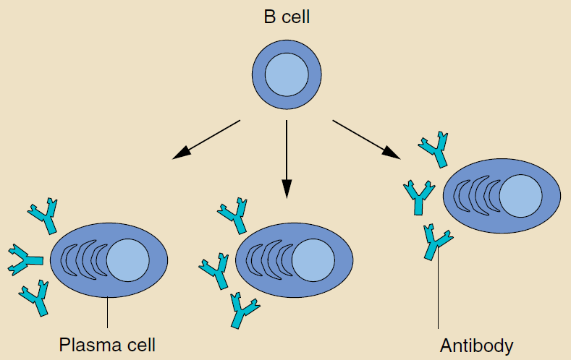
Figure ( 4 )
each B cell is programmed to make one specific antibody . For example, One B cell will make an antibody that attacks a bacterium that causes pneumonia . When a B cell encounters its triggering antigen, it gives rise to many large cells known as Plasma Cells . Every plasma cell is essentially a factory for producing an antibody . Each of the plasma cells descended from a given B cell manufactures millions of identical antibody molecules and pours them into the bloodstream .
An antigen matches an antibody as a key matches a lock . Some matches exactly ; others fit more like a skeleton key . But whenever antigen and antibody interlock, for destruction .
Antibodies belong to a family of large molecules known as Immunoglobulins. Different types play different roles in the immune defense strategy.
- Immunoglobulin G, or IgG, Works efficiently to coat microbes, speeding their uptake by other cells in the immune system.
- IgM is very effective at killing bacteria.
- IgA concentrates in body fluids-tears, saliva , the secretions of the respiratory tract and the digestive tract-guarding the entrances to the body .
- IgE , Whose natural job probably is to protect against parasitic infections , is the villain responsible for the symptoms of allergy .
- IgD remains attached to B cells and plays a key role in initiating early B-cell response .

T Cells
Unlike B cells , T cells do not recognize free-floating antigens . Rather their surfaces contain specialized antibody-like receptors that see fragments of against on the surfaces of infected or cancerous cells .
T cells contribute to immune defenses in two major ways : some direct and regulate immune responses ; others directly attack infected or cancerous cells .
Helper T cells or Th cells , coordinate immune responses by communicating with other cells . Some stimulate nearby B cells to produce antibody , others call in microbe-gobbling cells called phagocytes , still others activate other T cells .
Killer T cells also called Cytotoxic T Lymphocytes or CTLs , perform a different function . These cells directly attack other cells carrying certain foreign or abnormal molecules on their surfaces. CTLs are especially useful for attacking viruses because viruses peeking out from the cell membrane and launch an attack to kill the cell .
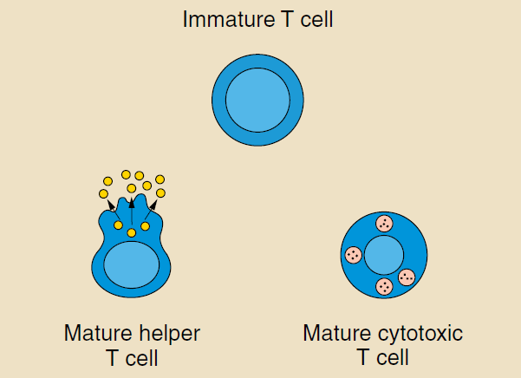
Figure ( 5 )
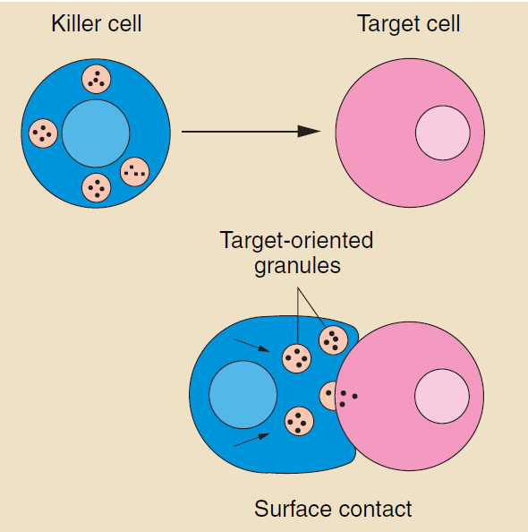
Figure ( 6 )
Cells carrying certain foreign or abnormal molecules on their surfaces . CTLs are especially useful for attacking viruses because viruses often hide from other parts of the immune system while they grow inside infected cells . CTLs recognize small fragments of these viruses peeking out from the cell membrane and launch an attack to kill the cell .
In most cases , T cells only recognize an antigen if it is carried on the surface of a cell by one of the body`s own MHC , or Major Histocompatibility Complex , molecules . MHC molecules are proteins recognized by T cells when distinguishing between self and no self . A self MHC molecule provides a recognizable scaffolding to present a foreign antigen to the T cell .
Although MHC molecules are required for T-cells responses against foreign invaders , they also pose a difficulty during organ transplantation .Virtually every cell in the body is covered with MHC proteins , but each person has a different set of these proteins on his or her cells . If a T cell recognizes a nonself MHC molecule on another cell , it will destroy the cell .
Therefore , doctors must match organ recipients with donors who have the closest MHC makeup . Otherwise the recipient`s T cells with likely attack the transplanted organ , leading to graft rejection .

Natural killer ( NK )
Are another kind of lethal white cell , or lymphocytes .Like Killer T cells , NK cells area armed with granules filled with potent chemicals .
But while Killer T cells look for antigen fragments bound to self-MHC molecules , NK cells recognize cells lacking self-MHC molecules . The NK cells have the potential to attack many types of foreign cells .
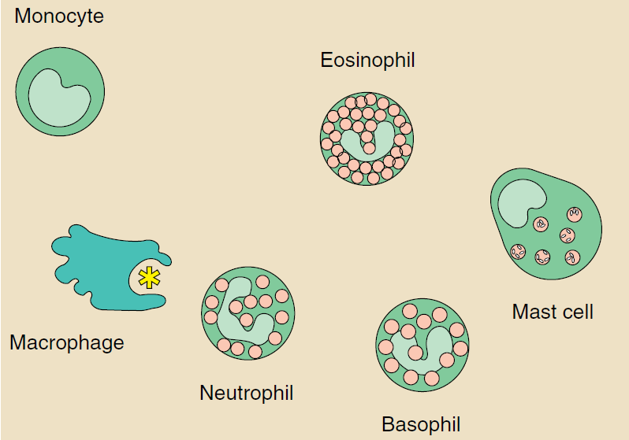
Figure ( 7 )
Both kinds of Killer cells slay on contact . They deadly assassins bind to their weapons , and then deliver a lethal burst of chemicals .

Phagocytes and Their Relatives
Phagocytes are large white cells that can swallow and digest microbes and other foreign particles. Monocytes are phagocytes that circulate in the blood.
When monocytes migrate into tissues , they develop into macrophages .
Specialized types of macrophages can be found in many organs , including lungs , kidneys , brain , and liver .
Macrophages play many roles . As scavengers , they rid the body of worn-out cells and other debris . They display bits of foreign antigen in a way that draws the attention of matching lymphocytes . And they churn out an amazing variety of powerful chemical signals , Known as monokines , which are vital to the immune responses .
Granulocytes are another kind of immune cell . They contain granules filled with potent chemical, which allow the granulocytes to destroy microorganisms .Some of these chemicals, such as histamine, also contribute to inflammation and allergy.
One type of granulocyte, the neutrophil, is also a phagocyte; it uses its prepackaged chemicals to break down the microbes it ingests . Eosinophils and basophil are granulocytes that ''degranulate,'' spraying their chemicals onto harmful cells or microbes nearby.
The mast cell is a twin of the basophil, except that it is not a blood cell. Rather, it`s found in the lungs, skin, tongue and linings of the nose and intestinal tract, where it is responsible for the symptoms of allergy.
A related structure , the blood platelet, is a cell fragment .Platelets ,too, contain granules .In addition to promoting blood clotting and wound repair ,platelets activate some of the immune defenses .
Cytokines
Components of the immune system communicate with one another by exchanging chemical messengers called cytokines. These proteins are secreted by cells and act on other cells to coordinate an appropriate immune response. Cytokines include a diverse assortment of interleukins, interferon, and growth factors.
Some cytokines are chemical switches that turn certain immune cell types on and off.
On cytokines, interleukin 2 (IL-2), triggers the immune system to produce T cells. Il-2`s immunity –boosting properties have traditionally made it a promising treatment for several illnesses .Clinical studies are ongoing to test its benefits in other diseases such as cancer , hepatitis C , and HIV infection and AIDS . Other cytokines also are being studied for their potential clinical benefit.
Other cytokines chemically attract specific cell types. These so-called chemokines are released by cells at a site of injury or infection and call other immune cells to the region to help repair the damage or fight off the invaders. Chemokines often play a key role in inflammation and are a promising target for new drugs to help regulate immune responses.
Complement
The complement system is made up of about 25 proteins that work together to '' complement'' the action of antibodies in destroying bacteria. Complement also helps to rid the body of antibody-coated antigens ( antigen-antibody complex ) . Complement proteins,which cause blood vessels to become dilated and then leaky , contribute to the redness, warmth , swelling , pain , and loss of function that characterize an inflammatory response .
Complement proteins circulate in the blood in an inactive form. When the first protein in the complement series is activated-typically by antibody that has locked onto an antigen-it sets in motion a domino effect. Each component takes its turn in a precise chain of steps known as the complement cascade. The end product is a cylinder inserted into-and puncturing a hole in-the cell`s wall. With fluids and molecules flowing in and out, the cell swells and bursts. Other components of the complement system make bacteria more susceptible to phagocytosis or broken other cells to the area .

THE IMMUNE SYSTEM AND THE NERVOUS SYSTEM

Evidence is mounting that the immune system are linked in several ways. one well-known connection involves the adrenal glands . In response to stress messages from the brain, the adrenal glands release hormones into the blood . In addition to helping a person respond to emergencies by mobilizing the body`s energy reserves, these ''stress hormones '' can stifle the protective effects of antibodies and lymphocytes.
Hormones and other chemicals known to convey messages among nerve cells have been found to ''speak'' to cells of the immune system . Indeed, some immune cells are able to manufacture typical nerve cell products , while some lymphokines can transmit information to the nervous system . What`s more , the brain may send messages directly down nerve cells to the immune system . Networks of nerve fibers have been found connecting to the lymphoid organs .

IMMUNITY: NATURAL AND ACQUIRED
Long ago, physicians realized that people who had recovered from the plague would never get it again; they had acquired immunity. This is because some of the activated T and B cells become memory cells.
The next time an individual meets up with the same antigen, the immune system is set to demolish it.
Immunity can be strong or weak , short-lived or long-lasting , depending on the type of antigen, the amount of the antigen , and route by which it enters the body , Immunity can also be influenced by inherited genes.
When faced with the same antigen , some individuals will respond forcefully , others feebly , and some not at all .
An immune responses can be sparked not only by infection but also by immunization with vaccines. Vaccines contain microorganisms- or parts of microorganisms-that have been started so they can provoke an immune response but not full-blown diseases .
Immunity can also be transferred one individual to another by injections of serum rich in antibodies against a particular microbe ( antiserum ).
For example , immune serum is sometimes given to protect travelers to countries where hepatitis A is widespread . Such passive immunity typically lasts only a few weeks or months .
Infants are born with weak immune responses but are protected for the first few months of life by antibodies received from their mothers before birth . Babies who are nursed can also receive some antibodies from breast milk that help to protect their digestive tracts .
Immune Tolerance
Immune Tolerance is the tendency of T or B lymphocytes to ignore the body`s own tissues . Maintaining tolerance is important because it prevents the immune system from attacking its fellow cells . Scientists are hard at work trying to understand how the immune system knows when to respond and when to ignore .
Tolerance occurs in at least two ways. Central tolerance occurs during lymphocyte development . Very early in each immune cell`s life , it is exposed to many of the self molecules in the body . If it encounters these molecules before it has fully matured , the encounter pathway and the immune cell dies . This process , called clonal deletion , helps ensure that self-reactive T cells and B cells do not mature and attack healthy tissues .
Because maturing lymphocytes do not encounter every molecule in the body , they must also learn to ignore mature cells and tissues .
In peripheral tolerance , circulating lymphocytes might recognize a self molecule but cannot respond because some of the chemicals signals required to activate the T or B cells are absent . So-called clonal anergy , therefore, keeps potentially harmful lymphocytes switched off . Peripheral tolerance may also be imposed by a special class of regulatory T cells that inhibits helper or cytotoxic T-cell activation by self antigens .
Vaccines
Medical workers have long helped the body`s immune system prepare for future attacks through vaccination . Vaccines consist of killed or modified microbes , components of microbes , or microbial DNA that trick the body into thinking an infection has occurred. An immunized person`s immune system attacks the harmless vaccine and prepares for subsequent invasions .
Vaccines remain one of the best ways to prevent infectious diseases such as smallpox , polio and whooping cough have been greatly controlled or eliminated through worldwide vaccination programs .

IMMUNOLOGY AND TRANSPLANTS

Each year millions of people lives are prolonged by transplanted organs , kidney , heart , lung , liver and pancreas . For a transplant to `` take`` , however , the body`s natural tendency to rid itself of foreign tissue must be overridden .
One way , tissue typing , makes sure markers of self on the donor`s tissue are as similar as possible to those of the recipient . Each cell has a double set of 6 major tissue antigens , and each of the antigens exists , in different individuals , in as many as 20 varieties . The chance of 2 people having identical transplant antigens is about 1 in 100,000 .
A second way is to lull the recipient`s immune system . This can be done with powerful immunosuppressive drugs such as cyclosporine A , or by using laboratory-manufactured antibodies that attack mature T cells .
Bone Marrow Transplants
When the immune response is severely depressed – in infants born with immune disorders or in people with cancer – one possible remedy is a transfer of healthy bone marrow . Introduced into the circulation , transplanted bone marrow cells can develop into functioning B and T cells .
In bone marrow transplants , a close match is extremely important . Not only is there a danger that the body will reject the transplanted bone marrow cells , but mature T cells from the bone marrow transplant may counterattack and destroy the recipient`s tissues . To prevent this situation , known as graft-versus-host disease , scientists use drugs or antibodies to ``cleanse`` the donor marrow of potentially dangerous mature T cells .

SUMMARY
Although scientists have learned much about the immune system, they continue to study how the body launches attacks that destroy invading microbes, infected cells, and tumors while ignoring healthy tissues.
New technology for identifying individual immune cells are now letting scientists quickly determine which targets are triggering an immune response. Improvements in microscopy are permitting the first-ever observations of B cells, T cells, and other cells as they interact within lymph nodes and other body tissues.
In addition, scientists are rapidly unraveling the genetic blueprints that direct the human immune response as well as those that dictate the biology of bacteria, viruses, and parasites. The combination of new technology anexpanded genetic information will no doubt teach us even more about how the body protects itself from diseases.

GLOSSARY

- lymph : a transparent , slightly yellow fluid that carries lymphocytes , bathes the body tissues , and drains into the lymphatic vessels .
- tonsils and adenoids : prominent oval masses of lymphoid tissues on either side of the throat .
- appendix : lymphoid organ in the intestine .
- phagocytes : large white blood cells that contribute to the immune defenses by ingesting microbes or other cells and foreign particles .
- cytokines : powerful chemical substances secreted by cells that enable the body`s cells to communicate with one another . Cytokines include Lymphokines produced by lymphocytes and monokines produced by monocytes and macrophages .
- antibodies : molecules ( also called Immunoglobulins ) produced by a B cell in response to an antigen .
- plasma cells : large antibody-producing cells that develop from B cells.
- helper T cells ( Th cells ) : a subset of T cells that carry the CD4 surface marker and are essential for turning on antibody production , activating cytotoxic T cells , and initiating many other immune functions .
- cytotoxic T lymphocytes : a subset of T cells that carry the CD8 marker and can destroy body cells infected by viruses or transformed by cancer .
- Major Histocompatibility Complex : a group of genes that controls several aspects of the immune response . MHC genes code for ``self`` markers on all body cells .
- graft rejection : an immune response against transplanted tissue .
- granules : membrane-bound organelles within cells where proteins are stored before secretion .
- monocytes : large phagocytic white blood cells which , when entering tissue , develop into macrophages.
- macrophage : a large and versatile immune cell that devours invading pathogens and other intruders . Macrophages stimulate other immune cells by presenting them with small pieces of the invaders .
- monokines: powerful chemical substances secreted by monocytes and macrophages . These molecules help direct and regulate the immune responses .
- granulocytes: phagocytic white blood cells filled with granules organisms . Neutrophils , eosinophils , basophils , and mast cells are examples of granulocytes .
- neutrophil : white blood cell that is an abundant and important phagocyte.
- Basophil : white blood cells that contribute to inflammatory reactions. Along with mast cells, basophils are responsible for the symptoms pf allergy.
- Platelet : cellular fragment critical for blood clotting and sealing off wounds.
- interleukins : a major group of Lymphokines and monokines.
- Interferon : protein produced by cells that stimulate anti-virus immune response or alter the physical properties of immune cells
- HIV : human immunodeficiency virus which causes AIDS.
- Chemokines : certain proteins that stimulate both specific and general immune cells and help coordinate immune responses and inflammation.

TABLE OF FIGURES
Figure (1) | The organs of the immune system positioned throughout the the body.
Figure (2) | The lymph node contains numerous specialized structures.  T cells concentrate in the paracortex, B cells in and around  the germinal centers , and plasma cells in medulla.
Figure (3) | Immune cells and foreign particles enter the lymph nodes via incoming lymphatic vessels or the lymph nodes` tiny blood vessels.
Figure (4) | B cells mature into plasma cells that produce antibodies.
Figure (5) | Some T cells are helper cells, others are killer cells.
Figure (6) | Killer cell makes contact with target cell, trains its weapons on the target, then strikes.
Figure (7) | Phagocytes, granulocytes, and mast cells, all with different methods of attack, demonstrate the immune system`s versatility.

RESOURCES AND REFERENCES

- Janeway Ch. Jr., Travers P., (1996) Immunobiology: The Immune System In Health and Diseases. Second edition.
- Warren, E., Levinson, Ernest Jawetz (1995) Medical Microbiology and Immunology, Third edition.
- Abul K. Abbas, Andrew H. Lichman, Jordan S. Pober (2000) Cellular and Molecular Immunology, Fourth edition.
- http://www.bio.davidson.edu/courses/Immunology/Bio307.html
- http://www.niaid.nih.gov/publications/autoimmune/work.htm

