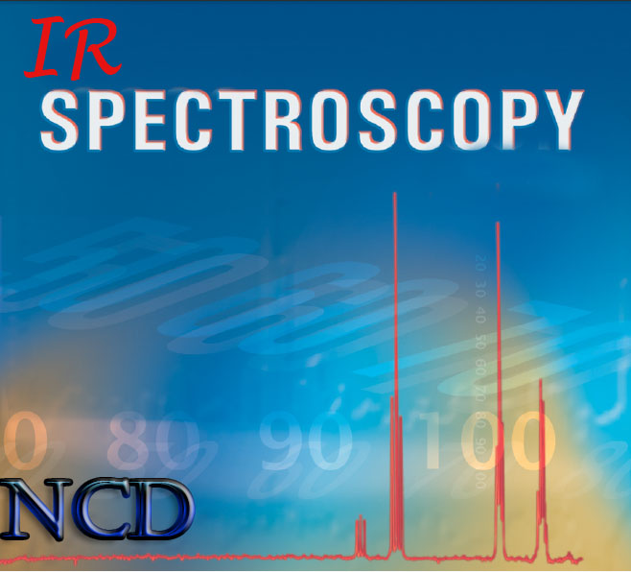
Syrian Arab Republic
Ministry Of Education
National Center for the Distinguished

A seminar with the title :
Infrared spectroscopy
Introduced by the student : zain nofal
to miss bayan alsoufi
For the scholar year 2014-2015

Introduction

determining the structures of compounds is an important part of organic chemistry. After a compound has been synthesized, its structure must be confirmed. Chemists who study natural products must determine the structure of a naturally occurring compound before they can design a synthesis to produce the compound in greater quantities than nature can provide or before they can design and synthesize related compounds with modified properties.
Are there any technique that we can determine by it the organic compounds structures precisely ?
a number of different instrumental techniques are used to identify organic compounds. These techniques can be performed quickly on small amounts of a compound and can provide much more information about the compound’s structure than simple chemical tests can provide.
These techniques are mass spectrum and nuclear magnetic resonance and infrared spectroscopy.
Infrared spectroscopy is certainly one of the most important analytical techniques available to today’s scientists. One of the great advantages of infrared spectroscopy is that virtually any sample in virtually any state may be studied. Liquids, solutions, pastes, powders, films, fibers, gases and surfaces can all be examined with a judicious choice of sampling technique. As a consequence of the improved instrumentation, a variety of new sensitive techniques have now been developed in order to examine formerly intractable samples. Infrared spectrometers have been commercially available since the 1940s. At that time, the instruments relied on prisms to act as dispersive elements, but by the mid-1950s, diffraction gratings had been introduced into dispersive machines. The most significant advances in infrared spectroscopy, however, have come about as a result of the introduction of Fourier-transform spectrometers. This type of instrument employs an interferometer and exploits the well-established mathematical process of Fourier-transformation. Fourier-transform infrared (FTIR) spectroscopy has dramatically improved the quality of infrared spectra and minimized the time required to obtain data. In addition, with constant improvements to computers, infrared spectroscopy has made further great strides. Infrared spectroscopy is a technique based on the vibrations of the atoms of a molecule. An infrared spectrum is commonly obtained by passing infrared radiation through a sample and determining what fraction of the incident radiation is absorbed at a particular energy. The energy at which any peak in an absorption spectrum appears corresponds to the frequency of a vibration of a part of a sample molecule.

Basic principles

Electromagnetic spectrum
Spectroscopy was originally the study of the interaction between Electromagnetic radiation and matter as a function of wavelength (λ).
Electromagnetic radiation is radiant energy having the properties of both particles and waves. A continuum of different types of electromagnetic radiation—each type associated with a particular energy range—constitutes the electromagnetic spectrum (Figure 2). Visible light is the type of electromagnetic radiation which we are most familiar with , Infrared refers to that part of the electromagnetic spectrum between the visible and microwave regions.
A particle of electromagnetic radiation is called a photon. We may think of electromagnetic radiation as photons traveling at the speed of light. Because electromagnetic radiation has both particle-like and wave-like properties, it can be characterized by either its frequency$(ν)$ or its wavelength$(λ)$ , Frequency is defined as the number of wave crests that pass by a given point in one second. Frequency has units of hertz (Hz). Wavelength is the distance from any point on one wave to the corresponding point on the next wave. Wavelength is generally measured in micrometers$(μm)$ or nanometers$(nm)$. One micrometer is 10⁻⁶ of a meter; one nanometer (nm) is 10⁻⁹ of a meter.
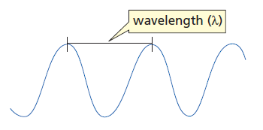
Figure 1 : an electromagnetic wave
The frequency of electromagnetic radiation, therefore, is equal to the speed of light (C) divided by the radiation’s wavelength:
$$ν=\frac{C}{λ}$$
But the energy of an electromagnetic wave is given by the equation :
$$E=h.ν$$
From the equations above we get :
$$E=\frac{h.C}{λ}$$
Where h is Planck’s constant = 6.6 x 10^{–34} joules-sec
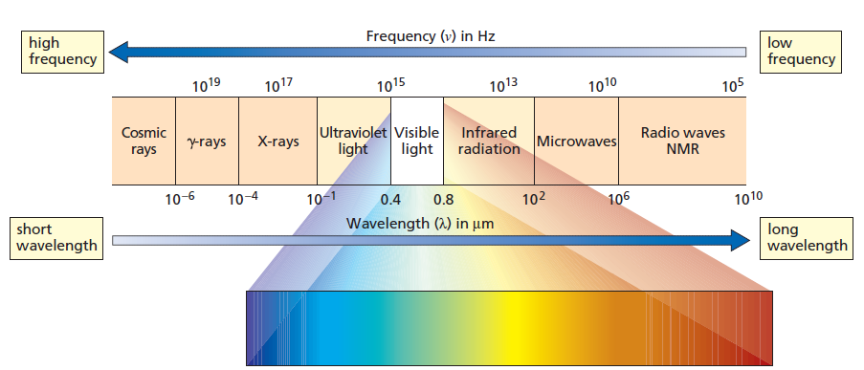
Figure 2 : the electromagnetic spectrum
The IR region is divided into three regions: the near, mid, and far IR The mid IR region is of greatest practical use to the organic chemist. This is the region of wavelengths between
3 x 10⁻⁴ and 3 x 10 ⁻³cm. Chemists prefer to work with numbers which are easy to write; therefore IR spectra are sometimes reported in $(μm)$, although another unit the wave number is currently preferred.
A wavenumber is the inverse of the wavelength in cm:
$$\overline{ν}= \frac{1}{λ}$$

Absorption of infrared radiation
In other spectroscopic technics the incoming radiation excite the particles to a higher energy state but The photons energies associated with the infrared part of the spectrum ( from 1 to 15 kcal/mol) are not large enough to excite electrons, but may induce vibrational excitation of covalently bonded atoms and groups. The covalent bonds in molecules are not rigid sticks or rods but are more like stiff springs that can be stretched and bent.
The covalent bonds in molecules are constantly vibrating. So when we say that a bond between two atoms has a certain length, we are specifying an average because the bond behaves as if it were a vibrating spring connecting two atoms. A bond vibrates with both stretching and bending motions. A stretch is a vibration occurring along the line of the bond that changes the bond length. A bend is a vibration that does not occur along the line of the bond, but changes the bond angle. A diatomic molecule such as $H-Cl$ can undergo only a stretching vibration since it has no bond angles.
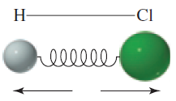
Figure 3 : stretching vibration

The vibrations of a molecule containing three or more atoms are more complex Such molecules can experience symmetric and asymmetric stretches and bends(Figure 4), and their bending vibrations can be either in-plane or out-of-plane. Bending vibrations are often referred to by the descriptive terms rock, scissor, wag, and twist.
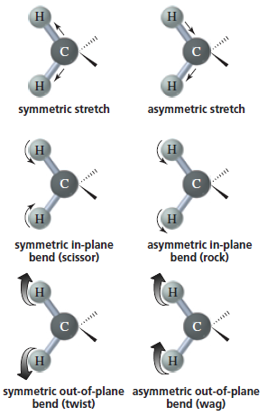
Figure 4 : vibration trends
Each stretching and bending vibration of a bond in a molecule occurs with a characteristic frequency. When a compound is bombarded with radiation of a frequency that exactly matches the frequency of one of its vibrations, the molecule will absorb energy. This allows the bonds to stretch and bend a bit more. Thus, the absorption of energy increases the amplitude of the vibration, but does not change its frequency.
By experimentally determining the wavenumbers of the energy absorbed by a particular compound, we can ascertain what kinds of bonds it has. For example, the stretching vibration of a bond $C=O$ absorbs energy of wavenumber ~1700 cm⁻whereas the stretching vibration of an $O-H$ bond absorbs energy of wavenumber ~3450 cm⁻¹.
Let us consider how bond strength and masses of the bonded atoms affect the infrared absorption frequency , we will consider a diatomic molecule as a tow vibrating masses connected by a string , and let us take (K) as the force constant of the spring , which express the stiffness of the spring , and the masses ( m₁ and m₂) of the tow bonded atoms . the natural frequency of the vibration of a bond is given by the equation :
$$\overline{v}= \frac{1}{2πC}\sqrt{\frac{K}{μ}}$$
Which is derived from Hook's law for vibrating springs , the reduced mass$μ$ of the system is given by :
$$μ=\frac{m_{\begin{aligned}1 \\ \end{aligned}}m_{2}}{m_{1}+m_{2}}$$
Two things should be noticeable immediately . One is that stronger bonds have a larger force constant K and vibrate at a higher frequencies than weaker bonds , The second is that bonds between atoms of higher masses vibrates at lower frequencies than bonds between lighter atoms.
In general , triple bonds are stronger than double bonds or singe bonds between the same two atoms and have higher frequencies of vibration.
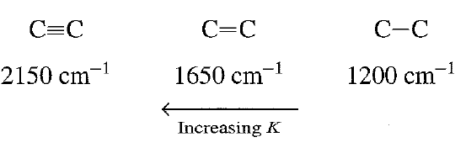
Figure 5: the effect of bond order on the absorbed radiation frequency.
A typical IR spectrum is shown in the Figure 5 . The wavenumber plotted on the X-axis, is proportional to energy; therefore, the highest energy vibrations are on the left. The percent transmittance (%T) is plotted on the Y-axis. An absorption of radiant energy is therefore represented by a “trough” in the curve: zero transmittance corresponds to 100% absorption of light at that wavelength
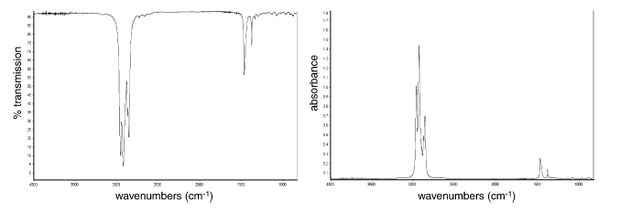
Figure 6: The IR spectrum of octane, plotted as transmission (left) and absorbance (right).
We can see from the Figure 5 that a simple molecule as octane can give a bit complex spectra due to the different patterns of vibration.

The spectrometer

The instrument used to obtain an infrared spectrum is called an IR spectrometer. An infrared spectrum is obtained by passing infrared radiation through a sample of the compound. A detector generates a plot of percent transmission of radiation versus the wavenumber (or wavelength) of the radiation transmitted. At 100% transmission, all the energy of the radiation passes through the molecule. Lower values of percent transmission mean that some of the energy is being absorbed by the compound. Each downward spike in the IR spectrum represents absorption of energy. The spikes are called absorption bands. Most chemists report the location of absorption bands using wavenumbers.
A newer type of IR spectrometer, called a Fourier transform IR (FT-IR) spectrometer, has several advantages. Its sensitivity is better because, instead of scanning through the frequencies, it measures all frequencies simultaneously. With a conventional IR spectrometer, it can take 2 to 10 minutes to scan through all the frequencies. In contrast, FT-IR spectra can be taken in 1 to 2 seconds. The information is digitized and Fourier transformed by a computer to produce the FT-IR spectrum. The spectra shown in this text are FT-IR spectra. An IR spectrum can be taken of a gas, a solid, or a liquid sample. Gases are expanded into an evacuated cell (a small container). Solids can be compressed with anhydrous KBr into a disc that is placed in the light beam. Solids can also be examined as mulls. A mull is prepared by grinding a few milligrams of the solid in a mortar. Then a drop or two of mineral oil is added and the grinding continued. In the case of liquid samples, a spectrum can be obtained of the neat (undiluted) liquid by placing a few drops of it between two optically polished plates of NaCl that are placed in the light beam. Alternatively, a small container (called a cell) with optically polished NaCl or AgCl windows is used to hold samples dissolved in solvents. Ionic substances without covalent bonds are used for discs, plates, and cells because they don’t absorb IR radiation. (Glass, quartz, and plastics have IR-absorbing covalent bonds.) When solutions are used, they must be in solvents that have few absorption bands in the region of interest. Commonly used solvents are CH₂Cl₂ and CHCl₃ In a double beam spectrophotometer, the IR radiation is split into two beams—one that passes through the sample cell and the other that passes through a cell containing only the solvent. Any absorptions of the solvent are thus canceled out, so the absorption spectrum is that of the solute alone.

Spectral Analysis
Once an infrared spectrum has been recorded, the next stage of this experimental technique is interpretation. Fortunately, spectrum interpretation is simplified by the fact that the bands that appear can usually be assigned to particular parts of a molecule, producing what are known as group frequencies.

Characteristic Infrared Absorption Bands
The stretching and bending vibrations of each bond in a molecule can give rise to an absorption band, so IR spectra can be quite complex. But we have a number of absorption bands that we can easily tell an important information about the molecule from their appearance or absence. For example in the Figure 7 the absorbing peak at 3400 cm⁻¹ for $O-H$ stretching and the absorbing peak at 1700 cm⁻¹ for $C=O$ stretching and at 3000 cm⁻¹ For the $C-H$ stretching. And the part of the spectrum from 1400 to 600 cm⁻¹ is called the fingerprint region because it is characteristic of the compound as a whole, just as a fingerprint is characteristic of an individual. Even if two different molecules have the same functional groups, their IR spectra will not be identical, since the functional groups are not in exactly the same environment; this difference is reflected in the pattern of absorption bands in the fingerprint regions. Each compound shows a unique pattern in this region.
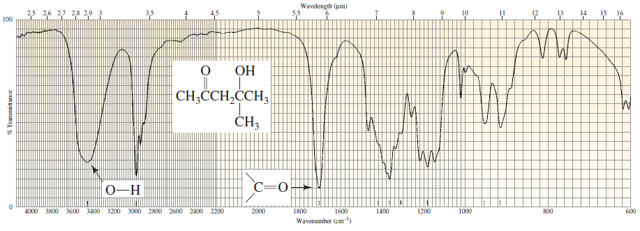
Figure 7:The infrared spectrum of 4-hydroxy-4-methyl-2-pentanone.
Because it takes more energy to stretch a bond than to bend it, absorption bands for stretching vibrations are found in the functional group region from 4000 to 1400 cm⁻¹ whereas absorption bands for bending vibrations are typically found in the fingerprint region from 1400 to 600 cm⁻¹. Stretching vibrations, therefore, are the most useful vibrations in determining what kinds of bonds a molecule has. The IR stretching frequencies associated with different types of bonds are shown in Table1.
This table is very important when examining an IR spectra of a compound because we can tell from a glance a few important structural information about the unknown molecule by seeing the appearance or the absence of intense characteristic absorbing bands that are listed in this table.
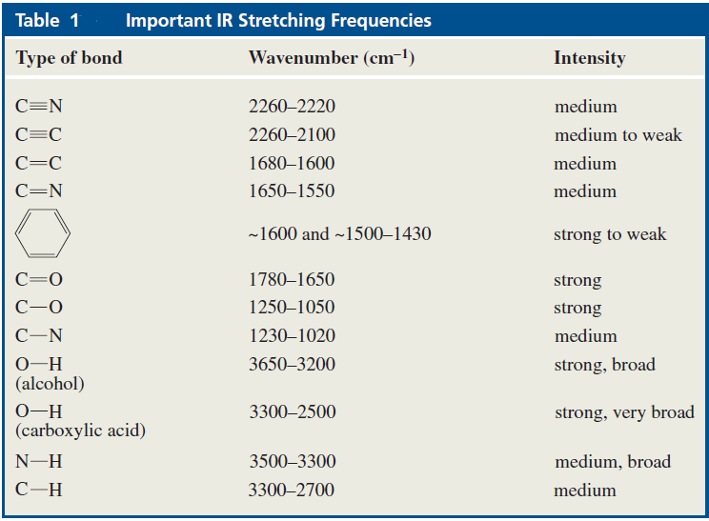

The Intensity of Absorption Bands
The strong absorption at 1715 cm⁻¹ that corresponds to the carbonyl group $C=O$ is quite intense. In to the characteristic position of absorption , the shape and intensity of this peak are also unique to the $C=O$ bond . This is true for almost every type of absorption peak ; both shape and intensity characteristics can be described , and these characteristics often enable the chemists to distinguish the peak in potentially confusing situations . For instance, to some extent $C=O$ (1850-1630 cm⁻¹) and $C=C$ (1680-1620 cm⁻¹ ) bonds absorb in the same region of the infrared spectrum, however the $C=O$ bond is a strong absorber , whereas the $C=C$ bond generally absorbs only weakly . Hence , trained observers would not interpret a strong peak at 1670 cm⁻¹ to be a $C=C$ double bond , nor would they interpret a weak absorption at this frequency to be due to a carbonyl group.
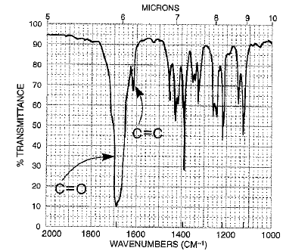
Figure 8 : a comparison of the intensities of the C=O and C=C absorption bands.
The intensity of an absorption band depends on the size of the change in dipole moment associated with the vibration: The greater the change in dipole moment, the more intense the absorption. that the dipole moment of a bond is equal to the magnitude of the charge on one of the bonded atoms, multiplied by the distance between the two charges. When the bond stretches, the increasing distance between the atoms increases the dipole moment. The stretching vibration of an $O-H$ bond will be associated with a greater change in dipole moment than that of an $N-H$ bond because the bond is more polar. Consequently, the stretching vibration of the $O-H$ bond will be more intense. Likewise, the stretching vibration of an$N-H$ bond is more intense than that of a $C-H$ bond because the $N-H$ bond is more polar.

$O-H$ Absorption Bands
The presence of hydrogen bonding is of great importance in a range of molecules. For instance, the biological activity of deoxyribonucleic acid (DNA) relies on this type of bonding. Hydrogen bonding is defined as the attraction that occurs between a highly electronegative atom carrying a non-bonded electron pair (such as fluorine, oxygen or nitrogen) and a hydrogen atom, itself bonded to a small highly electronegative atom. An example of this type of bonding is illustrated by the interactions between water molecules in Figure 9.
$O-H$ absorption bands are easy to detect. Polar bonds show intense absorption bands and the bands are quite broad (Figure 7). The position and the breadth of an $O-H$ absorption band depend on the concentration of the solution. The more concentrated the solution, the more likely it is for the OH-containing molecules to form intermolecular hydrogen bonds. It is easier to stretch an $O-H$ bond if it is hydrogen bonded, because the hydrogen is attracted to the oxygen of a neighboring molecule. Therefore, the $O-H$ stretch of a concentrated (hydrogen bonded) solution of an alcohol occurs at 3550 to 3200 cm⁻¹ whereas the $O-H$ stretch of a dilute solution (with little or no hydrogen bonding) occurs at 3650 to 3590 cm⁻¹ .Hydrogen-bonded OH groups also have broader absorption bands because the hydrogen bonds vary in strength . The absorption bands of non-hydrogen–bonded OH groups are sharper.

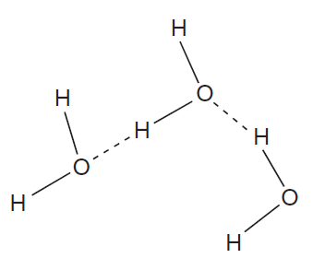
Figure 9 : Hydrogen bonding of water molecules

$C-H$ Absorption Bands
The strength of a $C-H$ bond depends on the hybridization of the carbon: The greater the s character of the carbon, the stronger the bond it forms . Therefore, a $C-H$ bond is stronger when the carbon is sp hybridized than when it is sp² hybridized, which in turn is stronger than when the carbon is sp³ hybridized. More energy is needed to stretch a stronger bond, and this is reflected in the $C-H$ stretch absorption bands, which occur at ~3300 cm⁻¹ if the carbon is sp hybridized, at ~3100 cm⁻¹ if the carbon is sp² hybridized, and at ~2900 cm⁻¹ if the carbon is sp³ hybridized. A useful step in the analysis of a spectrum entails looking at the absorption bands in the vicinity of 3000 cm⁻¹ Figures 10, 11, and 12 show the IR spectra for methyl cyclohexane, cyclohexene, and ethyl benzene, respectively.
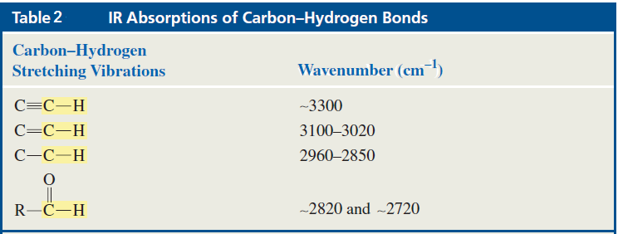
The only absorption band in the vicinity of 3000 cm⁻¹ in Figure 10 is slightly to the right of that value. This tells us that the compound has hydrogens bonded to sp³ carbons, but none bonded to sp² or sp carbons. Each of the spectra in Figures 11 and 12 shows absorption bands slightly to the left and slightly to the right of 3000 cm⁻¹ indicating that the compounds that produced those spectra contain hydrogens bonded to sp² and sp³ carbons. Once we know that a compound has hydrogens bonded to sp² carbons, we need to determine whether those carbons are the sp² carbons of an alkene or of a benzene ring. A benzene ring is indicated by sharp absorption bands at ~1600 cm⁻¹ and 1500-1430 cm⁻¹ , whereas an alkene is indicated by a band at ~1600 cm⁻¹ only (Table 2). The compound with the spectrum shown in Figure 11 is, therefore, an alkene, while that shown in Figure 12 has a benzene ring.
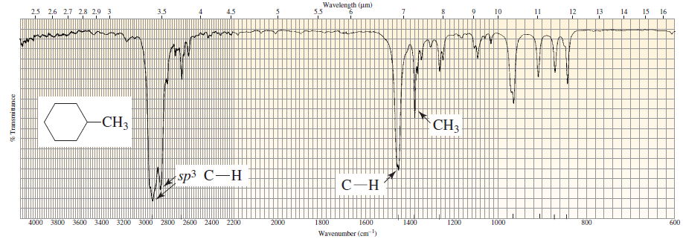
Figure 10 : The IR spectrum of methyl cyclohexane.
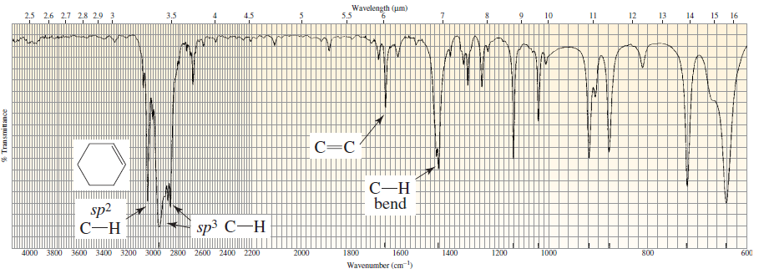
Figure 11 : The IR spectrum of cyclohexene.
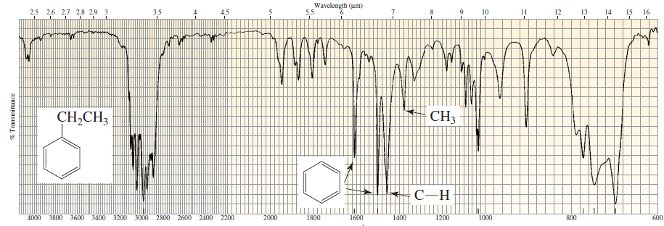
Figure 12 : The IR spectrum of ethyl benzene.

Resonance and Inductive Electronic Effects
Any table that contains absorption bands frequencies shows a range of wavenumbers for each stretch because the exact position of the absorption band depends on other structural features of the molecule, such as electron delocalization, the electronic effect of neighboring substituents, and hydrogen bonding. Important details about the structure of a compound can be revealed by the exact position of the absorption band. For example, the IR spectrum for 2-pentanone shows that the carbonyl group absorbs at 1720 cm⁻¹ whereas the IR spectrum for 2-cyclohexenone shows that the carbonyl group absorbs at a lower frequency (1680 cm⁻¹). 2-Cyclohexenone absorbs at a lower frequency because the carbonyl group has less double-bond character due to electron delocalization. Because a single bond is weaker than a double bond, a carbonyl group with significant single-bond character will stretch at a lower frequency than will one with little or no single-bond character.
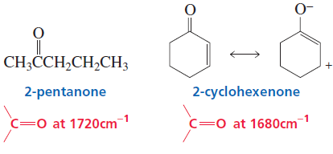
Putting an atom other than carbon next to the carbonyl group also causes the position of the carbonyl absorption band to shift. Whether it shifts to a lower or to a higher frequency depends on whether the predominant effect of the atom is to donate electrons by resonance or to withdraw electrons inductively.
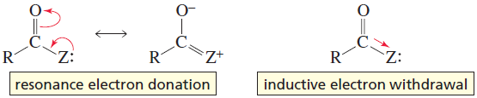
The predominant effect of the nitrogen of an amide is electron donation by resonance. Therefore, the carbonyl group of an amide has less double-bond character than does the carbonyl group of a ketone, so it is weaker and stretches more easily (1660 cm⁻¹). In contrast, the predominant effect of the oxygen of an ester is inductive electron withdrawal, so the resonance contributor with the $C-O$ single bond contributes less to the hybrid. The carbonyl group of an ester, therefore, has more double bond character than does the carbonyl group of a ketone, so the former is stronger and harder to stretch (1740 cm⁻¹ ).
A bond shows a stretch between 1250 and 1050 cm⁻¹ If the $C-O$ bond is in an alcohol or an ether, the stretch will occur toward the lower end of the range. If, however, the $C-O$ bond is in a carboxylic acid (Figure 13) ,the stretch will occur at the higher end of the range. The position of the $C-O$ absorption varies because the $C-O$ bond in an alcohol is a pure single bond, whereas the $C-O$ bond in a carboxylic acid has partial double-bond character that is due to resonance electron donation. Esters show $C-O$ stretches at both ends of the range because esters have two $C-O$ single bonds—one that is a pure single bond and one that has partial double-bond character.
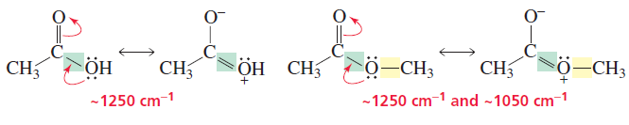
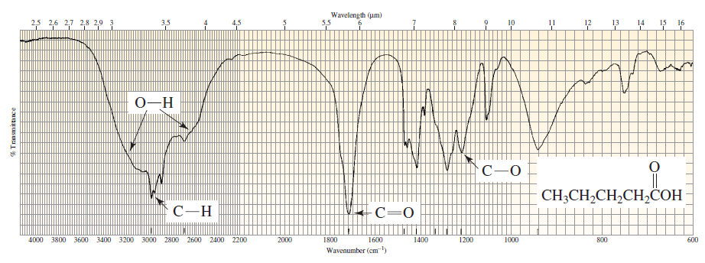
Figure 13 : The IR spectrum of pentanoic acid.

Identifying Infrared Spectrums
after we now know the basics of analyzing infrared spectra let us try to identify the compounds which give the spectrum in the Figure 14 and 15.
The absorptions in the 3000 cm⁻¹ region in Figure 14 indicate that hydrogens are attached to both sp² carbons ( 3075 cm⁻¹ ) and sp³ carbons ( 2950 cm⁻¹ ), Now let’s see if the sp² carbons belong to an alkene or to a benzene ring. The absorption at 1650 cm⁻¹ and the absorption at ~890 cm⁻¹ . suggest that the compound is a terminal alkene with two alkyl substituents at the 2-position.The lack of absorption at ~720 cm⁻¹ indicates that the compound has fewer than four adjacent methylene groups.
We are not surprised to find that the compound is 2-methyl-1-pentene.
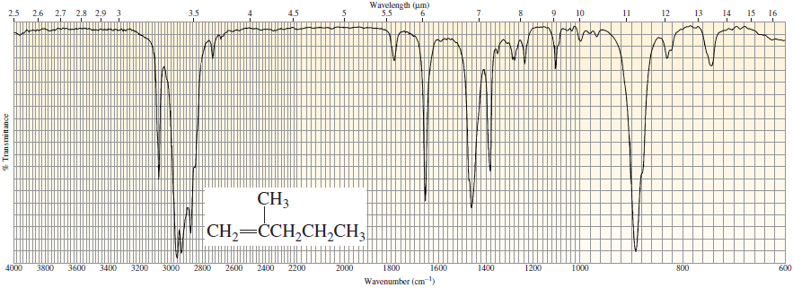
Figure 14 : the IR spectrum for 2-methyl-1-pentene
The absorption in the region 3000 cm⁻¹ in Figure 14 indicates that hydrogens are attached to sp³ carbons The relatively strong absorption band at 3300 cm⁻¹ suggests that the compound has one $N-H$ bond. The presence of the $N-H$ bond is confirmed by the absorption at 1560 cm⁻¹ The $C=O$ absorption at 1660 cm⁻¹ indicates that the compound is an amide.
The compound is N-methylacetamide.
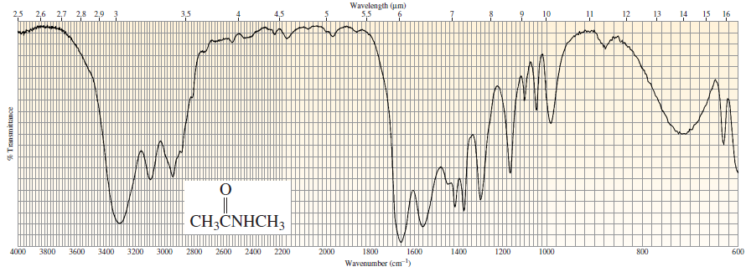
Figure 15 : the IR spectrum for N-methylacetamide.

conclusion
The IR spectroscopy became one of the most important techniques available for identifying molecular structure in the last century competing with other important techniques like nuclear magnetic resonance , X-ray diffraction and UV-vis spectroscopy in the defining of proteins structure and complicated amino and nuclear acids .
The information that IR spectrum provides are very valuable for the organic and biological chemists , cause it tell us almost the whole structure of the examined molecule by the appearance or absence of certain bands in the spectrum.

References
- Introduction to infrared spectroscopy ,Theophile Theophanides.
- organic chemistry lab courses at the University of Colorado, Boulder, Dept of Chem and Biochem. (2002)
- Introduction to Spectroscopy 3th edition , Pavia , Lampman , Kriz .
- Organic chemistry , 4th edition , Paula Bruice.
- Infrared Spectroscopy: Fundamentals and Applications B. Stuart 2004 John Wiley & Sons, Ltd

Table of Figures
Figure 1 : an electromagnetic wave 4
Figure 2 : the electromagnetic spectrum 5
Figure 3 : stretching vibration 6
Figure 4 : vibration trends 6
Figure 5: the effect of bond order on the absorbed radiation frequency. 7
Figure 6: The IR spectrum of octane, plotted as transmission (left) and absorbance (right). 7
Figure 7:The infrared spectrum of 4-hydroxy-4-methyl-2-pentanone. 9
Figure 8 : a comparison of the intensities of the C=O and C=C absorption bands. 11
Figure 9 : Hydrogen bonding of water molecules 12
Figure 10 : The IR spectrum of methyl cyclohexane. 13
Figure 11 : The IR spectrum of cyclohexene. 13
Figure 12 : The IR spectrum of ethyl benzene. 13
Figure 13 : The IR spectrum of pentanoic acid. 15
Figure 14 : the IR spectrum for 2-methyl-1-pentene 15
Figure 15 : the IR spectrum for N-methylacetamide. 16

Table of contents
Introduction 3
Basic principles 4
Electromagnetic spectrum 4
Absorption of infrared radiation 5
The spectrometer 8
Spectral Analysis 9
Characteristic Infrared Absorption Bands 9
The Intensity of Absorption Bands 10
$O-H$ Absorption Bands 11
$C-H$ Absorption Bands 12
Resonance and Inductive Electronic Effects 14
Identifying Infrared Spectrums 15
conclusion 17
References 18
Table of Figures 19

Introduction to infrared spectroscopy ,Theophile Theophanides.
organic chemistry lab courses at the University of Colorado, Boulder, Dept of Chem and Biochem. (2002)
Introduction to Spectroscopy 3th edition , Pavia , Lampman , Kriz .
Organic chemistry , 4th edition , Paula Bruice.
Infrared Spectroscopy: Fundamentals and Applications B. Stuart 2004 John Wiley & Sons, Ltd.

