**Syrian Arab Republic**

**Ministry of Education**

**National Center For the distinguished**

**QUARKS**

**offering*:* SaraNasser**

***The supervisor: M. Bayan Soufi***

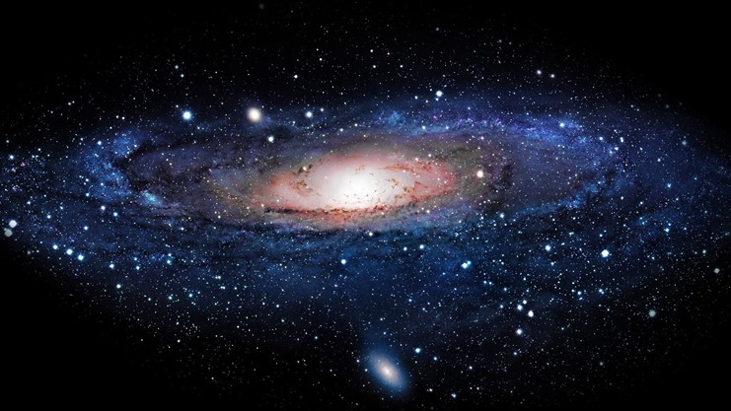

# The problem of the: seminar

Cosmogony, the origin of the matter, the matter's components are issues which perplexed the scientists

The atomic physics and the under atomic physics are new sciences have created and developed rapidly.

In addition to, the four basic forces in the universe were united and then, they separated. So that, the human have studied them and benefited from them in his medical,economic,martial domains.

All of that depends on knowing the matter's components and try to know the components of the components that discovered.

After recognizing the components of the **Atom**, the most of the scientists thought that electrons, neutrons and protons are the smallest particles. But in 1964 they proved –theoretically- that protons and neutrons have components. So, we can't consider them as initial particles. In 1968, they found the proof for these tiny particles's existence (the coponenets of protons and neutrons) . Then, they called them QUARKS .

from all of that, lots of quastions can occur like:

What are the QUARKS ??

How did they be discovered ???

What is the story behind their weird name"QUARKS"??

What are the kinds of QUARKS ???

What the relationship between them and the four forces in the universe?

To answer all of these questions, I prepared this seminar.

# The introduction of substance's structure:

The [1]Greek philosophers were the first who gave their vision of a substance's structure when they said "the part of substance that doesn't never set part is the **Atom**" ,and the Arab philosophers called it the essence,this is what we call today **Atom**

## The components of the Atom:

[2]**1:** nucleus**:**

Discovered by Ernest Rutherford in 1911, the nucleus is the central part of an atom, Composed of **protons** and [**neutrons**](http://education.jlab.org/glossary/neutron.html),

the nucleus contains most of an atom's mass.

**Proton**[3]

Protons are positively charged particles found within atomic nuclei. Protons were discovered by Ernest Rutherford in experiments conducted between the years 1911 and 1919.

Experiments done at **the Stanford Linear Accelerator Center** in the late 1960's and early 1970's showed that protons are made from other particles called quarks..

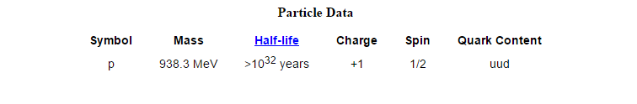

**Neutron**[4]

Neutrons are uncharged particles found within atomic [nuclei](http://education.jlab.org/glossary/nucleus.html). Neutrons were discovered by James Chadwick in 1932. Experiments done at **the** [**Stanford Linear Accelerator Center**](http://www.slac.stanford.edu/) in the late 1960's and early 1970's showed that neutrons are made from other particles called [quarks](http://education.jlab.org/glossary/quark.html).

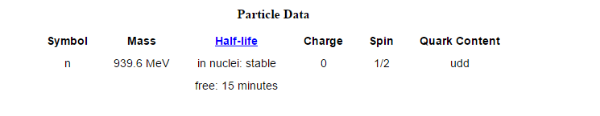

[5]**2:**Electron**:**

Electrons are negatively charged particles that surround the atom's [nucleus](http://education.jlab.org/glossary/nucleus.html) so fast . Electrons were discovered in 1897.

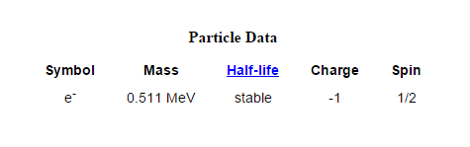

. .

Thus..

_ the[6] **Atoms** are made of extremely tiny particles called protons, neutrons,and electrons.

_ Protons and neutrons are in the center of the atom,making up the nucleus.

_ Electrons surround the nucleus

_ Protons have a apositive charge.

_ Electrons have a negative charge.

So the charge on the proton and electron are exactly the same size but opposite.

_ Neutrons have no charge.

* There's a large distance between the nucleus and the electrons's orbits.
* _ The electrons are so tiny.So that, their masses are ignored, and they round so fast surroundings the nucleus.

# Otherwise.. The matter consists of:

Hadrons:

Hadrons consist of quarks, and the quarks exist only in groups with other quarks.

There are two classes of hadrons:

**🡺** Baryons:

are any hadron which is made of three quarks (qqq).

Like proton (made of two up quarks and one down quark (uud)), and neutron(made of one up quarks and two down quark(udd)).

**🡺** Mesons:

Contain a quark and an antiquark(q , q-).

[7]One example of a meson is a pion (π+), which is made of an up quark and a down anitiquark. The antiparticle of a meson just has its quark and antiquark switched, so an antipion (π-) is made of a down quark and an up antiquark.

Leptons:

[8]Leptons are particles with little mass that interact through the electromagnetic and weak forces.

There are six known leptons: the **electron**, the **muon**, the **tau** (all with a charge of -1), the **electron** **neutrino**, the **muon** **neutrino** and the **tau** **neutrino** (all without charge).

Leptons have a spin of 1/2 and are believed to be fundamental particles.

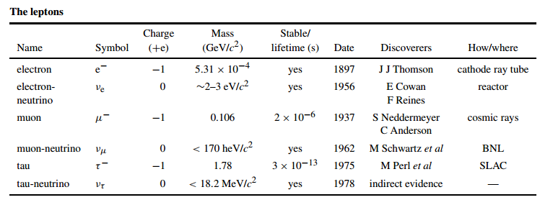

# The origin of Quarks

[9]The present understanding, in a nutshell. We believe that the Universe started off with a "Big Bang", with enormously high energy and temperature concentrated in an infinitesimally small volume. The Universe immediately started to expand at a furious rate and some of the energy was converted into pairs of particles and antiparticles with mass remember Einstein's **E= mc2**.))

In the first tiny fraction of a second, only a mix of radiation (photons of pure energy) and quarks, leptons and gauge bosons existed. During the very dense phase particles and antiparticles collided and annihilated each other into photons leaving just a tiny fraction of matter to carry on in the Universe. As the Universe expanded rapidly, in about a hundredth of a second it cooled to a "temperature of about 100 billion degrees, and quarks began to clump together into protons and neutrons which swirled around with electrons, neutrinos and photons in a grand soup of particles. From this point on, there were no free quarks to be found. In the next three minutes or so, the Universe cooled to about a billion degrees, allowing protons and neutrons to clump together to form the nuclei of light elements such as deuterium, helium and lithium. After about three hundred thousand years, the Universe cooled enough (to a few thousand degrees) to allow the free electrons to become bound to light nuclei and thus formed the first atoms. Free photons and neutrinos continue to stream throughout the Universe meeting and interacting occasionally with the atoms in galaxies, stars and in us!

We see now that to understand how the Universe evolved we really need to understand the behavior of the elementary particles: the quarks, leptons and gauge bosons. These make up all the known recognizable matter in our Universe.

Beyond that, the Universe holds at least two dark secrets: Dark Matter and Dark Energy! The total amount of luminous matter (e.g., stars, etc.) is not enough to explain the total observed gravitational behavior of galaxies and clusters of galaxies. Some form of mysterious Dark Matter has to be found.

**p.c.** **Antimatter**

For every type of matter particle we've found, there also exists a corresponding **antimatter** particle, or **antiparticle**.

When a matter particle and antimatter particle meet, they annihilate into pure energy!

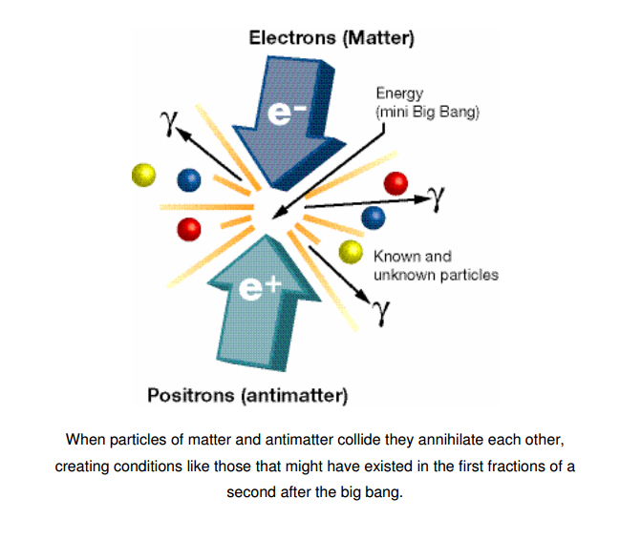

# Discovering Quarks

Although there were no direct evidence of the presence of quarks until they were discovered in 1968, the model of Quarks was set 1964 by Mori, Gellman and George Zweig.

Quarks were first discovered in experiments done at the [**Stanford Linear Accelerator Center**](http://www.slac.stanford.edu/)(**SLAC**).  
When guest experience of throwing the protons by neutrons, they noticed that protons and neutrons seemed as it was composed of three particles. This experience pointed to that proton has internal structure that subnet, this Proton composed of similar small objects, which means that it is not fundamental constituent (this model explains quarks).

## The silly name "quark"!!!!

The Gellman name the new particle"quark" after hearing the voice of ducks in the same moment he was thinking about naming. It took some time to formulate correct spelling new term (Voice of ducks), and Zweig suggested "Ace". But the term Gellman became more famous to accept a quark model.

Then,in 1968 the first physical evidence of the existence of the quarks appeared.

**So,now we can..**

# Determine what is the quark:

**[10]The quarks** are the building blocks which build up matter, i.e., they are seen as the "elementary particles".

[11]In the present, standard model, there are three families of quarks. Each family contains two quarks. The first family consists of **Up** and **Down** quarks, the quarks( that join together to form protons and neutrons). The second family consists of **Strange** and **Charm** (quarks and only exist at high energies). The third family consists of **Top** and **Bottom** quarks and only exist at very high energies). Also, for each of these quarks, there is a corresponding **antiquark**..

c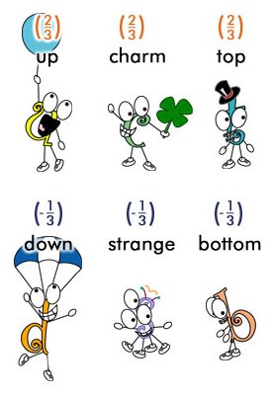

## 1: The Up and the Down quarks:

Are the most common and least massive quarks, noticed as we said before by Murry Gell-Mann J and George Zweig, and discovered in 1986.

|  |  |  |
| --- | --- | --- |
| The down quark | The up quark |  |
| D | u | Symbol |
| -1/3 | +2/3 | Charge |
| 6 MeV/c2 | 3 MeV/c2 | Mass |

[Protons](http://education.jlab.org/glossary/proton.html) and [neutrons](http://education.jlab.org/glossary/neutron.html) are each composed of three [quarks](http://education.jlab.org/glossary/quark.html). Protons are made up of two 'up' quarks and one 'down' quark, while neutrons are made up of two 'down' quarks and one 'up' quark

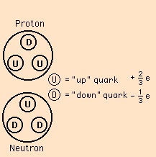

.

## 2: The Charm and the Strang quarks:

**The Charm quark:**

In 1970 Both of John Iliopoulos, Sheldon Glashow and Mayani proposed paper which presented many of the conclusions in the presence of quark has not been discovered yet, named charm quark. And the charm quark Produced in1974, the same time in **Stanford Linear Accelerator** **Center** by Burton Richter and in Brookhaven National Laboratory by samuel ting.

**The strange quark:**

In 1947 during a study of cosmic ray interactions, a product of a proton collision with a nucleus was found to live for much longer time than expected: 10-10 seconds instead of the expected 10-23 seconds! This particle was named the [lambda particle](http://hyperphysics.phy-astr.gsu.edu/hbase/particles/lambda.html#c1) (Λ0) and the property which caused it to live so long was dubbed "strangeness" and that name stuck to be the name of one of the [quarks](http://hyperphysics.phy-astr.gsu.edu/hbase/particles/quark.html#c1) from which the lambda particle is constructed. The lambda is a [baryon](http://hyperphysics.phy-astr.gsu.edu/hbase/particles/baryon.html#c1) which is made up of three quarks: an up, a down and a strange quark.

|  |  |  |
| --- | --- | --- |
| The strange quark | The charm quark |  |
| S | C | Symbol |
| -1/3 | +2/3 | Charge |
| 100 MeV/c2 | 1300 MeV/c2 | Mass |

## 3: The top and bottom quarks:

**The top quark:**

Convincing evidence for the observation of the top quark was reported by Fermilab 's Tevatron facility in April 1995. The evidence was found in the collision products of 0.9 TeV protons with equally energetic antiprotons in the proton-antiproton collider. The evidence involved

**The bottom quark:**

In 1977, an experimental group at [Fermilab](http://hyperphysics.phy-astr.gsu.edu/hbase/particles/accel.html#c2) led by Leon Lederman discovered a new resonance which was interpreted as a bottom-antibottom quark pair and called the [Upsilon meson](http://hyperphysics.phy-astr.gsu.edu/hbase/particles/hadron.html#c4)

|  |  |  |
| --- | --- | --- |
| The bottom quark | The top quark |  |
| B | T | Symbol |
| -1/3 | +2/3 | Charge |
| 4300 MeV/c2 | 175 000 MeV/c2 | Mass |

**4: Each type of mentioned quarks there is a antiquark.**

**p.s.** Gluons are the particles responsible for binding quarks to each other.

**p.s.** we can create some pairs of quarks & anti-quarks, by the conversion of energy into matter. (Particles & anti-particles have to be created in pairs to balance charge, etc..).

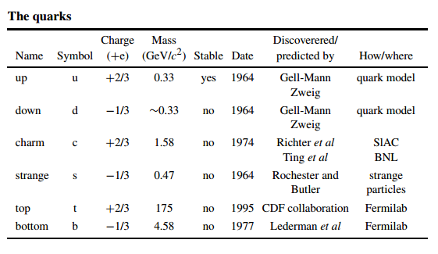

# Important Terms:

Boson: A particle with a spin that is a whole number multiple of h/2π. All exchange particles are bosons and all ‘material’ particles are fermions. Hadrons can be bosons if the quarks inside are in the correct alignment for their spins to add to a whole number.

Carrier particle: all interactions which affect matter particles are due to an exchange of force carrier particles, a different type of particle altogether. These particles are like basketballs tossed between matter particles (which are like the basketball players). What we normally think of as "forces" are actually the effects of force carrier particles on matter particles.

The basketball animation is, of course, a very crude analogy since it can only explain repulsive forces and gives no hint of how exchanging particles can result in attractive forces.

Particle physicists have found that we can explain the force of one particle acting on another to incredible precision by the exchange of these force carrier particles.

One important thing to know about force carriers is that a particular force carrier particle can only be absorbed or produced by a matter particle which is affected by that particular force. For instance, electrons and protons have electric charge, so they can produce and absorb the electromagnetic force carrier, the photon. Neutrinos, on the other hand, have no electric charge, so they cannot absorb or produce photons.

Dark matter: Matter that does not interact with electromagnetic radiation and so cannot be astronomically observed directly. Dark matter is needed to explain how stars move inside galaxies. It has also been included in theories of galaxy formation. The inflationary theory implies that most of the universe is composed of dark matter. Hot dark matter particles move close to the speed of light. Cold dark matter particles are moving at speeds very much slower than light.

EM: Physical Chemistry

Fermilab: The American accelerator centre near Chicago. Fermilab has been a major force in particle physics and most recently was home to the discovery of the top quark.

Generation: Quarks and leptons can be grouped into generations by the way they react to the weak force. There are three generations of lepton and three generations of quark.There are..

Spin: A fundamental property of particles. Spin has no classical equivalent it is a quantum mechanical property. The closest classical idea is to imagine that particles spin like tops. However, a top can spin at any rate, whereas particles can only spin at a rate that is a multiple of h/2π. Fermions spin at odd multiples of h/4π (e.g. quarks and leptons which spin at h/4π). Bosons (e.g. photons, gluons, etc) spin at h/2π or h/π.

Strangeness:

Any hadron that contains a strange quark is said to have the property strangeness. This property can be treated a little like lepton number as it is conserved in all reactions that do not involve the weak force. The strangeness of a hadron can be −1 (one strange quark), −2 (two s quarks), −3 (three s quarks), +1 (one antistrange quark), 0 (either no strange quarks or an ss combination) etc.

# c:

## 1:[12]The electromagnetic force:

The electromagnetic force causes like-charged things to repel and oppositely-charged things to attract. Many every day forces, such as friction, and even magnetism, are caused by the electromagnetic, or EM force. For instance, the force that keeps you from falling through the floor is the electromagnetic force which causes the atoms making up the matter in your feet and the floor to resist being displaced.   
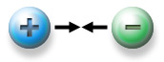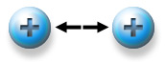

The carrier particle of the electromagnetic force is the **photon**(http://particleadventure.org/images/page-elements/gamma.gif). Photons of different energies span the electromagnetic spectrum of x rays, visible light, radio waves, and so forth.

Photons have zero mass, as far as we know, and always travel at the "speed of light", c, which is about 300,000,000 meters per second, or 186,000 miles per second, in a vacuum.

## 2: [13]The gravity:

Things interact without touching!.How do two magnets "feel" each other's presence and attract or repel accordingly? How does the sun attract the earth?.The answers to these questions are "gravity"

Gravity is weird. It is clearly one of the fundamental interactions, but the Standard Model cannot satisfactorily explain it. This is one of those major unanswered problems in physics today.

In addition, the gravity force carrier particle has not been found. Such a particle, however, is predicted to exist and may someday be found: the **graviton**.

Fortunately, the effects of gravity are extremely tiny in most particle physics situations compared to the other three interactions, so theory and experiment can be compared without including gravity in the calculations. Thus, the Standard Model works without explaining gravity.

## 3: The strong force:

[14]A fundamental force of nature The strong force is mediated by exchange particles called **gluons**. Gluons also carry color and so are subject to the force themselves the strong.

[15]Two protons placed 1 m apart from each other would electromagnetically repel with a force some 1042 times greater than the gravitational attraction between them. Over a similar distance the strong force would be zero. If, however, the distance were reduced to a typical nuclear diameter, then the strong force would be at least as big as the electromagnetic. It is the strong force attraction that enables a nucleus which packs protons into a small volume, to resist being blown apart by electrostatic repulsion.

The strong force only acts between quarks. The leptons do not experience the strong force at all

This incredibly strong force acting between the quarks holds them together to form objects (particles) such as the proton and the neutron. If the leptons could feel the strong force, then they would also bind together into particles. This is the major difference between the properties of the quarks and leptons.

As we mentioned, current theories of the strong force suggest that it is impossible to have a single quark isolated without any other quarks. All the quarks in the universe at the moment are bound up with others into particles. When we create new quarks in our experiments, they rapidly combine with others. This happens so quickly that it is impossible to ever see one on its own.

## 4: c:

[16]The weak force is the most difficult of the fundamental forces to describe. This is because it is the one that least fits into our typical imagination of what a force should do.

It is possible to imagine the strong force as being an attractive force between quarks, but the categories ‘attractive’ and ‘repulsive’ do not really fit the weak force. This is because it changes particles from one. type to another.

The weak force is the reason for the generation structure of the quarks and leptons. The weak force is felt by both quarks and leptons. In this respect it is the same as the electromagnetic and gravitational forces the strong force is the only one of the fundamental forces that is only felt by one class of material particle.

If two leptons come within range of the weak force, then it is possible. for them to be changed into other leptons

.**[17]**Color**:[18]**

Quarks have a fundamental property called color which comes in three types: red, blue and green. Color plays a similar role in the theory of the strong force as electric charge does in the theory of electromagnetism Antiparticles have anticolor: antired, antiblue and antigreen. All hadrons must be colorless—a baryon must have one quark of each color, a meson has a color, anticolor pair (i.e. blue, antiblue, etc). Leptons do not possess color, and so do not feel the strong force..

# The four forces's impact on quarks:

Quarks affect by four basic forces, the electromagnetic force despite the quarks themselves uncharged, they get in the structure of charged particles such as the protons and some types of mesons , they also affect by gravity and The strong force

The quarks affect by the weak force through vulnerability

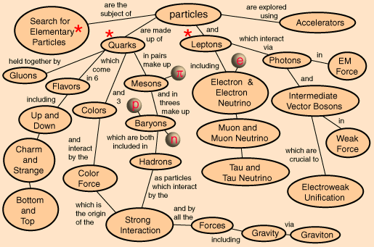

# Looking into the future

One of the primary goals for the new and upgraded facilities in Fermilab near Chicago (the Tevatron) and CERN in Geneva Switzerland (the Large Hadron Collider or LHC) is to find the Higgs boson, the one missing element of the Standard Model..

Evidence for supersymmetric partners of the known particles is a goal in all experiments, as part of the search for the true particle theory beyond the Standard Model. Beyond that is the need to find anything that can point to a real Grand Unification with the gravitational force A different kind of e collider is being planned internationally — the International Linear Collider or ILC, a very high energy linear collider, with two opposing linear accelerators tens of kilometers long. The technical challenges are many and this is likely to be the first truly world-wide accelerator collaboration

.

**BOOKS**:

**REFERENCES**

Quarks,Leptons and the Big Bang,second edition, Jonathan Allday._

_A Brief Interduction to Particle Physics, Nari Mistry, Laboratory for Elementary Particle Phisics Cornell University.

**WEBSITES:**

_School&Library Products- Encyclop Aedia Britannica- Quark"colours"

[**http://www.britannica.com/EBchecked/topic/486323/quark/284650/Quark-colours**](http://www.britannica.com/EBchecked/topic/486323/quark/284650/Quark-colours)

_ The Particle Adventure (Lawrence Berkeley Lab)

[**http://www.particleadventure.org/particleadventure/**](http://www.particleadventure.org/particleadventure/)

**Contents**

The problem of the: research 2

The introduction of substance's structure: 3

The components of the Atom: 3

Otherwise.. The matter consists of: 5

Hadrons 5

Leptons 6

The origin of Quarks: 6

Discovering Quarks: 8

The silly name "quark"!!!! 8

Determine what is the quark: 9

1: The Up and the Down quarks: 9

2: The Charm and the Strang quarks: 10

3: The top and bottom quarks: 11

four fundamental forces: 14

1:The electromagnetic force: 14

2: The gravity: impact 15

3: The strong force: 15

4: The weak force: 16

1. Chemistry of the NCD
2. **'** Jefferson Lab(Exploring The Nature Of Matter)-ScienceEducation – Glossary - Nucleus
3. Jefferson Lab(Exploring The Nature Of Matter)- Science Education – Glossary - Proton
4. Jefferson Lab(Exploring The Nature Of Matter)- Science Education – Glossary - Neutron
5. Jefferson Lab(Exploring The Nature Of Matter)- Science Education - Glossary - Electron
6. ._ Chapter 4_ Protons, Neutrons, and Electrons_ Middle School Chemistry
7. The Particle Adventure The standard Model – Glossary- Hadrons
8. Jefferson Lab(Exploring The Nature Of Matter)- Science Education – Glossary - Leptons
9. A Brief Interduction to Particle Physics, Nari Mistry, Laboratory for Elementary Particle Phisics Cornell University –page 6
10. Serway Ch 47
11. Jefferson Lab(Exploring The Nature Of Matter)- Science Education – Glossary- Quarks
12. The Particle Adventure- Glossary- Electromagnetism
13. The Particle Adventure- Glossary- Gravity
14. Quarks, Leptons and the Big Bang – second edition – Jonathan Allday – page 399
15. Quarks, Leptons and the Big Bang – second edition – Jonathan Allday – page 12
16. Quarks, Leptons and the Big Bang – second edition – Jonathan Allday – page 14
17. School&Library Products- Encyclop Aedia Britannica- Quark"colours
18. Quarks, Leptons and the Big Bang- second edition – page 388