Abstract
In the dark night sky, we see many stars and it looks like some stars are very close together. Proximity of two stars is apparent in some cases due to the effect of projection of stars according to an observer. Nevertheless, we also see stars that are gravitationally bound and their proximity on the night sky is not just the effect of projection. When both stars are visible, sequence of observations would indicate that the stars move around a common center of gravity.
Observations indicate that majority of stars have a companion, thus that stars are in more than 50% of cases united in a system of two or more stars. Multiple systems consist of stars, which are gravitationally bound and move around a common center of gravity. Systems of multiplicity three an higher are frequent and are representing approximate 20% of the total stellar population, but higher is the number of stars in system, lower is the number of known systems. Double stars, or in a shorter-term binaries, are important because they are numerous and we can compare them among themselves. They are the main source of our knowledge on basic characteristics of stars, because we get their values of masses, temperatures luminosities, radii… with modeling.

Adnan S.Saood
Fifth Generation
Astrophysics
10-2015
Comparing between Spectroscopic and Photometric Method for Binary stars Mechanical and Kinetic Data Acquisition
National Syrian Center for the Distinguished
المركز الوطني للمتميزين

Table of Contents

1 Table of Contents 2
2 The pure mechanics of the system 3
2.1 Types of binaries in accordance to the observational characteristics 5
3 Methods of Data acquisition 7
3.1 Photometry 7
3.2 Spectroscopy 8
4 System Geometry 10
4.1 Roche Lobe 10
4.2 Kepler’s Law 11
4.3 Magnitude, distance and luminosity 11
4.4 Eccentricity 12
4.5 Mass and Velocity 13
4.6 Inclination, radii and temperature 14
5 Conclusion 17
6 Bibliography 19

The pure mechanics of the system

In order to model stars, we must first have a knowledge of their physical properties. In this chapter, we describe how we know the stellar properties that stellar models are meant to replicate. Some of our data comes from observations of nearby single stars, but much of our information comes from binary stars. We will begin by describing the orbit of a binary and how these orbits are observed. We conclude this chapter with a discussion of how stellar masses are obtained from observations of the spectra of binary stars.
Given a central force, the motion of two bodies is found from the Lagrangian, which can be expressed as:

$$L=\frac{1}{2}m_{1}v_{1}^{2}+\frac{1}{2}m_{2}v_{2}^{2}+\frac{Gm_{1}m_{2}}{\left|r_{2}-r_{1}\right|}$$
We choose barycentric coordinate system, so that

$$m_{1}r_{r}+m_{2}r_{2}=0$$
And therefore

$$m_{1}r_{1}=m_{2}r_{2}$$
We define the relative separation to be

$$r=r_{1}+r_{2}$$
We can use these two equations to solve for $r_{1}$and $r_{2}$in terms or $r$to get

$$r_{1}=\frac{m_{2}}{M}r$$
$$r_{2}=\frac{m_{1}}{M}r$$
Where $M=m_{1}+m_{2}.$ Note that $θ_{1}=θ_{2}-π=θ$

Assuming that the orbits lie in a plane, we have

$$v_{1}^{2}={\dot{r}}_{1}^{2}+r_{1}^{2}{\dot{θ}}_{1}^{2}={\left(\frac{m_{2}}{M}\right)}^{2}\left({\dot{r}}^{2}+r^{2}{\dot{θ}}^{2}\right)$$
$$v_{2}^{2}={\dot{r}}_{2}^{2}+r_{2}^{2}{\dot{θ}}_{2}^{2}={\left(\frac{m_{1}}{M}\right)}^{2}\left({\dot{r}}^{2}+r^{2}{\dot{θ}}^{2}\right)$$
$$L=\frac{1}{2}\left(\frac{m_{1}m_{2}^{2}}{M^{2}}\right)\left({\dot{r}}^{2}+r^{2}{\dot{θ}}^{2}\right)+\frac{1}{2}\left(\frac{m_{2}m_{1}^{2}}{M^{2}}\right)\left({\dot{r}}^{2}+r^{2}{\dot{θ}}^{2}\right)+\frac{Gm_{1}m_{2}}{r}=\frac{1}{2}\left(\frac{m_{1}m_{2}}{M}\right){\dot{r}}^{2}+\frac{1}{2}\left(\frac{m_{1}m_{2}}{M}\right){\dot{r}}^{2}+\frac{Gm_{1}m_{2}M}{Mr}$$

$$L=\frac{1}{2}μ{\dot{r}}^{2}+\frac{1}{2}μr^{2}{\dot{θ}}^{2}+\frac{GμM}{r}$$

Since $L$is independent of$θ$, we have

$$\frac{∂L}{∂\dot{θ}}=constant$$

$$\frac{∂L}{∂\dot{θ}}=μr^{2}\dot{θ}=J=angular momentum$$
The total energy is also conserved, and it is given by

$$\frac{1}{2}m_{1}v_{1}^{2}+\frac{1}{2}m_{2}v_{2}^{2}=\frac{Gm_{1}m_{2}}{r}=\frac{1}{2}μ\left(\dot{r}+r^{2}{\dot{θ}}^{2}\right)-\frac{GμM}{r}=C$$

Now we can express the total energy as an equation that is dependent upon $r$ only.

$$\dot{θ}=\frac{J}{μr^{2}}⇒{\dot{θ}}^{2}=\frac{J^{2}}{μ^{2}r^{4}}$$
$$C=\frac{1}{2}μ{\dot{r}}^{2}+\frac{1}{2}\frac{J^{2}}{μr^{2}}-\frac{GμM}{r}$$

Types of binaries in accordance to the observational characteristics

There are more types of binary stars that are classified in accordance to their observational characteristics; discussion of them can be more detailed in a more generalized paper.

• Optical double stars: They are not gravitational bound, but we see both components with a telescopic eyepiece or with a naked eye. Therefore, they just simply lie along the same line of sight and they are not true binaries. We cannot determine any physical parameters apart from those obtainable for single stars.

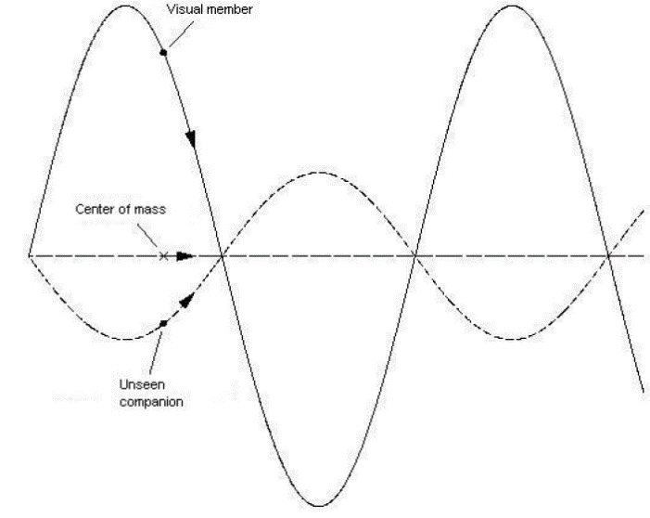

Figure ‎2-1 an astrometric binary, which contains one visible member. The oscillatory motion of the observable star implies the unseen star

Figure ‎2-2 an astrometric binary, which contains one visible member. The oscillatory motion of the observable star implies the unseen star

• Astrometric binaries: If only one component is visible and the other one is too faint or is too close to its brighter companion, we cannot observe both components of the double system with telescope. That this bright star has a companion we detect by astrometric methods. Astrometry measures and explains the positions and movements of stars and other celestial bodies. If only one star is present, it moves on a straight line. But in binary or multiple system orbital motion is different. In this case, the unseen component is implied by the oscillatory motion of the observed element of system as shown in figure 1.

• Spectroscopic binaries: In this case, the components are so close to one another that even with a high-resolution telescope, we are unable to observe both members directly. We can detect the presence of the binary system via Doppler Effect.

• Eclipsing binaries: If the line of sight of the observer lies close to the orbital plane of the system, we can witness eclipses: the part of the light is blocked as one component passes in front of the other, the observed flux is diminished. Such a time-dependent change in flux enables us to constrain the physical parameters of binary system. Eclipses can be used to obtain inclination, stellar masses and radii, orbital eccentricity, effective temperatures… Eclipsing binary system could also be spectroscopic or astrometric system at the same time if we can see eclipses.

Binary stars are also ideal distance estimators, since absolute magnitudes of the components may be readily obtained from luminosities, as it is shown in chapter 3.3.

Methods of Data acquisition
Before modeling and studying eclipsing binaries we must have some measurements. In this chapter we will present methods to obtain diverse and accurate observational data. Eclipsing binary studies involve combination of photometric and spectroscopic data.

Photometry

This is the most popular and accessible method in astronomy. Photometry is the measurement of the intensity of electromagnetic radiation usually expressed in apparent magnitude. Apparent magnitude is a numerical scale to describe how bright each star appears in the sky. The lower the magnitude, the brighter the star.
The photometry measurement is done with an instrument with a limited and carefully calibrated spectral response. Photoelectric detectors convert light into an electrical signal. There are three detector types: the photomultiplier tube, photodiode and charge-coupled device (CCD) [6]. The CCD devices are most commonly used nowadays. These are solid-state devices with an array of picture elements called pixels. Each pixel is a tiny detector– a CCD array can have thousands to one million or more pixels. The same technology is used in nowadays digital cameras and smartphones cameras. CCDs are very sensitive to light over a wide range of wavelengths from the ultraviolet to infrared, and can measure many stars at once in contrast to photomultiplier tubes and photodiodes that measure one star at a time. Even the amateur astronomers can easily use it.

Photometric measurement consists of wavelengths that can pass through a filter without being attenuated. That gives us photometric light curve, which reveals variability of the source, if variability is periodic, it is customary to fold the observational data to phase interval [0, 1] or [-0.5, 0.5]: $Φ=\frac{T-T_{0}}{P}$ Where $T$ is heliocentric Julian date (astronomers use Julian calendar), $T_{0}$ is reference epoch and $P$ is period. With this transformation, we construct a phase light curve. Then from phased light curve, we can extract physical parameters, like temperature ratio, radii of both components…

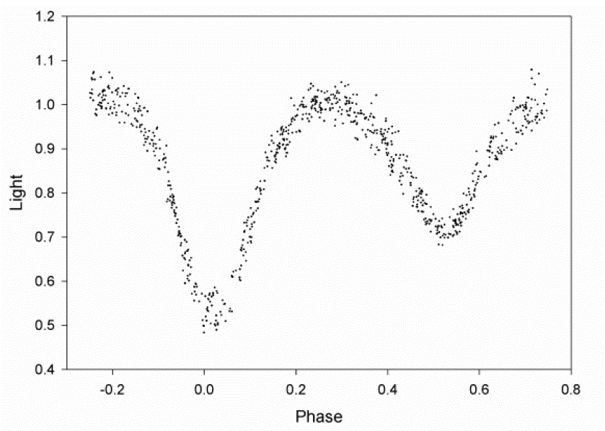

Figure ‎3-1Photometric light curve of Beta Lyrae, an eclipsing binary system. It presents the changes of magnitude as a function of orbital phase.

Figure ‎3-2Photometric light curve of Beta Lyrae, an eclipsing binary system. It presents the changes of magnitude as a function of orbital phase.

Figure 2 presents a phase light curve where the phase is defined to be 0.0 at the primary minimum. Primary minimum is deeper and occurs when the hotter star passes behind the cooler one, because luminosity of the star is defined as $=4πR^{2}σT^{4}$ . On the other hand, secondary minimum occurs when the cooler star passes behind the hotter one.

Spectroscopy
Spectroscopic measurements are based on dispersing the beam of light into the wavelength-distributed spectrum. Resolution of the spectrum is defined as:

$$R=\frac{λ}{Δλ}$$

Where $Δλ$ is the smallest wavelength resolution element of the instrument that is being used. Details of the spectrum are important, so we need a really high resolution. $R≈5000$ corresponds to medium resolution, where strong spectral lines can be studied, if $R≈20000$ (high resolution) we can study narrow spectral lines. From measuring the changes of spectral line positions in time, we can obtain radial velocity of the source. And by measuring the changes in spectral line shapes in time, we can do Doppler tomography of the source. Doppler effect for distant objects (for example galaxies) is very large, but for closer objects like binary stars the Doppler effect is very small, so a high level of resolution is important. Once we have radial velocities, a radial velocity curve may be assembled by listing radial velocities as function of time or phase. Fiigure 3 shows velocity curve as a function of time, according to position of the stars. When the star moves away from us, the velocity is defined as positive asnd when stars move in our direction the velocity is negative. In some way this curve is similar to a light curve, but we get different physical parameters, like mass ratio, eccentricity, semi-major axis…

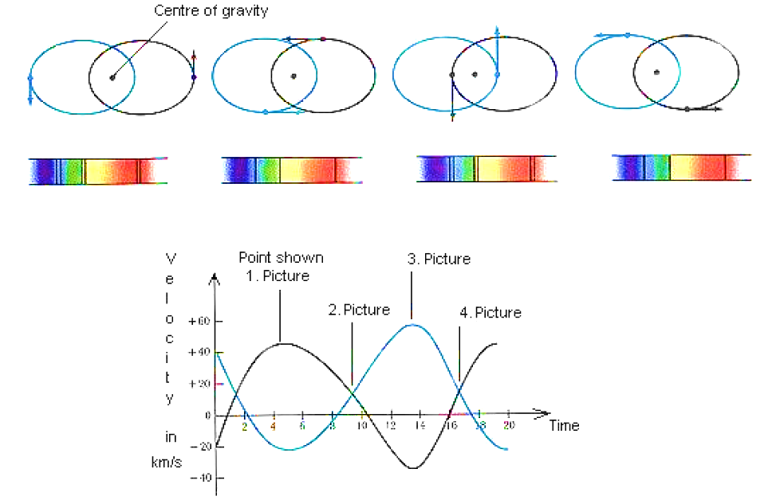

Figure ‎3-3 Observed radial velocity curve as a function of time[8]

Figure ‎3-4 Observed radial velocity curve as a function of time[8]

System Geometry
In this chapter, we will briefly familiarize ourselves with the basic physics for understanding eclipsing binaries.

Roche Lobe
In binary system stars can be more or less apart. If the stars are close, they will influence each other and they will change their shape. Star’s external envelope will strongly increase and deform circular to teardrop-shape. The Roche lobe is the region of space around a star within which orbiting material is gravitationally bound to the star. Binary systems are classified into tree classes: detached, semidetached and contact systems, as is shown in figure 4.
Binary stars with radii much smaller than their separation are nearly spherical and they evolve nearly independently. This system is a detached system. These binaries are ideal physical laboratories for studying the properties of individual stars. If one star expands enough to fill Roche lobe, then the transfer of mass from this star to her companion can begin. Such system is called a semi-detached binary system. In case when both stars fill, or even expand beyond, their Roche Lobes stars share a common atmosphere. Such a system is called a contact binary system. In this seminar, we will only present detached binary systems.
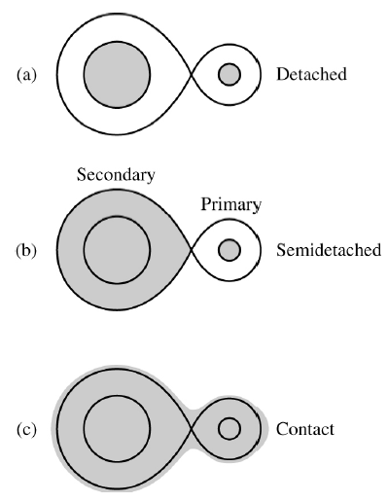

Figure ‎4-1Classes for binary stars system.

Figure ‎4-2Classes for binary stars system.

Kepler’s Law
Motion of stars in a binary system around the mutual center of mass constitutes a classical two-body problem. Kepler third law gives us an equation:
$$\frac{a^{3}}{t_{0}^{2}}=\frac{G\left(m_{1}+m_{2}\right)}{4π^{2}}$$

Where $m_{1}$ and $m_{2}$ are point masses of individual stars, $t_{0}$ is orbital period and $a$is separation between them. This formula also applies for binary stars, because of the universality of the gravitational force. From this formula we can also express he angular frequency of the orbital$ω$:

$$ω^{2}={\left(\frac{2π}{t_{0}}\right)}^{2}=\frac{G\left(m_{1}+m_{2}\right)}{a^{3}}$$

When binary stars are very close then this angular frequency of the orbit is equal to the starts rotation.

Magnitude, distance and luminosity
In chapter we talked about magnitude. The brightness of a star is measured in terms of the radiant flux $j$received from the star. Radiant flux is a total amount of light energy of all wavelengths that falls on oriented perpendicular area per unit time. Radiant flux received from the star depends on intrinsic luminosity and the distance from the observer. The equation for star flux $j$ with luminosity $L$ is: $=\frac{L}{4πr^{2}}$ . If we observe two stars with apparent magnitude $m_{1}$ and $m_{2}$ in relation to their flux ratio, the equation is:

$$m_{1}-m_{2}=-2.5\log_{10}\left(\frac{j_{!}}{j_{2}}\right)$$

We already explained the difference between absolute and apparent magnitude in chapter 2.1, but we did not write down the connection, which is called the star distance module:

$$m-M=5\log_{10}\left(\frac{d}{10pc}\right)$$

Where $m$is apparent and $M$absolute magnitude, $d$ is the distance to the star and $10pc$ is a distance of 10 parsecs. We are able to measure apparent magnitude and if we could somehow measure or calculate the absolute magnitude, we would have no problem calculating the distance to the star.
Using the equation 4 and consediring two stars at the same distance, we see that the ratio of their flux is equal to the ratio of their luminosities. So we could rewrite equation (5): ${100}^{\frac{M_{1}-M_{2}}{5}}=\frac{L_{2}}{L_{1}} ,$ Where $M_{1}$ and $M_{2}$ are absolute magnitude of both stars. Our nearest star is the sun and we have a lot information about it. By letting one of these stars be the Sun, then we get the relation between a star’s absolute magnitude and its luminosity:
$$M=M_{⨀{ }}-2.5\log_{10}\left(\frac{L}{L_{⨀{ }}}\right)$$

Eccentricity
In chapter Spectroscopy we see that we can measure radial velocity, which depends upon the position of the stars. The shape and amplitude of the curve depends upon the eccentricity of the orbit and on the angle from which we observe the binary (inclination). If the plane of the star system lies in the line of sight of the observer $(i=90)$ and the orbit is circular, then the radial velocity curve will be sinusoidal. But if the inclination is no $i=90$, then only amplitudes on the curve change by the factor $\sin{i}$. In some cases the orbit is not circular and radial velocity curve changes the shape and becomes skewed, as shown in figure 5. Motion of a star is affected by the attraction from the other star. The star moves faster when it is nearer to the companion and slower when it is further, so velocity curve become skewed.

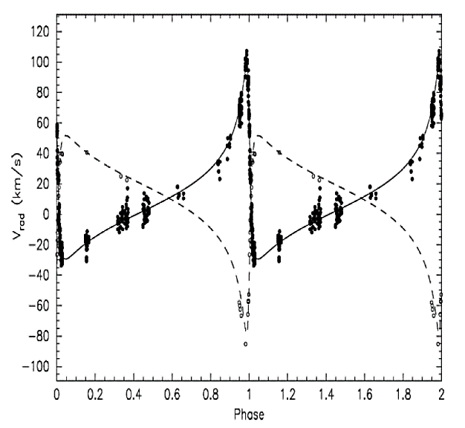

Figure ‎4-3Radial velocity curve for two stars in elliptical orbits.

Figure ‎4-4Radial velocity curve for two stars in elliptical orbits.

Mass and Velocity
Interacting two-body system or many-body system is most easily solved in the reference frame of the center of mass. If we assume that all of the forces acting on individual particles in the system are due to other particles contained within the system, Newton’s third law requires that the total force must be zero:

$$F=\frac{dp}{dt}=M\frac{∂^{2}R}{∂t^{2}}=0$$

Where $M$is total mass of the system.

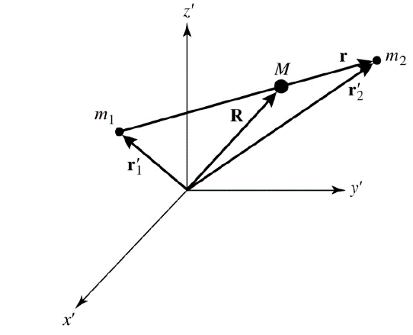

Figure ‎4-5Coordinate system indicating the position of m1, m2 and the center of mass M.

Figure ‎4-6Coordinate system indicating the position of m1, m2 and the center of mass M.

Equation for center of gravity is:

$$R=\frac{m_{1}r_{1}^{'}+m_{2}r_{2}^{'}}{m_{1}+m_{2}}$$

However, if we choose a coordinate system for which the center of mass coincides with the origin of coordinates then the upper equation must be zero. In figure 6 we see a connection: $r_{2}^{'}=r_{1}^{'}+r$ and from equation (7) it follows:

$$r_{1}^{'}=-\left(\frac{m_{2}}{m_{1}+m_{2}}\right)r$$

$$r_{2}^{'}=\left(\frac{m_{1}}{m_{1}+m_{2}}\right)r$$

If we consider only the lengths of the vector $r_{1}^{'}$ and $r_{2}^{'}$ we find out:

$$\frac{m_{1}}{m_{2}}=\frac{r_{2}^{'}}{r_{1}^{'}}=\frac{a_{2}}{a_{1}}$$

Where $a_{1}$ and $a_{2}$ are the semi-major axes of the ellipses. If we assume that the orbital eccentricity is very small, then the velocity of stars are $v_{1}=\frac{2πa_{1}}{t_{0}}$ and${ v}_{2}=\frac{2πa_{2}}{t_{0}}$ .
From chapter 3.4 we know that the velocity depends on inclination and radial velocity for both stars are $v_{1r}=v_{1}\sin{i}$ and $v_{2r}=v_{1}\sin{i}$. If we carry this in equation (10)

$$\frac{m_{1}}{m_{2}}=\frac{v_{2r}}{v_{1r}}$$

Inclination, radii and temperature
Inclination $i$ is the angle between the orbital plane and plane-of-sky. It can assume any value on the interval [0,90], where $i=0$ means that we look on the plane of the system face on and if $i=90$, then we see a binary from the edge.

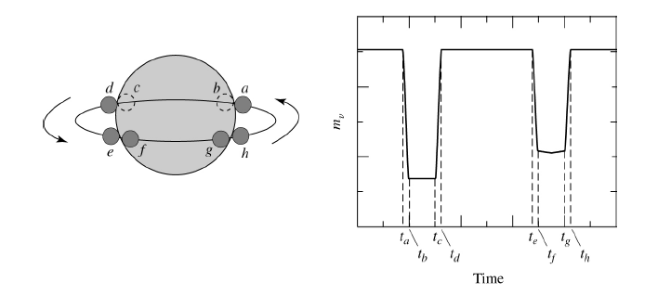

Figure ‎4-7 The light curve of eclipsing binary
From a phase light curve, more exactly from duration of eclipses, we can get the radii of each member. Referring to the figure 7, the amount of time between first contact $\left(t_{0}\right)$ and minimum light $\left(t_{b}\right)$, combined with the velocities of the stars, lead directly to equation of the radius of smaller star and similarly for a bigger star for second eclipse:

$$r_{s}=\frac{v}{2}\left(t_{b}-t_{a}\right)$$
$$r_{l}=\frac{v}{2}\left(t_{c}-t_{a}\right)=r_{s}+\frac{v}{2}\left(t_{c}-t_{b}\right)$$

Where $r_{s}$ is radius of small star, $r_{l}$ is radius of large star and $v=v_{s}+v_{l}$ is the relative velocity of two stars.
From the light curve, we can also obtain the ratio of effective temperatures of the binaries. This is obtained from the dip of the light curve and deeper the dip is, the hotter star passing behind its companion is. Stefan-Boltzmann equation connects total energy radiative surface flux with temperature:$j=σT^{4}$. This law applies only for perfect black bodies, an assumption which does not apply to real stars, thus we use this equation to define the effective temperature $T_{e}$ of star’s surface [4]:

$$j_{surface}=σT_{e}^{4}$$

Assuming that the observed flux is constant across the disk (but we know that is not true, in here we will neglect this), Then the amount of light when we do not see eclipses is given by:
$$B_{0}=k\left(πr_{l}^{2}j_{rl}+πr_{s}^{2}j_{rs}\right)$$

Where $k$is a constant that depends on the distance of system and the nature of the detector . Light detected during the primary minimum $\left(B_{p}\right)$ and secondary minimum $\left(B_{s}\right)$ is:

$$B_{p}=kπr_{l}^{2}j_{rl}$$

$$B_{s}=k\left(πr_{l}^{2}-πr_{s}^{2}\right)j_{rl}+kπr_{s}^{2}j_{rs}$$

Because we cannot determine $k$ exactly, we must see ratios. From the ratio of the depth of primary to the depth of the secondary minimum, we find out:

$$\frac{\left(B_{0}-B_{p}\right)}{B_{0}-B_{s}}={\left(\frac{T_{S}}{T_{l}}\right)}^{4}$$

Conclusion
Double stars are unique because they allow measurements of mass stars, which is not identifiable in any other way, but it is a basic parameter, which determines the evolution of individual stars. In addition, we provide measurements of the stellar radius of stars with great accuracy. As the temperature is easily measurable (like in single stars) by multiplying it with the luminosity we get distance to a star. A detailed understanding of the structure and evolution of stars requires knowledge of their physical characteristics. We have shown that eclipsing binaries play a special role in star research, because from their typical geometrical layout and well-understood physics we can extract a lot of information. From observation, the stars we get data how the brightness changes over time and their radial velocities. From numerical models and high analytical programs, we can accurately determine values of various physical parameters: mass and radii of both stars, inclination, eccentricity of the orbit, effective temperature, luminosity. . .

Understanding binaries also helps us to understand wider universe: star evolution and because stars are main component part of galaxies, therefor helps us understand evolution of galaxies too.

At the end, considering the inexactitude of the spectroscopic method, and the easiness of the photometric method, as a young astrophysicist, it is better for us to use the photometric way first then, use the spectroscopic method to be certain about the results came out of programs such as the PHOBE™ or the StarLight Pro™. The spectroscopic method is not very accurate if we are studying a binary star system with a plane of motion not perpendicular to line connecting both, the center of the observing telescope, and the center of mass (i=0).

The Photometric method becomes more and more accurate if the plane of motion is more closing to be parallel to the line matching the center of the telescope and the center of mass.

It is more academic to use both, but if the time is not in our hand, it is better to use photometry; because it gives us a brief information about the star we are studying, the spectroscopy comes next.
The mechanics of real binary star is very complicated, so we need high level of programing to simulate it, which comes after reconstructing a model of it using upper advanced analytical mathematics.

Index

Eccentricity 12
individual stars 11
particles contained 13
Photometry 7
Roche Lobe 10
semi-detached binary system 10
Spectroscopy 8
System Geometry 10

Table of Figures

Figure ‎2-1 an astrometric binary, which contains one visible member. The oscillatory motion of the observable star implies the unseen star 5
Figure ‎2-1 an astrometric binary, which contains one visible member. The oscillatory motion of the observable star implies the unseen star 5
Figure ‎3-1Photometric light curve of Beta Lyrae, an eclipsing binary system. It presents the changes of magnitude as a function of orbital phase. 8
Figure ‎3-1Photometric light curve of Beta Lyrae, an eclipsing binary system. It presents the changes of magnitude as a function of orbital phase. 8
Figure ‎3-2 Observed radial velocity curve as a function of time[8] 9
Figure ‎3-2 Observed radial velocity curve as a function of time[8] 9
Figure ‎4-1Classes for binary stars system. 11
Figure ‎4-1Classes for binary stars system. 11
Figure ‎4-2Radial velocity curve for two stars in elliptical orbits. 13
Figure ‎4-2Radial velocity curve for two stars in elliptical orbits. 13
Figure ‎4-3Coordinate system indicating the position of m1, m2 and the center of mass M. 13
Figure ‎4-3Coordinate system indicating the position of m1, m2 and the center of mass M. 13
Figure ‎4-4 The light curve of eclipsing binary 15

Bibliography

Kallrath, J., & Milone, E.F., 2009, Eclipsing binary stars: modeling and analysis. (Springer).
Phillips, A.C., 2013, The physics of stars. (John Wiley & Sons).
Slawson, R.W., Prša, A., Welsh, W.F., et al., 2011, The Astronomical Journal 142(5): 160.
Tokovinin, A., 2004, Statistics of multiple stars. in Revista Mex. Astron. Astrofis.(Ser. Conf.), (7).
T. Moon, Stellar Photometry, http://www.assa.org.au/articles/ stellar photometry/ (26. 10. 2015)
B. W. Carroll, D. A. Ostlie, An Introduction to Modern Astrophysics, (Addison-Wesley Publishing Company, 1996)
A. Prsa, PHOEBE Scientific Reference, http://phoebe.fiz.uni-lj.si/?q=node/8 (20. 10. 2015)
T. Moon, Stellar Photometry, http://www.assa.org.au/articles/ stellar photometry / (26. 10. 2015)
http://www.etsu.edu/physics/ignace/binaries.html (5. 10. 2015)

Slawson, R.W., Prša, A., Welsh, W.F., et al., 2011, The Astronomical Journal 142(5): 160.
Ibid.
Kallrath, J., & Milone, E.F., 2009, Eclipsing binary stars: modeling and analysis. (Springer).
Slawson, R.W., Prša, A., Welsh, W.F., et al., 2011, The Astronomical Journal 142(5): 160.
B. W. Carroll, D. A. Ostlie, An Introduction to Modern Astrophysics, (Addison-Wesley Publishing Company, 1996)
Phillips, A.C., 2013, The physics of stars. (John Wiley & Sons).
T. Moon, Stellar Photometry, http://www.assa.org.au/articles/ stellarphotometry/ (26. 10. 2010)
Tokovinin, A., 2004, Statistics of multiple stars. in Revista Mex. Astron. Astrofis.(Ser. Conf.), (7).
Kallrath, J., & Milone, E.F., 2009, Eclipsing binary stars: modeling and analysis. (Springer).
A. Prsa, PHOEBE Scientific Reference, http://phoebe.fiz.uni-lj.si/?q=node/8 (20. 10. 2010)
B. W. Carroll, D. A. Ostlie, An Introduction to Modern Astrophysics, (Addison-Wesley Publishing Company, 1996)
The same last reference
The same last reference
B. W. Carroll, D. A. Ostlie, An Introduction to Modern Astrophysics, (Addison-Wesley Publishing Company, 1996)
B. W. Carroll, D. A. Ostlie, An Introduction to Modern Astrophysics, (Addison-Wesley Publishing Company, 1996)
B. W. Carroll, D. A. Ostlie, An Introduction to Modern Astrophysics, (Addison-Wesley Publishing Company, 1996)
A. Prsa, PHOEBE Scientific Reference, http://phoebe.fiz.uni-lj.si/?q=node/8 (20. 10. 2010)
Kallrath, J., & Milone, E.F., 2009, Eclipsing binary stars: modeling and analysis. (Springer).

