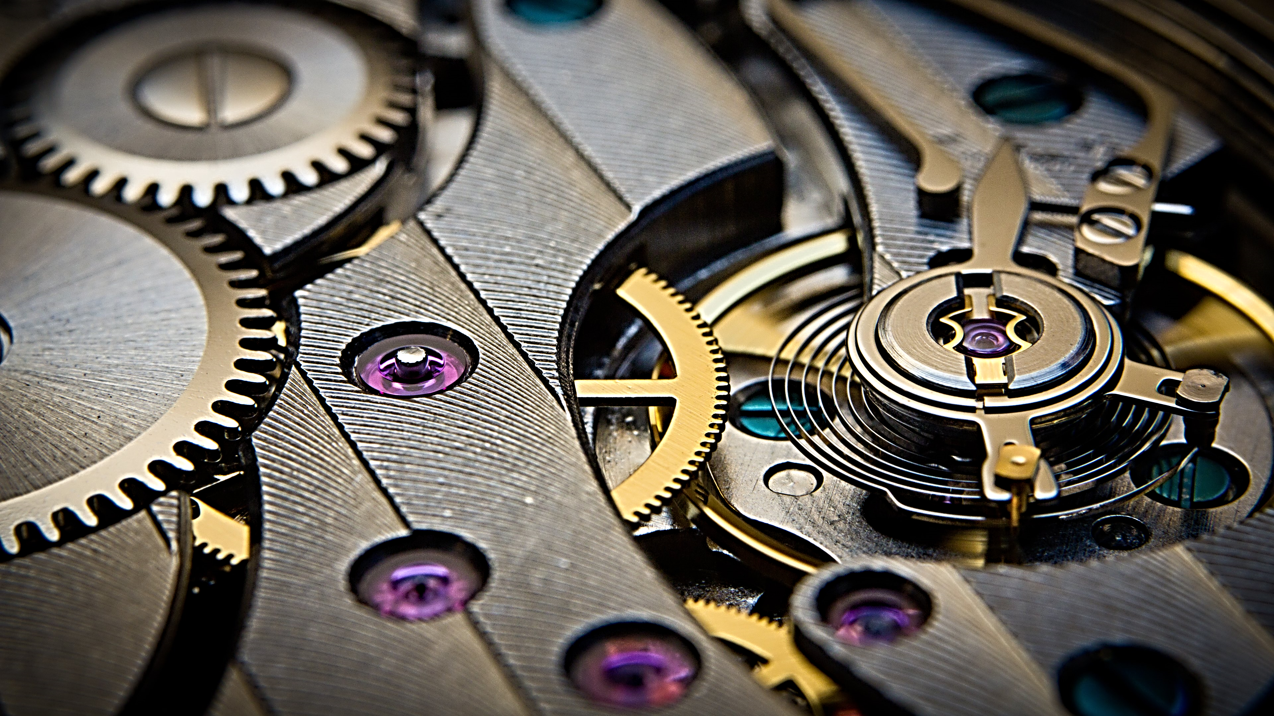
Syrian Arab Republic
Ministry Of Education
The National Center For Distinguished

Gears’ Magic

Prepared by:
MHD.ADIB BATOUS
SUPERVISOR:
Mrs. MAHMOUD NOAH
2015/2016
Contents
Contents…………………………………………………………………………………………….. 2
Research Aims ……………………………………………………………………………………..3
The Introduction……………………………………………………………………………………4
Chapter (1): Types of Gears:…………………………………………………….……………….5
Section (1.1): Parallel Axes Gear:…………………………………………….…………………5
Spur Gear………………………………………………………………….………………………...5
Helical Gear………………………………………………………………………………………...5
Rack Gear……………………………………………………………………………………………5
Internal Gear………………………………………………………………………………………..6
Section (1.2): Intersecting Axes: ……………………………………...…………………………6
Straight Bevel Gear………………………………………………………………………………...6
Spiral Bevel Gear…………………………………………………………………………………...6
Miter Gear………………………………………………………...…………………………………7
Section (1.3): Nonparallel Nonintersecting Axes: ……………..………………………………7
Screw Gear…………………………………………………………………………………………..7
Worm Gear…………………………………………………………………………………………..7
Chapter (2): Gears’ Magic………………………………………………………………………...8
Section (2.1): Differential Gear……………………………………………..……………………8
Section (2.2): Manual transmission (gear box) ………………………………………………10
Section (2.3): Torsen Differential………………………………………………………………11
The conclusion ……………………………………………………………………………………13
Figures list …………………………………………...……………………………………………14
Reference and resources…………………………………………………………………………15

Research Aims:
  - To understand the mechanical methods of gears.
  - To Introduce different types of gears
- To Present some of Gears’ applications.
- To present the car’s mechanical components.
- How do Transmission machines ;( Gear Box), work?
- Explain how do open and torsen differential gear work.

The introduction:
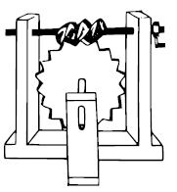
We are using the gears in almost every mechanical machine in our life such the cars, hoist, watch, planimeter …etc.
FIG 1 Archimedes’ hoist

A Gear or Cogwheel is a rotating machine part having cut teeth, which mesh with another toothed part to transmit torque. Two or more gears working in a sequence (train) are called a gear train or; in many cases, a transmission.
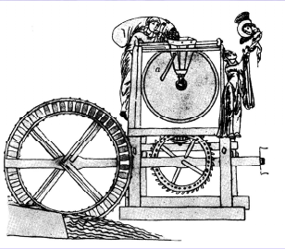
Gears were already in use 350 B.C (about 2300 years ago), Aristotle in the fourth century B.C mentions in his writings that gears were being used very commonly in many applications.
FIG 2 Vitruvius' water wheel and grain mill
A hundred years later that day, a Hellenistic mathematician Archimedes (287-212 B.C) drew a diagram of a hoist that was driven with a set of Worm and Worm Wheel. Fig (1)
Vitruvius a military engineer in his writing in 28 B.C has described a number of gear applications, typical ones are shown in. Fig (2) and (3)
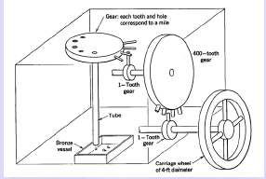
Since the recent decades the gears have been developed and a lot of ingenious mechanisms have been invented.
FIG 3 the odometer for a carriage
In this research I am going to compare between various types of common gears according to their (torque, application), and finally I will talk about three fantastic mechanisms in gears’ world, which we always use in our daily life, but we don’t know their importance.

Chapter (1): Types of Gears
The purpose of using gears is to transmit the direction, speed, or torque.
FIG 4 Parallel Axes Gear
Section (1.1): Parallel Axes Gears:
Such Fig (4)
Consist of four main types:
Spur Gear, Helical Gear, Rack Gear, Internal Gear

Spur Gear
The teeth are straight and parallel to the shaft axis. Transmits power and motion between rotating two parallel shafts.
Its features:
FIG 5 Spur Gear contact surface
- Easy to manufacture.
- The most common type of gear.
- Noisy.
Spur Gear used only in transmitting torque.
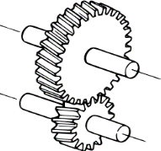
Its contact surface is shown in Fig (5)
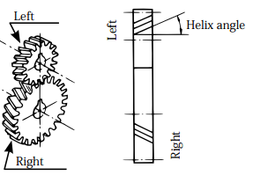
Helical Gear
FIG 6 The hand of helix
The teeth are twisted oblique to the gear axis.
The hand of helix is designated as either left or right. Fig (6)
Right-hand and left-hand helical gears mate as a set, but they must have the same helix angle.
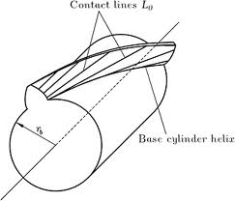
Its features:
FIG 7 Helical Gear contact surface
- Has higher strength compared with a spur gear, because its contact surface is bigger than the contact surface in spur gear. Fig (7)
- More effective in reducing noise and vibration when compared with a spur gear.
Helical Gear used in transmission components, speed reducers, etc.
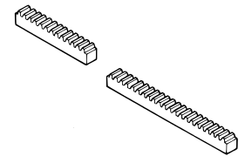
Rack Gear
The rack is a bar containing teeth on one face for meshing with a gear.
Rack can be meshed with spur gear.
Its features:
- Changes a rotary motion into a rectilinear motion and vice versa.
Rack gear used in transfer system for machine tools, printing presses, robots, etc.
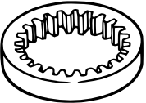
Internal Gear
An annular gear having teeth on the inner surface of its rim
The internal gear always meshes with an external gear.
Its features:
- When meshing an internal gears with an external gear the rotation occurs in the same direction.
- It’s useful for high load and high speed application with high reduction ratio.
Internal gear used in planetary gear drives of automobile automatic transmissions.

Section (1.2): Intersecting Axes Gears
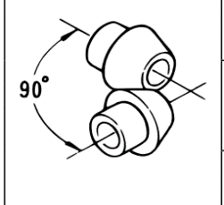
Such Fig (8).
FIG 8 Intersecting Axes Gears
Consist of three main types:
Straight Bevel Gear, Spiral Bevel Gear, Miter Gear
Straight Bevel Gear
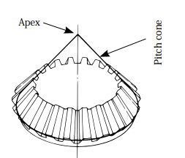
One of a pair of gears used to connect tow shafts whose axes intersect, and the pitch surfaces are cones. Fig (9)
FIG 9 Straight Bevel Gear
And it’s a simple form of bevel gear having straight teeth which, if extend inward, would come together at the intersection of the shaft axes
Its features:
- Relatively easy to manufacture.
- Provide reduction ratio up to approx. 1:5.
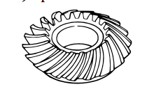
Straight Bevel Gear used in machine tools, printing presses, etc. it’s suitable for use as differential gear unit.
FIG 10 Straight Bevel Gear
Spiral Bevel Gear
Bevel gear with curved, oblique teeth to provide gradual engagement and larger contact surface at a given tome than an equivalent Straight Bevel Gear. Fig (10)
Its features:
- Has higher contact ratio, higher strength and durability then an equivalent straight bevel gear
- Allows a higher reduction ratio.
- Has better efficiency of transmission with reduced gear noise.
- Involves some technical difficulties in manufacturing.
Spiral Bevel Gear used in: automobiles, tractor, vehicles, and final reduction gearing for ships, especially suitable for high-speed, heavy lad drives

Miter Gear
A special class of bevel gear where the shafts intersect at 90 DEG and the gear ratio is 1:1. It is used to change the direction of shaft rotation without change in speed.
Section (1.3): Nonparallel Nonintersecting Axes Gears:
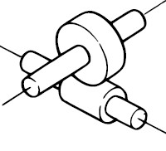
Such Fig (11).
FIG 11 Nonparallel Nonintersecting Axes Gears
Consist of two main type:
Screw Gear, Worm Gear Pair
Screw Gear
A helical Gear that transmit power from one shaft to another nonparallel, nonintersecting shaft. Fig (12).
Its features:
FIG 12 Screw Gear
- Can be used as a speed reducer or as a speed increaser.
- Due to sliding contact, has higher friction. Non suitable for transmission of high horsepower.
Screw Gear used as a driving gear for an automobile, automatic machines that require intricate movement.
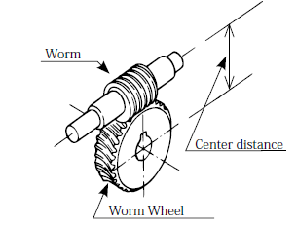
Worm Gear Pair
FIG 13 Worm Gear Pair
Worm is a shank having at least one complete tooth (thread) around the pitch surface and is the driver of a worm wheel.
Worm wheel is a gear with teeth cut in an angle to driven by a worm, the worm gear pairs is used to transmit motion between two shafts which are 90 DEG to each other and lie on a plane. Fig (13).
Its features:
- Provide large reduction ratios for a given center distance.
- Quiet and smooth meshing action.
- It is not possible for a worm wheel to drive a worm.
Worm Gear Pair used as a speed reducers, anti-reversing gear devices making the most of its self-locking features, machine tools, indexing devices, chain blocks, portable generators, etc.

Chapter (2): Gears’ Magic
Section (2.1): Deferential Gear
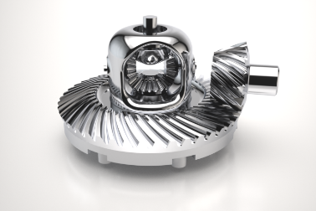
In the early automobile each wheel turn separately and only one wheel was connected to the engine, but when only one wheel was driven by the engine, it had to do all the work and it couldn’t get a good enough grip on the road to do its job properly, so the one wheel drive was soon out of date. But if two wheels are locked on an axel so they are not free to turn separately, one or the other has to slide, so the engineers had to find a way to connect both wheels to the engine without sliding or slipping in turns, the device which make this possible is called the Differential. Fig (14)
FIG 14 Differential Gear
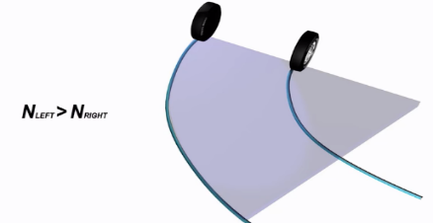
It’s called the (Differential) because it can drive the wheels at different speeds.
FIG 15 Right turn
The Differential looks complicated but once we understand its principles, it is amazingly simple.
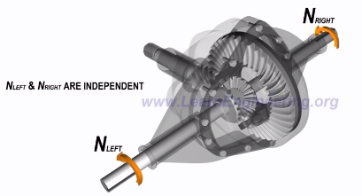
The main function of the differential is to allow the wheels to turn at deferent rpm while receiving power from the engine. Consider that the wheels will turn, it’s clear that the left wheel has to travel more distance compared to the right wheel, this mean the left wheel has to rotate at a higher speed. Fig (15)
FIG 16 differential action
If these wheels were connected using a solid shaft, the wheels would have to slip to accomplish the turn, this is exactly where the differential comes.
The mechanism in the differential allows left and right wheels to turn at deferent rpm while transferring power to both wheel. Fig (16)
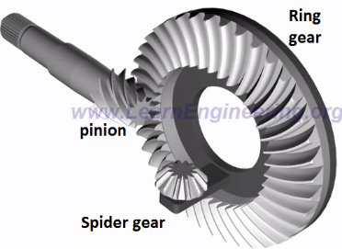
Power from the engine is transfer to the ring gear by a pinion gear, the ring gear is connected to a spider gear which is free to make to kinds of rotation one with ring gear, and second on its own axes. Fig (17)
FIG 17 Differential gear's components
Spider gear is meshed with tow side gears, so power from the engine flows from the pinion to the left and right wheels.

There are deferent cases of moving:
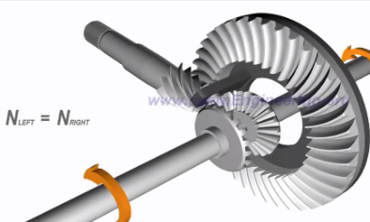
The vehicle moves straight: in this case spider gear rotate along with ring gear but it’s not rotate on its own axes, spider gear will push and make the side gears turn, and both will turn at the same speed. Fig (18)
FIG 18 Differential's action in straight move
- The vehicle turns right: in this case the spider gear plays a pivotal role, along with the rotation of the ring gear, it rotates on its own axes, so the spider gear is having a combined rotation. Fig (19)
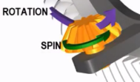
The effect of combined rotation on the side gears is interesting, when properly meshed, side gear has to have same peripheral velocity as that of the spider gear, when the spider gear is spinning as well as rotating peripheral velocity at the left side of spider gear is sum of spinning and rotational velocity, but at right side it’s the difference of the tow, as shown in Fig (20) that mean the left side gear will have a higher speed compared to the right side gear, this is the way the differential manages To turn left and right wheels at different speed.
FIG 19 combined rotation
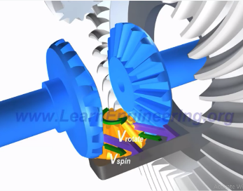
- The vehicle turns left: peripheral velocity at the left side of spider gear is the difference of spinning and rotational velocity, but at right side it’s the sum of the tow, that mean the right side gear will have a higher speed compared with the left side gear.
FIG 20 The Result of the combined rotation

In order to carry load one more spider gear is usually added, for spider gear arrangement is also use for heavy load vehicle. As shown in Fig (21)
The differential has two more function:
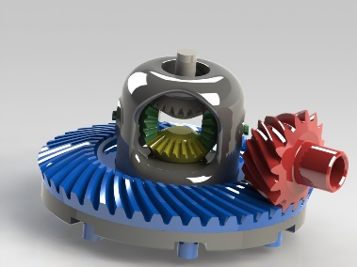
First is speed reduction at pinion/ring gear assembly this will result a torque multiplication, the other function is to turn power flow direction by 90 degree.
FIG 21 open differential gear
The differential we have gone through so far is known as open differential.
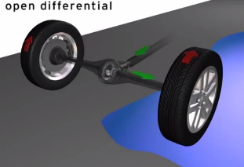
It has one disadvantage, consider a satiation, where one wheel of the vehicle is in a surface with a good traction and other wheel on a slippery track, in this case the open differential will send the majority of the power to the slippery wheel so the vehicle won’t be able to move, as shown in Fig (22), to overcome this problem, torsen differential are introduced.
FIG 22 power flow on a slippery track

Section (2.2): manual gear box
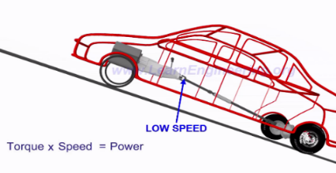
Why transmission is required in an automobile?
FIG 23 the relation between speed and torque
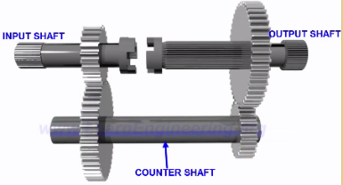
The power generated by the engine flows through the transmission before it reaches the drive wheels, the basic function of the transmission is to control the speed and torque available to the drive wheels for different driving conditions, for example, if you want to climb a hill you need more torque by reducing the speed at the transmission we will be able to achieve higher torque for the same power input, conversely if the torque demand is low we can increase the transmission speed. As shown in Fig (23)
FIG 24 the basic component of gear box
Manual transmissions work in simple principle of gear ratio.
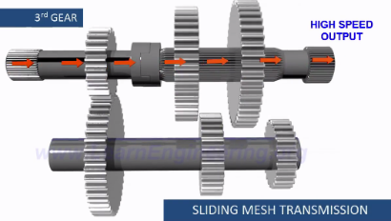
A basic transmission mechanism is shown in Fig (24), here the input and output shaft are connected through a counter shaft, if three speed mechanism will look like Fig (25), it’s clear that just by sliding the gear we can achieve different transmission ratios this transmission is more specifically called a sliding mesh transmission, they are good for controlling the speed but they have an inherit disadvantage it is noisy and complex operation to slide from one gear and engage with another gear.
FIG 25 Sliding mesh transmission
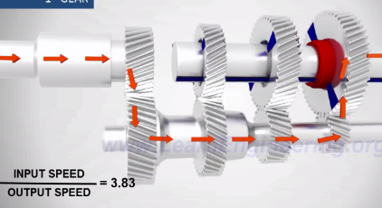
The constant mesh transmission permanently solve this problem. here, the gear are always in mesh but with a major different, the output gears are loosely connected to the shaft, if we connect only one gear to the shaft, the shaft will have the speed of the connected gear, with the help of the hypothetical connector, as shown in Fig (26), different gear ratio can be provide, how does that works? Fig (27)
FIG 26 the hypothetical connector role in transmission
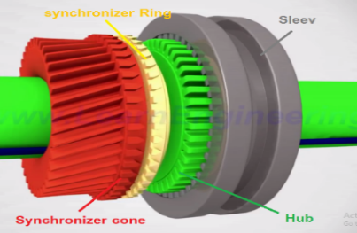
First of all the main shaft gear have synchronizer cone-teeth arrangement, a hub is fixed to the shaft , a sleeve that’s free to slide over the hub is also used in the system, it’s clear that if the sleeve get connected with the teeth of the , the gear and shaft will turn together. But during the gearbox operation the shaft and gear will be rotating at different speeds, so the hub must lock with the gear.
FIG 27 the basic components for meshing gears
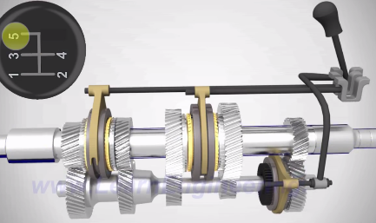
A synchronizer ring helps to match the speed of the gear with the shaft, the synchronizer ring is capable of rotating along with hub but it’s free to slide axially, before moving the sleeve the clutch is pressed, this way power flow to the gear is discontinued when we move the sleeve, it press the synchronizer ring against the cone, due to the high frictional force between synchronizer ring and the cone, the speed of the gear will be come as the same of the shaft, at this time the sleeve can slipped further and get locked with gear, thus the gear get locked with the shaft in smooth way, and the same mechanism is employed to shift to other gears.
FIG 28 manual gear box
The fifth gear is used to turn the output shaft in a higher speed than in the input shaft .Fig (28)

The reverse gear use three gears arrangement (input gear, output gear, idle gear)
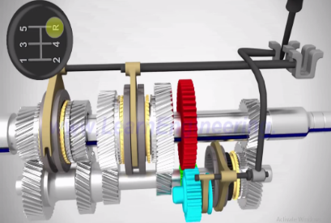
When the idle gear (in blue) is pushed and connected to the other two gears, the output shaft will turn in the reverse direction. The final shape of the gearbox shown in Fig (29)
FIG 29 manual gear box with reverse gear
The reverse gear doesn’t have the synchronizer ring mechanism, this mean that the gearbox rotation has to stop completely before apply the reverse gear.

Section (2.3): Torsen differential
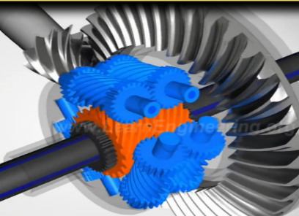
Torsen differential is the most unique and ingenious method of providing differential action while overcoming the traction difference problem. Fig (30)
FIG 30 torsen differential
The internal components of a torsen are quite different from that of a conventional differential.
At the heart of the system, lies a specially shape gear pair assembly.
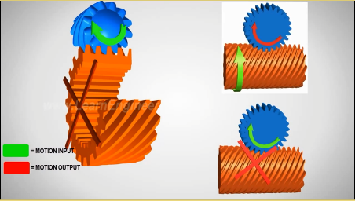
As we can see in Fig (30), one gear is a spur gear and the other one is a worm gear, a torsen works on a simple principles of worm gear worm wheel , the is the spinning worm gear can rotate the wheel but the rotating wheel cannot spin the worm gear.
FIG 31 mechanical curb using worm gear
A three pair of such worm wheels are fitted with the case, so the engine power received by the case, is transferred to the worm wheels, each end of the wheels is fitted with a spur gear. As shown in Fig (30)

Now, I will consider different driving scenarios
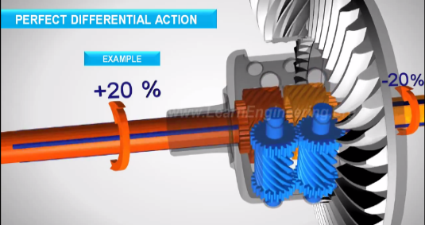
- The vehicle move straight : the worm wheels will push and turn the worm gears so both the drive wheels will rotate at the same speed, in this condition the worm wheels do not spin on its axes, in this condition the whole mechanism moves as single solid unit.
FIG 32 differential action in torsen differential
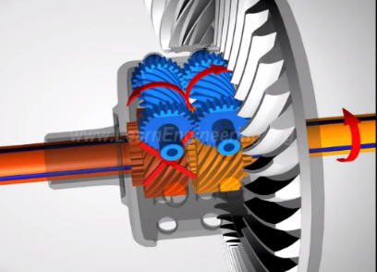
- The vehicle turns right: Fig(32): as we mentioned before that, the left wheel has to travel more distance compared to the right wheel, the speed differential is perfectly supported in the torsen, the worm gear of the faster left axel will make the corresponding worm wheel spin on its axe, on the other side relative to the case, the slow right axel is turning in the opposite direction, thus the right worm wheel will spin in the opposite direction ,the meshing spur gear at the end of the worm wheel will make sure that the worm wheels are spinning at the same speed, thus it guaranties a perfect differential action.
FIG 33 torsen differential’s way in avoiding obstacle
Now!! How the torsen over comes the drive wheels traction difference problem? FIG (33)
As soon as the slippery wheel start to spin excessively the speed change will be transferred to the worm wheel, the right wheel transfers the speed change to the left worm wheel, since they are connected through spur gears, the left side worm wheel will not be able turn the corresponding worm gear, because as we mention, a worm wheel cannot drive a worm gear, as a result, the whole mechanism gets locked, And the left and right wheels turn together, this allows a large amount of torque to be transferred to the high traction wheel.
To carry the loads tow more worm wheels pair are added.

The conclusion:
As we saw in this research, the gears have a pivotal role in transmitting speed and torque by transmitting the power between two different gears and more, changing the direction of power flow between planes by using the intersecting axes gears and Nonparallel Nonintersecting Axes gears and finally reducing the amount of needed motors to do any task by taking different outputs of one gear and more such in gearbox and watch.
So the gears make an important part in almost every mechanical machine
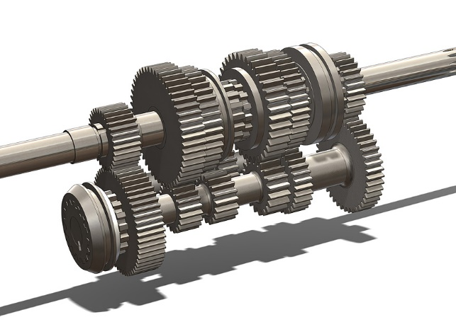
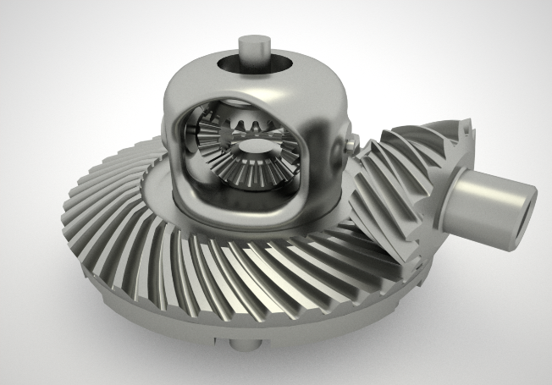
For supporting what I have mentioned and explained in this research, I made a design for the gearbox and the open differential gear using SolidWorks to make understanding of these mechanisms be easier, Fig (34) Fig (35), also I compared between the normal gearbox that used in car and the gearbox, which I have made out of Lego, Fig (36).
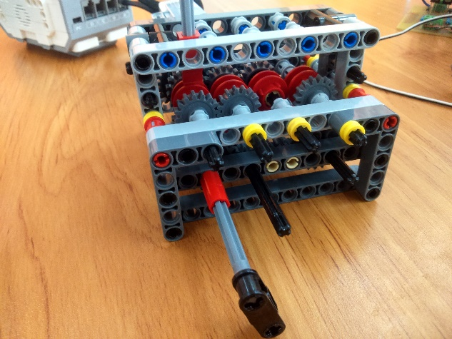
FIG 34Lego Gearbox
FIG 35 Differential Gear
FIG 36 Gearbox
Figures list:
FIG 1 Archimedes’ hoist 4
FIG 2 Vitruvius' water wheel and grain mill 4
FIG 3 the odometer for a carriage 4
FIG 4Parallel Axes Gear 5
FIG 5Spur Gear contact surface 5
FIG 6 The hand of helix 5
FIG 7 Helical Gear contact surface 5
FIG 8 Intersecting Axes Gears 6
FIG 9 Straight Bevel Gear 6
FIG 10 Straight Bevel Gear 6
FIG 11 Nonparallel Nonintersecting Axes Gears 7
FIG 12 Screw Gear 7
FIG 13 Worm Gear Pair 7
FIG 14 Differential Gear 8
FIG 15 Right turn 8
FIG 16 differential action 8
FIG 17 Differential gear's components 8
FIG 18 Differential's action in straight move 9
FIG 19 combined rotation 9
FIG 20 The Result of the combined rotation 9
FIG 21 open differential gear 9
FIG 22 power flow on a slippery track 9
FIG 23 the relation between speed and torque 10
FIG 24 the basic component of gear box 10
FIG 25 Sliding mesh transmission 10
FIG 26 the hypothetical connector role in transmission 10
FIG 27 the basic components for meshing gears 10
FIG 28 manual gear box 11
FIG 29 manual gear box with reverse gear 11
FIG 30 torsen differential 11
FIG 31 mechanical curb using worm gear 11
FIG 32 differential action in torsen differential 12
FIG 33 torsen differential’s way in avoiding obstacle 12

Reference and resources:

. "How a differential works." from www.learnEngineering.org.

. "Manual Transmission, How it works." from www.learnEngineering.org.

. "Torsen Differential, How it works." from www.learnEngineering.org.

CO., K. G. I. "The ABCs of Gears."

CO., K. G. I. "Introduction to Gears." (First).

Prof.K.Gopinath&Prof.M.M.mayuram Machine Deisgne ||.

CO., K. G. I. "The ABCs of Gears."
Prof.K.Gopinath&Prof.M.M.mayuram Machine Deisgne ||.
CO., K. G. I. "Introduction to Gears." (First). , Prof.K.Gopinath&Prof.M.M.mayuram Machine Deisgne ||.
. "How a differential works." from www.learnEngineering.org.
. "Manual Transmission, How it works." from www.learnEngineering.org.
. "Torsen Differential, How it works." from www.learnEngineering.org.

