**Considerations to choose your accelerometer** **sensor**

المركز الوطني للمتميزين

The National Centre for the Distinguished

**حساسات قياس التسارع**

تقديم: ندى سامر سلمان

تاريخ:2015-2016

# Abstract :

An accelerometer is an electromechanical device that measures acceleration forces. These forces may be static, like the constant force of gravity pulling at our feet, or they could be dynamic - caused by moving or vibrating the accelerometer. There are many types of accelerometers developed and reported in the literature. The vast majority is based on piezoelectric crystals, but they are too big and to clumsy. People tried to develop something smaller,

that could increase applicability and started searching in the field of microelectronics.

# introduction:

Accelerometers are defined as acceleration sensors that measure the linear acceleration along their sensitive axis. These devices have many application areas in the military and industrial fields, such as, activity monitoring in biomedical applications, active stabilization, robotics, vibration monitoring, navigation and guidance systems, and safety-arming in missiles.

Being low cost, small size and having low power consumption, micromachined accelerometers are widely used for low-cost industrial applications, such as platform stabilization of video-cameras, shock monitoring of sensitive goods, electronic toys, and automotive applications.

Automotive industry led the way to high volume applications of the micromachined accelerometers. IC compatible micro fabrication processes enable the fabrication of these mechanical transducers together with their readout circuitry on the same substrate resulting in more reliable and higher performance accelerometers. There are several companies manufacturing micromachined accelerometers in high-volumes.

For each application, different accelerometers with different performance requirements are employed so what is the most important factors we should consider choosing the most suitable accelerometer for our application?

# **Accelerometer’s work principle**:

Generally, accelerometers consist of a seismic mass suspended to a fixed frame by a spring, as shown in figure 2.1. The inertia of the suspended mass is used to sense the acceleration. The working principle of an accelerometer is based on Newton’s second law of motion, which can be expressed as, assuming a constant mass

F = m× a

with *F* [N] the resulting force on a mass *m* [kg] due to an applied acceleration *a* [m/s2]. The force exerted on the mass by the acceleration causes a displacement ofthe mass with respect to the frame and a corresponding elongation or shortening $∆$*t* [m] of the spring with spring constant *k* [N/m] of

$$∆t=-\frac{F}{k}=-\frac{m.a}{k}$$

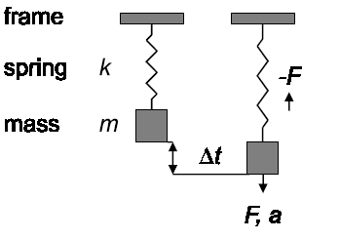Thus, the displacement of the mass is a measure for the acceleration acting on the mass. In addition, a stress profile arises in the spring due to its change in length. Therefore, the acceleration can also be determined by measuring the stress in the spring. both of which give an output signal related to the acceleration. Stress based measurements use the piezoresistive, piezoelectric or piezojunction effect or resonators, whereas displacement based measurements use a capacitive, inductive, optical, thermal or electron-tunneling read-out principle.

Figure

Micromachined accelerometers have been reported since 1979. Most designed accelerometers should only be sensitive to accelerations in one direction and should reject components of the acceleration vector in the other two directions. These devices are called *uniaxial* accelerometers.

It is possible to use three uniaxial accelerometers rotated 90o with respect to each other to sense the full acceleration vector. However, this may cause problems like a high off-axis sensitivity due to misalignment, and dimensions and power consumption of the device being larger than necessary. These problems can be circumvented by an accelerometer design with only one seismic mass which is truly capable of sensing the full acceleration vector.[1]

# Classification of Micromachined Accelerometers

Micromachined accelerometers can be classified into seven groups according

to their transduction mechanisms:

* Piezoresistive
* Capacitive
* Tunneling Current
* Piezoelectric
* Optical
* Thermal
* Resonant

First six classes of accelerometers generally have stationary seismic masses under no acceleration, and transduction from mechanical to electrical domain is by means of measuring the deflection of the seismic mass. Whereas, last group of accelerometers have continuously resonating members in order to sense the external acceleration.[2]

## Piezoelectric Accelerometers

Piezoelectric accelerometers rely on the piezoelectric effect of quartz or ceramic crystals to generate an electrical output that is proportional to applied acceleration. The piezoelectric effect produces an opposed accumulation of charged particles on the crystal. This charge is proportional to applied force or stress. A force applied to a quartz crystal lattice structure alters alignment of positive and negative ions, which results in an accumulation of these charged ions on opposed surfaces. These charged ions accumulate on an electrode that is ultimately conditioned by transistor microelectronics. the total amount of accumulated charge is proportional to the applied force, and the applied force is proportional to acceleration. Electrodes collect and wires transmit the charge to a signal conditioner that may be remote or built into the accelerometer. Sensors containing built-in signal conditioners are classified as Integrated Electronics Piezoelectric (IEPE) or voltage mode; charge mode sensors require external or remote signal conditioning. Once the charge is conditioned by the signal conditioning electronics, the signal is available for display, recording, analysis, or control. PCB sensors containing integral electronics are known by their trademarked term, Integrated Circuit - Piezoelectric, or ICP®.

### Structure of Piezoelectric Accelerometers

A variety of mechanical configurations are available to perform the transduction principles of a piezoelectric accelerometer. These configurations are defined by the nature in which the inertial force of an accelerated mass acts upon the piezoelectric material. At PCB, there are two primary configurations in use today: Shear and Flexural Beam. A third configuration, Compression, is used less now than previously at PCB, but is included here as an alternative configuration.

Figure

#### Shear Mode

Shear mode designs bond, or "sandwich," the sensing crystals between a center post and seismic mass. A compression ring or stud applies a preload force required to create a rigid linear structure. Under acceleration, the mass causes a shear stress to be applied to the sensing crystals. By isolating the sensing crystals from the base and housing, shear accelerometers excel in rejecting thermal transient and base bending effects. Also, the shear geometry lends itself to small size, which minimizes mass loading effects on the test structure. With this combination of ideal characteristics, shear mode accelerometers offer optimum performance

Figure -Shear Mode

#### Flexural Mode

Flexural mode designs utilize beam-shaped sensing crystals, which are supported to create strain on the crystal when accelerated. The crystal may be bonded to a carrier beam that increases the amount of strain when accelerated. This design offers a low profile, light weight, excellent thermal stability, and an economical price. Insensitivity to transverse motion is also an inherent feature of this design. Generally, flexural beam designs are well suited for low-frequency, low-g-level applications like those which may be encountered during structural testing.

Figure -Flexural Mode

#### Compression Mode

Compression mode accelerometers offer simple structure, high rigidity, and historical availability. There are basically two types of compression designs: upright, and isolated.

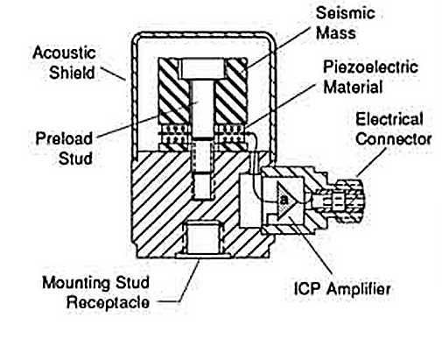Upright compression designs sandwich the piezoelectric crystal between a seismic mass and rigid mounting base. An elastic stud or screw secures the sensing element to the mounting base. When the sensor is accelerated, the seismic mass increases or decreases the amount of force acting upon the crystal, and a proportional electrical output results.   
The larger the seismic mass is, the greater the stress and, hence, the output are. Due to their inherently stiff structure, the upright compression design offers high resonant frequencies, resulting in a broad, accurate frequency response range. This design is generally very rugged and can withstand high-g shock levels. However, due to the intimate contact of the sensing crystals with the external mounting base, upright compression designs tend to be more sensitive to base bending (strain) and thermal transient effects. These effects can contribute to erroneous output signals when used on thin, sheet-metal structures or at low frequencies in thermally unstable environments, such as outdoors or near fans and blowers.

Figure -Upright compression

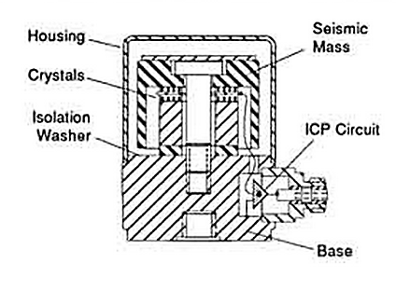Isolated compression designs reduce erroneous outputs due to base strain and thermal transients. These benefits are achieved by mechanically isolating the sensing crystals from the mounting base and utilizing a hollowed-out seismic mass that acts as a thermal insulation barrier. These mechanical enhancements allow stable performance at low frequencies, where thermal transient effects can create signal "drift" with other compression designs.[3]

Figure -Isolated compression

### Piezoelectric Material

There are two types of piezoelectric material that are used for PCB accelerometers. Each material offers certain benefits, and material choice depends on the particular performance features desired of the accelerometer:

* Quartz:

Quartz witch is a natural crystal is widely known for its ability to perform accurate measurement tasks and contributes heavily in everyday applications for time and frequency measurements. Examples include everything from wrist watches and radios to computers and home appliances. Accelerometers benefit from several unique properties of quartz. Since quartz is naturally piezoelectric, it has no tendency to relax to an alternative state and is considered the most stable of all piezoelectric materials. This important feature provides quartz accelerometers with long-term stability and repeatability. Also, quartz has virtually no pyroelectric effect (output due to temperature change), which provides stability in thermally active environments. Because quartz has a low capacitance value, the voltage sensitivity is relatively high compared to most ceramic materials, making it ideal for use in voltage-amplified systems. Conversely, the charge sensitivity of quartz is low, limiting its usefulness in charge-amplified systems, where low noise is an inherent feature. The useful temperature range of quartz is limited to approximately 600 °F (315 °C).

* polycrystalline ceramics:

A variety of ceramic materials are used for accelerometers, depending on the requirements of the particular application. All ceramic materials are man-made and are forced to become piezoelectric by a polarization process. This process, known as "poling," exposes the material to a high-intensity electric field. This process aligns the electric dipoles, causing the material to become piezoelectric. Unfortunately, this process tends to reverse itself over time until it exponentially reaches a steady state. If ceramic is exposed to temperatures exceeding its range or electric fields approaching the poling voltage, the piezoelectric properties may be drastically altered or destroyed. Accumulation of high levels of static charge also can have this effect on the piezoelectric output. PCB uses three classifications of ceramics. First, there are high-voltage-sensitivity ceramics that are used for accelerometers with built-in, voltage-amplified circuits. There are high-charge-sensitivity ceramics that are used for charge mode sensors with temperature ranges to 400 °F (205 °C). This same type of crystal is used in accelerometers that use built-in charge-amplified circuits to achieve high output signals and high resolution. Finally, there are high-temperature ceramics that are used for charge mode accelerometers with temperature ranges to 600 °F (316 °C) for monitoring of engine manifolds and superheated turbines.

Capacitive accelerometers**:**

Capacitive accelerometers convert the acceleration into a capacitance change. When an acceleration is applied to the accelerometer, the seismic mass deflects from its rest position and changes the capacitance between the mass and the conductive stationary electrodes by a narrow gap. An electronic circuitry can easily measure this capacitance change.

Capacitive accelerometers have several advantages, which make them very attractive for numerous applications. They have a low temperature dependency unlike piezoresistive accelerometers. Moreover, they have very good DC response, high voltage sensitivity, low noise floor, and low drift. Another important property of the capacitive accelerometers is their low power dissipation, as well as their simple structure. However, one drawback of the capacitive accelerometers is their sensitivity to electromagnetic interference, as their sense nodes are high impedance, addressing the necessity of high-quality packaging and shielding of both the sensor and the readout circuit.

Figure (7) and (8) show most widely used capacitive accelerometer structures. The first one is a vertical accelerometer structure. The mass and the conductive electrode under the mass form a parallel plate capacitor. Many vertical capacitive accelerometers utilize this principle for forming parallel plate capacitors.

Acceleration through z-axis deflects the mass resulting in a change in the gap between the mass and the conductive electrode. So, the capacitance of the structure either decreases or increases regarding to the direction of the applied acceleration. There are also accelerometer structures consist of thick silicon proof mass and two electrodes under and top of the mass forming a differential capacitance structure . The accelerometer operates between ±1.2 g having an equivalent acceleration resolution of 20 μg/ Hz . Another vertical accelerometer structure composed of interdigitated sense fingers operates in ± 27g range . Three metal layers of a conventional CMOS process are placed inside the sense fingers such that vertical

deflection of the mass changes the overlap area of these metal layers. This device has a voltage sensitivity of 0.5 mV/g/V with cross axis sensitivity lower than -40 dB and noise floor of 6mg/ Hz .

Figure (8) shows the basic lateral accelerometer structure . In this structure, the overlap area of the fingers connected to the mass, and fingers connected to the stationary anchors form the sense capacitance. When the mass of the accelerometer deflects, so the fingers connected to the mass, gap between movable fingers and stationary fingers increases on one side and decreases on other side. Hence, capacitance of the one side increases and capacitance of the other side decreases. Consequently, these types of accelerometers are sensitive to acceleration in the substrate plane.

Another conventional name of the stated devices is the varying gap accelerometers, since the capacitance variation due to acceleration is based on the changing gap between the mass and electrode as in Figure (7), or the changing gap between the stationary and movable fingers. However, for the varying gap accelerometers, crashing problem between the electrodes is possible. Because of this problem, there are also varying area type accelerometers in the literature. Most of these are based on the overlap length change of the stationary and movable fingers.

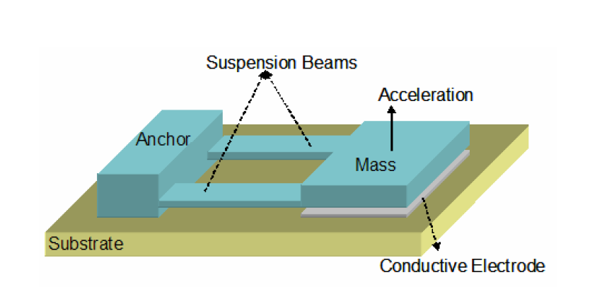

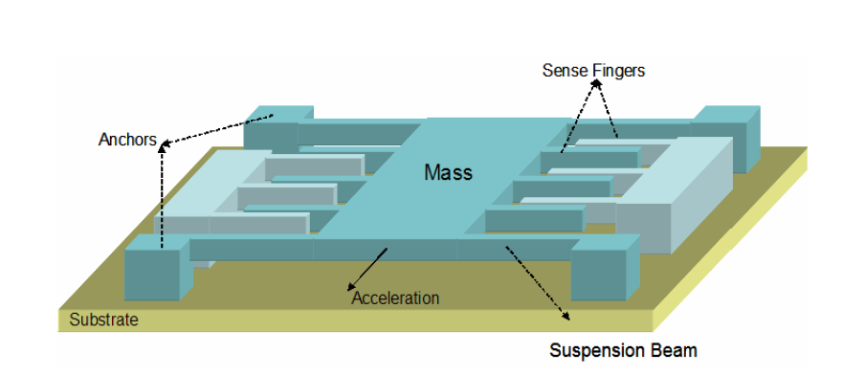

Figure

Figure

Some other accelerometer designs use torsional springs and parallel plate capacitors for acceleration sensing in vertical direction. One side of the mass is heavier than the other side so, the proof mass moves along the out of plane direction under acceleration along z-axis. Advantage of this structure on conventional z-axis accelerometers is the built in over-range protection.

In conclusion, most of the research on the accelerometers is based on the capacitive accelerometers, as they provide high sensitivity, low noise floor, and low temperature dependence, making them attractive for the areas where high performance is necessary.[4]

# Accelerometer Sensing Systems

accelerometers can be broken down into two categories that define their mode of operation. Internally amplified ICP® accelerometers contain built-in microelectronic signal conditioning. Charge mode accelerometers contain only the sensing element with no electronics.

## ICP® Accelerometers

ICP is PCB's registered trademark that stands for "Integrated Circuit - Piezoelectric" and identifies PCB sensors that incorporate built-in, signal-conditioning electronics. The built-in electronics convert the high-impedance charge signal that is generated by the piezoelectric sensing element into a usable low-impedance voltage signal that can be readily transmitted, over ordinary two-wire or coaxial cables, to any voltage readout or recording device. The low-impedance signal can be transmitted over long cable distances and used in dirty field or factory environments with little degradation. In addition to providing crucial impedance conversion, ICP sensor circuitry can also include other signal conditioning features, such as gain, filtering, and self-test features. The simplicity of use, high accuracy, broad frequency range, and low cost of ICP accelerometers make them the recommended type for use in most vibration or shock applications. However, an exception to this assertion must be made for circumstances in which the temperature, at the installation point, exceeds the capability of the built-in circuitry. The routine temperature range of ICP accelerometers is 250 °F (121 °C); specialty units are available that operate to 350 °F (177 °C).

The electronics within ICP accelerometers require excitation power from a constant-current regulated, DC voltage source. This power source is sometimes built into vibration meters, FFT analyzers, and vibration data collectors. A separate signal conditioner is required when none is built into the readout. In addition to providing the required excitation, power supplies may also incorporate additional signal conditioning, such as gain, filtering, buffering, and overload indication.

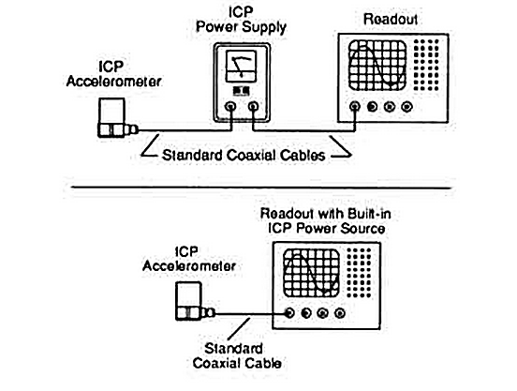

## Charge Mode Accelerometers

Charge mode sensors output a high-impedance, electrical charge signal that is generated by the piezoelectric sensing element. This signal is extremely sensitive to corruption from environmental influences. To conduct accurate measurements, it is necessary to condition this signal to a low-impedance voltage before it can be input to a readout or recording device. A charge amplifier or in-line charge converter is generally used for this purpose. These devices utilize high-input-impedance, low-output-impedance inverting amplifiers with capacitive feedback. Adjusting the value of the feedback capacitor alters the transfer function or gain of the charge amplifier.

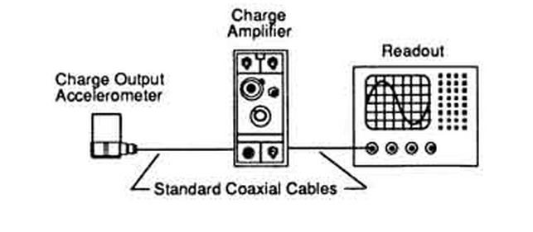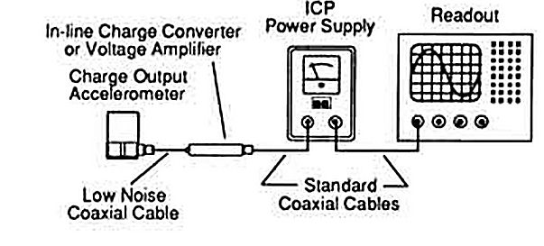Typically, charge mode accelerometers are used when high temperature survivability is required. If the measurement signal must be transmitted over long distances, PCB recommends the use of an in-line charge converter, placed near the accelerometer. This minimizes the chance of noise. In-line charge converters can be operated from the same constant-current excitation power source as ICP® accelerometers for a reduced system cost.

Sophisticated laboratory-style charge amplifiers usually include adjustments for normalizing the input signal and altering the feedback capacitor to provide the desired system sensitivity and full-scale amplitude range. Filtering also conditions the high and low frequency response. Some charge amplifiers provide dual-mode operation, which provides power for ICP® accelerometers and conditions charge mode sensors. Because of the high-impedance nature of the output signal generated by charge mode accelerometers, several important precautionary measures must be followed. Always use special low-noise coaxial cable between the accelerometer and the charge amplifier. This cable is specially treated to reduce triboelectric (motion induced) noise effects. Also, always maintain high insulation resistance of the accelerometer, cabling, and connectors. To insure high insulation resistance, all components must be kept dry and clean.[5]

# Reading Accelerometer Specifications

## Dynamic Specifications

Sensitivity (mV/g) :This specification shows the “nominal” sensitivity. This is the voltage output per engineering unit; for example, 100 milli-Volts per g (100 mV/g) will yield an AC voltage output of 100 milli-Volts per g of acceleration. The AC voltage will alternate at frequencies corresponding to the vibrational frequencies. The amplitude of the AC signal will correspond to the amplitude of the vibration measured. All frequencies will be present simultaneously. This is what creates a vibrational signal spectrum.

Sensitivity Tolerance(+/-)

The tolerance of the sensitivity. This is the maximum allowable difference between the nominal sensitivity for a model type and the actual measured sensitivity of a particular sensor as measured at room temperature at 100

Hz. The exact sensitivity of production accelerometers may vary from the nominal sensitivity within the specified tolerance range. The exact sensitivity of each unit is listed in the calibration data (test data) provided with each sensor. Internally amplified accelerometers are specified in “volts per g”. Internally amplified velocity sensors are specified in “Volts per inch per second”. Non-internally amplified, charge mode type, sensors are specified in picoCoulombs per g, or “pC/g”.

Electronic Noise:  
This is the electronic noise generated by the amplifier circuit. Noise is specified as either “broadband”, or “spectral”. The broadband measurement is a measurement of the total noise energy over a specified bandwidth (typically 2 - 25,000 Hz). Spectral noise is the noise measured at a specific frequency. This energy is specified in equivalent units of vibration, “g”s. Typically, the measured noise decreases as frequency increases. However, because lower acceleration readings are normally associated with lower frequencies, noise at low frequencies is more often a problem than noise at high frequencies.

Peak Amplitude :  
Peak amplitude defines the maximum amplitude vibration that can be measured by a sensor before distortion occurs in the amplifier due to overloading. This can be estimated roughly as follows:

a) calculate the difference between the power supply voltage and the BOV

b) calculate the difference between the BOV and ground (0)

c) take the smaller of the value in a) or b) above and subtract 2 Volts.

d) take this value and divide it by the sensitivity (in volts) of the sensor

e) the resulting number is a good approximation of the maximum

amplitude signal (expressed in “g”s) that may be measured before distortion occurs. Peak amplitude is a function of the sensitivity of the sensor, the power supply voltage and the BOV of the sensor. This is the same for all 2 wire “ICP” type sensors. The laws of physics are the limit here, and apply equally to all sensor manufacturers. If the maximum amplitude of a given sensor is not sufficient for the application. Normally, the solution is to use a sensor with a lower sensitivity, or in some cases it may be possible to use a sensor with a higher BOV and power supply voltage.

Frequency Response :  
The frequency response specification shows the maximum deviation of sensitivity over a frequency range. Remember, the nominal and actual sensitivity for a sensor are measured at a specific frequency; normally

100 Hz for most industrial sensors. The frequency response specification shows a range at +/- a percentage

(example, +/- 5%, or +/- 10%), or it may show a range for +/- 3 dB. The +/- percentage means that over the specified frequency range the sensitivity will be within the percentage stated. The 3 dB range is generally used in military or scientific specifications, 3 dB is approximately 40%. So +/- 3 dB is approximately +/– 40 %.

The frequency response of a sensor is typically governed at the high frequency end primarily by the mechanical resonance of the sensor. Low end frequency response limitations are the result of low frequency “highpass”

filtering used by all manufacturers to reduce the amplifier noise at low frequencies. In some cases, primarily low frequency sensors, there may also be high frequency “low-pass” filters used to eliminate unwanted signals and

interference from high frequency vibration signals.

Resonance Frequency:  
 This is the primary (largest) mechanical resonance of the sensor.However, there may be sub-resonances present at lower frequencies.

Temperature Output Sensitivity:

This is the voltage output per degree of measured temperature. The temperature circuit is separate from the accelerometer circuit The temperature circuit is powered by the same type of power supply as an internally amplified accelerometer. The temperature circuit “biases” this power supply voltage down to a voltage that corresponds to the accelerometer case temperature. Some older models (793T-1) provide an output in volts per degree Celsius. This limits the usable range to a low temperature of 0° C. Newer models provide an output corresponding to degrees Kelvin (K). Zero degrees Kelvin equals a zero Volt output. Zero degrees Kelvin

equals –273°C.

Temperature Output Range:

The temperature output range for units measuring in Kelvin is –50°C to 120°C. The limiting factor is the operating range of the accelerometer

## Electrical Specifications:

Power, Voltage: The maximum and minimum input power voltage that should be supplied to

the sensor. Over voltage powering may damage the sensor. Under voltage

powering may result in poor amplifier performance and signal distortion due

to overloading the amplifier with vibration signals that exceed the maximum

peak amplitude as discussed above.

Power, Constant Current:

The input power current must be regulated to protect the amplifier from damage. This current regulation is normally done by a constant current diode (CCD) in the data collector or analyzer power supply.

Bias Output Voltage: BOV is set by the amplifier circuit “biasing” the input power voltage down to a preset level. The normal range for BOV of a good sensor is typically the nominal value specified on the data sheet, +/- 2 Volts.

Turn-On Time: The time required by a sensor to reach 90% of it’s final BOV after initial powering. This is important for sensors that are not powered until the time when data is to be taken.

Shielding :Sensors are either case isolated, or case grounded. A case isolated sensor has the signal return and ground circuit isolated from the external case the of the sensor. A case grounded sensor has the signal return and ground circuit electrically connected to the external case of the sensor. A Faraday shield is used to shield the amplifier circuit from electro-magnetic interference. Practically all Wilcoxon Research sensors (except for some special laboratory models) have protection against mis-wiring and electrostatic discharge (ESD).

## Mechanical Specifications:

Temperature Range: This is the temperature range over which the sensor is designed to be operated. It is also the maximum and minimum storage temperatures. Permanent damage may result from exposure to temperatures outside of those specified. Normally, exposures to temperatures outside of the specified range for brief periods of time will not result in damage to the sensor.

Weight: Weight of sensor excluding any external cabling.

Sensing Element Design:The sensor design is also specified in this line on many specifications (shear, compression, or flexure).

Sealing: Sealing is either hermetic or epoxy. The I.P. rating is also provided. Case Material Most industrial housings are corrosion resistant, non-magnetic, 316L stainless steel.

Mounting: Stud, captive bolt, or epoxy[6]

ADXL335 accelerometer with arduino:

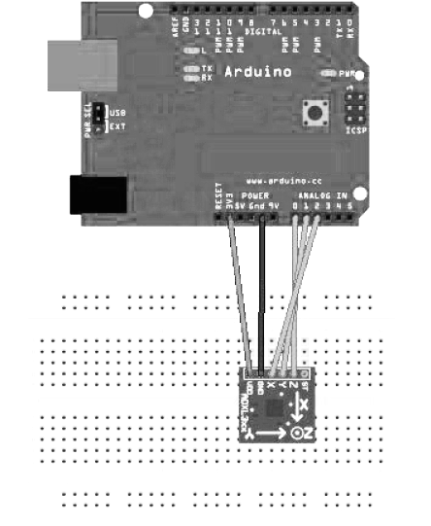Accelerometers detect movement in all directions—they notice moving them up, down, forward, backward, to the left, or to the right. Many popular gadgets such as the iPhone and the Nintendo Wii controllers contain accelerometers. here is how to interpret accelerometer data correctly and how to get the most accurate results using arduino open-source prototyping platform  
parts

1. A half-size breadboard or an Arduino Prototyping shield

with a tiny breadboard

2. An ADXL335 accelerometer

3. Some wires

4. An Arduino board such as the Uno, Duemilanove, or Diecimila

5. A USB cable to connect the Arduino to your computer

Wiring Up the Accelerometer: To power the sensor, connect GND to the Arduino’s ground pin and 3V to the Arduino’s 3.3 volts power supply. X, Y, and Z will then deliver acceleration data for the x-, y-, and z-axes. the ADXL335 is an analog device: it delivers results as voltages that have to be converted into acceleration values. So, the X, Y, and Z connectors have to be connected to three analog pins on the Arduino. For example connect Z to analog pin 0, Y to analog pin 1, and X to analog pin 2.

## programming

**const unsigned int** X_AXIS_PIN = 2;

**const unsigned int** Y_AXIS_PIN = 1  
**const unsigned int** Z_AXIS_PIN = 0;

**const unsigned int** BAUD_RATE = 9600;

**void** setup() {

Serial.begin(BAUD_RATE);

}

**void** loop() {

Serial.print(analogRead(X_AXIS_PIN));

Serial.print(*" "*);

Serial.print(analogRead(Y_AXIS_PIN));

Serial.print(*" "*);

Serial.println(analogRead(Z_AXIS_PIN));

delay(100);

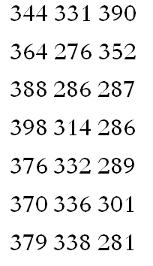}

We define constants for the three analog pins and initialize the serial port in the setup() function. In the loop() function, we constantly output the values we read from the analog pins to the serial port. Open the serial monitor, and move the sensor around a bit—tilt it around the different axes. You should see an output similar to the following:

Finding Edge Values**:**

The physical world often is far from being perfect. That’s especially true for the data many sensors emit, and accelerometers are no exception. They slightly vary in the minimum and maximum values they generate, They might change their output values even without moving them, or they might not change their output values correctly.

**const unsigned int** X_AXIS_PIN = 2;

**const unsigned int** Y_AXIS_PIN = 1;

**const unsigned int** Z_AXIS_PIN = 0;

**const unsigned int** BAUD_RATE = 9600;

**int** min_x, min_y, min_z;

**int** max_x, max_y, max_z;

**void** setup() {

Serial.begin(BAUD_RATE);

min_x = min_y = min_z = 1000;

max_x = max_y = max_z = -1000;

}

**void** loop() {

**const int** x = analogRead(X_AXIS_PIN);

**const int** y = analogRead(Y_AXIS_PIN);

**const int** z = analogRead(Z_AXIS_PIN);

min_x = min(x, min_x); max_x = max(x, max_x);

min_y = min(y, min_y); max_y = max(y, max_y);

min_z = min(z, min_z); max_z = max(z, max_z);

Serial.print(*"x("*);

Serial.print(min_x);

Serial.print(*"/"*);

Serial.print(max_x);

Serial.print(*"), y("*);

Serial.print(min_y);

Serial.print(*"/"*);

Serial.print(max_y);

Serial.print(*"), z("*);

Serial.print(min_z);

Serial.print(*"/"*);

Serial.print(max_z);

Serial.println(*")"*);

}

We declare variables for the minimum and maximum values of all three axes, and we initialize them with numbers that are definitely out of the sensor’s range (-1000 and 1000). In the loop() function, we permanently measure the acceleration of all three axes and adjust the minimum and maximum values accordingly. After a short while of moving the sensor in all directions, the minimum and maximum values will stabilize, and the output should be like this: x(247/649), y(253/647), z(278/658)[7]

# Accelerometer’s real life applications:

Accelerometers play a large role in the world around us. There are a multitude of

applications in which they are used. A list of some applications is shown below:

• **Automotive Applications**

_ Airbag deployment

_ Anti-Lock Braking Systems/Traction Control Systems

_ Vehicle Dynamics Control/Electronic Stability Control systems

_ Anti-Theft Systems

_ Active Suspensions

**• Industrial Applications**

_ Vehicle Tilt Monitoring

_ Railway Applications (Train Inclination and suspension)

_ Oil drilling, tilt measurement in harsh environments

_ Seismic Imaging and oil exploration

_ Structural stability tests

• **Consumer Electronics**

_ Inertial Navigation/GPS aid

_ Smartphones/Tablets/Laptops

_ Video Game Consoles

_ Sports aids (running devices, pedometers, etc)

_ Picture/Video image stabilization/anti-blur

_ Other: Hard Disk Protection

• **Medical/Sciences**

_ Sport Sciences

_ Geophysical Applications ( earthquake monitoring)

_ Medical Treatment: Evaluating disorders, Radiation oncology

**• Military/Aerospace**

_ Explosions/Weapons Tests

_ Military Surveillance

_ Smart Weapons

_ Structural Analysis

_ Flight Testing

Many of these applications can require different full scale ranges. For instance, in

automotive applications, whereas anti-lock braking systems and traction control systems

have a typical range of ±1g, while vertical body motion of the car uses sensors in the ±2g

range.[8]

Conclusion**:**

In order to choose the most the suitable sensor for my application, I should take care of several considerations like determining the type of measurement to be made, is it vibration, shock, seismic or motion? having a precise and complete idea about all different kinds of accelerometer sensors and their specifications. In addition, understanding the sensor’s specifications is very essential because of their importance in specifying the suitable sensing system according to the surrounding condition including temperature, maximum acceleration levels, and humidity.

considering resolution and sensitivity, when either a low-level signal and/or a wide dynamic range is required, the accelerometer's resolution and sensitivity become important. An accelerometer converts mechanical energy into an electrical signal (the output). The output is expressed in terms of millivolts per g (mV/g), or, in the case of a charge-mode accelerometer, the output is expressed in terms of picoCoulombs per g (pC/g). Accelerometers are offered in a range of sensitivities and the optimum sensitivity is dependent on the level of the signal to be measured e.g., in the case of a high g shock test, low sensitivity is desirable. In the case of low-level signals, the best approach is to use an accelerometer of high sensitivity to provide an output signal well above the amplifier's noise level. For example, if the expected vibration level is 0.1 g and the accelerometer has a sensitivity of 10 mV/g, then the voltage level of the signal would be 1 mV, and a higher sensitivity accelerometer may be desirable.  
Resolution is related to the accelerometer's minimum discernable signal. This parameter is based on the noise floor of the accelerometer (and in the case of an IEPE type, the internal electronics) and is expressed in terms of g rms.

**References:**

1. (1997). "Reading Accelerometer Specifications." 2015, from <http://www.wilcoxon.com/technotes/spec.pdf>.
2. (2015). "Introduction to Piezoelectric Accelerometers." from <https://www.pcb.com/techsupport/tech_accel.aspx>.
3. Bao, M.-H. (2000). Micro mechanical transducers: pressure sensors, accelerometers and gyroscopes, Elsevier.
4. Lotters, J. C. (1997). A highly symmetrical capacitive traxial accelerometer, Universiteit Twente.
5. Piezotronics, P. (2005). "Introduction to Piezoelectric Accelerometers." Véase también http://www. pcb. com/techsupport/tech_accel. php.
6. Schmidt, M. (2011). Arduino, Pragmatic Bookshelf.
7. Tse, C. (2013). Design of a Power Scalable Capacitive MEMS Accelerometer Front End, University of Toronto.
8. Walter, P. (2008). "Selecting accelerometers for and assessing data from mechanical shock measurements." PCB Electronics, Depew, NY, PCB Electronics Technical Note No. TN-24.
9. YAZICIOĞLU, R. F. (2003). Surface Micromachined Capacitive Accelerometers Using MEMS Technology, MIDDLE EAST TECHNICAL UNIVERSITY.

# Table of Contents:

Abstract : 1

introduction: 2

Accelerometer’s work principle: 3

Classification of Micromachined Accelerometers 4

Piezoelectric Accelerometers 4

Structure of Piezoelectric Accelerometers 4

Piezoelectric Material 6

Capacitive accelerometers 7

Accelerometer Sensing Systems 9

ICP® Accelerometers 9

Charge Mode Accelerometers 10

Reading Accelerometer Specifications 11

Dynamic Specifications 11

Electrical Specifications: 12

Mechanical Specifications: 13

ADXL335 accelerometer with arduino: 14

Wiring Up the Accelerometer: 14

programming 14

Finding Edge Values 15

Accelerometer’s real life applications: 16

Conclusion 17

Table of Contents: 19

1. Lotters, J. C. (1997). A highly symmetrical capacitive traxial accelerometer, Universiteit Twente.

  
2. YAZICIOĞLU, R. F. (2003). Surface Micromachined Capacitive Accelerometers Using MEMS Technology, MIDDLE EAST TECHNICAL UNIVERSITY.

  
3. (2015). "Introduction to Piezoelectric Accelerometers." from https://www.pcb.com/techsupport/tech_accel.aspx.

  
4. YAZICIOĞLU, R. F. (2003). Surface Micromachined Capacitive Accelerometers Using MEMS Technology, MIDDLE EAST TECHNICAL UNIVERSITY.

  
5. (2015). "Introduction to Piezoelectric Accelerometers." from https://www.pcb.com/techsupport/tech_accel.aspx.

  
6. (1997). "Reading Accelerometer Specifications." 2015, from http://www.wilcoxon.com/technotes/spec.pdf.

  
7. Schmidt, M. (2011). Arduino, Pragmatic Bookshelf.

  
8. Tse, C. (2013). Design of a Power Scalable Capacitive MEMS Accelerometer Front End, University of Toronto.

  