




Syrian Arab Republic.

Ministry of Education.

National Center for Distinguished.
2015/2016

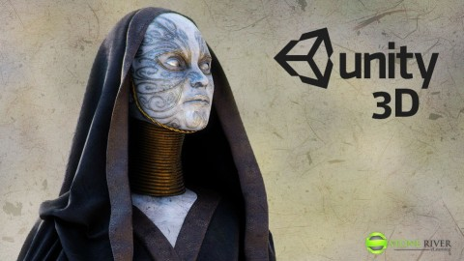
Seminar in informatics Entitled:
Unity 3D
The Future Gaming Portal
Preparation of student: Boushra Ali Younes.
The eleventh grade.
Supervisor teacher: teacher Amjaad TAHA
Introduction:
Technology is a tool. It helps us accomplish amazing things, hopefully more quickly and more easily and more amazingly than, if we hadn’t used the tool. Before we had newfangled steam –powered hammering machines, we had hammers. And before we had hammers, we had the painful process of smacking a nail into aboard with our bare hands. Technology is all about making our lives better and easier. And less painful. Unity 3D is a new piece of technology that strives to make life better and easier for game developers.
There are many questions we will try to answer them:
- What is the unity 3D?
- How can we use unity to develop games?
- What did the games (unity 3D games) take to build them?
- Do we use a programing language in the unity games?
- What is Code?
- How does Unity 3D use C#?
- what Is Programming?
- What does C# look like?

► Overview Of Game Engines and Unity 3D:
►A brief history of game engines:

All game engine is basically software that provide many of the basic function that are commonly used to build a video game. Most game engines allow for rendering either 2D or 3D shapes by importing files generated in a third-party software such as Blender, or 3D Studio Max or Maya, if you can afford them. Another function often found in a game engine is the ability to write software for the game engine to run. Unity 3D allow you to write software to run your game in C#.
3D engines have a relatively short history in general computing. Their evolution has been hot and fast. Starting around the 1990s, the 486 processor finally made its way into the general populace as a processor fast enough to allow for everyone to play 3D games. Or at least pseudo-3D, 2D images drawn in the shape of three-dimensional geometry. The technology for true 3D game polygons would take a few more years to make it onto the average person’s desktop.
Pseudo-3D was used to describe skewing and scaling flat sprites or 2D images to appear as though they were in 3D space. True vertex transformation wouldn't appear in popular video game engines on the PC with games such as Quake 1 till 1995. This was greatly with the help of faster and enhanced graphics processors. The modding community took Quake 1 and created many new addition and full conversions. When powerful graphics processing units (GPUs) were introduced, it opened the floodgates for many more 3D games to make their appearance. At first, these game functioned only on million-dollar com-putters, but thanks to 3dfx, NVidia, and Maxtrox in the late 1990s, the GPU quickly came to the forefront of the 3D gaming engine technologies that introduced many concepts such as spline surfaces, complex shadows, and lighting with Quake 2. Around 1998, Epic Games’s Unreal Engine took off with the launch of Unreal Tournament and Half-Life. More modding and conversions exploded onto the scene.
Many successful game modifications including Counter-Strike would go on to be one of the most played online multiplayer games Valve Software would publish for years to come.
Before the availability of dedicated GPU and cheap RAM, computers didn't have enough free resources to support a game engine and editing tools. Often the game itself required so much of the computer that; there was little room left for any extras, such as particle editors or just-in-time compiling.
The modding community influenced business, making Unreal 2 and Source modder friendly. Garry's Mod and Unreal Editor changed how game engines were made by adding tons of user-friendly tools.
Many users bought games specifically to "mod", or modify, and create new games. It is not a surprise that at this time many game engines would show up on the scene to scene to cater to the modding community and the independent game developer. The large game engines found them- selves top heavy by focusing on large publishers.
Companies such as Render Ware and Gamebryo found themselves poorly positioned to compete against newcomers who focused on the independent developers such as Unity 3D.
With the independent games developers in mind, many games engines focused on affordability and cross-platform development. Tools such as Game Marker, UDK, and of course Unity 3D allowed for many people to learn and built games without the multimillion-dollar investment formerly required for game production.
۞۞۞۞۞۞۞۞۞۞۞۞۞۞۞۞۞۞
►Unity 3D Overview:
Let's with a brief overview of the user interface (UI) and where to create the files you need to work on.
When starting up for the first time.
Select Create New Project and put the contents of the new project into your Documents directory. This directory can live anywhere and can be moved later on. We just need to find somewhere to put a project to begin.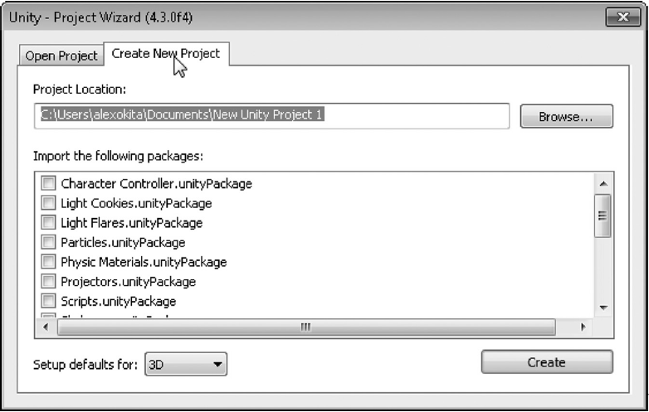
(Picture (1): create new project)
When Unity first opens, you should see a splash screen referring you to different tutorial resources and language guides.
►The Main Panel:
Once the project is set, the main editor panel will open. The Unity 3D interface is divided into five major parts:
(1) Toolbar.
(2) Hierarchy panel.
(3) Scene and Game view.
(4) Inspector panel.
(5) Project and Console Panel.
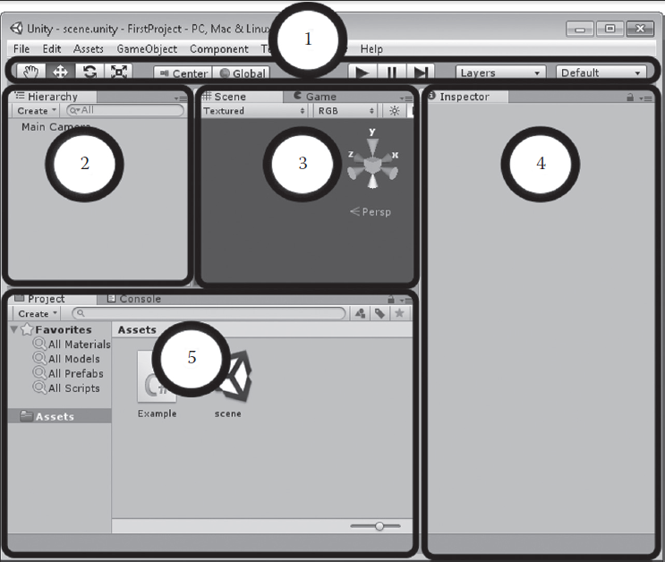
Each panel is labeled with a panel at the top left.
(Picture (2): The Main Panel)

(1)- Toolbar:
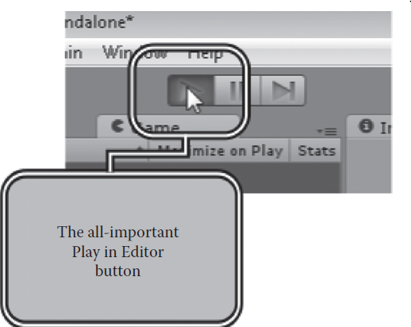
Label 1 in the figure shows us the toolbar, consisting of the navigation or manipulation tools and the Play, Pause, and Stop Forward buttons. We use the play in Editor Button to test our code. When this button is pressed, the Game panel will automatically come to the front. All of the code in the scene will begin to run. This is important because we use Unity 3D to test all of the code we will be writing.

(Picture (3): Toolbar)
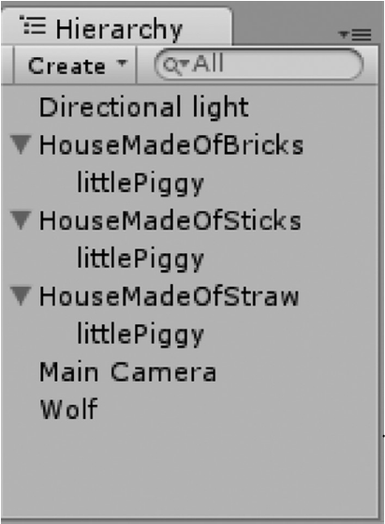
(2)-Hierarchy Panel:
Label 2 shows us the hierarchy panel. In a new scene, you'll only have a Main Camera. The hierarchy panel shows you all of the different objects that are going to make your game scene. Any zombies, environments, camera lights, and sounds can be found in this panel once they're in the scene. When any object is parented to another, it can be found by expanding the parent object with the triangle. In the fol-lowing example, you'll find a piggy parented to a house.

(Picture (4): Hierarchy Panel)

(3). Scene and Game View
Label 3 shows us both the scene and game views. The scene is more like a construction view of the game. The Game panel is the view of the game through the Main Camera. The difference here is that the Scene panel cannot be seen by the player, only you as the creator of the game can access the scene view. With this view, you will be able to place and arrange any object light and zombie you like.
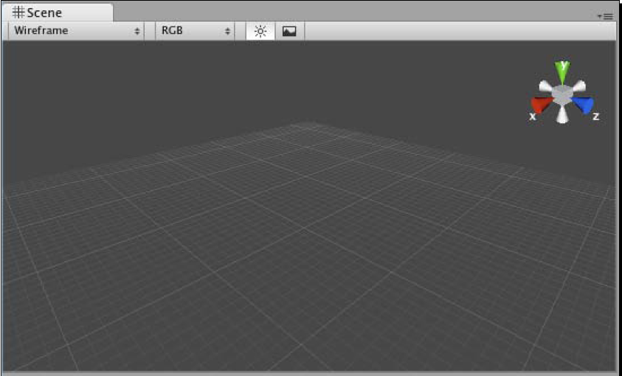
So the scene window is where you can position your Game Object and move things around. This window has various controls to change its level of detail. Use these controls to toggle lighting on and off, and to display the window contents with textures, wireframes, or a combination of both. You can use the colorful gizmo in the top-right corner to constrain the window to the X, Y and Z axes to view the top and sides of your scene. Chick on the white box in the middle to return to perspective view. This what the Scene window looks like when you start a new project or create a new Scene. You can think of scenes as levels or stages in your game.
(Picture (5), the scene window)

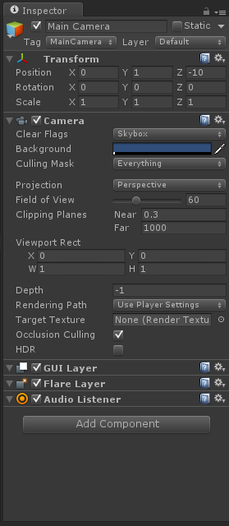
4-Inspector Panel:
Label 4 shows us the Inspector panel. By selecting an object in either the hierarchy or the scene view, you'll be able to look at their various properties. Things such as a transform, which show the object's position, rotation, and scale in the scene, can also be altered by you to edit the scene.
The Inspector is a context-sensitive panel, which means that it changes depending on what you select elsewhere in Unity. This where you can adjust the position, rotation, and scale of Game Objects listed in the Hierarchy panel. The Inspector can also display controls to configure components that add functionality to Game Objects. Between the three main panels in Unity(Hierarchy, Project, and Inspector), the Inspector is where you'll likely spend most of your time because that's where you'll be tweaking and fiddling with every aspect of the elements that comprise your game projects. (Picture (6), Inspector Panel)

(5) Project and Console Panel:
Finally, label 5 shows us the Project and Console Panel. The project view shows us all of the various assets we create to add to a scene. When we save a scene, it then turns into an asset for us to open from the project view. As we create new C# files, they too will be shown to us in the project view.
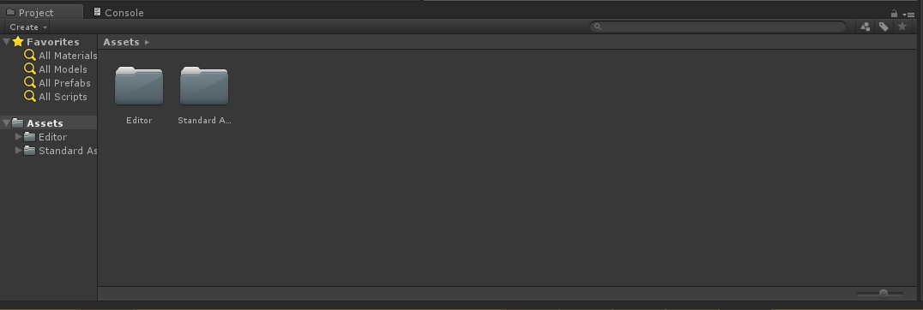
. (Picture (7), the project and console panel)
Origin story:
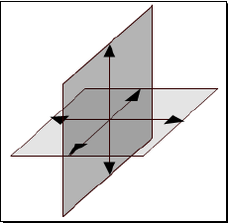
The center of your game world is called the Origin. The Origin is the magical place in 3D space where everything begins. 3D space is divided up by X, Y, and Z-axis. If you remember your Cartesian grid from grade school, or if you've ever seen a bar or line graph, the X-axis runs one way (usually horizontally), and the Y-axis runs perpendicular to it (usually vertically). 3D is like taking a second piece of paper and sticking it at right angles to your graph so that you have a third axis firing straight up at your face from your desk, and down into the floor in the opposite direction.
(Picture (8), X, Y, and Z-axes)

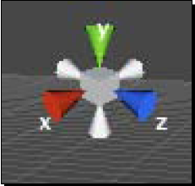
The orientation (the way the X, Y, and Z-axes are positioned) varies from program to program. Unity has aY-up orientation. The X and Z-axes run perpendicular to each other on the "floor", and the Y runs straight up into the sky and straight down to the center to the Earth where there are probably goblins or some such creatures.

(Picture (9), the X, Y, and Z-axes in Scene)
In Unity 3D you can add a light:
- In the menu, chick on Game Object / Create Other. The tree types of light that Unity supports are listed there: point light, spotlight, and directional light.
- Choose Directional light.
A new directional light is added to the Scene. The icon looks like a little yellow sun. when the light is selected (as it is now ), a tube of yellow rays shoots out from it. That tube shows us which way the light is pointing.
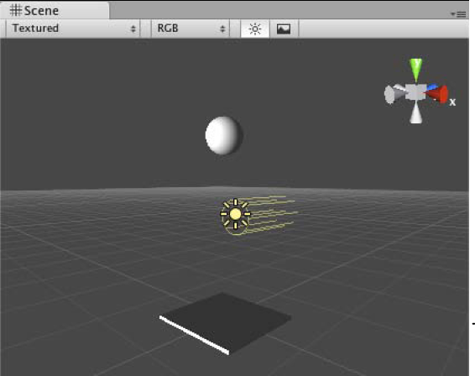

(Picture (10), lights)

►Code Comfort:
►What is Code ?
Code is just a series of instruction that you give to Unity to make it do stuff. We write lines (sentences) of code describing what to accomplish; these lines are called statements. Unity reads these statements and carries out our instruction. In Unity, you usually take a set of instructions and "stick" it to a Game Object. From now on, we'll use Unity's terminology Script to describe a collection of code statements.
►How does Unity 3D use C#?

Unity 3D has very few built- in function when it comes to making things interactive. Everything is done through various programming languages such as Boo, C#, and JavaScript.
- Boo : is a part of old Unity 3D programming which is a language that com about when Unity 3D was first introduced. (Picture (11), BOO icon)

- JavaScript : is a common programming language used by many web developers. That is why it was first used several versions ago to attract a wider audience of web developers looking to get into 3D game development.
(Picture (12), JAVASCRIPT icon)
- Unity 3D integrated C# to attract an even wider group of developers by using a more universally used programming language. C# is used by a large community of programmers. Unity 3D is also a cross-platform game engine, and a developer working on either OS X or Windows can both share and use files for Unity 3D. C# is exactly the same on both Mac and PC, so there is no concern over what operating system you're going to use.
 (Picture (13), programming languages which are used by Unity 3D)

►what Is Programming?
It's all about writing code. Programming is a process in which we organize data and use logic to do something with those data. The data are everything a computer can store; they can range from numbers to zombie characters in a video game. You do this by writing text into files called source code. Source code written into text files replaces punch cards used by the computing machines half a century ago.
When data are combined with logic and then written into a single file, they're called a class. Classes are also data, and as such as can be managed with more logic. Classes are used to create objects in the computer's memory and can be duplicated to have a life of their own.
Classes are used to build objects. Each piece of data within the class becomes a part of that objects. Different Chunks of data inside of a class are called class members. Class members can also be chunks of logic called functions or methods.
In a game with a horde of zombies, each zombie is duplicated or instanced from a zombie class. Each zombie has unique values for each attribute or data element in the class. This mean hit points, and locations are unique for each duplicate zombie object. Objects created from a class are called instances.
Similar to families, objects can inherit properties from one another. The child sometimes called subclass inherits attributes from its parent. for instance, the child created from a zombie may inherit the parent's hunger for brains. To be useful, the child zombie can also add new objects and change the objects it inherited from its parent class. As a result, now the child zombie might have tentacles that the parent didn't have.
Objects talk to each other through events and messages. Shooting at zombies can create an event, or in programmer terms, it "raises" an event. The bullet impact events tells the zombie class to then take necessary steps when hit by a bullet. Events command the class to take action on its data, which is where functions come in.
Functions, also known as methods, are sections of logic that act on data. They allow your class to create additional events and talk to yet more objects. As the player presses the trigger and moves the joystick around, yet more events can be raised and messages can be sent. Events and messages allow the player to interact with your world; logic events and objects together build your game.
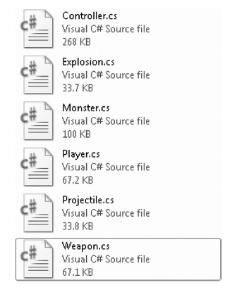
►What does C# look like?
A game in Unity 3D is made up of many different C# files. Each file can be referred to as a "class" and end with the .cs file extension (which stands for C Sharp). This isn't a class like those that are taught. It is more akin to biology in which classes are categories that define different groups of organisms.
A basic game might have several different classes, each one named according to its purpose. Each one of these classes contains the text that is your actual C# code. Just so you know, by default Windows will hide the extensions of your files. As a result, if classes appear is simply Weapon or Monster and there is no exten-sion.cs, then you should go into the Tools menu, select Folder Options/View, and enable file extensions.
►Examples of Unity 3D games:
We'll take a look at some Unity 3D Games and talk about what it took to build them.
- Big Fun Racing:
Big Fun Racing: is a simple but effective game where you zip around collecting coins in a toy truck. It features a number of different levels and unlockable vehicles. The game designer sunk a few months into the game in his off-hours, with a little help from outsource artists to create the vehicle models.
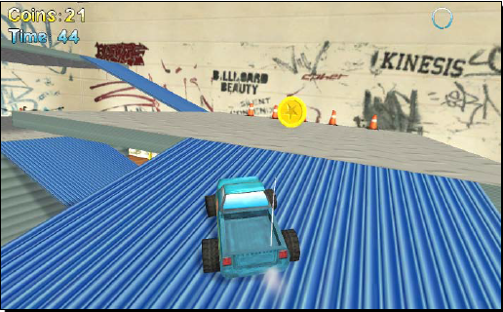
(Picture (14), the game: Big Fun Racing)
- Diceworks:
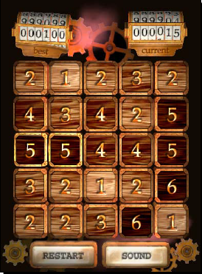
Diceworks is a very simple, well-polished game designed for the iPhone in Unity 3D. We won't be covering any iPhone development, but it's good to know that your Unity content can be deployed to a number of other devices and platforms, including the Apple iPhone or iPod touch, and the Nintendo Wii. The iPhone and Wii versions of the software cost an additional fee, but you can deploy your games to the web, to the Mac, and to the PC for free using the indie version of Unity.

(Picture (15), the game: Dice works)
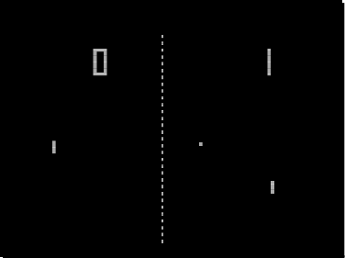
- Pong:
The original Pong is credited with kick starting the commercial video game industry that we know today.
The mechanic: Pong takes its name from ping pong, a real-world activity where two players use paddles to bounce a ball at each other across a table with a tiny net. Ping Pong was adapted from tennis, after people finally realized that all that running around was too mush effort.
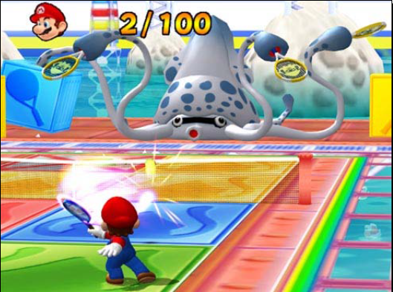
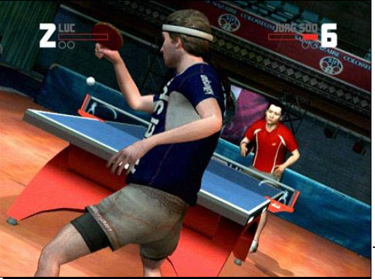
(Picture (16, 17), the game: Pong)
- Shoot the moon:
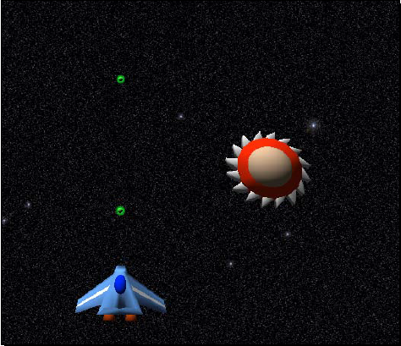
(Picture (18), The game: Shoot the moon)
۞۞۞۞۞۞۞۞۞۞۞۞۞
•• Conclusion ••
Making a game is more fun than making accounting software. Having fun learning is more important as getting high-test scores. After a test, you pretty much forget the anguish of studying all night and what it was for. So there is no reason to make learning menial work because studying should not be boring.
Unity 3D provides us with a complete set of tools we can also use in our code quickly and easily. Unity 3D is limited to older versions of the C# library. Today, C# is in its fifth version and it's continuing to grow. Not all features added to C# are allowed in Unity 3D for reasons of security or platform compatibility.
When c# is compiled into other platform, such as iOS or Android, many of the tricks we discussed don’t exist. The desktop environment is still the more powerful, not just because of the central processing unit and the graphics-processing unit: as of today, the operating system (OS) of desktop still has plenty more ability than that of a mobile OS.
- In this Seminar, we have talked about:
A brief history of game engines and their development during the development time. And we have talked about Unity 3D Overview:
►The Main Panel:
(1) Toolbar. (2) Hierarchy panel. (3) Scene and Game view.
(4) Inspector panel. (5) Project and Console Panel.
And What is Code? How does Unity 3D use C#? (((Boo, C#, JavaScript)))) what Is Programming? What does C# look like? And Examples of Unity 3D games ((((Big Fun Racing, Dice works, Shoot the moon, Pong))))
These examples help us to understand the mechanization of unity 3D or 2D.
۞۞۞۞۞۞۞۞۞۞۞۞۞

•• Results ••
We find that Technology is a tool. It helps us accomplish amazing things, hopefully more quickly and more easily and more amazingly than, if we had not used the tool. Unity contains all of the tools that you need to create an island or any kind of landscape. It has terrain tools that let you model your level right inside the software. It contains a ready-made first person controller prefab object you can plunk into the world with automatic WASD keyboard controls that will allow you to explore the terrain. Unity automatically takes care of the rendering (drawing), collisions, physics, and sound effects. So Unity 3D is very important for games and their development.
۞۞۞۞۞۞۞۞۞۞۞۞
•• Suggestions ••
- Use Unity's applications in manufacturing and housing projects.
- And use Unity's applications in teaching, (we can use the simulation, "men-machine" and solve the problems)
- Develop the Unity's programs because it is a very important tool in high tech.

References:
- Alan Thorn, Pro Unity Game Development With C#, London, 2014.
- Alex Okita, Learning C# Programming with Unity 3D, CRC Press, Taylor and Francis Group, LLC, New York, 2015.
- Folder, Lincoln Green, Content Creation in Unity 3D, p22.
- Ryan Henson Creighton, Unity 3D Game Development by Example Beginner's Guide, Packet Publishing, the first published: September 2010.

Index of images:
Image number: | Image name: | Page:
1 | create new project | p:5
2 | The Main Panel | p:6
3 | Toolbar | p:7
4 | Hierarchy Panel | p:7
5 | the scene window | p:8
6 | Inspector Panel | p:9
7 | the project and console panel | p:10
8 | X, Y, and Z-axes | p:10
9 | the X, Y, and Z-axes in Scene | p:11
10 | lights | p:11
11 | BOO icon | p:12
12 | JAVASCRIPT icon | p:12
13 | programming languages which are used by Unity 3D | p:13
14 | the game: Big Fun Racing | p:16
15 | the game: Dice works | p:17
16 | the game: Pong | p:18
17 | The game: Shoot the moon | p:18

Index:
Title: | Page:
Cover. | 1
Introduction. | 2
► Overview of Game Engines and Unity 3D: | 3
- A brief history of game engines: | 3
- Unity 3D Overview: | 5
(1) Toolbar. | 7
(2) Hierarchy panel. | 7
(3) Scene and Game view. | 8
(4) Inspector panel. | 9
(5) Project and Console Panel. | 9
(6)Origin story. | 10
►Code Comfort: | 12
- What is Code? | 12
- How does Unity 3D use C#? | 12
- what Is Programming? | 14
- What does C# look like? | 15
- Examples of Unity 3D games. | 16
Conclusion. | 19
Results. | 20
Suggestions. | 20
References. | 21
Index of images. | 22
Index. | 24

The End.

Learning C# programming with Unity 3D. p 5, 6.
Learning C# Programming with Unity 3D. P16.
Unity 3D Game Development By Example. P 19.
Learning C# Programming with Unity 3D. p 17.
Unity 3D Game Development by Example. P 22/23.
Unity 3D Game Development By Example. P 55/56.
Learning C# Programming with Unity 3D. p 6.
Learning C# Programming with Unity 3D. P 7.
Unity 3D Game Development By Example. P 41.
Unity 3D Game Development By Example. P 293.

