

*A research in physics named by :*

***The Fermi Paradox***



***BY : obada Al-Azki***

***Class : 11th .***

***Date : 2015 – 2016 .***

***Supervised by : Abd ALrhman ALhashm .***

***Contents***

Introduction : **Error! Bookmark not defined.**

The Fermi paradox: 3

Types of civilization: 5

BS-model of development of Civilizations in Universe: 6

Status of Universe in BS-model without bonus : 9

BS-model with bonus. The Contact of Civilizations: 11

Drack equation: 14

Possible conclusion for the paradox: 17

***Table of figures:***

Figure 1 7

Figure 2 8

Figure 3 11

Figure 4 12

Figure 5 13

## Introduction:

The idea of existent of intelligent civilizations outside the Milky Way was and still a controversial subject for everyone, and most of these questions are is there an intelligent life in other plants?? And for the last five years the scientist found that there is more than 36 star like our sun and it has plants have the same mars size, although that the astronomers couldn’t reach for plants look like earth, today…we are very sure that those plants are nearby in other galaxies.

The earth is 4.5 billion years old, and the fact that life has been appeared with this fast according to the biological scale, we assume that for completing this action was easy for the nature, so there is a lot of reasons to think that the universe is full of living things at least…and that what is the Fermi paradox is questioning. And I will talk about it in this research to find some of reasonable conclusions.

So the question is:

Where is everybody?? And are we alone??

## The Fermi paradox:

***T***he Fermi Paradox is the apparent contradiction between the high probability extraterrestrial civilizations' existence and the lack of contact with such civilizations.

In general, solutions to Fermi's paradox come down to either estimation of Drake equation parameters i.e. our guesses about the potential number of extraterrestrial civilizations or simulation of civilizations development in the universe.

We consider a new type of cellular automata that allows to analyze Fermi paradox.

We introduce bonus stimulation model (BS-model) of development in cellular space (Universe) of objects (Civilizations). When civilizations get in touch they stimulate development each other, increasing their life time. We discovered nonlinear threshold behavior of total volume of civilizations in universe and on the basis of our model we built analogue of Drake equation. [1]

The paradox suggested by E. Fermi in 1950 has been formulated in the form of a question – «where is everybody? ». At the heart of Fermi paradox is the fact of absence of observations of extraterrestrial Civilizations, their activity or traces of their activity. Let’s assume that the Civilizations develop at the same rates, as unique one known to us at the Earth. In this case, it follows that (1) those Civilizations which have begun the development a little earlier than Earth civilization, should possess enormous technological possibilities and their activity would be conspicuous. There is a great number of publications on discussion of Fermi paradox and many different lines of thought used for its explanation (2, 3), in the book (4) fifty speculative decisions are resulted.

In (5) Fermi paradox is discussed within the limits of the percolation theory (6). The possibility of existence of infinite cluster of Civilizations (using the percolation theory terminology) is considered as the answer to Fermi paradox. It is assumed here, that Civilizations are born at the same moment and that they live infinitely long. Civilizations not belonging to such infinite cluster remain separated, lonely.

We support the view that Civilizations are being born, develop, reach their golden ages and then die. It is possible to understand as dying both destruction, loss of interest to world around them, a cutoff in the development of technologies and the terminations of interaction with surroundings. According to Lipunov  (7), each Civilization has a date of birth and the initial life time limited by some specific factors. Possible reason for disappearance of Civilizations is the loss of interest to development - «the universal cause of death of Intellect in the Universe can be connected with loss of its basic functions – knowledge functions» (7). We assume, that the unique reason which can prolong a lifetime of the Civilization, is the contact to other Civilizations. The meeting of Civilizations generates the new purposes and objects of knowledge, necessity to use an Intellect.

We propose the following model of existence, development and dying of Civilizations in the Universe. Civilizations are born with the probability n and have the initial life time (time of expansion) 0 T set in advance after which they die (disappear or cease to show itself). Contact of developing Civilizations increases actual life time for everyone contacted on a certain extra time, named further a time bonus  .

We will refer to this model as a Bonus Stimulated model (figure 1).

Further we will use terminology adapted for discussion of Fermi paradox even though the offered model can describe and another phenomena. It is possible to offer the analogy to economy, and in this instance the initial lifetime  is a seed capital of the new formed company. Also this capital defines time of company’s independent life, while association process of this company with other companies stimulate the further development, increasing stability of existence of association by  value etc.[2]



## Types of civilization:

***Type one:***

This kind is evolved enough has the access to the whole energy on their plant.

***Type two:***

This kind is more evolved to have the control of his sun energy.

***Type three:***

This kind is the most evolved kind, and it might be like god to us, because it controls its whole galaxy.



1 symbols of civilization

## BS-model of development of Civilizations in Universe:

BS-model defines the Universe as the cellular automata. The rules of this automata define the behavior of Civilizations - objects which born, grow and die in the Universe. A Civilization is a set of the cells joined by their "history". Specific for this cellular automata is that its behavior is depended not only on its condition at the previous moment, but on the events which took place in the Universe much earlier, beginning with the births of the oldest Civilization, existing currently in the Universe. In BS-model the depth of “history” is not constant.

In the present paper the two-dimensional cellular automata of sizeis considered. A Civilization is a square of Universe cells. The centre of square is the Civilization birthplace. Following rules are set:

1. The Civilization birth. New Civilization can be born in the free cell of Universe not occupied currently by another Civilizations. Probability of birth - n, size - single cell.
2. Civilization growth and dying. For each step of time each Civilization changes its size by one layer of cells on each side. If the Civilization exists less  time steps, its size increases, and if it is more than  - decreases. When the size becomes equal to the zero, then the Civilization is considered to disappear (this alien culture died, not demonstrating any signs of life, etc.). Initial life time  is the same to all Civilizations.
3. Civilizations aggregation. If, during the growth, one Civilization meets another (the same cell of the Universe has to belong to both Civilizations) they form the cluster and lifetime  of each Civilization is increased by bonus time . If the Civilization joins the existing cluster, the bonus  is given to all Civilizations in the cluster. Further development of each Civilization goes according to rule 2.

On Fig. 1 the development of Civilizations in Universe is shown in the space and time schematically (without «cellness»). The time axis is directed from below upwards. In this view the Civilization is two cones with joined bases and cone point specifies the birthplace of Civilization.

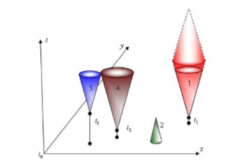

Figure 1

Fig. 1. Sketch of Civilizations development in the space and time. The single Civilization 1 develops since  to the present moment and will die at the time  in the future, the Civilization 2 – is born earlier, reached  and dies. Civilizations 3 and 4 were born at  and  accordingly, presently they both form cluster and obtain for everyone a time bonus , then they will develop further.

On Fig. 2 consecutive time slices of the developing Universe (fragment) are presented schematically (with «cellness»). The volume of the occupied space  grows eventually. In the shown fragment: 115, 148, 197 occupied cells for each consecutive time step.

Thus, in BS-model the developing of Civilizations in Universe is governed by three parameters: -initial life time of the Civilization, n - probability of birth of the Civilization, -bonus time. Incorporation of bonus time, an extra time of development (growth) of the Civilization is essentially new assumption of BS-model. Fermi paradox within the limits of the proposed model will be resolved, if it will be known the values of parameters when the Universe will be occupied by a single cluster of Civilizations or on the contrary, rare or local associations of Civilizations will take place only. In the latter case it is fair to say that Civilizations are separated and we are single in the Universe.

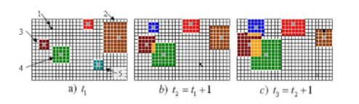

Figure 2

Fig. 2. Birth, growth and dying of Civilizations in Universe (three consecutive time steps). The Civilization 1 is born at and further develops with steps  and  , the Civilization 2, having existed more than time steps, dies and goes away, Civilizations 3, 4, and then 1 on a step  form the cluster. Lifetime for 3 and 4 will increase by, after step Civilizations 3 and 4 will possess bonus  , and 1 – bonus . The Civilization 5 dies and disappears at step.

The purpose of numerical simulation was to find such set of Civilization parameters  at which there is a transition similar to phase transition, from the Universe with volume occupied by Civilizations  , where  is Universe volume, to almost civilized Universe with total volume of Civilizations of the order .

The size of cellular automata used to simulate Universe was  cells, modeling time 320000 steps. Lower and upper limits for initial life time and bonus was  and  accordingly.

## Status of Universe in BS-model without bonus :

For the case  we have to notice that the volume occupied by Civilizations  will fluctuate around certain value. The cause of fluctuations is a random overlap of neighboring Civilizations that form small clusters made of independent Civilizations.

Let us not to consider this overlapping. In this case we are able to obtain the analytical dependence of the occupied volume  on Civilization parameters  .

In the Universe at each time interval there will be Civilizations of all linear sizes from 1 to. For all sizes except maximal one there exists a pair of Civilizations – one growing and one dying away. Therefore number of Civilizations of maximal size  is equal to , for smaller size  and following equation can be written:

 (1)

Considering in (1) that  it is possible to estimate following sum as. Thus, from (1) one can expect that the volume occupied by Civilizations in the Universe is directly proportional to probability of birth of the Civilizations  and to cube of initial life time.

 (2)

Numerical simulation of BS-model for values  an  gives following values for indexes a and B in equation (2)

 (3)

The  and  values calculated on the base of BS-model (3) are close to those found from theoretical estimation (2) and show that overlapping of Civilizations is rather insignificant. Accordingly, the quantity of contacts appears are also insignificant and each Civilization in such Universe will live as we do now: it is impossible to assert "no, aliens is a myth", but it is impossible to prove "yes", as the contact is hardly probable.

## C:\Users\ZB\Desktop\المركز\صور فيرمي مهم\galaxy2.jpg

## BS-model with bonus. The Contact of Civilizations:

Another state of the Universe is able to reach in case of a nonzero bonus which Fermi paradox can be solved positively: they do exist, but it is necessary to wait.

At small bonus values  the behavior of the Universe has a little difference from stable no-bonus state with the fluctuations, described in Sec. 3. The volume occupied by Civilizations insignificantly increases at  increase, as well as amplitude of its fluctuations does. However at some threshold bonus  the actual life time of Civilizations at their consecutive association increases so much that allows them to develop enough to be able to form huge cluster filling almost all the Universe.

In Fig. 3 we present the dependence of relative occupied volume in the Universe  upon time for  and  и are shown and civilized Universe scenario 3 given for  .

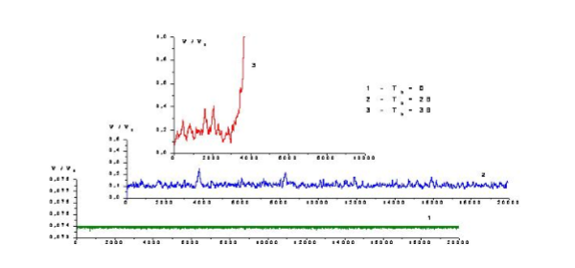

Figure 3

Fig. 3. Possible scenarios of the development of the Universe. The dependence of the relative occupied volume  on time for various time bonuses is shown (specified in drawing).

For scenario 3 further growth of the occupied volume  will continue up to  .

Considerable difference of the occupied volume  at which Universe will be surely civilized in BS-model from threshold value at percolation (5) Universe models  is unexpected. It shows basic difference of "phase" transition in BS-model from percolation phase transition situation.

On Fig. 4 dependence of averaged (over 100 runs) relative occupied volume  for  and  on a time bonus  is presented. Results for different Universe simulation times are presented, each following consecutive time is 4 times longer than previous.

Thus, (see Fig. 4) there exists a critical bonus value  sufficient for starting the aggregation of Civilizations in Universe. One can say that critical value of a bonus points to the beginning of “ civilizationing” or "globalization” process. Simulation time does not affect  value.

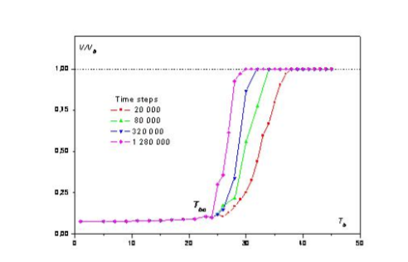

Figure 4

Fig. 4. Dependence of averaged relative occupied volume  for  and on a time bonus  at various simulation times (specified in drawing).

In the language of Fermi paradox we conclude that the older is Universe (longer simulation time), the more definitely it arrives at their final state – transition from split Universe to civilized one occurs certainly at sufficient

.In the younger Universe (short simulation time) for  aggregation take place with some probability which, in turn, depends on Universe life time. The longer Universe exist, the greater is the probability of aggregation of Civilizations. For this "globalization” to happen there exists an obstacle, it is necessary to wait, but now our Earth Civilization has hope, hope for contact, of course if will be sufficiently large for the contact.

Fig. 5 presents the final state of the Universe in BS-model, it shows an interfacial surface between the split and civilized status of Universe.

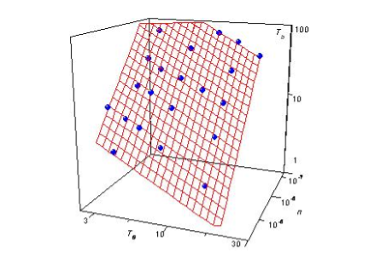

Figure 5

Fig. 5 Dependence of a critical time bonuson initial life time of Civilizations and probability of their birth.

Indeed, (see Fig. 5) the higher birth probability of Civilizations and the longer initial life time, the time bonus should be less to conquer the Universe by bonus stimulated Civilizations. Again we represent  as power dependence on  and . We found from numerical simulations appropriate exponents (critical indexes) and coefficient:

 (4)

If  is below threshold value, we do not stand a chance to come into contact. It is the main feature of BS-model of the Universe, that the new parameter  changes simple structure of Drake equation (8, 9), that defines quantity of Civilizations with which we will be able to get into contact.

## Drack equation:

Drake equation (8, 9) depends on seven different parameters: some of them concern Universe astronomical quantities and others are Civilizations parameters:



Where

— number of reasonable civilizations already in contact.

 — The average rate of star formation per year in our galaxy.

 — The fraction of stars that have planets.

 — The average number of planets that can potentially support life per star with planet.

 — The fraction of the above that eventually produce life at some point of their development.

 — The fraction of the above that actually will develop intelligent life.

 — The fraction of civilizations that develop a technology that releases Detectable signs of their existence.

—The length of time that civilizations will be able to release detectable signals into space.

Modern, certainly, not indisputable, estimations for are the values of an order of 1, (more precisely (10) from 0.05 to 5000). The same estimation is also true for any other Civilization in our Universe, hence, Intellect should extend on all of the Universe. While this fact did not happened yet, unfortunately, or to be more precise we are not included yet in this global process which, probably, already going on!

***\*Analogue to Drake equation and conclusion remarks:***

Drake equation (8, 9) is widely known and is often used in discussion of Fermi paradox. It is product of various probabilities or, more likely, «improbabilities». This equation takes into account both parameters of our Universe, s well as the probabilities related to development of Civilizations in the Universe. Those last ones assume independence of Civilizations from each other, their infinitely long lifetimes and constant expansion in space. Proposed BS-model of development of Civilizations in the Universe does not contain these assumptions. Probably Drake equation has to have even more parameters and new models will be necessary to define them more precisely, but proposed BS-model shows that there can be other parameters still not considered in Drake formula.

Limited initial life time  together with stimulating bonus time  dramatically changes the development of Civilizations in the Universe. A consequence of three logical laws of Civilization development brings about a threshold presence, «phase transition» in status of the Universe. In the space of Civilizations parameters there exists a surface dividing a status of the Universe in two "phases": split and civilized. Otherwise, using (4) it is possible to write down the following relation:

 (5)

When the set of Civilization parameters  satisfies (5) the Universe will be civilized and we will have a chance to meet aliens or at least to observe them in the space. The equation (5) is analogue of Drake equation in BS-model.

Certainly, the BS-model cannot be used for an estimation of probability of Civilization contact in real Universe directly, but it offers a way to take into account non-uniformity in the development of Civilizations and their dependence on each other. As a result the scenario of development of Intellect in Universe becomes not trivial.

The BS-model is rather simple but allows for further improvements and possible rules alteration, introducing of probabilities of any events, etc. These modifications can be made both with the reference to Fermi paradox simulation, as well as to other possible applications of this model.

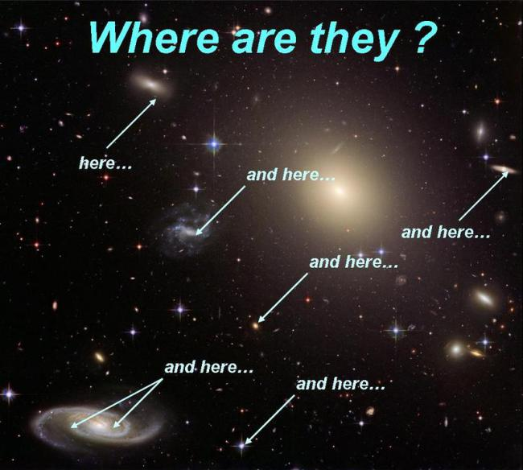

## Possible conclusion for the paradox:

***Possible Conclusion #1: We are unique in the Universe.***

Note that long times between galaxies means that we only need to be a once-in-a-galaxy accident.

Large fraction of galaxies could have civilizations, and we would not know about it.

***Counterarguments to #1:***

•Life arose too easily on Earth to be unique

•Many other animals are close to our intelligence, so that can’t be unique either.

***Possible Conclusion #2: Civilizations are short lived.***

Assume that there are a million planets in the galaxy which form intelligent life during a 2 billion year period.

But each one is only capable of, or interested in, interstellar communication for a thousand years…how many would be there now?

On average, only one would be communicating at any given time.

***Counterarguments to #2:***

• Colonization of other planets will make a species effectively immortal (no single thing would wipe out).

• We, and presumably aliens, have a strong drive to better technology.

***Possible Conclusion #3: Interstellar travel is too hard! And there is no shortcut!***

Anybody is here now or ever was because no civilization ever developed technology to make visits reasonable.

Even though that may be hundreds or thousands of civilizations in the galaxy, each is confined to their home planet.

No colonization. No artifacts.

Perhaps communications in the future.

As part of this, it could be that resource depletion means that civilizations go through our stage and then have to retreat technologically.

No interest in major expenditure needed to travel between stars.

***Counterarguments to #3***

• Consider how far we have come in the last 100 years.

• Now project 1000 years into future.

• Do you really think such travel will be impossible for us?

***Possible Conclusion #4: Self-replicating machines are impossible!***

The argument is:

If self-replicating machines can exist, then they can spread without worry about the time that it takes.

Once capable of space travel, they can colonize the galaxy.

So why aren’t they here…. Because they don’t exist.

***Counterarguments to #4:***

• But (clunky) versions already exist!

• Development is needed, but with the much better computers of the future, surely this will not be a barrier.

***Possible Conclusion #5: Mature civilizations have no motivation for colonizing other worlds.***

Realistically, interstellar colonization is not a solution to the problems on a planet…It’s too hard to ship many people away…

The economic return of colonization is highly questionable….

The benefit to society is questionable.

So why a world would chose to do it?

***Counterarguments to #5:***

• All we need is one species with colonization impulse.

• If advanced species are common, this becomes very likely.

***Possible Conclusion #6: We live in a Zoo.***

The Zoo hypothesis:

There is an extensive interstellar civilization. Earth is considered too primitive for contact. We have been declared off-limits for now…. Observe but do not allow detection.

Similar idea: we are simply beneath the notice of galaxy-spanning civilizations.

They only need bother with much more advanced species.

***Counterarguments to #6:***

• Again, only takes one to violate contact ban.

• Might think colonizers are more aggressive, too.

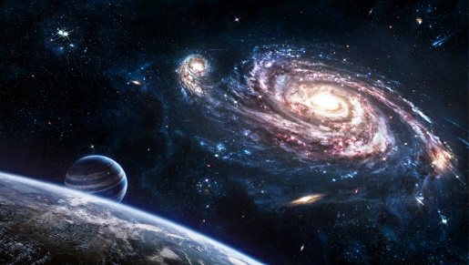

**References:**

**1. M.H. Hart, An Explanation for the Absence of Extraterrestrials on Earth. Q.J.R. Astr. Soc. 16, 128-135 (1975); reprinted in Extraterrestrials: Where Are They?, Michael H. Hart, Ben Zuckerman, eds., Pergammon Press, 1982.**

**2. M.J. Fogg, Temporal Aspects of the Interaction among First Galactic Civilizations: The Interdice Hypothesis. Icarus 69, 370-384 (1987).**

**3. G.D. Brin, The ‘Great Silence’: The Controversy Concerning Extraterrestrial Intelligent Life. Q.J. R. Astr. Soc. 24, 283-309 (1983).**

**4. S. Webb, Where Is Everybody? Fifty Solutions to the Fermi Paradox. (New York, Copernicus Books, 2002).**

**5. G.A. Landis, The Fermi Paradox: An Approach Based on Percolation Theory. Journal of the British Interplanetary Society, London, 51, 163-166 (1998).**

**6. D. Stauffer, A. Aharony, Introduction to Percolation Theory. (2nd ed., Taylor&Francis, 1992**

**7. V.M. Lipunov, God Being Scientifically Discovered, Zemlya i Vselennaya, 1, 37-41, (1995)**

**8. V. Sullivan, We are not alone. (New York, McGraw-Hill Book Co., 1964)**

**9. Drake F.D. “The radio search for intelligent extraterrestrial life” In Current Aspects of Exrtabiology, G. Mamikunian, M.H. Briggs (eds.), (Tech. Rep. 32-428, Jet Propulsion 323346 1965)**

1. Nauka - Service JSC, Moscow, Russia.
2. National Technical University of Ukraine “KPI”, Dep. of General and Theoretical Physics, Kiev, Ukraine.