TITLE OF THE SEMINAR :
The Secret Of Extinction Of The Dinosaurs

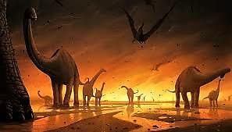
A SEMINAR IN GEOLOGY AND BIOLOGY
PRESENTED BY : ALAA ALKHATEEB
STUDENT FROM : 11TH GRADE
IN : 2015 / 2016
SUPERVISED BY : Mr. MAZEN IBRAHIM
Introduction :
Once upon a time, and during the Earth's history, a group of reptiles is named "dinosaurs" have ruled the planet. Dinosaurs were the largest terrestrial creatures have ever ruled the Earth but from about sixty-five million years ago the dinosaurs died out, along with over than 50% from other creatures all over the world from unknown causes.
SO ;
1)- What was the cause of that mass extinction ?
2)- How did scientists discover dinosaurs and know about their extinction ?
3)-Why did some species survive and dinosaurs didn’t although they were the strongest creatures during that period ?
I will try to answer those questions in this seminar and I hope it will be an exciting research for you…

CHAPTER (1)

DINOSAURS SPECIES AND TIME OF LIFE

"Dinosaurs were reptiles, they were terrestrial; that is, they lived on land. A common characteristic of dinosaurs was that their legs were directly under their bodies, instead of projecting out to the sides like the legs of lizards." (1)
Reptilia
This phylogenetic tree shows the relationships of different groups of organisms to each other.
It also shows that each of birds and dinosaurs are evolutionary stages of Dinosauria .
Diapsid
Dinosauria
Archosauria
Aves

Birds
Most dinosaurs
Crocodiles
Lizards and snakes
Turtles
GRAPH 1

"Dinosaurs were lived in the Mesozoic Era which is divided into Three time periods:
1)- The Triassic period: the oldest, saw the appearance of Earth’s first dinosaurs.
It started at 248 and ended at 206 mya.
2)- The Jurassic period: from 206 to 144 million years ago. It saw the emergence of
massive plant-eating.
3)- The Cretaceous period: this period was ruled by an amazing variety of dinosaurs.
It started at 144 and ended at 65 mya ." (2)
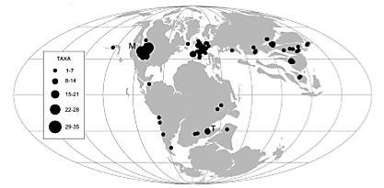

TABLE (1)

FIGURE (1)

"Dinosaurs can be split into two groups, according to their hip bones: the saurischians FIGURE (2) (the lizard-hipped dinosaurs) and the ornithischians FIGURE (3) or bird-hipped dinosaurs.
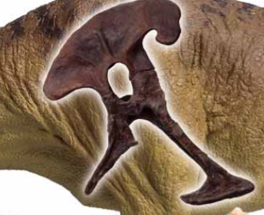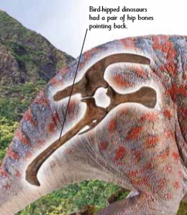
FIGURE (3)
FIGURE (2)

Saurischians :
All meat-eating dinosaurs were lizard- hipped, but some plant-eaters were also lizard-hipped. Saurischians can be divided into two main groups :
1). Theropods, the meat-eaters, such as Dilophosaurus.
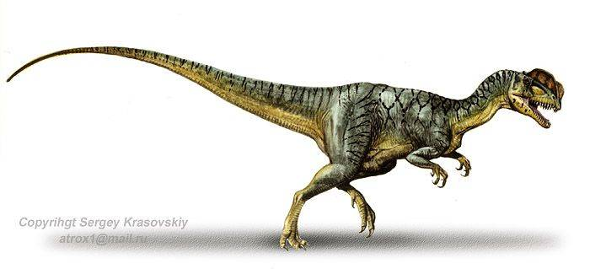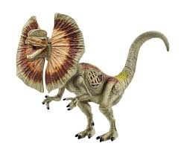
FIGURE (5)

FIGURE (4)

2). Sauropodomorphs, such as Brachiosaurus, with their small heads and long necks.
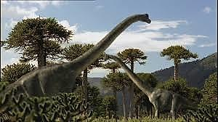
FIGURE (6)

Ornithischians :
These were all plant-eaters. The swept-back bones allowed more room for the digestive organs, and meant their bellies could be carried well back, allowing some to walk or run away from danger on two legs. Ornithischians can be divided into three main groups .
1). Thyreophorans, the four- footed, armour-plated dinosaurs (e.g. stegosaurus ), (FIGURE 7).
2). Marginocephalians, who had heads with bony frills or horns (e.g. Triceratops), (FIGURE 8) .
3). Ornithopods, the two-legged plant-eaters (e.g. Iguanodon), (FIGURE 9) . " (3)
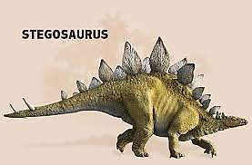
FIGURE (7)

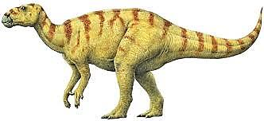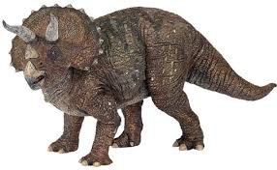
FIGURE (8)

FIGURE (9)

________________________________________________________________
(1)_ "Prehistoric life" p : 2 .
(2)_ "First-children's-encyclopedia" pp : 182_183 .
(3)_ "First-children's-encyclopedia" pp : 185_186 .

CHAPTER (2)

FOSSILS

"Fossils are the remains and evidence of plants and animals that once lived on Earth ." (4)
The importance of fossils :
"Both the geographical distribution of organisms and when organisms lived on Earth can be inferred by examining the fossil record. the geologic time scale is based on evidence in the fossil record and has been shaped by mass extinctions." (5)
The conditions for forming the fossils :
1)- "the body of the fossilized creature should have solid parts like bones and shells cause the loose parts decomposes unless special circumstances encountered help save them if, for example, buried and covered with ice or buried in asphaltic or resins.

2)- the creature have to be buried rapidly, That keeps it from weather effects that work to break up the solid parts and offset unretentive and rapid burial of soft material in the creature as they degrade and wear out due to bacteria." (6)
The ways of fossils formation : There are a lot of ways that formed the fossils, but we will talk about the way that dinosaur's fossils form.
1)- "mineralizing :
It is the most common type of fossils. In some cases, an organism breaks down, leaving a hollow space. This mold may fill with minerals. In other cases, the pores of the organism are filled with minerals, preserving the shape of the organism." ⁽⁷⁾
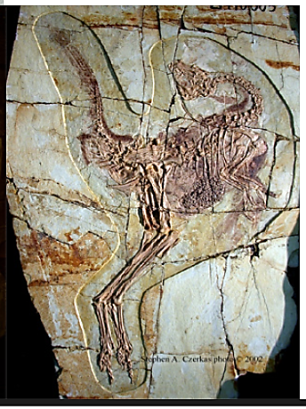
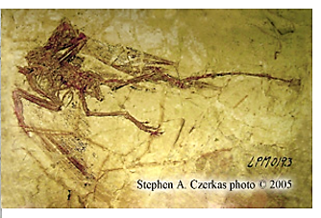

FIGURE (10)
FIGURE (11)

2)- foot prints :
Some animals may leave their feet on the soft sedimentary materials edition, and when this becomes hardened sediment. saves copyright as a kind of fossils.
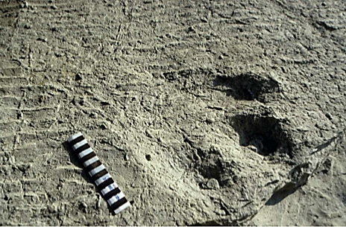
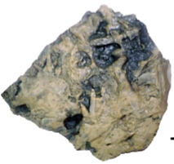

FIGURE (13)
FIGURE (12)
{ PROBLEMS WITH EVALUATING THE FOSSIL RECORD AND }
{ EXTINCTIONS }
"A. Data base is too small.
1). Fossil record is incomplete. The vast majority of past organisms in the biosphere were rarely preserved.
2). Fossilization process is selective, favoring certain circumstances and habitats. Inclusions in amber are based in that they selected small organisms that frequent habitats associated with resin-producing trees. Permineralized fossils occurred in areas where sediment could have inundated them. Large bones were more apt to be preserved than small ones. Organisms with hard structures such as shells and teeth are more frequently represented than soft-bodied creatures.
3). Fossil record is not continuous, leaving large gaps and often resulting in the sudden appearance of lineages previously thought to be extinct (Lazarus effect). Very few sites are currently known to span the K/T boundary, and even these have discontinuities.
4). At fossil sites, the absence of an organism does not mean that it was not present. Nor does the presence of a fossil tell you more than that a lineage was present at a particular time and place. A single fossil provides no information about the global distribution, how long the lineage survived, or when it became extinct. The apparent absence from one location does not preclude survival elsewhere. Accordingly, it is impossible to evaluate extinctions with negative data.
5). Cretaceous fossil sites are not distributed uniformly, so determining global patterns of various lineages is very difﬁcult.
6). Rare species may not be represented at all at some sites, but that doesn’t mean they were not present.
B. Data may be ﬂawed.
1). Dating of fossils is often indirect, so their ages and the actual timing of some extinctions may be erroneous.
2). Many fossils are redposited from older strata into younger beds, thereby confusing the record (Zombie effect).
3). As you approach extinction boundaries, the volume of rock available for sampling often decreases, thus lowering the chances of ﬁnding a particular fossil (Signor-Lipps effect).
C. Human factors.
1). There appear to be strong biases operating in the identiﬁcation of fossils and the evaluation of extinctions, and with such a small database, interpretations can be motivated by prejudice.
2). Because there is no immediate urgency to resolve the issue of K/T extinctions, effort should be made to determine whether extinctions of various groups were abrupt or gradual, rather than supporting a cause.
D. Inherent scientiﬁc difﬁculties.
1). Interpretation of fossils is based on inferences gathered from scientiﬁc knowledge representing only a few hundred years of human experience. Mistakes are probable because our current database may be ﬂawed and is certainly incomplete.
2). Aseemingly small ecological change, such as a slight global warming or cooling, could have far-reaching biological consequences both regionally and globally, while a dramatic event such as a meteor impact could be signiﬁcantly less important because of the unpredictability of its consequences.
3). Extinctions may be random, but random events can occur in clusters.
4). Species have different degrees of importance in biological systems. The extinction of a keystone species may have a cascade effect and result in secondary extinctions that are a direct corollary but unrelated to the cause of the original extinction.
5). Species longevity differs. Species with short longevity spans that may have become extinct under normal circumstances cannot be distinguished from those that may have survived longer if an extinction event had not occurred. These short-lived species skew the interpretation of extinctions." (8)

________________________________________________________________
(4)_ "Earth science geology, the environment, and the universe" p : 648 .
(5)_ "Science" p : 462 .
(6)_ "علم الأحياء والأرض" p : 127 .
(7)_ "Science" p : 451 .
(8)_ "What bugged the dinosaurs? Insects, disease, and death in the Cretaceous" pp : 221_223 .

CHAPTER (3)

THE MASS EXTINCTION

"An extinction event is a time in the Earth’s history when many living organisms die off. Species are always going extinct, but it happens much more quickly during an extinction event." ⁽⁹⁾
There were 5 mass extinctions during the whole Earth's history which are shown in CHART (1) .
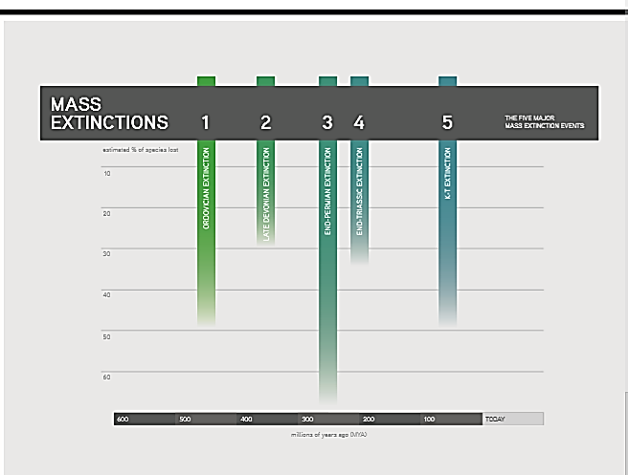

CHART (1)

The extinct organisms :
Before we talk about the extinct organisms we have to know some new definitions :
1). "Amniota : Taxon of vertebrates including mammals and reptiles (including birds).
2). Ectotherm : Animals that produce their heat from external sources such as the sun .
3). Endotherm : Animals that produce their heat internally through metabolic means.
Chances of survival were much lower if you were a large, terrestrial, amniotic endotherm rather than a small, freshwater, anamniotic ectotherm ." ⁽¹⁰⁾
We will know why the all that is true after we acquaint about the cause(s) of the KT extinction .
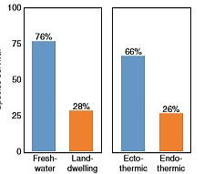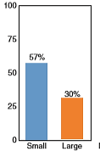

CHART (2)
Theories of extinction

_ _ _ _ _ _ _ _ _ _ _ _ _ _ _ _ _ _ _ _ _ _
• The theories ( 2, 3, 4 ) will be tested by using the vertebrate record (fossils).
1). The supernovae theory :

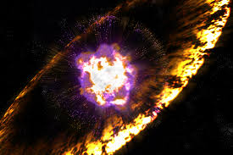
FIGURE (14)

"These colossal stellar explosions radiate as much energy as about ten billion suns, or as much as all the stars in a galaxy combined. Terrestrial environments could be affected at distance of up to one hundred light years. Several lines of astrophysical evidence suggest these explosions occur at a rate of about one every fifty years per galaxy, showing some association with spiral arms. This translates into an average of one supernova within 50 light years of the Earth every 70 million years. At a distance of 50 light years the stresses exerted on the biosphere by a nearby supernova would not be instantaneous. An initial burst of electro-magnetic radiation would be injected into the atmosphere over an interval of a few hours. It would be followed in three to thirty years by an intense flux of cosmic rays at the leading edge of a relativistic blast wave. High levels of background radiation ( ~ 300 r) would persist for about 10 years. Some 3,000 to 30,000 years later, the Earth would be immersed in the expanding shell of the supernova remnant, implying radiation doses of about ten roentgen per year for thousands of years. The effects of the initial electromagnetic wave and the following pulse of cosmic radiation might be correlated respectively with disturbances in plant communities and the extermination of the dinosaurs. Presumably the damage sustained by the ozone layer in the wake of the cosmic ray blast would be somewhat less effective, biologically, due to the previous elimination of UV sensitive forms when the layer was disrupted by the initial wave of electromagnetic radiation. There is as yet no compelling astrophysical evidence for a 65 million year old supernova remnant near the solar system, but it is rather unlikely that one would have remained over such a great length of time."(11) "To further test the supernova hypothesis, the team reasoned out what other lines of evidence might be relevant. Luis Alvarez realized that if a supernova had actually occurred, it would have also released plutonium-244, which would have accumulated alongside the iridium at the KT boundary. Excited about the possibility of the supernova discovery (strong evidence that the dinosaurs had been killed off by an imploding star would have made worldwide headlines), the team decided to perform the difficult plutonium tests. When Helen Michel and Frank Asaro came back with the test results, they were elated to have discovered the telltale plutonium!. But double-checking their results by replicating the analysis led to disap- pointment: their first sample had been contaminated by an experiment going on in a nearby lab—there was no plutonium in the sample at all, contradicting the supernova hypothesis The team came up with the idea of an asteroid impact which would explain the iridium (since asteroids contain much more iridium than the Earth’s crust) and the lack of plutonium." (12)

2). The asteroid impact theory :
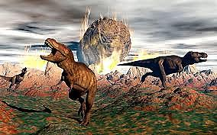
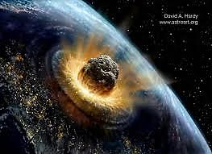

FIGURE (15)
FIGURE (16)

"Evidence has been growing that the mass extinction at the end of the Cretaceous which marked the end of the dinosaurs–was caused by a giant meteor impact. An asteroid 10–12 km in diameter collided with the Earth at a site on the Yucatan Peninsular of Mexico."(13) "Such an impact would have blown 25 trillion metric tons of rock and sediment high into the atmosphere. The crater, now buried beneath a kilometre of limestone, is called Chicxulub."(14) "Most major groups of organisms were devastated and all known species of dinosaurs, pterosaurs, ammonites, mosasaurs, and plesiosaurs become extinct."(13) "During the late Cretaceous, the Yucatan Peninsular was a shallow sea, so the meteor probably landed in less than 100m of seawater. The impact triggered a submarine earthquake, which generated a tidal wave 100 m high, which ﬂooded coastlines halfway across the world. The meteor punched through the Earth’s crust, ejecting hundreds of cubic kilometres of dust high into the atmosphere. Everything within a radius of several hundred kilometres was incinerated by the ﬁreball, and the dust covered the entire Earth for months."(14) "This blockage greatly reduced or possibly stopped photosynthesis. Many individual plants would have been stunted or killed, and many plant species would have become extinct. Herbivorous dinosaurs and other vertebrates that fed upon these plants would have disappeared, which in turn would have caused the extinction of the carnivorous dinosaurs that fed upon the herbivores. This process appears to have taken only a few thousand years at the most."(15) "The excavated crater was 15–20 km deep and about 200 km in diameter. The impact caused an earthquake of magnitude 12 to 13."(14) "Soot and charcoal, which are evidence of widespread fires, are also common in the sediments."(13) "Over 70% of species were made extinct by the Yucatan impact. Some people estimate that 99% of individuals were killed, even in species which survived. An increase in the element iridium at the Cretaceous/Tertiary (K/T) boundary. A high level of iridium found in rocks from this time period in many places on the Earth is a strong indication of an extraterrestrial source for the iridium, such as from an asteroid striking the Earth. Iridium, a very heavy element, like gold, is rare at the surface of the Earth_"but is relatively common In meteorites and asteroids" (13)_ except where concentrated in a small area by very deep volcanoes."(14) "We can start testing the asteroid impact theory by examining the effects of such possibly related events as acid rain, sharp temperature decrease, and global wildﬁre.
a) We know from work on living species and habitats that among vertebrates, acid rain hurts aquatic organisms most, killing both adults and eggs laid in the water. Among the aquatic organisms, however, only sharks and their relatives show very high levels of extinction. Other aquatic species did very well through the K/T transition, thus acid rain was probably not a major factor.
b) If a sharp drop in temperature had occurred, the species that should have been most affected would have been cold-blooded (ectothermic) vertebrates that spend at least part of their time out of water this is why today we see far fewer species of amphibians and reptiles (except warm-blooded or endothermic birds) in the far northern and far southern regions of the world. Yet, most of these ectotherms, except lizards, did well through the K/T boundary. Whether dinosaurs should be considered as endotherms, ectotherms, or as having another kind of physiology remains controversial.
c) Finally, a global wildﬁre is argued to have consumed 25 percent of all above ground burnable material. Geological evidence for wildﬁre has been presented based on large amounts of carbon and other compounds occurring at the K/T boundary. Some paleontologists argue that such a global wildﬁre would have transported great quantities of detritus (very small fragments of plant and animals) into the streams, which would have favored the survival of aquatic animals that eat such material. Other scientists argue that a global wildﬁre would have been an equal opportunity killer: terrestrial creatures would have been burned on land, and aquatic vertebrates would have suffocated from all the burned material dumped into their environments. Thus, depending upon how the fossil information is interpreted, global wildﬁre could have been either a signiﬁcant or unimportant event at the K/T boundary." (15)

3). The Deccan Traps theory :
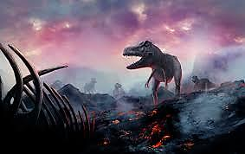
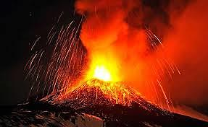

FIGURE (17)
FIGURE (18)

"Massive eruptions of ﬂood basalts on the Indian subcontinent, called the Deccan Traps, occurred at the time of the K-T boundary. Flood basalts ﬂow from great ﬁssures and volcanoes with moderate amounts of explosive power. They are more like the lava ﬂows of the Hawaiian Islands than the explosive eruption of Mount St. Helens, which literally blew the mountain apart. However, the Deccan Traps erupted over four or more million years and produced enough lava to cover both Alaska and Texas to a depth of 2000 ft (610 m). The effects of such massive volcanism have not been as well studied as the effects proposed in other extinction theories. It is clear, however, that such eruptions would greatly increase the amount of very ﬁne-grained material in the atmosphere. This “dust” would decrease the amount of sunlight reaching the Earth’s surface, which would in turn lead to long-term global cooling. Both cooling and a decrease of sun reaching the Earth’s surface would, over this long time interval, change the vegetation and thus, affect the animals feeding upon it." (15) If the Deccan Traps have erupted, they would have caused global wildﬁres and sharp decreasing in the temperature for long time. "Whether this is a necessary correlate remains to be seen, but others have argued that the physical evidence does not support the occurrence of a global wildﬁre at the K/T boundary." (16) And we explain about both the possibility of existing a global wildfire and the sharp drop in temperature in the KT boundary while testing the asteroid impact theory in page 15.

4). The marine regression theory :
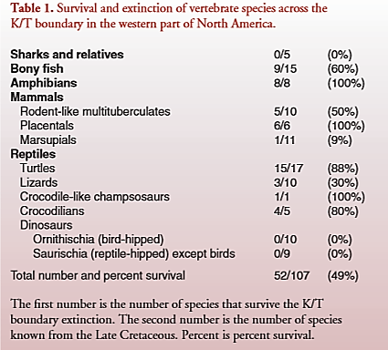

TABLE (2)

"This theory relates extinction to marine regression, which is the process whereby very shallow seas that covered much of the low-lying areas of continents drain away, back into the deeper ocean basins. One of the greatest such marine regressions is recorded in rocks near the end of the Cretaceous Period, some 65 mya. Unlike the eruption of the Deccan Traps, which took place over millions of years, the terminal Cretaceous marine regression occurred over a much shorter period of time, only tens or hundreds of thousands of years. Estimates suggest that 11.2 million square miles of land were exposed during this interval, more than twice the next largest such addition of land during the past 250 million years. The landmass that was exposed is approximately equal to the area of modern day Africa. As these continent-sized shallow seas drained away, great areas of low, coastal habitat were fragmented into smaller and more isolated areas. As these habitats for terrestrial coastal species shrank and became more distant from one another, population sizes would have decreased. Furthermore, as land emerged from the sea, land bridges were exposed, such as the Bering land bridge between Asia and North America. This new land would allow migration of terrestrial vertebrates and the potential for increased competition among previously separated species. River systems that had once ﬂowed over relatively short distances grew in length as the shoreline receded further and further and provided greater habitat for many fresh water organisms. As new land areas were exposed with the regression of the great interior seaways, the climate cooled and climatic extremes increased, further stressing an already stressed environment.
Testing the theory :
Global marine regression began in the last few million years of the Cretaceous. As this occurred, tremendous new tracts of dry land were added. Dinosaurs may well have lived away from the seacoast near the end of the Cretaceous, but their habitats would not have been affected. The well-known dinosaur bearing vertebrate localities near the K/T boundary, however, come from coastal plain habitats. Thus, it is from this information that we should draw our inferences of what may have occurred. As indicated in TABLE (2), the fossil record shows a 0 percent survival for both dinosaurs and sharks and their relatives. With marine regression, the coastal plain habitats were being drastically reduced, stranding dinosaurs in ever-smaller areas this is similar to what humans are doing to the habitats of large mammals in Africa today. The loss of habitat stressed the dinosaur populations, setting them up for any other biotic insults such as that from even a small asteroid impact or from massive volcanism. At the same time, the coastlines were retreating away from the Western Interior taking the sharks and relatives with them. Sharks could follow freshwater courses up to a few hundreds of miles or kilometers, but not thousands of miles or kilometers. Their marine connections were severed. Much larger and longer rivers replaced the small coastal streams, which continued to support many species of freshwater ﬁsh, turtles, amphibians, and crocodilians. This too is supported by the evidence shown in TABLE (2). In fact, freshwater species did very well, with descendants such as paddleﬁsh, sturgeon, gar, snapping turtles, and alligators still plying the Missouri-Mississippi river systems. The lowering of sea level reconnected once separated landmasses, such as eastern Asia and western North America. The fossil record shows that the earliest relatives of what would later evolve into hoofed mammals and whales probably reached North America at this time (65 mya) their possible ancestors being placental mammals known in Asia 20 million years earlier. These new North American placental mammals had teeth that resembled those of the opossum-like marsupials living in North America at this same time. The marsupials arose in North America over 100 mya and were very common for at least the 20 million years leading up to the K/T boundary 65 mya. It seems likely that the appearance of these new placental mammals in North America spelled competitive doom for the marsupials. Interestingly, when both groups appear in South America a few million years after the K/T boundary, they do not compete. Rather, the placentals became more strictly herbivorous, while the marsupials became omnivorous and carnivorous, including large saber-toothed marsupial cats. The one group whose fossil record cannot be explained by marine regression is the lizards, which underwent a drastic reduction, at least in western North America. A possible explanation is that when the climate became wetter in this area following the K/T boundary, the more dry-adapted lizards could not tolerate the changes." (15)

5). The Continental Collisions :
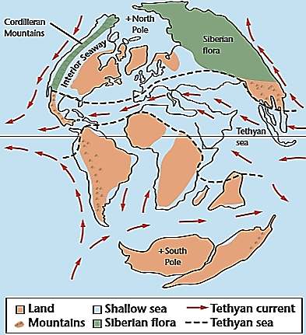

FIGURE (19)
"While the final breakup of Pangaea, the Continental Collisions occurred during the Cenozoic, plate tectonic also brought continents together during this time. The spectacular result of one such collision is the Himalayan Mountains. India traveled north and collided with the southern margin of Asia. The force of this tremendous continent-to-continent collision resulted in the formation of the Himalayan Mountains, which contain the point of highest elevation on Earth, Mt. Everest. The rocks at the top of Mt. Everest are Ordovician marine limestones. Tectonic forces have pushed what was the seafloor during the Ordovician to the top of the world! Africa also drifted north after the breakup of Pangaea and collided with the connected collision landmass of Europe and Asia, or Eurasia. This continent-to-continent collision formed the Alps. Before Africa collided with Eurasia, a narrow sea called the Tethys Sea separated the two continent, as shown in FIGURE (19) ."(17) "An important that occurred during the Mesozoic Era was the breakup of Pangaea. Because heat causes solid object to expand, the heat coming from within Earth beneath Pangaea caused the continent to expand. By the Late Triassic, the brittle lithosphere of Pangaea and cracked and broken apart. As some of the large cracks, or rifts, widened and as the landmass spread apart, the ocean flooded the rift valleys. This resulted in the formation of new oceans that divided the newly separated continents. The breakup of Pangaea resulted in the formation of the Atlantic Ocean. As North America rifted away from Europe and Africa, some of the spreading areas joined together to form a long, continuous rift system called the Mid-Atlantic Ridge.
Active tectonism in western North America :
In contrast to the passive margin that existed along eastern North America during the Mesozoic, the active subduction along the western coast continued through the Middle Triassic. Geologists refer to the mountain ranges that formed in western North America during this time as the Cordillera, which means "mountain range" in Spanish. Deformation along the western margin of North America increased substantially when Pangaea broke apart. Three major episodes of orogenies-mountain building-occurred along the western margin of North America during the Mesozoic. Different types of deformation occurred during each of these orogenies. The oldest orogeny was characterized by a tremendous number of igneous intrusions. Large bodies of granite called batholiths exist throughout the cordillera. The spectacular exposure of Half-Dome at Yosemite National Park was intruded during this orogeny. The next orogeny was characterized by low-angle thrust faulting and folding. This was caused by collisional tectonism along the western margin of North America. This type of deformation began in the Late Jurassic and continued through the Late Cretaceous. The thrust faults run north-south and place older rocks on top of younger rocks in Utah, Idaho, Wyoming, western Canada, and Montana, show in FIGURE (20)
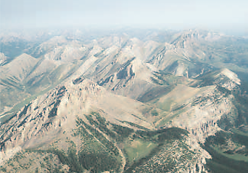

FIGURE (20)

Seaways and sand dunes :
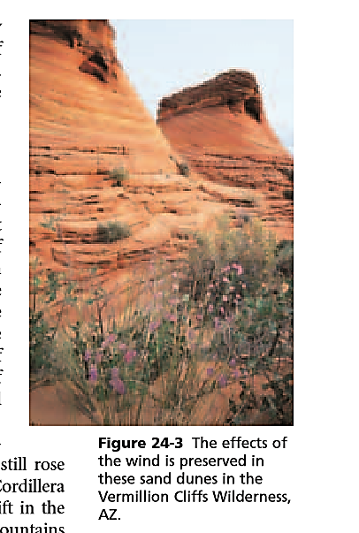
Throughout the Early and Middle Triassic, the supercontinent Pangaea and a single global
ocean defined Earth's paleogeography. As Pangaea began to split apart, numerous rift basins
formed in eastern North America, and large blocks of crust collapsed to form deep valleys. The
Triassic ended with a rapid drop in sea level that caused sedimentation in the western United
States to change dramatically during the Late Triassic and Early Jurassic. Western North America
become much more arid, and it was covered by a thick blanket of sand. Strong winds shaped
the sand into dunes. Evidence of this ancient desert is preserved in large-scale, cross-bedded sandstone deposits some of which are shown in FIGURE (21). Sea level rose again in the Jurassic, and a shallow sea covered central
North America. The Appalachian Mountains still rose high in the east, and the newly formed
mountains of the Cordillera rose high in the west. As the mountains continued to uplift in the
west, large river systems transported sediments from the mountains into the sea. The deposits
of the Late Jurassic river systems are preserved today as multicolored sandstones, siltstones, an
mudstones. They are well known for large numbers of dinosaurs fossils. The ocean continued
to rise onto North America during the Cretaceous Period, and the Gulf of Mexico flooded the
entire southeastern margin of North America. As a result, a sea covered the interior of North
America from Texas to Alaska."⁽¹⁸⁾ "Volcanism is generally active as long as the fault is active"⁽¹⁹⁾.
Although the Continental Collisions occurred a huge destruction, form the Terrible earthquake
to the large sandstorms, may there were more than a tectonic formation during the Mesozoic
Era. The first continental formation was from about 150 mya. Pangaea separated into two major
Parts (Lurasia and Gondwana), FIGURE (22) . The second one was from about 100 mya. Gondwana separated
FIGURE (21)
onto four major parts (Africa, South America, North America, Australia+Antarctica), FIGURE (23) .
• The main role of extinction is : "Extinction of a widespread species, or a widespread group of species, requires an environmental shock (physical or biological) which is not normally encountered during the geological life spans of such species or groups, and the shock must be applied rapidly enough over a broad geographic area to prevent adaptation by natural selection or escape by migration. If the most effective extinction mechanisms are beyond the experience of the victims, a high degree of apparent randomness should be expected. Survivors are most likely to be those organisms which are fortuitously preadapted to an "unexpected" stress."⁽²⁰⁾ The Continental Collision theory throw down some questions like : why did dinosaurs extinct from the continental collision from about 65 mya and not from the other collisions from about 150 and 100 mya?. Another countermanding is that the continental formations took long time to form and their effects weren't neither applied rapidly nor struck surprisingly and that dissimilates the main role of extinction, but it may were a cause for another more important event which is the volcanic eruption.
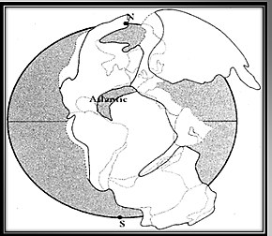
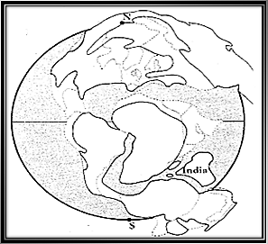

FIGURE (22)

FIGURE (23)

____________________________________________________________________________________________________________________________________________
(9)- "Extinction level events", p : 3.
(10)- "Dinosaurs, extinction theories for", p : 1.
(11)- "The enigma of the extinction of the dinosaurs", p : 175.
(12)- "Asteroids and dinosaurs : unexpected twist and an unfinished story", p : 4.
(13)- "Earth science geology, the environment, and the universe", pp : 633-634.
(14)- "Rocket in Space", pp : 92, 96-98.
(15)- "Dinosaurs Extinction, Changing Views", pp : 103-105.
(16)- "Dinosaurs extinction theories for", p : 3.
(17)- "Earth science geology, the environment, and the universe", p : 638.
(18)- "Earth science geology, the environment, and the universe", pp : 624-626.
(19)- "Sudden extinction of the dinosaurs : Latest Cretaceous, upper great plains", p : 839.
(20)- "The role of extinction in evolution", p : 6762.

Conclusions and recommendations :
When using the vertebrate fossil record to test the various theories of dinosaur extinction, it appears that marine regression explains more of the highly selective pattern of extinctions and survivals through the K/T transition than do either an asteroid impact or massive volcanism. When combined with evidence from plants and marine species, it appears that marine regression, an asteroid impact, and massive volcanism each probably played a signiﬁcant role in what is the best known mass extinction in Earth’s history, cause the catastrophes which happened on land were in India and in southeastern of North America beside of Europe, and have attacked the biggest numbers of dinosaurs existed on Earth, and that explain both of the extinction of some marine organisms and the complete extinction of dinosaurs. The terrestrial organisms found hard to survive may because the majority of the destruction generated by that mass extinction were on land (volcanism eruption and meteor impact) but the freshwater organisms could be protected much more than terrestrial one by diving deeply in the oceans. Large animals like big dinosaurs need a big amount of food to survive and during the mass extinction, there were trophic catastrophes affect on organisms especially on large one so that small animals have had more chance to survive than large one, and with the same cause, endothermic animals used to survive much more than the ectothermic organisms did. The three main causes of the KT mass extinction may weren't the only causes for that extinction and scientists find hard to explore more about them cause of the problems with evaluating the fossils record that we talked about in fossils chapter of this seminar so that, no of the question above would be answered rightly and completely until these causes being known.
And finally, I recommend by continuing the researches in this field to finally reveal the secret of the extinction of the dinosaurs and then to answer most of the questions about them.

Figures Index
CITATION SITE | DESCRIPTION | PAGE | FIGURE
Late Jurassic climates, vegetation, and dinosaur distributions | The distribution of dinosaurs on Earth | 4 | FIGURE (1)
First children's encyclopedia | The hip bones of Saurischian dinosaurs | 5 | FIGURE (2)
First children's encyclopedia | The hip bones of Ornithischain dinosaurs | 5 | FIGURE (3)
A gallery of dinosaurs and other early reptiles | Dilophosaurus dinosaur | 5 | FIGURE (4)
A gallery of dinosaurs and other early reptiles | Dilophosaurus dinosaur | 5 | FIGURE (5)
A gallery of dinosaurs and other early reptiles | Brachiosaurus dinosaur | 5 | FIGURE (6)
A gallery of dinosaurs and other early reptiles | Stegosaurus  Dinosaur | 6 | FIGURE (7)
A gallery of dinosaurs and other early reptiles | Triceratops  Dinosaur | 6 | FIGURE (8)
A gallery of dinosaurs and other early reptiles | Iguanodon  Dinosaur | 6 | FIGURE (9)
Feathered dinosaurs and the origin of flight | Fossils for an Archaeopteryx dinosaur | 8 | FIGURE (10)
Feathered dinosaurs and the origin of flight | Fossils for a Caudipteryx dinosaur | 8 | FIGURE (11)
A gallery of dinosaurs and other early reptiles | Theropod footprints at Praiada Corva | 9 | FIGURE (12)
Dinosaurs of Portugal | Ornithischain footprint at Porto Escada | 9 | FIGURE (13)
Supernovae and the extinction of the dinosaurs | A supernovae explosion | 13 | FIGURE (14)
A gallery of dinosaurs and other early reptiles | An asteroid impact kills dinosaurs | 14 | FIGURE (15)
A gallery of dinosaurs and other early reptiles | An asteroid impact the Earth | 14 | FIGURE (16)
A gallery of dinosaurs and other early reptiles | A volcanic eruption burns up dinosaurs | 15 | FIGURE (17)
A gallery of dinosaurs and other early reptiles | A volcano erupt lavas | 15 | FIGURE (18)
Earth science geology, the environment, and the universe | Earth's form from about 65 mya | 18 | FIGURE (19)
Earth science geology, the environment, and the universe | A Paleozoic limestones in the Sawtooth Mountain which were thrust eastward during the second Mesozoic oregeny | 19 | FIGURE (20)
Earth science geology, the environment, and the universe | A sand dunes place in the Vermillion Cliffs wilderness where the effects of the wind is preserved in | 20 | FIGURE (21)
Proposal on dinosaurs extinction | Earth's form from about 100 mya | 20 | FIGURE (22)
Proposal on dinosaurs extinction | Earth's form from about 150 mya | 20 | FIGURE (23)

(Graphs, Tables, Charts) Index

CITATION SITE | DESCRIPTION | PAGE | GRAPH, TABLE, CHART
Extinction level events | The five major mass extinction events | 12 | CHART (1)
Dinosaurs, extinction theories for | Differential patterns of vertebrate species survival at the KT boundary | 12 | CHART (2)
Evolution and the fossils record | The Earth's historical eras | 4 | TABLE (1)
Dinosaurs extinction : changing views | Survival and extinction of vertebrate species across the KT boundary in the western port of North America |  | TABLE (2)
Science | The relationship of different groups of organisms to each other | 4 | GRAPH (1)

English references

- Understanding Science how Science really work. 2007. Asteroids and dinosaurs : unexpected twists and an unfinished story. The University of California, Museum of Paleontology, California.
Available online at : (www.understandingscience.org).
- C.J. Hawkesworth, & PA.I.S. Kemp. 2006. Evolution of the continental crust. Nature, Vol. 443, doi : 10.1038/ nature 05191. Nature Publishing Group. pp : 811-817 .
- Center for Informal Science Education, Florida Museum of Natural History. Prehistoric life. Marvelous Explorations through Science and Stories. MESS.
- Centre for Continuing Education. 2014. Rocks in space asteroids, comets and meteors (Lecture 5). Modern astronomy: voyage to the planets. University of Sydney, Sydney .
- Chirag Shah, Viren Amin, & Harit Desai. 1997. Proposal on Dinosaur Extinction .
- Cynthia Stokes Brown. Extinction level events. Newsela, The Lexile Framework for Reading .
- D.A. Russell. 1979. The enigma of the extinction of the dinosaurs. Ann. Rev. Earth Planet. Sci. pp : 163-182 .
- David E. Fastovsky, & Peter M. Sheehan. 2005. The extinction of the dinosaurs in North America. GSA Today: v. 15, no. 3, doi: 10:1130/1052-5173 . pp : 1-10 .
- David M. Raup. 1994. The role of extinction in evolution. Proc. Nati. Acad. Sci. USA Vol. 91, pp : 6758-6763 .
- David Peters. 1989. A gallery of dinosaurs and other early reptiles. first edition. A. Knopf, New York .
- George Poinar .J.R., & Roberta Poinar. 2008. What bugged the dinosaurs ? insects, disease, and death in the Cretaceous. Princeton University Press, New Jersey .
- Glencoe McGraw-Hill. 2004. The Mesozoic and Cenozoic eras. Earth science geology, the environment, and the universe. pp : 624-651.
- Haraldur Sigurdsson (ed), Bruce F. Houghton (ed), Stephen R. Mcnutt (ed), & others. Encyclopedia of volcanoes. Academic Press, San Diego .
- Harcourt School. 2006. Science. Harcourt School Publishers, Orlando .
- J. David Archibald, & Norman MacLeod. 2007. Dinosaurs extinction theories for. J. David Archibald, & Norman MacLeod. Encyclopedia of biodiversity. Elsevier. pp : 1-9 .
- J. David Archibald. 1996. Dinosaurs extinction : changing views. Dinosaurs : the science behind the story. Columbia University Press, Columbia. pp : 99–106 .
- John Pojeta, Jr. & Dale A. Springing. 2001. Evolution and the fossils record. American Geological Institute, Alexandria .
- Luis W. Alvarez. 1983. Experimental evidence that an asteroid impact led to the extinction of many species 65 million years ago. Proc. Natl. Acad. Sci. USA, Vol. 80. pp : 627-642 .
- M.T. Antunes, O. Mateus, & C.R. Palevol. 2003. Dinosaurs of Portugal. Editions Scientifiques Et Medicals SAS. pp : 77–95.
Available online at : (www.sciencedirect.com) .
- P. McAllister Rees, Christopher R. Noto, J. Michael Parrish, & Judith T. Parrish. 2004. Late Jurassic climates, vegetation, and dinosaur distributions. The Journal of Geology, Vol. 112. pp : 643-653. The University of Chicago, Chicago .
- Penny Smith (ed), Lorie Mack (ed), Caroline Stam (ed), & Lee Wilson (ed). 2010. First children's encyclopedia . first edition. Darling Kindersley Limited, London .
- Peter M. Sheehan, David E. Fastovsky, Raymond G. Hoffmann, & others. 2006. Sudden extinction of the dinosaurs : latest Cretaceous, upper great plains, U.S.A. Science, New Series, Vol. 254, No. 5033. pp : 835-839. American Association for the Advancement of Science .
- Russell, D.A., & W. Tucker. 1971. Supernovae and the extinction of the dinosaurs. Nature 229. pp : 553–554. Nature Publishing Group.
- Yinxian Li, Stephen Czercas, Sylvia Czercas, & Jinglu Li. 2005. Feathered dinosaurs and the origin of flight. The Dinosaur Museum, Utah., The Fossil Administration Museum, Liaoning., & Beipiao City Paleontological Research Center, Liaoning .

Arabic references

- د. عمر أبو عون, عبد الله علي, و آخرون. 2014-2015. علم الأحياء والأرض / كتاب الطالب / الصف الثامن. المؤسّسة العامّة للطباعة في الجمهورية العربية السورية.

Table of contents

Cover page ……………………………………………………………………………………………………………………………………………………. (1)
Introduction .…………………………………………………………………………………………………………………………………………………. (2)
Chapter (1) : Dinosaurs species and time of life …………………………………………………………………............................... (3)
Time of life ……………………………………………………………………………………………………………………………………..……………….. (4)
Dinosaurs species ………………………………………………………………………………………………………………………………………………. (5)
Chapter (2) : Fossils …………………………………………………………………………………………………………………………..……………. (7)
The importance of fossils …………………………………………………………………………………………………………………………………….. (8)
Conditions and ways of fossils formation ………………………………………………………………………………………………………………… (8)
Problems with evaluating the fossils record and extinction …………………………………………………………………………………………. (9)
Chapter (3) : The mass extinction ………………………………………………………………………………………………………………..... (10)
The five mass extinctions ………………………………………………………………………………………….…..……………………………………. (11)
The extinct organisms …………………………………………………………………………………………………..…………………………………… (11)
Theories of extinction : The supernovae theory ………………………………………………………………………………...……………………. (12)
The asteroid impact theory …………………………………………………………………………………………………………….…………………… (13)
The Deccan Traps theory …………………………………………………………………………………………………………………………………….. (14)
The marine regression theory …………………………………………………………………………………………………………………………….... (14)
The continental collision theory ……………………………………………………………………………………………………….………………….. (16)
Conclusions and recommendations ..………………………………………….………………………………………………………………… (18)
Figures index ……………………………………………………………………………………………………………………………….………………………………….. (19)
(Graphs, Tables, Charts) index ………………………………………………………………………………………………………………………. (21)
References …………………………………………………..……………………………………………………………….……………………………… (21)

