

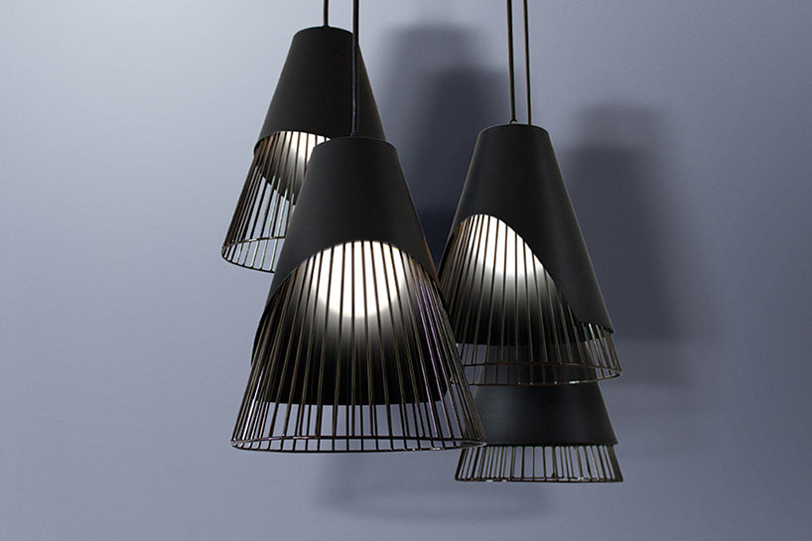

The title of seminar: Conic sections

Presented by: Ali Al-Saleh

Grade: eleventh grade

Under the supervision of: Mr. Mortada Ayyash

Date: 2015-2016

Syrian Arab republic

Ministry of education

National center for the distinguished

Index:

|  |  |  |  |  |
| --- | --- | --- | --- | --- |
|  | Title | | | Page number |
|  | Index | | | 1 |
|  | Photo index | | | 1 |
|  | The inquiry and keywords | | | 3 |
|  | Introduction | | | 4 |
| 1. | The sections of a cone | | | 6 |
| 1.1. | Circular section | | | 6 |
| 1.2. | Elliptical section | | | 6 |
| 1.3. | Parabolic section | | | 6 |
| 1.4. | Hyperbolic section | | | 7 |
| 2. | Definitions of conics and their algebraic equations | | | 7 |
| 2.1. | Circles | | | 7 |
| 2.2. | The Ellipse and Hyperbola | | | 8 |
| 2.2.1. | Ellipses | | | 8 |
| 2.2.2. | Hyperbolas | | | 11 |
| 2.3. | Parabolas | | | 13 |
| 2.3.1. | Reflective Property of the Parabola | | | 16 |
| 2.3.2. | How to make a tangent line for a parabola | | | 17 |
| 3. | Shifted Conics | | | 19 |
|  | Conclusion | | | 19 |
|  | References | | | 20 |
| Figure number | | Page number |
| Figure (1) | | 4 |
| Figure (2) | | 5 |
| Figure (3) | | 5 |
| Figure (4) | | 6 |
| Figure (5) | | 6 |
| Figure (6) | | 6 |
| Figure (7) | | 7 |
| Figure (8) | | 8 |
| Figure (9) | | 8 |
| Figure (10) | | 10 |
| Figure (11) | | 11 |
| Figure (12) | | 11 |
| Figure (13) | | 13 |
| Figure (14) | | 14 |
| Figure (15) | | 14 |
| Figure (16) | | 15 |
| Figure (17) | | 16 |
| Figure (18) | | 16 |
| Figure (19) | | 16 |
| Figure (20) | | 17 |
| Figure (21) | | 18 |

The inquiry(the problem that our research tackles):

How do CONIC SECTIONS(conics) form?

How to describe conics using algebraic equations?

Do they exist in our real life?!?!? if yes, then what

are the applications of conics?

What are Parabolas properties? And how to make a

tangent for a Parabola?

Key words: Conic sections, Parabola, Hyperbola, Ellipse (circular section), degenerate conics.

Introduction:

What are conic sections (conics)?

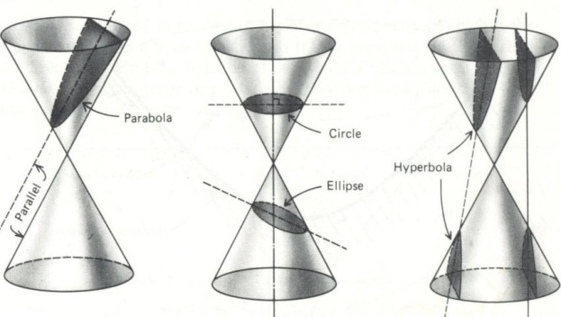CONIC SECTIONS ARE curves that can be obtained by intersecting a double-napped right circular cone with a plane. Our immediate goal is to describe conics using algebraic equations. We then turn to applications of conics, which range from the design of suspension bridges to the design of satellite-signal receiving dishes and to the design of whispering galleries, in which a person standing at one spot in a gallery can hear a whisper coming from another spot in the gallery. The orbits of celestial bodies and human-made satellites can also be described by using conics.

Figure 1

Notice from Figure 1 that in the formation of the four basic conics, the intersecting plane does not pass through the vertex of the cone. When the plane does pass through the vertex, the resulting figure is a **degenerate conic,** as shown in Figure 2.

Figure 2

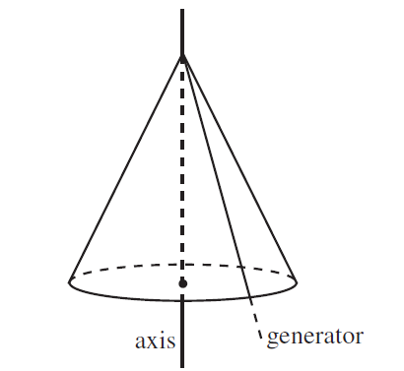In the description below, we shall use diagrams showing just a part of a cone, but you should imagine that the cone extends infinitely far. We shall also talk about the axis of the cone, and a generator. The axis is the central line about which the cone is symmetric. A generator is a line which, when rotated about the axis, sweeps out the cone.

Figure 3

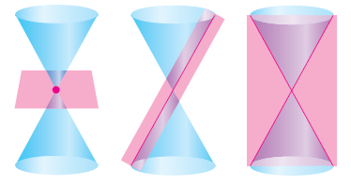Conic sections were discovered during the classical Greek period, which lasted from 600 to 300 B.C. By the beginning of the Alexandrian period, enough was known of conics for Apollonius (262–190 B.C.) to produce an eight-volume work on the subject.

This early Greek study was largely concerned with the geometric properties of conics. It was not until the early seventeenth century that the broad applicability of conics became apparent.

Parametric equations afford a way of describing curves in the plane and in space.

Polar coordinates provide an alternative way of representing points in the plane. Certain curves have simpler representations with polar equations than with rectangular equations.

1. The sections of a cone

If we cut a cone at different angles, then we will obtain different types of conic section. There are four different types we can obtain.

* 1. 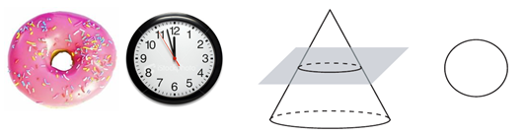First, we can make the obvious cut, Or section, perpendicular to the axis of the cone. This gives us a circle.

Figure 4

* 1. Next, we can make the cut at an angle to the axis of the cone, so that we still get a closed curve which is no longer a circle. This curve is an ellipse.

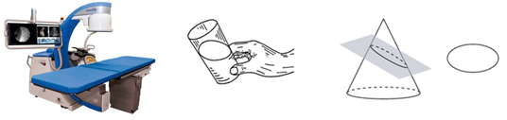

Figure 5

* 1. 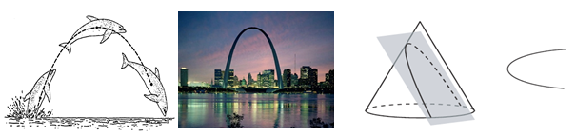If we now make the cut parallel to the generator of the cone, we obtain an open curve. This is a parabola.

Figure 6

* 1. 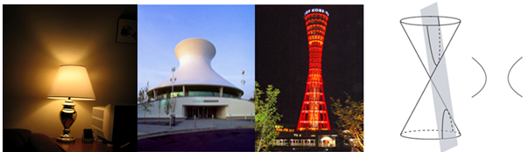Finally, we make the cut at an even steeper angle. If we imagine that we have a double cone, that is, two cones vertex to vertex, then we obtain the two branches of a hyperbola.

Figure 7

The four different types of conic section are:

• the circle, where the cone is cut at right-angles to its axis.

• the ellipse, where the cone is cut at an oblique angle shallower than a generator.

• the parabola, where the cone is cut parallel to a generator.

• the hyperbola, where a double cone is cut at an angle steeper than a generator.

1. Definitions of conics and their algebraic equations[1]
   1. Circles

A circle is defined as the set of all points in a plane that are equidistant from

a fixed point called the center. The fixed distance from the center is called the

radius and is denoted by r, where r<0.

Suppose a circle is centered at the point (*h*, *k*) and has radius, *r* (Figure 8). The distance formula can be used to derive an equation of the circle. Let (*x*, *y*) be any arbitrary point on the circle. Then, by definition, the distance between (*h*, *k*) and (*x*, *y*) must be *r*.

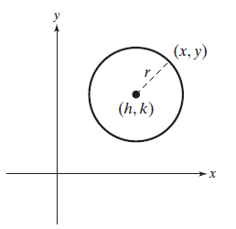**Standard Equation of a Circle**

The **standard equation of a circle**, centered at (*h*, *k*) with radius *r*, is given by ${(x-h)}^{2}+{(y-k)}^{2}=r^{2}$ where r>0

*Note:* If a circle is centered at the origin (0, 0), then h=0 and k=0, and the equation simplifies to $x^{2}+ y^{2}=r^{2}.$

Figure 8

* 1. **The Ellipse and Hyperbola**
     1. **Ellipses**

An **ellipse** is the set of all points (*x*, *y*) such that the sum of the distance between (*x*, *y*) and two distinct points is a constant. The fixed points are called the foci (plural of *focus*) of the ellipse.

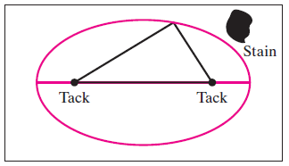To visualize an ellipse, consider the following application. Suppose Sonya wants to cut an elliptical rug from a rectangular rug to avoid a stain made by the family dog. She places two tacks along the center horizontal line. Then she ties the ends of a slack piece of rope to each tack. With the rope pulled tight, she traces out a curve. This curve is an ellipse, and the tacks are located at the foci of the ellipse (Figure 9).

Figure 9

To find an equation for an ellipse, suppose that the ellipse is placed so that its major axis lies along the -axis and its center is at the origin, as shown in Figure 15. Then its foci *F*1 and *F*2 are at the points (-*c*, 0) and (*c*, 0) , respectively. Let the sum of the distances between any point *P*(*x*, *y*) on the ellipse and its foci be

2*a*< 2*c* < 0 . Then, by the definition of an ellipse we have

$$d{\left(P, F1\right)}_{+}d\left(P, F2\right)=2a$$

that is, $\sqrt{{\left(x+ c\right)}^{2}+y^{2}} + \sqrt{{\left(x-c\right)}^{2}+y^{2}}=2a$

or $\sqrt{{\left(x-c\right)}^{2}+y^{2}}=2a$ $-$ $\sqrt{{\left(x+ c\right)}^{2}+y^{2}}$

Squaring both sides of this equation, we obtain

$x^{2} - 2cx + c^{2} + y^{2} = {4a}^{2} - 4a\sqrt{{\left(x+ c\right)}^{2}+y^{2} }+ x^{2} + 2cx + c^{2} + y^{2}$

or, upon simplification, $a\sqrt{{\left(x+ c\right)}^{2}+ y^{2}}$ = $a^{2}+cx$

Squaring both sides again, we have

$a^{2}\left(x^{2}+ 2cx+ c^{2}+ y^{2}\right)= a^{4}+ {2a}^{2}cx+c^{2}x^{2}$

which yields $\left(a^{2}-c^{2}\right)x^{2}+ a^{2}y^{2}=a^{2}(a^{2}-c^{2})$

Recall that a > c , so $a^{2}-{ c}^{2}>0$. Let $b^{2}= a^{2}- c^{2}$ with $b>0$. Then the equation of the ellipse becomes

$$b^{2}x^{2}+a^{2}y^{2} = {a^{2}b}^{2}$$

or, upon dividing both sides by $a^{2}b^{2}$, we obtain

$\frac{x^{2}}{a^{2}}+ \frac{y^{2}}{b^{2}}=1$

By setting y=0 , we obtain $x=±a$, which gives (-*a*, 0) and (*a*, 0) as the vertices

of the ellipse. Similarly, by setting x=0 , we see that the ellipse intersects the

y-axis at the points (0, -*b*) and (0, *b*) . Since the equation remains unchanged if x is

replaced by -x and y is replaced by -y , we see that the ellipse is symmetric with

respect to both axes.

Observe, too, that b<a , since

$$b^{2}= a^{2}- c^{2}<{ a}^{2}$$

So as the name implies, the length of the major axis, 2a , is greater than the length of the minor axis, 2b. Finally, observe that if the foci coincide, then c=0 and a=b, so the ellipse is a circle with radius r=a=b.

Placing the ellipse so that its major axis lies along they-axis and its center is at the origin leads to an equation in which the roles of x and y are reversed. To summarize, we have the following.

**Standard Equation of an Ellipse**

An equation of the ellipse with foci $(±c,0)$ and vertices $\left(±a,0\right)$ is

$$\frac{x^{2}}{a^{2}}+ \frac{y^{2}}{b^{2}}=1 a≥b>0$$

and an equation of the ellipse with foci $\left(0,±c\right)$ and vertices $\left(0,±a\right)$ is

$$\frac{x^{2}}{b^{2}}+\frac{y^{2}}{a^{2}}=1 a≥b>0$$

Where $c^{2}=a^{2}-b^{2}$.

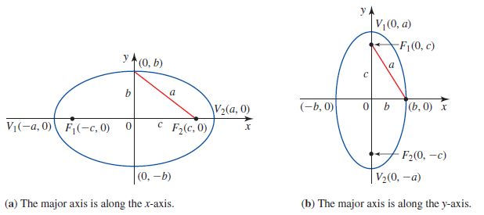

Figure 10

**Note:** An ellipse with center at the origin and foci lying along the x-axis or the y-axis is said to be in **standard position**.

* + 1. **Hyperbolas**

The definition of a hyperbola is similar to that of an ellipse. The *sum* of the distances between the foci and a point on an ellipse is fixed, whereas the *difference* of these distances is fixed for a hyperbola.

DEFINITION

A **hyperbola** is the set of all points in a plane the difference of whose distances

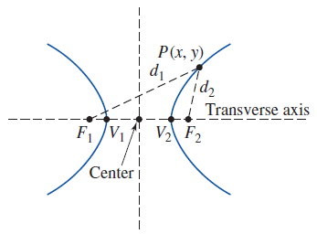from two fixed points (called the **foci**) is a constant.

Figure shows a hyperbola with foci F1 and F2. A point P(x, y) is on the hyperbola if and only if $\left|d1-d2\right|$ is a constant. The line passing through the foci intersects the hyperbola at two points, V1 and V2 , called the **vertices** of the hyperbola.

The line segment joining the vertices is called the **transverse axis** of the hyperbola, and the midpoint of the transverse axis is called the **center** of the hyperbola.

Figure 11

Observe that a hyperbola, in contrast to a parabola or an ellipse, has two separate branches.

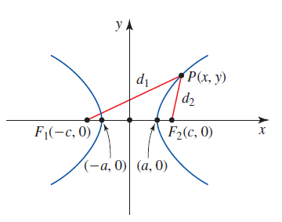The derivation of an equation of a hyperbola is similar to that of an ellipse. Consider, for example, the hyperbola with center at the origin and foci F1(-c, 0) and F2(c, 0) on the x-axis. (See Figure 12.) Using the condition

d(P,F1)-d(P,F2)=2a , where $a$ is a positive constant, it can be shown that if P(x, y) is any point on the hyperbola, then an equation of the hyperbola is $\frac{{ x}^{2}}{ a^{2}}-\frac{y^{2}}{b^{2}}=1$

Figure 12

Where $b= \sqrt{c^{2}-a^{2}}$ or $c= \sqrt{a^{2}+b^{2}}$.

Observe that the x-intercepts of the hyperbola are $x=±a$, giving (-a,0) and (a,0) as its vertices. But there are no y-intercepts, since setting x=0 gives $y^{2}=-b^{2}$, which has no real solution. Also, observe that the hyperbola is symmetric with respect to both axes.

If we solve the equation

$\frac{{ x}^{2}}{ a^{2}}-\frac{y^{2}}{b^{2}}=1$

For y , we obtain

$y= ±\frac{b}{a}\sqrt{x^{2}-a^{2}}$

Since $x^{2}-a^{2}≥0$ or, equivalently, $x≤-a$ or $x≥a$, we see that the hyperbola actually consists of two separate branches, as was noted earlier. Also, observe that if $x$ is large in magnitude, then $x^{2}-a^{2}≈ x^{2}$, so $y=±\left(\frac{b}{a}\right)x$.

This heuristic argument suggests that both branches of the hyperbola approach the slant asymptotes $y=±\left(\frac{b}{a}\right)x$ as $x$ increases or decreases without bound. (See Figure 13.)

Finally, if the foci of a hyperbola are on the y-axis, then by reversing the roles of $x$ and $y$, we obtain

$\frac{{ y}^{2}}{ a^{2}}-\frac{x^{2}}{b^{2}}=1$

as an equation of the hyperbola.

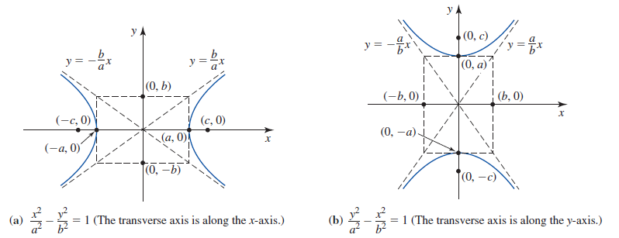**Standard Equation of a Hyperbola**

Figure 13

An equation of the hyperbola with foci $(±c,0)$ and vertices $(±a,0)$ is

$$\frac{{ x}^{2}}{ a^{2}}-\frac{y^{2}}{b^{2}}=1$$

Where $c=\sqrt{a^{2}+b^{2}}$. The hyperbola has asymptotes $y=±\left(\frac{b}{a}\right)x$. An equation

of the hyperbola with foci $(0,±c)$ and vertices $(0,±a)$ is

$$\frac{{ y}^{2}}{ a^{2}}-\frac{x^{2}}{b^{2}}=1$$

Where $c=\sqrt{a^{2}+b^{2}}$. The hyperbola has asymptotes $y=±\left(\frac{a}{b}\right)x$.

The line segment of length 2b joining the points (0,-b) and (0,b) or (-b,0) and (b, 0) is called the **conjugate axis** of the hyperbola.

* 1. **Parabolas**

**DEFINITION**

A **parabola** is the set of all points in a plane that are equidistant from a fixed point (called the **focus**) and a fixed line (called the **directrix**). (See Figure 14.)

By definition the point halfway between the focus and directrix lies on the parabola.

This point *V* is called the **vertex** of the parabola. The line passing through the focus and perpendicular to the directrix is called the **axis** of the parabola.

Observe that the parabola is symmetric with respect to its axis.

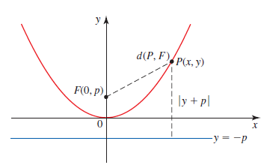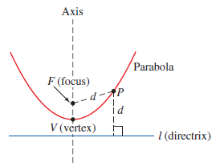

Figure 14

Figure 15

To find an equation of a parabola, suppose that the parabola is placed so that its

vertex is at the origin and its axis is along the y-axis, as shown in Figure 15. Further,

suppose that its focus $F$ is at (0,p), and its directrix is the line with equation $y=- p$.

If P(x, y) is any point on the parabola, then the distance between $P$ and $F$ is

d(P, F) $=\sqrt{x^{2}+{(y-p)}^{2}}$

whereas the distance between $P$ and the directrix is $\left|y+p\right|$. By definition these distances are equal, so

$$\sqrt{x^{2}+{(y-p)}^{2}}= \left|y+p\right|$$

Squaring both sides and simplifying, we obtain

$$x^{2}+{(y-p)}^{2}= {\left|y+p\right|}^{2}= {(y+p)}^{2}$$

$$x^{2}+y^{2}-2py+p^{2}= y^{2}+2py+p^{2}$$

$$x^{2}=4py$$

**Standard Equation of a Parabola**

An equation of the parabola with focus (0, p) and directrix $y=- p$ is

$$x^{2}=4py$$

If we write $a= \frac{1}{(4p)}$, then the standard Equation becomes $y=ax^{2}$. Observe that the parabola opens upward if $P>0$ and opens downward if $P<0$. (See Figure 16.) Also, the parabola is symmetric with respect to the y-axis (that is, the axis of the parabola coincides with the *y*-axis), since the standard Equation remains unchanged if we replace *x* by -*x*.

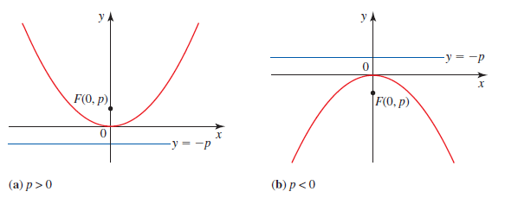

Figure 16

Interchanging $x$ and $y$ in the standard Equation gives

$$y^{2}=4px$$

which is an equation of the parabola with focus F(p,0) and directrix $x=- p$. The parabola opens to the right if $p>0$ and opens to the left if $p<0$. (See Figure 17.) In both cases the axis of the parabola coincides with the *x*-axis.

**Note:** A parabola with vertex at the origin and axis of symmetry lying on the

$x$-axis or $y$-axis is said to be in **standard position.**

* + 1. 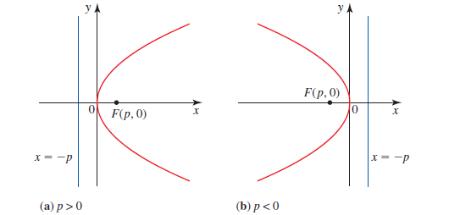**Reflective Property of the Parabola**

Figure 17

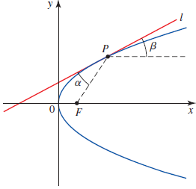Suppose that P is any point on a parabola with focus F , and let $l$ be the tangent line to the parabola at P. (See Figure 18.) The reflective property states that the angle $a$ that lies between $l$ and the line segment FP is equal to the angle $β$ that lies between $l$ and the line passing through P and parallel to the axis of the parabola. This property is the basis for many applications.

Figure 18

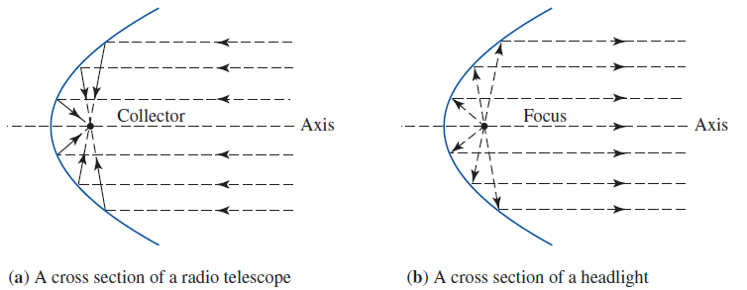As was mentioned earlier, the reflector of a radio telescope has a shape that is obtained by revolving a parabola about its axis. Figure (19a) shows a cross section of such a reflector. A radio wave coming in from a great distance may be assumed to be parallel to the axis of the parabola. This wave will strike the surface of the reflector and be reflected toward the focus F , where a collector is located. (The angle of incidence is equal to the angle of reflection.)

Figure 19

The reflective property of the parabola is also used in the design of headlights of automobiles. Here, a light bulb is placed at the focus of the parabola. A ray of light emanating from the light bulb will strike the surface of the reflector and be reflected outward along a direction parallel to the axis of the parabola (see Figure 19b).

* + 1. **How to make a tangent line for a parabola[2]**

It is sometimes convenient to express both x and y values on the parabola in terms of a third variable t. This variable is called a parameter, and the equations we obtain are called the parametric equations of the parabola.

It makes sense to try to choose how we express x and y in terms of t so that we avoid a square root, and we will do this if we can make 4ax a complete square. Let us take $x = {at}^{2}$. Then $y^{2} = 4ax = 4a^{2}t^{2}$, so that y = 2at, where t can be either positive or negative. As t increases from a large negative value to a large positive value, the point moves along the parabola, passing through the origin when t = 0.

Figure 20

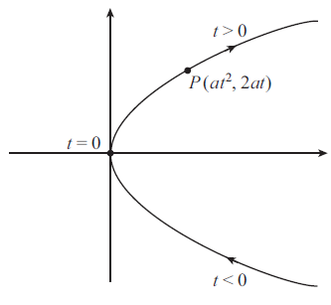The parametric equation of a parabola with directrix x = −a and focus (a, 0) is x = at2 , y = 2at .

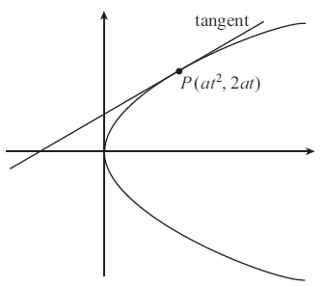

Figure 21

The parametric equation of a parabola with directrix x = −a and focus (a, 0) is

x = ${at}^{2}$, y = $2at$.

We can use the parametric equation of the parabola to find the equation of the tangent at the point P.

We shall use the formula for the equation of a straight line with a given gradient, passing through a given point. We know that the tangent passes through the point P, but what is its gradient?

We can work it out using calculus, because the gradient is just the derivative dy/dx. If we use the formula for differentiating a function of a function, we get

$\frac{dy}{dx}=\frac{dy}{dt}*\frac{dt}{dx}=\frac{\frac{\frac{dy}{dt}}{dx}}{dt}$.

Now $y = 2at$ and $x = {at}^{2}$, so that

$$\frac{dy}{dt}=2a, \frac{dx}{dt}=2at$$

Giving $\frac{dy}{dx}=\frac{2a}{2at}=\frac{1}{t} .$

Now the equation of a straight line with gradient m passing through the point (x1, y1) is

$$y - y1 = m(x - x1) ,$$

so the equation of the tangent at P is

$$y-2at=\frac{1}{t}*(x-{at}^{2}).$$

We can multiply by t to give $t\left(y - 2at\right)= x -{ at}^{2} ,$

and then multiplying out the bracket and collecting together like terms we get

$$ty = x + {at}^{2}$$

as the equation of the tangent to the parabola at P.

The tangent to a parabola at the point P(at2, 2at) is given by

$ty = x + {at}^{2}$.

1. **Shifted Conics**

By using certain techniques, we can obtain the equations of conics that are translated from their standard positions. In fact, by replacing $x$ by $x-h$ and $y$ by $y-k$ in their standard equations, we obtain the equation of a parabola whose vertex is translated from the origin to the point $(h,k)$ and the equation of an ellipse (or hyperbola) whose center is translated from the origin to the point $(h,k)$.

Conclusion:

The *conic sections* (or conics) – the circle, the ellipse, the parabola and the hyperbola - play an important role both in mathematics and in the application of mathematics to engineering(Parabolic Reflectors or collectors, satellite dishes, Telescopes, bridges, Suspension Bridges Cables, buildings and much more…).

|  |  |  |
| --- | --- | --- |
| **Conic** | **Orientation of axis** | **Equation of conic** |
| Parabola | Axis horizontal | $${\left(y- k\right)}^{2}= 4 p(x- h)$$ |
| Parabola | Axis vertical | $${\left(x- h\right)}^{2}= 4 p(y- k)$$ |
| Ellipse | Major axis horizontal | $$\frac{{\left(x- h\right)}^{2}}{a^{2}}+\frac{{\left(y- k\right)}^{2}}{b^{2}}=1$$ |
| Ellipse | Major axis vertical | $$\frac{{\left(x- h\right)}^{2}}{b^{2}}+\frac{{\left(y- k\right)}^{2}}{a^{2}}=1$$ |
| Hyperbola | Transverse axis  horizontal | $$\frac{{\left(x- h\right)}^{2}}{a^{2}}-\frac{{\left(y- k\right)}^{2}}{b^{2}}=1$$ |
| Hyperbola | Transverse axis  Vertical | $$\frac{{\left(y- k\right)}^{2}}{a^{2}}-\frac{{\left(x- h\right)}^{2}}{b^{2}}=1$$ |

References:

* CALCULUS (SOO T. TAN) book, Chapter 10 Conic Sections.
* [www.mathcentre.ac.uk](http://www.mathcentre.ac.uk)
* [www.ms.uky.edu](http://www.ms.uky.edu)
* <http://ccins.camosun.bc.ca/~jbritton/jbconics.htm>
* Instructional Unit on Conic Sections. University of Georgia.  <http://jwilson.coe.uga.edu/emt669/Student.Folders/Jones.June/conics/conics.html>
* CURVE BUILDING. An Exploration with Algebraic Relations University of Georgia. <http://jwilson.coe.uga.edu/Texts.Folder/cb/curve.building.html>

* كتاب الرياضيات (الهندسة التحليلية) 3.ثانوي علمي لمنهاج الجمهورية العربية السورية: (الوحدة الأولى) القطوع المخروطية.

1. CALCULUS (SOO T. TAN) book, Chapter 10 Conic Sections.
2. [www.mathcentre.ac.uk](http://www.mathcentre.ac.uk)