***National center for distinguished***

***Ministry of education in Syria***

***By: EMAD AKHRAS***

***Supervisor: FADIAH ALI***

***2015 - 2016***

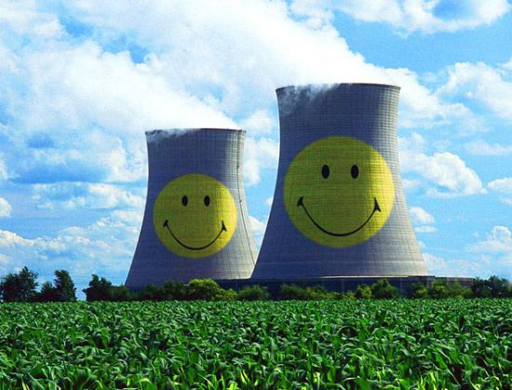

*URANIUM RADIOISOTOPES THERAPY*

# ***Introduction:***

Uranium was discovered in 1789 by German chemist Martin Klaproth while analyzing mineral samples from the Joachimsal silver mines in the present day Czech Republic.[1]

Apart from its value to chemists, the only significant use for uranium throughout the 1800s was to color glass and ceramics. Ceramic glazes ranging from orange to bright red were used on items as varied as household crockery and architectural decorations.

Antoine Henri Becquerel discovered the phenomenon of radioactivity by exposing a photographic plate to Uranium 1896.[2]

Uranium’s radioactive properties were not noticed until 1896. French scientist Henri Becquerel did not realize the full significance of his discovery, but one of his students, Marie Curie, currently interpreted his results and chose the name radioactivity for the new phenomenon. Working with her husband Pierre, Marie Curie went on to discover another new element, Radium in 1898.

After the Curie’s first work with radioactive materials, many scientists began to study Uranium. In 1939, Otto Hahn in Germany performed the first proven nuclear fission. By this time the world was on the edge of war. A team led by Enrico Fermi built the first nuclear reactor (atomic pile) in great secrecy at the University of Chicago in 1942.

The pile achieved the first controlled nuclear reaction in 1942. The U.S assembled a team to develop an atomic weapon and their work known as Manhattan project, resulted in the first nuclear explosion at the trinity test site in New Mexico in July 1945.1

A month later Japanese cities of Hiroshima and Nagasaki were destroyed. After the war ended, attention quickly turned to benefit from the nuclear energy. In 1957, the first full-scale U.S nuclear power plant went into service at Shippingport, Pennsylvania. It had a generating capacity of 60 megawatts, a small amount by today’s standards.2

Canada and Sweden also succeed in independently generating nuclear electricity, in 1962 and 1964 respectively. The first export orders for nuclear power reactors awarded by Italy in 1958. Kazakhstan was the first producer from mines (27% of world supply).

**So, could we use uranium and its isotopes for remedy?**

# ***Uranium and its isotopes:***

## ***What is uranium?***

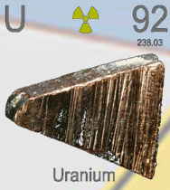Uranium (atomic number: 92, element symbol: U) is a naturally occurring, metallic element and in its pure form it is silver-colored.

**Figure 1: uranium in nature**

It is 70% more dense than lead and nearly as strong as steel, making it one of the heaviest of the natural elements. While uranium is found in the air, water, soil and rocks but it is never found in the metal form, only in the in the form of minerals.[3]

Uranium probably best recognized for its use in nuclear plants and in the making of nuclear weapons but, while most people may think it is highly radioactive in truth, it only carries a mild radioactivity and uranium minerals are very useful for dating rocks and determining the age of the earth.

Martin Heinrich Klaproth discovered it in 1789 and he named the element after the planet Uranus while exposure to high levels of it can result in some health concerns.

In 1938, German physicists Otto Hahn and Fritz Strassmann showed that uranium could split into parts to yield energy[4].

It can be used in the following applications[5]:

|  |  |
| --- | --- |
| COMMON MILITARY USES | COMMON CIVILIAN USES |
| High density bullets | Pottery glazes |
| Missile ballets | Glassworks |
| Aircraft control counterweight | Photographic chemicals |
| Armored plates on tanks & combat vehicles | High-Energy X-rays |
| Fashioned into containers for  transport of radioactive materials | Fuel for commercial power plants |

## ***What are radioisotopes?***

The isotopes of an element have the same number of protons in their atoms (atomic number) but different number of neutrons. In an atom in natural state, the number of external electrons also equals the atomic number.

When a combination of neutrons and protons, which does not already exist in nature, is produced artificially, the atom will be unstable and is called a radioactive isotope or radioisotope. There are also a number of unstable natural isotopes arising from decay of primordial uranium and thorium.

Radioisotopes can be manufactured in several ways. The most common is by neutron activation in a nuclear reactor. This involves the capture of neutron by nucleus of an atom resulting in an excess of neutrons (neutron rich). Some radioisotopes are manufactured in a cyclotron in which protons are introduced to the nucleus resulting in a deficiency of neutron (proton rich).

The nucleus of radioisotopes usually becomes stable by emitting an alpha and/or beta particle. These particles may be accompanied by the emission of energy in the form of electromagnetic radiation known as gamma rays (like X-rays). This process is known as radioactive decay[6].

Radioactive products that are used in medicine are referred to as radiopharmaceuticals.

Uranium has an atomic number of 92 which means there are 92 protons and 92 electrons in the atomic structure.

In nature, uranium atoms exist as several isotopes: primarily Uranium-238, Uranium-235 , and a very small amount of Uranium-234.

|  |  |
| --- | --- |
| Summary of uranium isotopes[7] |  |
| % found in %found in %found in No. of No. of half-life  natural U enriched U depleted U proton neutrons (years) | *Isotope* |
| 99.284 96.471% 99.8% 92 148 4.468 billion | *Uranium-238* |
| 0.711 3.5% 0.02% 92 143 703.8 million | *Uranium-235* |
| 0.0055 0.029% 0.001% 92 142 245.500years | *Uranium-234* |

These three kinds of radiation have very different properties in some respects but all are lionizing radiation-each is energetic enough to break chemical bonds, thereby possessing the ability damage or destroy living cells.

|  |
| --- |
| *Uranium decay chain-main branch[8]* |

|  |  |  |
| --- | --- | --- |
| 3) Protactinium-234  (half-life:1.17 minutes)  Beta decay | 2) Thorium-234  (half-life:24.1 days)  Beta decay | 1) Uranium-238  (half-life:4.40 billion years)  Alpha decay |
| 6) Radium-220  (half-life:1.000 years)  Alpha decay | 5) Thorium-230  (half-life:75.400 years)  Alpha decay | 4) Uranium-234  (half-life:245.000 years)  Alpha decay |
| 9) Lead-214  (half-life:20.8 minutes)  Beta decay | 8) Polonium-218  (half-life:75.400 years)  Alpha decay | 7) Radon-222  (half-life:3.82 days)  Alpha decay |
| 12) Lead-210  (half-life:22.3 years)  Beta decay | 11) Polonium-214  (half-life:103 microseconds)  Alpha decay | 10) Bismuth-214  (half-life:19.9 minutes)  Beta decay |
| 15) Lead-206  (stable) | 14) Polonium-210  (half-life:138 days)  Alpha decay | 13) Bismuth-210  (half-life:5.01 days)  Beta decay |

Uranium-238 emits alpha particles which are less penetrating than other forms of radiation, and weak gamma rays as long as it remains outside the body, uranium poses little health hazard (mainly from the gamma rays).

The property of uranium important for nuclear weapons and nuclear power is its ability to fission or split into two lighter fragments when bombarded with neutrons releasing energy in the process. Of the naturally occurring uranium isotopes, only uranium-235 can sustain a chain reaction a reaction in which each fission produces enough neutrons to trigger another, so that the fission process is maintained without any external source of neutrons. In contrast, uranium-238 cannot sustain a chain reaction. Nevertheless, it can be converted to plutonium-239, which virtually non-existent in nature was used in the first atomic bomb tested July 16/1945 and the one dropped on Nagasaki on August 9/1945.

# ***Uranium hazards:***

## ***How am I exposed to uranium?***

Because of the natural occurrence of uranium in the environment, the general population is exposed.

However, that level of exposure is quite small. The most common reasons for individuals who do not work with uranium to be exposed to higher than normal levels include:

1- Living near a uranium mine and near a coal-fired power plant.

2- Drinking water that has a high degree of uranium.

3- Breathing air that has a high degree of uranium.

4- Eating foods grown in soil that has a high degree of uranium.

5- Individuals who work with phosphate fertilizers[9].

## ***What are the symptoms of uranium exposure?***

Human beings can come into contact with three different types of uranium- natural, depleted and enriched. It does not matter which type you come into contact with, if the levels are extreme enough, the uranium exposure could cause tissue damage in your body, specifically in the kidneys. Although the element is only mildly radioactive, it is toxic to the human body if ingested or inhaled (above normal level).

During the military operation Desert Storm in 1991, many soldiers were diagnosed with extensive uranium exposure. Those soldiers experienced rashes, kidney problems, respiratory difficulties and cataracts, unfortunately those with kidney problems typically do not exhibit any symptoms until the late stages of kidney disease. At that point, there may be blood evident in the urine or may notice decrease in urine production.

There may also be a high level of proteins noticeable in the urine[10].

*Health damages by chronic exposure of a population to low dose radiation[11]*

|  |  |  |  |  |
| --- | --- | --- | --- | --- |
|  | **Genetic diseases** | **Mortality**  **by cancer** | **Effects after**  **exposure in**  **womb** | **Diseases other**  **than cancer**  **and tumors** |
| **ICPR risk data** | 1.3% per Sv | 5% per Sv | No effects $<$ 0.1 Sv | No effects |
| **Evaluation by**  **ECRR** | Underestimation  by factor 100-2000 | Underestimation  by factors 100-2000 | Cancer  Cerebral disability  Mental illness  Child diseases  Infant mortality  Spontaneous  Low birth weight | Manifold |

# ***Nuclear medicine:***

This is a branch of medicine that uses radiation to provide information about the functioning of a person specific organ or to treat disease. In most cases, the information is used by physicians to make a quick, accurate diagnosis of the patient illness.

The thyroid, bones, heart, liver and many other organs can be easily imaged, and disorders in their function revealed. In some cases, radiation can be used to treat diseased organs, or tumors.

Over 10000 hospitals, worldwide use radioisotopes in medicine, and about 90% of the procedures are for diagnosis. The most common radioisotopes used in diagnosis is technetium-99, with some 40-45 million procedures per year (16.7 million in USA in 2012, 550000 in Australia).

In developed countries (26% of world population), the frequency of diagnosis nuclear medicine is 1.9% per year, and the frequency of therapy with radioisotopes is about one tenth of this. In the USA, there are over 20 million nuclear medicine procedures per year among 311 million people, and in Europe, about 10 million among 500 million people, and in Australia there are about 560000 per year among 21 million people, 470000 of these using reactor isotopes. The use of radiopharmaceuticals in diagnosis is growing at over 10% per year.

The global radioisotopes market was valued at 4.8$ billion in 2012, with medical radioisotopes accounting for about 80% of this, and is poised to reach about 8$ billion by 2017. North America is the dominant market for diagnosis radioisotopes with close to half of the market share, while Europe accounts for about 20%.

Nuclear medicine was developed in the 1950s by physicians with an endocrine emphasis, initially using iodine-131 to diagnosis and then treat thyroid disease.

In recent years, specialists have also come from radiology, as dual CT/PET procedures have become established.[12]

Computed X-ray tomography (CT) scans nuclear medicine contribute 36% of the total radiation exposure and 75% of the medical exposure to the USA population.[13]

The report showed that Americans average total yearly radiation exposure had increased from 3.6 msv (millisievert) to 6.2 msv per year since the early 1980s, due to medical related procedures. (Industrial radiation exposure, including that form nuclear power plants, is less than 0.1% of overall public radiation exposure).

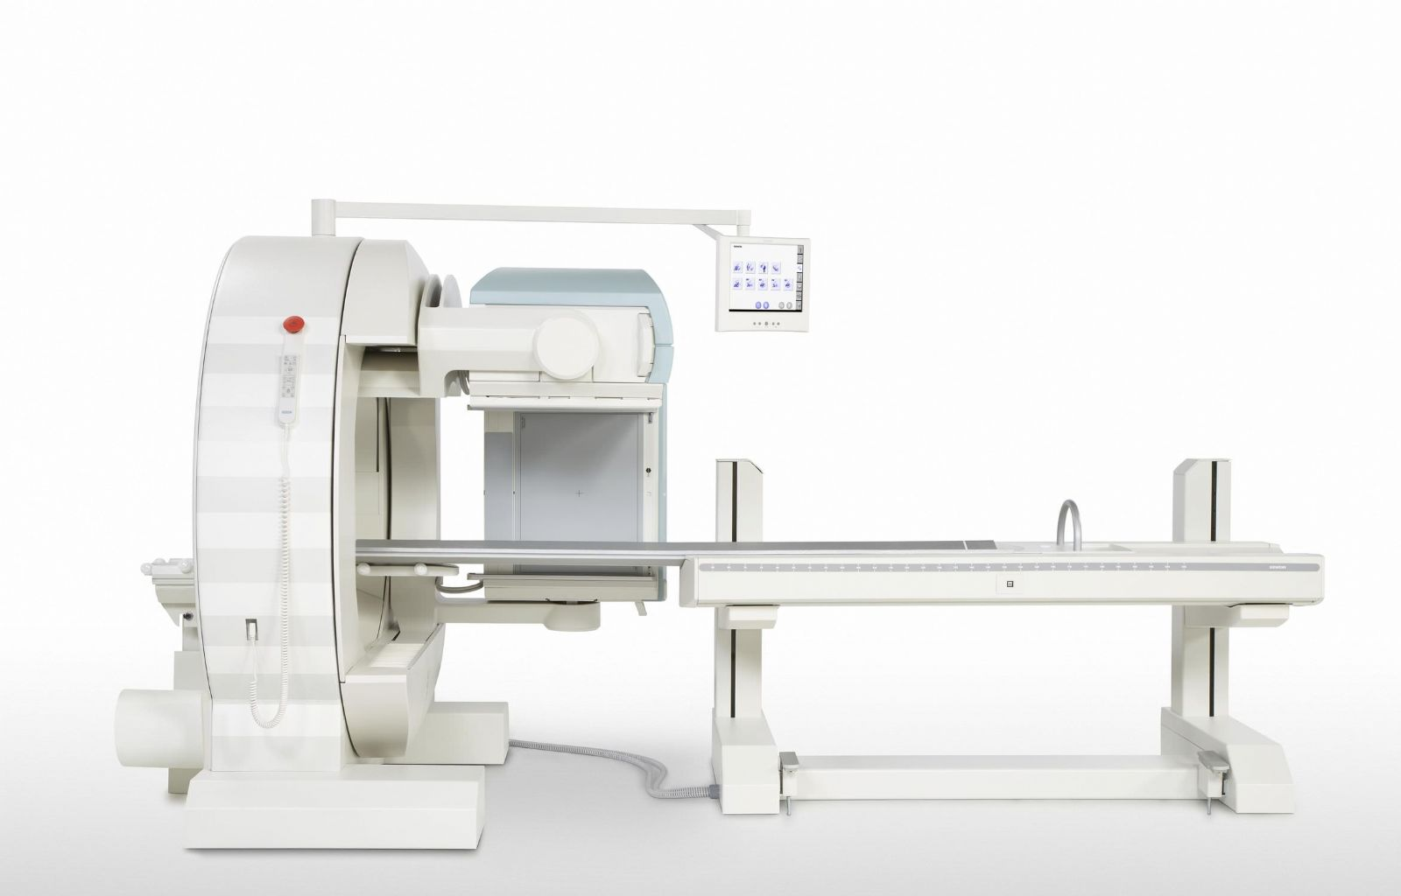An important nuclear medicine procedure is Magnetic Resonance Imaging (MRI), which uses powerful magnets and radio waves to create cross sectional images of organs and internal structures in the body. It does not use radioisotopes or ionizing radiation, but relies on nuclear magnetic resonance of hydrogen.[14]

**Figure 2: magnetic resonance imaging**

## ***Diagnostic technique in nuclear medicine:***

Diagnostic technique in nuclear medicine use radioactive tracers that emit gamma rays from within the body. These tracers are generally short-lived isotopes linked to chemical compounds that permit specific physiological processes to be scrutinized. They can be given by injection, inhalation or orally. The first type are where single photons are detected by a gamma camera that can view organs from many different angles.

The camera builds up an image from the points from which radiation is emitted; this image is enhanced by a computer and viewed by a physician on a monitor for indication of abnormal conditions.[15]

A more recent development is Positron Emission Tomography (PET), which is a more precise, and sophisticated technique using isotopes produced in a cyclotron.

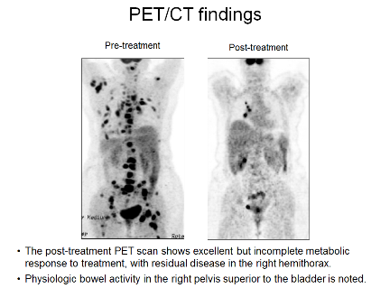A positron emitting radionuclide is introduced, usually by injection, and accumulates in the target tissue. As it decays it emits a positron, which promptly combines with a nearby electron resulting in the simultaneous emission of two identifiable gamma rays in opposite directions. These are detected by a PET camera and give very precise indication of their origin. PET most important clinical role is in oncology, with (Flourine-18) as the tracer, since it has proven to be the most accurate noninvasive method of detecting and evaluating most cancers. It is also well used in cardiac and brain imaging.[16]

**Figure 3: PET/CT treatment**

New procedures combine (PET) with computed X-ray tomography (CT) scans to give Co-registration of the two images (PETCT), enabling 30% better diagnosis than with traditional gamma camera alone. It is a very powerful and significant tool which provides unique information on a wide variety of disease from dementia to cardiovascular and cancer (oncology).

Positioning of the radiation source within the body makes the fundamental difference between nuclear medicine imaging and other imaging technique such as X-ray.

Gamma imaging by either method described provides a view of the position and concentration of the radioisotopes within the body. Organ malfunction can be indicated if the isotopes is either partially taken up in the organ (cold spot), or taken over a period, an unusual pattern or rate of isotopes movement could indicate malfunction in the organ.

A distinct advantage of nuclear imaging over X-ray technique is that both bone and soft tissue can be imaged very successfully. This has led to its common use in developed countries where the probability of anyone having such as test is about one in two and rising. The mean effective dose is 4.6 msv per diagnosis procedure.[17]

## ***Radionuclide therapy (RNT):***

Rapidly dividing cells are particularly sensitive to damage by radiation. For this reason, some cancerous growths can be controlled or eliminated by irradiating the area containing the growth.

External irradiating (sometimes-called teletherapy) can be carried out using a gamma beam from a radioactive (cobalt-60) source. Though in developed countries the much more versatile linear accelerators are now being utilized as a high-energy X-ray source, (gamma and X-ray are much the same). An external procedure is known as the gamma knife radiosurgery, and involves focusing gamma radiation from 201 sources of (cobalt-60) sources on a precise area of the brain with a cancerous tumor. Worldwide, over 30000 patients are treated annually, generally as outpatients.

Internal radionuclide therapy is by administering or planting a small radiation source, usually a gamma or beta emitter, in the target area. Short-range radiotherapy is known as brachytherapy, and this is becoming the main means of treatment. Iodine-131 is commonly used to treat thyroid cancer, probably by the most successful kind of cancer treatment. It is also used to treat non-malignant thyroid disorders. Iridium-192 implants are used especially in the head and breast. They are produced in wire form and are introduced through a catheter to the target area. After administering the correct dose, the implant wire is removed to shielded storage[18]. The brachytherapy (short-range) procedure gives less overall radiation to the body, is more localized to the target tumor and is cost effective.

Treating leukemia may involve a bone marrow transplant, in which case the defective bone marrow will first be killed off with a massive (and otherwise lethal) dose of radiation before being replaced with healthy bone marrow from a donor.

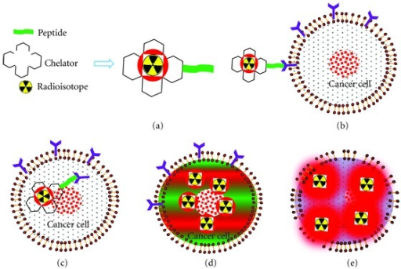Many therapeutic procedures are palliative, usually to relieve pain. For instance, strontium-89 and (increasingly) samarium-153 are used for the relief of cancer-induced bone pain. Rhenium-186 is a newer product for this.

Lutetium-177 Dotatate or Octreotate is used to treat tumors such as neuroendocrine ones, and is effective where other treatments fail. A series of four treatments delivers 32 GBq. After about four to six hours, the exposure rate of the patient has fallen to less than 25 microsieverts per hour at one meter and the patients can be discharged from hospital. Lu-177 is essentially a low-energy beta emitter and the carrier attaches to the surface of the tumor.[19]

**Figure 4: treating tumor by chelate radioisotopes**

A new field is **Targeted Alpha therapy (TAT)** or alpha radioimmunotherapy, especially for the control of dispersed cancer. The short range of very energetic alpha emissions in tissue means that a large fraction of the radiative energy goes into the targeted cancer cells, once a carrier such as a monoclonal antibody has taken the alpha emitting radionuclide such as (Bi-213) to exactly the right places. Clinical trials for leukaemia, cystic glioma and melanoma are under way. TAT using (Lead-212) to show promise for treating pancreatic, ovarian and melanoma cancers.[20]

An experimental development of this is **Boron Neutron Capture Therapy** using boron-10 which concentrates in malignant brain tumors. The patient is then irradiated with thermal neutrons which are strongly absorbed by boron, producing high energy alpha particles which kill the cancer, this requires the patient to be brought to a nuclear reactor, rather than the radioisotopes being taken to the patient.

Radionuclide therapy has progressively become successful in treating persistent disease and doing so with low toxic side effects. With any therapeutic procedure the aim is to confine the radiation to well defined target volumes of the patient. The doses per therapeutic procedure are typically 20-60 Gy.

## ***Diagnostic Radiopharmaceuticals:***

Every organ in our bodies acts differently from a chemical point of view. Doctors and chemists have identified a number of chemicals that are absorbed by specific organs. The thyroid, for example, takes up iodine; the brain consumes quantities of glucose, and so on. With this knowledge, radiopharmacists are able to attach various radioisotopes to biologically active substances. Once a radioactive form of one of these substances enters the body, it is incorporated into the normal biological processes and excreted in the usual ways.

Diagnostic radiopharmaceuticals can be used to examine blood flow to the brain, functioning of the liver, lungs, heart or kidneys, to assess bone growth, and to confirm other diagnostic procedures. Another important use is to predict the effects of surgery and assess changes since treatment. The amount of the radiopharmaceutical given to a patient is just sufficient to obtain the required information before its decay. The radiation dose received is medically insignificant. The patient experiences no discomfort during the test and after a short time, there is no trace that the test was ever done. The non-invasive nature of this technology, together with the ability to observe an organ functioning from outside the body, makes this technique a powerful diagnostic tool.

A radioisotopes used for diagnosis must emit gamma rays of sufficient energy to escape from the body and it must have a half-life short enough for it to decay away soon after imaging is completed.

The radioisotopes most widely used in medicine is (technetium-99m), employed in some 80% of all nuclear medicine procedures hence 30 million per year, of which 6-7 million are in Europe, 15 million in north America, 6-8million in Asia/Pacific (particularly Japan), and 0.5 million other regions.[21]

## ***Therapeutic Radiopharmaceuticals:***

For some medical circumstances, it is useful to destroy or weaken malfunctioning cells using radiation. The radioisotopes that generates that radiation can be localized in the required organ in the same way it is used for diagnosis through a radioactive element following its usual biological path, or through the element being attached to a suitable biological compound. In most cases, it is beta radiation which causes the destruction of the damaged cells. This is radionuclide therapy (RNT) or radiotherapy. Short-range radiotherapy is known as brachytherapy, and this is becoming the main means of treatment.

Although radiotherapy is less common than diagnosis use of radioactive material in medicine, it is nevertheless widespread, important and growing. An ideal therapeutic radioisotopes is a strong beta emitter with just enough gamma to enable imaging, e.g. lutetium-177. This is prepared form ytterbium-176 which is irradiated to become Yb-177 which decays rapidly to Lu-177. Yttrium-90 is used for treatment of cancer, particularly non-Hodgkin’s lymphoma and liver cancer, and it is being used more widely, including for arthritis treatment. Lu-177 and Y-90 are becoming the main RNT agents.

Iodine-131, samarium-153 and phosphorus-32 are also used for therapy. Iodine-131 is used to treat the thyroid for cancers and other abnormal conditions such as hyperthyroidism (over-active thyroid).

In a disease called polycythemia Vera, an excess of red blood cells is produced in the bone marrow. Phosphorus-32 is used to control this excess.

A new and still experimental procedure uses boron-10, which concentrates in the tumors. The patient is then irradiated with neutrons which are strongly absorbed by the boron, to produce high-energy alpha particles which kill the cancer.

Considerable medical research is being conducted worldwide into the use of radionuclides attached to highly specific biological chemicals such as immunoglobulin molecules (monoclonal antibodies). The eventual tagging of these cells with a therapeutic dose of radiation may lead to the regression or even cure of some disease.[22]

# ***Denouement and conclusion:***

Uranium is a heavy radioactive element that occurs in different isotopes, and is commonly used for making nuclear weapons and nuclear fuels. There are many numerous benefits of nuclear power, which outweigh possible negative effects[23] and as we saw, uranium is used widely for treating so, we should encourage using it especially in that field and I think it will be a great tool in future to protect our bodies against those diseases and treat as a vaccine.

1. Produces nuclear energy:

President Obama and his administration are keen to encourage the use of nuclear energy, which has less damaging on the environment as compared to other sources of energy like coal and natural gas. Once this has been accomplished, investors will certainly shift their focus towards uranium.

2. Less pollution:

Compared of different energy sources such as coal that have destructive effects, nuclear energy is pollution free.

Production of nuclear energy is also free from ${CO}_{2}$ emissions, which is the main source of environmental degradation from other energy sources.

3. Great financial potential:

While use of nuclear energy is on the upsurge, experimentation is also on the rise as well due to lack of regulations. For this reason, small miners will provide the highest profit, but they are at a greater financial risk. On the other hand, large miners have low risk and great profit potential.

4. It is renewable:

Another benefit of nuclear energy is the fact that it renewable but this will depend on the reactor being used in production. Currently, more than 442 reactors are operating around the world. With improvement in technology, thermal reactors would be used to capture uranium.

***Contents***

Introduction: 1

Uranium and its isotopes: 2

What is uranium? 2

What are radioisotopes? 3

Uranium hazards: 5

How am I exposed to uranium? 5

What are the symptoms of uranium exposure? 5

Nuclear medicine: 6

Diagnostic technique in nuclear medicine 8

Radionuclide therapy (RNT) 9

Diagnostic Radiopharmaceuticals 11

Therapeutic Radiopharmaceuticals 12

Denouement and conclusion: 13

***Image index:***

**Figure 1: uranium in nature** 2

**Figure 2: magnetic resonance imaging** 7

**Figure 3: PET/CT treatment** 8

**Figure 4: treating tumor by chelate radioisotopes** 10

***References:***

[www.epa.gov](http://www.epa.gov)

[www.web.ead.anl.gov](http://www.web.ead.anl.gov)

[www.cancer.gov](http://www.cancer.gov)

[www.ncbi.nih.gov](http://www.ncbi.nih.gov)

[www.world-nuclear.org](http://www.world-nuclear.org)

[www.ieer.org](http://www.ieer.org)

[www.iksr.org](http://www.iksr.org)

[www.pub.iaea.org](http://www.pub.iaea.org)

[www.snmmi.org](http://www.snmmi.org)

[www.caringforcarcinoid.org](http://www.caringforcarcinoid.org)

<http://nucleus.iaea.org>

[www.ist-socrates.berkeley.edu](http://www.ist-socrates.berkeley.edu)

[www.icpsr.umich.edu](http://www.icpsr.umich.edu)

[www.radiology.ucsf.edu](http://www.radiology.ucsf.edu)

[www.teachnuclear.ca](http://www.teachnuclear.ca)

[www.aph.gov.au](http://www.aph.gov.au)

<http://www.ocrwm.doe.gov/curriculum/unit2/lesson2reading.shtml>

[www.patient.co.uk](http://www.patient.co.uk)

[www.news-medical.net](http://www.news-medical.net)

1. [www.ist-socrates.berkeley.edu](http://www.ist-socrates.berkeley.edu)
2. [www.teachnuclear.ca](http://www.teachnuclear.ca)
3. [www.world-nuclear.org](http://www.world-nuclear.org)
4. [www.web.ead.anl.gov](http://www.web.ead.anl.gov)
5. <http://geoinfo.nmt.edu>
6. [www.epa.gov](http://www.epa.gov)
7. <http://geoinfo.nmt.edu>
8. <http://www.ocrwm.doe.gov/curriculum/unit2/lesson2reading.shtml>
9. [www.ieer.org](http://www.ieer.org)
10. Wise uranium project [www.wise-uranium.org](http://www.wise-uranium.org)
11. [www.iksr.org](http://www.iksr.org)
12. [www.icpsr.umich.edu](http://www.icpsr.umich.edu)
13. USA National Council of Radiation Protection& Measurements report in 2009
14. [www.patient.co.uk](http://www.patient.co.uk) , [www.cancer.gov](http://www.cancer.gov)
15. [www.news-medical.net](http://www.news-medical.net)
16. [www.ncbi.nlm.nih.gov](http://www.ncbi.nlm.nih.gov)
17. [www.radiology.ucsf.edu](http://www.radiology.ucsf.edu)
18. [www.snmmi.org](http://www.snmmi.org)
19. [www.caringforcarcinoid.org](http://www.caringforcarcinoid.org)
20. [www.ncbi.nlm.nih.gov](http://www.ncbi.nlm.nih.gov)
21. <http://nucleus.iaea.org>
22. [www.ncbi.nih.gov](http://www.ncbi.nih.gov) , [www.pub.iaea.org](http://www.pub.iaea.org)
23. [www.aph.gov.au](http://www.aph.gov.au)