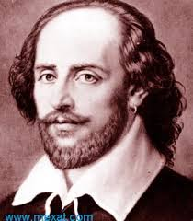

By



The national center Syrian Arab republic. for the distinguished

Ministry of education .

The national center for the distinguished.

English seminar for the tenth class

*William Shakespeare*

Written by: supervised by:

Ibrahim Somiia Suhier Kharma

2015-2016

Preface:

This seminar is for all people who are interested in realizing more about William Shakespeare. It tells us about William Shakespeare life from all sides ,where was he born? when did he start writing? what was the black sides for his character?

Research problem:

Do you know who is William Shakespeare?

If you ask any body this question, he will answer you yes I know him, but if he remember all his information about him he will answer you ,no I do not know any thing about him ,and for that I wrote this seminar to tell people more about William Shakespeare.

Research goals :

This seminar is for every one want to discover some thing new about William Shakespeare , but the main goal for this seminar is to make every body know about his history , his family and negative points at his life.

Thank you for reading

Ibrahim Somiia

***Chapter (1):***

Williams family:

William Shakespeare was born on April 23\ 1564, in Stratford-on-Avon. His father was John Shakespeare one of the trader and his mother was

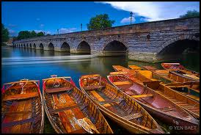Mary Arden . [1]He had three brothers Gilbert, Richard and Edmond, and they was younger than William ,and four sisters Hannah who died when she was baby , Margret who died after five months after her born and they were Williams bigger sisters, Hannah and Ann who they were younger than William.[2] He was probably educated at the King Edward IV Grammar School in Stratford, where he learned Latin , a little Greek and read Roman dramatists.[3] His family lived a kind of prosperity whereas his father bought tow houses budge his old ones ,then his life was turned by the trade and manufacture shake defect in economically turned days which happened on trade , import, export, confers and trading centers between the village ,towns and the seaboard cities ,so it rove by his and his wife materials ,and make all his time to resolve this problem which took all his time and make him very busy to go to his popularly jobs at the village, and the history do not know any thing about this problem exclusive the information which talk about the causes which rise on him , debits which he was demanded ,tenancies and mortgages, but the false at his problem was from the necessary false for his expansion at agriculture ,manufacture , trading and went to his popular works at the same time.[4]

This problem had came when William was twelve years old so he left the school around this age ,then he helped his father at his works ,and it is the works which can learn any boy the knowledge about social life which we can not learn it from the school books.

And at eighteen he married Ann Hathway the oldest daughter for her father and she was older than William about eight years, and he have from Ann three children Sawsan and a twins-a boy and a girl- Himont and Judith .

After the twins William had to look for a new job alternatively his old job, which it was helping his father ,which it was very cheap ,and the economy problem which happened at his family was growing up, because at the year which the twins was born at it his father was lost his popular works and his mint too, and it became on William the oldest between his brothers and the single father to have his new good job or leave the village to steep himself and his family.

And all of us know what did him do, he left the village and he did not went direct to London, and we do not know where he was , but their is a lot of stories about it I will talk about some of them later. [5]

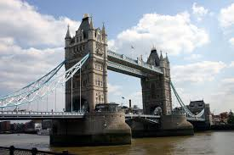

Coming back:

After this time of nothing about Shakespeare we here about him at 1591, and we know that this year was the end of his bad years ,and he started writing and representation, and he worked at the biggest acting group Earl Uph Leicester which for it the queen let the people built the theatres at London.

And what we know about Williams life after 1591 very small relatively to the other famous writers ,but it is not small if we compare it with what we know about writers from his time ,and it is good to tell us about his success ,rising up his business and departure a lot of his time to built up his rank ,so he had an apparel from the loftiness apparels (formally) ,which gave him the gentleman surname at 1596 .

He enter London's theaters by his belonging at Leicester group to his last day at acting , he tried a lot to encore his family topsoil which they lost it on selling and mortgage, he bought houses for his and his family habitations and he bought about 127 acre at old Stratford .[6]

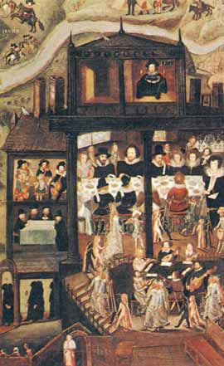Shakespeare death:

William came back to his born native land Stratford in 1611, and he stayed in it. And he did not go out it unless to go to London for working and came back to it again with all what he need to keep his family on life.

And he died at 23\4\1616 ,at the same day which he was born on it.

And he wrote before his death some poem cross, he call for write it on his tomb .

And he wrote on it some thing from his meaning reminder in bones sanctity which it is inside its tomb , and he asking the god to keep who keep it and cursed who move it from its place.

He wrote that because there is a place inside the chapel which cauld the bones house and they put inside it the bones which they take it from its tombs and the writer want to keep his bones inside its tomb.[7]

***Chapter 2:***

Notice: I wrote at this chapter the worst thing what he ever did and some thing we do not know any thing about it at his life.

His whore daughter:

His first child Saussan had been baptized in 26\5 from the second year after marriage that mean after six months after his marriage, so she was a whore daughter ,so the both family shrift that and tried to fix it ,to proof the rightful amour with out play with the marriage or the birth date.[8]

He stopped writing when he was around 45:

Like what did I found William Shakespeare stopped writing before 45 years old ,so that was very strange, cause of he was on the top of his success, and he did not say any raison for that .

That give us a lot to think about it ,like did William Shakespeare was the real writer for all of this plays ?

I do not know ,but there is a proof for it say the real writer for this plays died and William found it.

But the 45 ,or around it ,was not the middle of the road when the person die at 52 ,and it is not an easy thing to continuation writing for some one who supervise three theaters one of them are for him and the second and the third one he have a rate from them and the other rates are for the senior partner and for the acting and directing expert business ,and maybe he would be busy by some modernize works which is from his family and clan. [9]

Where is William:

There is not any thing wrote about William During the time between 1585 to 1591 and no body know where did he was , and there is a lot stories about this time from his life ,one of them say that William had not gone to London immediately ,but he had gone to Blemoth and had entered a bout to the eastern country after his visit to Italy ,because his depictions for this countries are the depiction for eyewitness.[10]

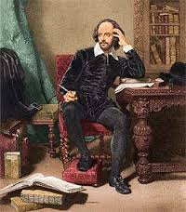

***Chapter(3):***

There is three sides from what did Shakespeare wrote tragedies ,comedy and philosophy .

And he wrote his philosophy when he was writing his plays , and a lot of it is creation lessons ,because we find a lot of that lessons in it like a feeling to could any social system to slip up, and it is a feeling as soon as feeling of the English philosopher Hones .And his plays help in rising up his creation feelings ,is very important thing came , from hair of writer at the psychology ,and his philosophy. And this philosophy came from the Christianity head and from the classical head to paint knowing the rank of people with a lot of colors for example at the “Lear king “We see the power of the stoics, especially Senek , and the mental of Shakespeare remember me by Muntiny .

But his work is more complicated than that ,and we think some times that Shakespeare’s brain is very strong ,to point wrote a good play inclined from a drama way and a poetry way is nothing fir his brain- because of it seems like apart of his brain is staying working at the background ,to think about this idea or that .Hamlet( chapter three sketch one) he discovered in a way (understood) complicated and contrary for the death and the revenge ,but the most famous part is the part of self murder:(We are or we are not. That is the question . 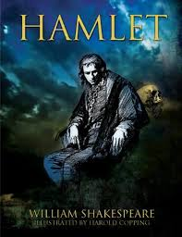

And do the soul find more nobility than misery the tabes the want on lot and its shake ,or arm against it to fight back the pain rushes ? the death ;the sleep; that is the all and for chill out finally at the tomb your horrible falls heart ; which end for the inheritance aches maybe any body will wish it more than that)

And even the most power romanticism drama from what Shakespeare wrote ,the storm with its magic ,monster and ghosts ,contain thinking about the antithetic Europe position , which is not always Nobel in the face of discovered the new world

The life is complicated and Shakespeare’s plays appear this dialectal observance .And what they Saied on the philosopher way is right to on the dramatic way ,even the comedian plays which play at the nothing which do not know how much time had gone ,so the dispute of wills and dispute of ideas is the dispute which created the dramatically stirs.[11]

After all of that we knew a lot of things about Shakespeare, which is not good at all, we knew some black points at his character some thing about his philosophy .

-Introduction by Shakespeare –Mahmoud Alagad –Abbas –Dar Alketab Alaraby -1969.

-The Europe history literature part 2-A group from writers-translated by Aljhem –siiah-the Syrian public organization-2013.

- <https://www.poets.org/poetsorg/poet/william-shakespeare> 12\9\2015

5:00

The list:

Cover---------------------------------------------------2.

Preface ------------------------------------------------3.

Research goals---------------------------------------3.

Research problem----------------------------------3.

Chapter one-----------------------------------------4.

Chapter tow-----------------------------------------8.

Chapter three---------------------------------------10.

Conclusion------------------------------------------- 12.

Origins ------------------------------------------------13.

List -----------------------------------------------------14.

1. <https://www.poets.org/poetsorg/poet/william-shakespeare>
2. Introduction by Shakespeare p32
3. <https://www.poets.org/poetsorg/poet/william-shakespeare>
4. Introduction by Shakespeare p32-33
5. P36-38 Introduction by Shakespeare from
6. Introduction by Shakespeare p42
7. Introduction by Shakespeare p43 and p 44
8. 37Introduction by Shakespeare p
9. Introduction by Shakespeare p46
10. 39Introduction by Shakespeare p38 and
11. The Europe history literature p 198