[1]Syrian Arab Republic Ministry of education National Centre of Distinguish



Golden success

Seminar Made for English

Written by: sally kourini

Supervisor: MS Souhair kharm

2015_2016

Contents:

Introduction-------------------------------------------------4

First chapter Things successful people have in common------------5

Second chapter Things successful people have avoided------------------7

Third chapter What story will you tell your children------------------13

Fourth chapter What is the difference between a human and an animal--------------------------------------------------------16

Fifth chapter A simple way to wisdom----------------------------------18

Sixth chapter The unlimited capital that every person has----------19

Seventh chapter The miracle of goals----------------------------------------21

Time management------------------------------------------23

Eighth chapter Paradigm-----------------------------------------------------25

Time when future looks dark---------------------------26

Ninth chapter Possible and impossible----------------------------------27

Tenth chapter Are women better than men----------------------------29

Our selection, our luck-------------------------------------31

Final chapter Successful people's opinion------------------------------------------31

Conclusion------------------------------------------------------------------39

References---------------------------------------------------------------41[2]

Introduction:

No matter how old you are, where you are from or what you do for a living, we all share something in common-a desire to be successful, however, as some may define success as being a loving and faithful spouse or a caring and responsible parent.

While most people would equate success with wealth, fame and power.

We all want to achieve success .

Actually, lessons and other tools for success are simple to learn.

But the question now is:

1)-how to be a successful person?

2)- why does it seem that some people have the knowledge and the talent that help them a lot to be successful but they are not?

3)- is there any impossible thing?

First chapter: things successful people have in common:

There are a lot of strategies out there on how to be a successful in life, but there is no better way to succeed than to follow that footsteps of those who have already done so, here are 13 success tips from some of the world's most successful and renowned people:

1)- they have a dream

2)- they have a plan

3)-have specific knowledge or training

4)-they are willing to work hard

5)- they do not take no for an answer

6)-they take responsibility

7)-they look for solutions to problem

8)-they make decisions

9)-they have the courage to admit they have made a mistake

10)- they are self-reliant

11)-successful people have specific knowledge, training, skills and talents.[3]

Second chapter;

things successful people have avoided:

So we know many steps successful people have followed to achieve their goals.

But what about the things they have avoided?

1-cry about getting enough feedback.

Younger generation, particularly, gen y, thrive on feedback indeed at any age level, being appreciated and knowing your work matters is important. But successful people rarely pause long enough to notice their bosses are not showering them with praise. They are too busy getting things done and deriving value from their own internal sense of accomplishment. While we all like to patted on the back, the more you can separate your need to be valued from externalcues, the better.

2-try to take credit constantly

If you are worried about who did what and getting the credit you deserve.

You are probably not as successful as you could be. Employees on the leader ship track working well on a team and are not worried about being called out as "special".

Many employees particularly, who are just starting out.,overestimate the value of theircontributions and feel shunted as a result.

more likely your work was part of a larger team effort.

celebrate by showering praise on your teammates to find meaning and move up the ladder.

3-Break commitments.

busy as a top boss might be, they rarely break a promise.

that does not mean they want shuffle around a meeting on you, but the word "cancel" is not usually in a leader's vocabulary.

leaders tend to be quite open about seeing opportunity in every interaction and believe keeping the commitments they have made to others is paramount.

it is how they earn respect, credibility and trust.

4-Take off work when sick

Whether you believe in work–life balance or not, you rarely see upper management taking off work when they do not feel good.

What gives? well, these leaders want to be at work. stressful as it may be, successful people enjoy their

when they become ill, their choice is to either sit on the couch in front of their television or sit at the office in front of their computer.

Most will choose the latter. despite the contagion factor, working while sick is commonplace among successful types unless they truly cannot get out of bed.

5- fail to see the whole picture.you might be annoyed at another's team lack of follow-through, but leaders see the whole picture.

They know the problems the other team is experiencing are common and just a part of building a company.

Your inability to put yourself in the other team's shoes, along with your experience, is likely coloring your frustration.

Next time you get upset, take a step back and see if you can get a broader look at the issue going on.

Could it be that you are not as smart as you thought and everyone really is doing her and his best to keep that project moving?

6-become resentful or jealous.

Real leaders do not hide from a competitors- they learn from them. And great employeesdo not shy away from impressive colleagues- they embrace them.

If you are wondering why all the attention is going to your new co- worker instead of you, find ways to support and celebrate that person.

Do not pout in a corner. When we resent the action or behavior of others, we do not have enough energy to succeed in on our own work.

7- ask for too little.

If there is one thing that is holding workers back across the country.

It is that they are asking for too little. Instead of getting paid what they are worth, instead of getting the top dollar deals and instead of creating powerful partnerships, they are settling. But successful people know how to ask for what they want. Whether it is for a raise, a sweeter deal or an introduction to an important figure, leaders do not shy away from potential moments of discomfort.

instead of accepting what is handed out, successful people do everything they can to control the outcome.

8-say" it is not my job":

Just because your job description does not include aiding the technical team or staying for a project lunch does not mean it is not your job.

Successful employees do not work in isolation; constantly seek opportunities to be useful and create value.

When you chip in and work as a team, you learn and understand more about the business and your colleagues.

With understanding comes empathy and efficiency, allowing you to enjoy going to work to work in the morning.

9-try to do it all:

you cannot have it all- at least not all at once. Successful people understand this and take pains to delegate and shine the light on others.

When we try to do too much, we are usually trying to prove something –that we are the best, that we can win, that we can do it.

But leaders know this is impossible. Successful people are adept at letting go and distributing the weight of a project among others. This means trusting and believing in your colleagues work ethic as much as your own.

10-delegate only boring work:

Instead of trying to prove something about yourself, hand off some of the fun, creative work to the interns and watch them thrive.

It is incredibly rewarding to nature new talent and successful people know that in order to build something meaningful and important, they cannot hold onto all the "good" work themselves.

Behind the scenes, leaders are checking off a whole lot of boring tasks, because when you do what no one else wants to do, you become indispensable.

Ifyou can avoid these 10 things on the road to success, you may find your journey a bit more rewarding, triumphant and meaningful.

Third chapter

There are lots of lessons for students to help them succeed in school, job and life.

what story will you tell your children?

The other day my seven –year-old daughter asked me to tell her a story, I thought that I could tell her my own story.

Here is what I told her:

I grew up financially poor in a tiny apartment in Pakistan, with my four brothers and two sisters. We were nine people, including my parents, living in two small rooms and most of us slept on the floor.

We could afford new clothing only once a year. We could eat only a single pieceof meat a day and although I would have like to drink a glass of milk every day, I received only one glass a weak since my parents did not have enough money to buy more meat or drink.

My neighborhood was really bad- drugs were being dealt all the time and fights between people and gangs were going almost every day.

My parents could afford to send me only to public schools, and my high school education in particular was not very good.

One problem was that all the courses were taught in Urdu, the native language of Pakistan while the children of rich families were getting taught in private schools where all courses were in English. Proficiency in English language was necessary to get a good job.

It was very difficult to complete my master's degree because of the poor education background but I did it by working very hard.

In my mind, failure was not an option. I was committed to completing my master's degree and I did this.

But I still could not get a job because I was not proficient in English, and as result had even less confidence in myself.

Fortunately, because of my good grades I was eventually able to get an education loan, and I came to the USA to study. I came here as a student and earned my master's in computer science from the "NJIT".

Soon I got a job. Today, I have a nice home in a good neighborhood, I drive a nice car and I have two nice children that have their own rooms and as much milk to drink as they want every day.[4]

Fourth chapter:

What is the difference between a human and an animal?

People usually think that the main difference between the human and an animal is our brain.

Since it sets human apart as the more intelligent species. This is true, but dolphins, whales and chimpanzees are also very intelligent. It is a fact that scientists have trained animals to perform, not only different tasks, but also basic mathematical function.

Perhaps a trained chimpanzee that can perform basic mathematical function is more intelligent than human common

You may be surprised to know that whales can communicate with each other at distances of up to 500 miles.

They can also sing a song,stop the song in the middle while they travel. and thencome back and start the song from the same point.

If whales can accomplish such a feat, then they may be at least as intelligent as many humans.

So what is the difference between a human and an animals? Howard h. Stevenson has answered it in his book Do Lunch or Be lunch.

The main difference between a human and an animal is that a human can change his future and an animal cannot. I agree with him wholeheartedly. For millions of years, animals have been living without changing their conditions. When things get bad they usually adapt to their environment, migrate to other areas, or just die.

So we have to remember that as human being, as we have the ability to change our circumstances, no matter how bad they seem to be. Our future depends only on ourselves.

[5][6]

Fifth chapter:

A simple way to wisdom

Once upon a time, a king told his men to search forsimple way through which people could learn wisdom.

The kings men scattered around the world to find it. After years of searching.They had gathered thousands of books that taught wisdom to people. But when the king looked at the large mound ofbooks, he said "it would take a whole lifetime to read these books, I need something much simpler than this".

So the king's men selected the top 100 books but still he was not satisfied. Then they narrowed it down to 10 books, but the king was still not satisfied.

Finally a single book was selected. Again the king asked them to narrow it down- first to a chapter, then to a page, then to a paragraph, then at last to just one sentence. fora longtime the men searchedforthe single sentence of wisdom that would satisfy the king. The sentence they finally chose was ;

There is no free lunch.

It means that you must pay a price to get what you want in this world.

There nothing free in the world. We have to work hard and pay a price to get what we want. If we try to get something for free, we are just fooling ourselves.

sixth chapter:

The unlimited capital that every person has.

When people want to start a business, their first step is to look at how much capital they have. Then they consider the abilities they have that will help them succeed.

The good news is that every person in his world is born with so much capital that even if they are only able to use 10% of it. they well be a sure success. So why do not all they succeed?.

To understand we need to sea just what this capital is and how can we use it?

The capital is the human brain. If one tried to build a supercomputer that could do the same things a human brain does, it would probably cost untold millions of dollars.

The human brain is the most complicated entity in the universe. It has a thousand billion neurons, or nerve cells and there are hundreds of thousand chemical reaction taking place there every minute.

Every nerve cell can interact with hundreds of thousands of other nerve cells in different ways.

This means that your brain is able togenerate for more thoughts than there are atoms in the entire universe.

If you want to understand the tremendouspower ofthe brain, look at how a child learns to speak a human language in a very short time.

Almost all children learn to spike before the age of three. Think about it when you are born you do not know what place this is, what the things are that are around you, or what all the noises mean. But in the short term from birth until the age of three, you get familiar with your surroundings.

You learnt that they are different words in the sentence "I love you very much". and you learn what their meaning is. Before you are three, you not only start to understand the language, you also start to be able to speak it.

As time goes on people have invented things such as a radio, airplane, television, computer and the internet- things that seemed impossible but were made possible just by using their brainpower.[7]

It has been estimated that no one in the world (not even famous scientists) ever uses more than 10% of his or her brainpower, and that the average person does not even uses 1% of his brainpower.

We have now estimated the abilities of our brains. Now the question is, how can we use the great power? We will learn this in the next term.

seventh chapter:

The miracle of goals

The first step to optimizing the abilities of the human brain is to learn to focus. this mean using all of your brainpower to solve a problem . it sounds difficult, but there is an easy way to focus. By setting goals

For examples, if your annual income is 30000$, you can set a goal of increasing your income to 50000$ within two years. If you are firm in your intention and are ready to achieve your goal, then you will definitely increase your income to 50000$ within two years.

How you will do this? The first step is to sit down and think of all the resources that can help you to achieve your goals.

Perhaps you need to get more training or to change your profession. You can start by collecting information from people who are earning 50000$ annually. You could collecting information about different profession to find out how they can improve your earning power.

If you have a business, you should think about ways to increase your sales.

If you are unable to increase your sales in your present location, then perhaps you should think about opening another site.

You have to think about your goal all the time and think of all the possible ways to reach it.

Many people, for examples, most students in university have some goals but most of them, beyond identifying that they want to be a doctor or a professor or an attorney or whatever, really do not do that much towards goal setting for a long term success. You have to take proper steps to get productive results as mentioned below:

1)- identify exactly what do you want

2)- write it down

3)- spell out why you want to reach this goals

4)- think about the obstacles you will have to overcome to reach your goals.

5)- identify the people, the goods and the organizations you need to work with to reach your goals.

6)- identify what you need to know or learn to reach your goals

7)- and finally, set a date when you expect to reach your goal.

People who set goals for long term success and take all the steps needed to achieve their goals, achieve much more financial and career success the people that they do not set goals even if they have the same educational background.

Time management

Using your time effectively is essential for success. Successful people understand that time is a unique and irreplaceable resource. It cannot be stored and the time that is gone will never come back.

Every person get the same amount of time, 24 hours per day, but successful people get a lot more done within this time than most people.

To effectively manage your time, you need to follow the three-step process:[8]

1)- Recorded your time

2)- manage your time

3)- consolidate your time

First step is to record or log your time use to find out where it actually goes. By recording time, you can identify time waster that include people and unproductive activities and better manage your time. Identify and eliminate the thing that need not to be done, the thing that do not contribute toward your goals.

To finish important tasks. You also need to set aside large chunks of time when there are no interruption and your energy level is high.

Actually, setting goals and then achieving them is not such a complicated task.

Anyone who is willing to work hard can achieve his goals. However, people often feel they have to work too hard to achieve their goal, or they are not motivated enough to set more goals after they achieve the first ones.

Is there a way by which goal setting can become part of your nature so that you can work hard to achieve your goals without feeling it?

Yes, there is a simple way that we will learn about in our next lesson.

Eighth chapter Paradigm:

A major change or improvement comes to someone's life when he understand his paradigm and change it. You can change your life without changing your paradigm. You can change your altitude; you can make yourself a hard-working person. You can set your goals and achieve them. But to bring a major change in your life. You need to change your paradigm.

Now the question is, what is a paradigm?

The way you see this world is your paradigm. Is it your worldview,and it comes out of your frame of reference. Everyone has a different frame of reference.

So, what is your paradigm? How do you see this world? do you think of yourself as a victim of circumstance? Do you think that whatever the condition are, you have to live with them because they cannot be changed ?or do you see yourself as someone who is determined to change your circumstancefor better, who will get the best out of life?

People learn their paradigm from others, and they reinforce them with the help of others. Your paradigm is created and changed by education, friend and the book you read.

Whatever your paradigm is, it will shape your circumstances. In most cases, a person is responsible for whatever happens to[9] him. To accept responsibility for your condition and circumstances is one of the first signs of adulthood.

So, do you think that you can change your circumstances to better? Sure you can, just try!

Time when future looks dark:

To everybody in hospital and feeling down the writer say to you:

It was around 1984, after I graduated from the university that I became sick diagnosed with tuberculosis (TB) disease, I was a 25- years-old-young, excited about starting life as an adult and there I was confined to bed as a patient of (TB). It was the most difficult time in my life when not just my future but my entire life looked very dark to me.

I used to cry when alone and asked god, why me? why among all of my friends, had he chosen me to go through this?.

In those days (TB) was considered a very dreaded disease in Pakistan and the concept of people in general was that if you have (TB), you just stay on bad, avoid meeting other people , cough and eventually die.

I imagined the same fate for me. But fortunately, by that time, because of advancement in the medical field, TB was a curable disease.

I stayed at home and took medicines for about one year. During this time, I avoided meeting people as much as possible and my parents hid from everybody the fact that I had TB.

Finally, I recovered fully and came back to my family, doing things such as applying to Americans universities for admission and taking language English courses.

When I latter looked back to those days, I regretted a little about feelings so hopeless and low about everything. You really cannot control sometimes what life throw your ways , but you can control what you do about it.

Life has a great ability to adjust itself according to the circumstances

People have recovered from deadly diseases such as cancer and have won the Olympics after becoming disable .

Sometimes has said whatever does not kill you makes you stronger, even it not physically, but definitely mentally.

Today, I feel being diagnosed of TB at the age of 25 is actually not a bad but a good chapter of my life, making me more proud that I was able to overcome yet another obstacle to succeed in life.

ninth chapter Possible and impossible:

I heard this story about George Dantzig who was a doctoral candidate at the university ,California, Berkeley in 1939.[10]

George Dantzing arrived late for a statistics class and found two problems written on the blackboard. He assumed they had been assigned for homework and copied them down.

He worked very hard to solve those problems but they were very difficult to solve .he still tried to solve them and finally succeed. He called his professor to apologize as it took him long to solve the problems and asked if he can still submit the homework.

The professor told him to throw it on his desk. He did so reluctantly because he worked so hard to solve these problems, and the professor's desk was covered with such a heap of paper that he feared his homework would be lost there forever.

A few weeks later, one Sunday morning he was awakened by someone banging on his front door. It was his professor .the professor ruched in with papers in hand, all excited ( I have just written an introduction to one of your papers, read it so I can send out right away for publication ) for aminute. George had no idea what he was talking about .

Later he found out that the problems on the black board that he had solved they were homework were in fact two famous unsolved problems in statistics.

It is good that he did not know that those problems were unsolvable.

If he had known, he would not have tried or would not have been able to solve them.

So, I wish that no one told what is possible and what is impossible. Because we have to limit if they are really impossible or possible.

Tenth chapter: Are women better than men?

There are three factors that may lead to the conclusion that women are better than men.

1)-in ancient times, when men spent all their time hunting for food, women discovered agriculture. Women explored soil fertility and grew crops agriculture made it possible to grow a surplus of food .freeing humanity to the time to think and to become civilized. So we can say that women helped to make the human race civilized and distinguished us from animals.

2)- the age of two or three, girls are smarter than boys of the same age. Girls begin to learn early and mature at an earlier age.

After that, ourmale-dominate society appears to suppress a girls development. [11]

3)- in the USA, women live an average of seven years longer than men.

This is probably because a women's body becomes stronger by going through hormonal changes, monthly menses, and a child-bearing.

Today, it seems that men are much more visible and successful in the corporate world.

The reason for this may be that because sheer physical strength was very important in primitive times, men were able to establish their lead and never gave it up.

But one can no longer succeed based on physical strength alone.

Whoever uses their brainpower, man or women, will succeed and lead.

Here I would also like to mention that, according to research, there is no difference in the intelligence of men and women.

Also, a women may not better than a man, but she is certainly not inferior. I think the time has come for women to reclaim their heritage and prove to the world that they can be useful and successful as men financially- economically and professionally. Many western women have dine .it is now time for eastern and minority women to do the same.

Our selection, our luck

This world have seen examples of great and cruel people: honest and dishonest people : great athletes, scientist and artists . and people who have done nothing for this world.

Billions of such examples are in front of as: from brave men to cowards: from the very rich to very poor : from very active people to lazy. And everyperson has a right to chooseand live life in whichever way he chooses.

The important truth is that whatever life one choses, is becomes one's fate or luck.

The reasonability lies with the person and his or her choice, and not on luck.

Final chapter:

In this chapter, I am showing you some successful people's opinion:

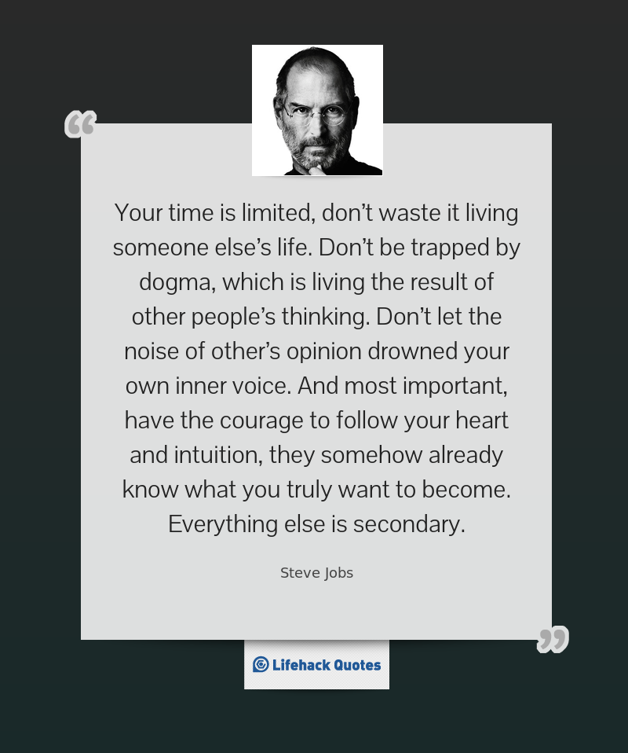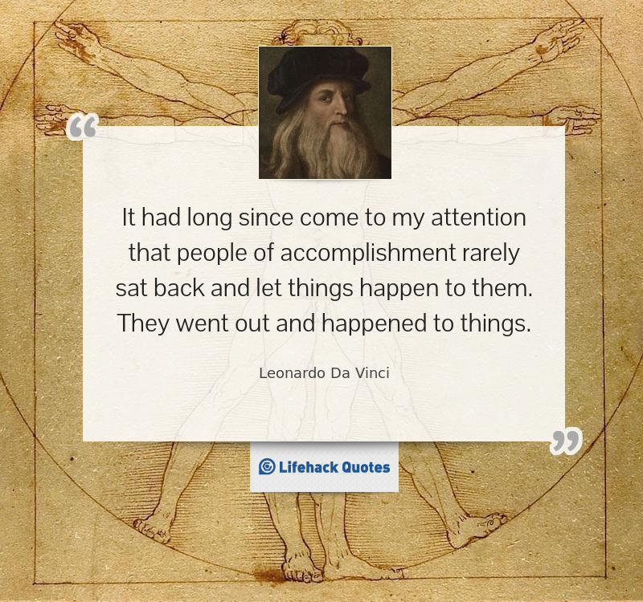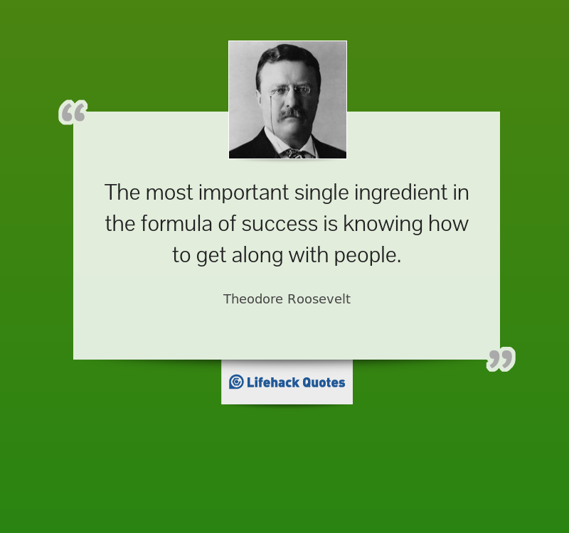





Conclusion:

So we have seen different opinion about ( how to be a successful person )

But in my opinion, the answer of this question is:

When you use your brainpower, have a great wisdom, manage your time, have the force to change your life to better and believe that your future will be wonderful,

Even it has some dark moment So we have seen different opinion about (how to be a successful person)

But in my opinion, the answer of this question is:

When you use your brainpower, have a great wisdom, manage your time, have the force to change your life to better and believe that your future will be wonderful,

Even it has some dark moments.

People who think that success just depends on talents and knowledge; I have a short advice for you:

Do not think that when you are clever, you will be successful.

But think that when you work hard, have your dreams, your energy, the commitment, the flexibility, the patience and the encouragement.

In this case, you will be successful.

So, manage your time and start your life with a white page filling of magnificent works that nobody has done .

And always remember

The winter is the beginning of the summer

The darkness is the beginning of the light

The stress is the beginning of the happiness

And the fail is the beginning of success

And now I do not hope you a bright chance because you have to work hard and make your chance by yourself.

References:

Reference's name: 13 tips from the world

It's website: [www.lifenack.org/articles/lifestyle/how-to-be-successful-in-life.html](http://www.lifenack.org/articles/lifestyle/how-to-be-successful-in-life.html)

Date: 28/10/2015

Reference's name: short stories for success in your career and life

It's website: [www.dishq.edu/doenlood/success-life.pdf](http://www.dishq.edu/doenlood/success-life.pdf)

Date:28/10/2015

Copyright; 2013 by khizer foundation international (KFi)

Email; [zkhizer@yohoo.com](mailto:zkhizer@yohoo.com)

Tel: 732-287-3622

Number of pages: 64

Photos

Reference's Email :[www.EnglishArab.net_Vb_T.34696_html](http://www.EnglishArab.net_Vb_T.34696_html)

1.
2.
3. 13 tips from the world success
4. Short stories for success in your career and life p;6
5. Short stories for success in life and career p:8
6. Short stories for success in life and career p: 9
7. Short stories for success in life and career p:14
8. Short stories for success in life and career p:21
9. Short stories for success in life and career p: 23
10. Short stories for success in life and career p: 28
11. Short stories for success in life and career p; 35